WEEKLY RESEARCH PROGRESS UPDATE

MathRepair
  - Learned Typed Verification, MATH-500 Evaluation, and Matched-Budget Ablations

Reporting date | 29 September 2026
Research stage | Supervisor follow-up experiments
Benchmark | MATH-500 hard subset, 40 level-4/5 problems
Primary model | qwen2.5:3b via local Ollama

Purpose of this update
This document reports the three requested follow-up tasks: training the first learned typed verifier, performing an answer-scored evaluation on the full MATH-500 hard subset, and completing the no-graph, no-typed-error, and no-symbolic/tool system ablations.

Executive Summary
- The learned verifier achieved 100.0% location and error-type accuracy on an eight-example synthetic held-out test, while the current structural/symbolic baseline covered 50.0%.
- The full 40-problem MATH-500 baseline obtained 10.0% answer accuracy (4/40), with 30 completed generations and 10 output failures retained in the denominator.
- Every matched-budget system variant finished at 5.0% final accuracy. Full MathRepair corrected one wrong answer but degenerated three initially correct answers.
- The results do not support an accuracy advantage for the current local-repair configuration but they identify verifier generalization and repair acceptance as the immediate research problems.

Supervisor Deliverable Checklist
Requested deliverable | Included in this report | Primary item
Learned verifier results | Yes: train/dev/test metrics and baseline comparison | learned_verifier_report.json
Real MATH-500 pilot accuracy | Yes: all 40 problems, failures, calls and tokens | math500_full40_baseline_report.json
Completed key ablations | Yes: no graph, no typed error, no symbolic/tool | math500_system_ablation_report.json
Error-type local-vs-global comparison | Yes: category-wise success rates and observed winner | error_category_analysis.json
Short current conclusion | Yes: current conclusion below | This document, Scientific Conclusions

Scope followed
The main effort was spent on methodological contribution and experimental evidence. No new web-interface work was prioritized during this cycle.

Main scientific finding
Strong performance on controlled copied verifier data did not transfer to hard open-ended mathematical traces. The negative result is taken as evidence rather than hidden or optimized away.

Requested Work and Completion Status
Focus area | Status | Evidence produced
Learned typed verifier | Completed | Deterministic training, development and test split, location/type metrics, rule/symbolic baseline comparison.
MATH-500 hard-subset evaluation | Completed | All 40 problems attempted; answer accuracy, output behavior, verifier detections, calls and token costs reported.
System-level ablations | Completed | No graph, no typed-error information, and no symbolic/tool support under a shared additional-token ceiling.

Learned Typed Verifier
The first learned verifier is an inspectable TF-IDF and logistic-regression baseline. One classifier localizes the first erroneous node and a second classifier predicts one of the eight frozen error types. Whole traces, rather than individual nodes, were kept separate across the split to reduce direct leakage.
The controlled dataset contains 48 examples: 32 train, 8 development, and 8 test examples. The location beginning (0.65) was selected on the development split.
Method | Coverage | Location accuracy | Type accuracy | End-to-end
Learned typed verifier | 100.0% | 100.0% | 100.0% | 100.0%
Current structural/symbolic heuristics | 50.0% | 50.0% | 50.0% | Not reported

Interpretation boundary
The test contains only eight controlled synthetic examples, one per class. The 100.0% result validates the training pipeline but does not establish generalization to natural model errors.

Full MATH-500 Hard-Subset Evaluation
The frozen 40-problem subset contains level-4 and level-5 problems from all seven MATH subjects. The baseline used qwen2.5:3b, seed 42, temperature 0, a 1,024-token output cap, and no repair. Reference answers were used only after generation for scoring.
Metric | Result | Measurement notes
Problems attempted | 40 | All remain in the accuracy denominator
Completed generations | 30 | Strict or normalized parse succeeded
Output failures | 10 | Not removed from accuracy
Strict-contract outputs | 1 | Exact requested steps-array schema
Normalized recoveries | 29 | Documented parser recovery
Correct answers | 4 | Exact/symbolic answer scoring
Answer accuracy | 10.0% | 4 correct out of 40
Model calls | 40 | One baseline call per problem
Prompt + completion tokens | 28,791 | Ollama-reported token counts

The low score reflects both incorrect mathematical answers and output-contract failures. Strict compliance was 1/40; 29 usable generations required normalized recovery. These two behaviors remain separate in the report so parser recovery is not presented as strict success.

Matched-Budget System Ablations
Supervisor comment addressed
These ablations are important because they identify which part of MathRepair is actually useful. The current runs therefore keep the baseline generations, seeds, model, answer scorer, and additional-token ceiling fixed across variants. The observed differences are reported below, including null results and repair regressions.

Every support reused the same frozen baseline generations. Full MathRepair established a shared additional-token ceiling of 8,487. Each detected case received at most one repair call; model, seed schedule, temperature, problem order, and answer scorer were held constant.
Variant | Initial | Final | Detected | Repair | Regressions | Calls | Tokens
Full MathRepair | 10.0% | 5.0% | 20 | 1/20 | 3 | 20 | 8,487
No graph | 10.0% | 5.0% | 30 | 0/19 | 2 | 19 | 8,218
No typed error | 10.0% | 5.0% | 20 | 1/20 | 3 | 20 | 8,107
No symbolic/tool support | 10.0% | 5.0% | 20 | 1/20 | 3 | 20 | 8,487

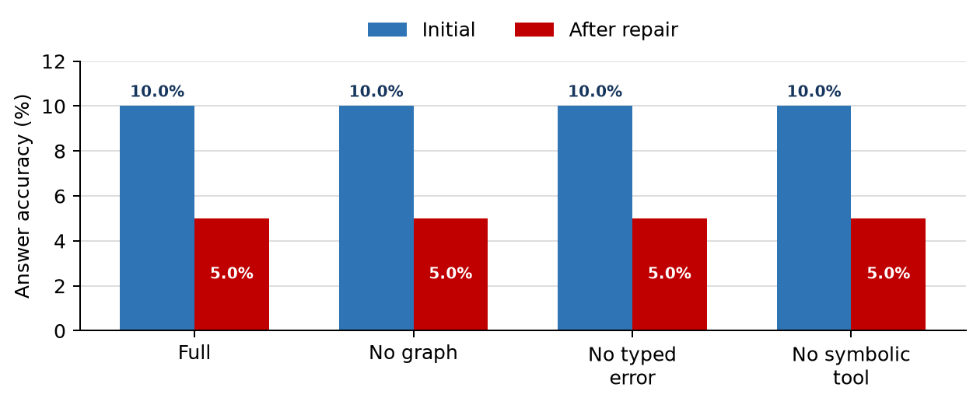
Figure 1. Initial and post-repair answer accuracy under the matched system-ablation protocol.

Ablation Interpretation
- Full MathRepair corrected one wrong answer in 20 repair attempts, but three initially correct answers became incorrect. Final accuracy fell from 10.0% to 5.0%.
- Removing graph features increased detections from 20 to 30. Eleven calls were skipped because the corresponding full-arm per-problem allocation was zero; the arm corrected no answer and regressed two.
- Removing typed-error information did not change final accuracy in this run. This null result is not evidence that typing is generally unnecessary because the model and verifier were already operating at low accuracy.
- The structural/symbolic heuristic withdrawn on every completed open-ended trace. Therefore, the identical full and no-symbolic results demonstrate zero tool coverage on this path, not that symbolic support has no value.

Error-Category Analysis
This analysis addresses the central research question: when does local repair help, and when does global regeneration work better? The comparison unit is an accepted, answer-correct repair among detected-error runs in the earlier matched-budget algebra pilot. The adaptive local arm is the primary local-repair comparison; uniform local results are shown as a secondary control.
Error category | Cases | Global success | Uniform local | Adaptive local | Best observed | Evidence
Arithmetic error | 1 | 0/1 | 0/1 | 0/1 | tie | observed
Algebraic transformation error | 5 | 2/5 | 1/5 | 1/5 | global_regeneration | observed
Missing assumption | 0 | -- | -- | -- | -- | no_observed_cases
Dependency error | 0 | -- | -- | -- | -- | no_observed_cases
Incomplete reasoning | 0 | -- | -- | -- | -- | no_observed_cases
Sign error | 1 | 1/1 | 0/1 | 1/1 | tie | observed
Logical inference error | 0 | -- | -- | -- | -- | no_observed_cases
Semantic interpretation error | 0 | -- | -- | -- | -- | no_observed_cases

Category-level finding
Global regeneration was stronger on the five observed algebraic-transformation cases (40.0% versus 20.0% for adaptive local repair). Adaptive local repair matched global regeneration on the single observed sign-error case (100.0%), while neither strategy succeeded on the single arithmetic-error case. Missing-assumption, dependency, incomplete-reasoning, logical-inference, and semantic-interpretation errors were not observed in this pilot.

This pattern supports the motivation for typed repair policies, but it is not yet a general claim: seven detected errors are too few, and five belong to one category. The next category-focused dataset should deliberately include valid traces and the currently unobserved error types.

Verifier-Stage Ablation Check
Variant | Location | Type | End-to-end
Full MathRepair | 100.0% | 100.0% | 100.0%
No graph | 100.0% | 87.5% | 87.5%
No typed error | 100.0% | -- | --
No symbolic/tool support | 100.0% | 100.0% | 100.0%

These eight-example synthetic ablations are supporting diagnostics only. They are not substitutes for final-answer or repair outcomes on MATH-500.

Scientific Conclusions
Current conclusion
The present evidence does not show that verifier-guided local repair outperforms a non-repair baseline on hard open-ended mathematics. The principal observed failure is unsafe repair acceptance after a synthetic-data verifier predicts errors outside its training distribution.

What currently works: the graph-integrated pipeline, reproducible typed-verifier training/evaluation, matched-budget accounting, and category-level comparison are operational. What still fails: the synthetic learned verifier transfers poorly to hard open-ended MATH traces, output-contract compliance is unstable, symbolic tools have zero coverage on that path, and local repair can regress an initially correct answer. The current methodological contribution is therefore the controlled framework for identifying these conditions, not a claim that local repair is universally superior.
- The learned-verifier training code and evaluation path are operational, but the current supervision set is too small and templated for broad claims.
- MATH-500 exposes output-contract instability: only one of 40 baseline outputs strictly followed the requested schema.
- A detector should learn a valid/no-repair outcome, and generated repairs need an independent acceptance check before replacing an initially correct answer.
- The earlier matched-budget result in which global regeneration reached 88.9% and local repair reached 86.1% remains scientifically relevant but the new hard-subset result strengthens the need for failure analysis rather than result tuning.

Limitations and Pending Direction
Limitation | Consequence | Candidate response after supervisor review
Synthetic verifier data | Perfect held-out template performance does not transfer to natural MATH traces. | Create reviewed natural-error and valid-trace labels.
No learned valid/no-repair class | The verifier can trigger repair on correct traces. | Train calibrated detection with abstention and valid examples.
No independent repair acceptance for open text | Correct answers can regress after local generation. | Add a separate acceptance verifier or answer-consistency gate.
Symbolic coverage is zero on open-ended traces | The no-symbolic ablation is non-informative. | Introduce domain-aware tool calls or formalizable substeps.
Small local model and unstable output contract | Ten baseline failures and low overall accuracy. | Confirm the next model/output protocol before further large runs.

No new methodological direction is started in this update. The candidate responses above are held for supervisor prioritization.

Reproducibility and Evidence
The commands below regenerate the learned-verifier report, run or resume the full baseline, run the matched system ablations, and execute the automated checks. Raw JSONL outputs are preserved locally and excluded from Git because they are large regenerable artifacts.
python learned_verifier.py
python math500_evaluation.py --model qwen2.5:3b --repair-attempts 0 --timeout-seconds 120 --max-output-tokens 1024 --report math500_full40_baseline_report.json --traces math500_full40_baseline_traces.jsonl
python math500_evaluation.py --model qwen2.5:3b --repair-attempts 0 --timeout-seconds 120 --max-output-tokens 1024 --report math500_full40_baseline_report.json --traces math500_full40_baseline_traces.jsonl --resume
python math500_system_ablation.py --model qwen2.5:3b --timeout-seconds 60 --max-output-tokens 192 --resume
python show_experiments.py
python -m unittest discover

Artifact | Purpose
learned_verifier_report.json | Train/dev/test metrics and baseline comparison
math500_full40_baseline_report.json | Full hard-subset accuracy and output behavior
math500_system_ablation_report.json | Matched-budget system-level ablation results
verifier_ablation_report.json | Controlled verifier-stage ablations
SUPERVISOR_NEXT_WEEK_RESULTS.md | Concise machine-readable-text summary

Automated verification at the time of this report: 144/144 tests passing.

