MathRepair Supervisor Progress Report
Verifier-Guided Local Repair for Mathematical Reasoning
Research progress review | Updated 23 September 2026
Repository: https://github.com/mwanajh/MathRepair_Project

1. Executive Summary
MathRepair now connects model-generated traces directly to its reasoning graph and includes a 40-problem MATH-500 pilot, a frozen eight-class error taxonomy, a 48-example typed-verifier dataset, a fresh three-arm matched-budget pilot, a frozen ablation matrix, and a versioned archive of 432 raw outputs. The earlier expanded algebra experiment found 100.0% local-repair accuracy versus 92.6% global regeneration. A newer and stricter total-budget pilot found 88.9% for global regeneration and 86.1% for both local arms. These protocols answer different questions, so the report does not claim universal local-repair superiority.
Defensible claim: The proposal-level experimental infrastructure is now implemented and produces reproducible, mixed results. Local repair led in the earlier expanded pilot, while global regeneration led by 2.8 percentage points in the fresh total-token-matched pilot.

2. Research Problem and Objectives
A final answer may be correct even when intermediate reasoning is invalid. An early transformation error can also propagate through later steps. The project therefore evaluates whether verifier-guided local repair can preserve valid reasoning and use compute more selectively than full regeneration.
- Verify each equation state with a symbolic checker.
- Identify and classify the first invalid transformation.
- Preserve the verified prefix and repair only the affected suffix.
- Represent dependencies with a reasoning graph and allocate compute to important error nodes.
- Compare no repair, verified global regeneration, and verified local repair under matched budgets.

3. Implemented System
The implemented pipeline consists of model generation, equation extraction, reasoning-state construction, symbolic verification, first-error localization, typed repair selection, local regeneration, and final re-verification. For currently supported equation-mode problems, repair candidates are accepted only after symbolic validation; the open-ended MATH-500 pilot remains text_unverified.
Component | Implemented capability
Symbolic verifier | Rule-based equation equivalence, supporting identities, arithmetic, sign, and algebraic-transformation checks; learned verifier remains deferred.
Typed-error taxonomy | Eight frozen supervision labels with definitions, examples, detection contracts, and allowed repair actions.
Reasoning graph | The model pipeline's internal representation, recording node state, parents, model reasoning, verification, affected descendants, repair, repaired state, and final status.
Repair policy | TOOL_EXECUTE, BACKTRACK, REFORMALIZE, LOCAL_RESAMPLE, REPLAN, and CONTINUE actions.
Local repair | Preserves the verified prefix, regenerates the affected suffix, and writes accepted repairs back to graph nodes.
Adaptive compute | Heuristic risk allocation plus measured uniform-local and adaptive-local arms under a shared token ceiling.
Benchmark and supervision data | A 40-problem MATH-500 hard pilot and 48 controlled typed-verifier training examples.
Experiment evidence | Matched-budget reports, a six-row ablation matrix, versioned output contracts, raw outputs, and artifact hashes.
Web demo | Retained as a secondary interactive graph view; methodology and experiments are the current priority.

4. Reasoning Graph Demonstration
For the branching demonstration 2(x + 3) = 14, n1 stores the model's invalid 2x + 3 = 14 transformation, n2-n3 are affected descendants, and n4-n5 form an independent valid branch. The graph records REFORMALIZE, the repaired state 2x + 6 = 14, recomputed x = 4, and final node statuses. This structure tests selective descendant propagation and zero allocation to unaffected nodes.

5. Experimental Design and Protocol Separation
The report contains two complementary experimental protocols. They use different budget definitions and must not be pooled into one performance claim.

5.1 Earlier Expanded Repeated-Seed Evaluation

Field | Protocol
Purpose | Earlier evidence for local versus global repair on symbolic algebra.
Model | qwen2-math:1.5b through the local Ollama API.
Dataset | 36 algebra problems: 18 earlier held-out and 18 new.
Trials | Three seeds and 36 runs per seed; 108 completed runs.
Strategies | No repair, verified global regeneration, and verified local repair.
Budget | Matched per detected-error case under the earlier protocol.
Metrics | Answer accuracy, valid-trace rate, calls, tokens, and paired confidence intervals.

5.2 Supervisor Task 1-7 Methodology

Field | Protocol
Internal representation | Model traces are verified and repaired as reasoning graphs with node state, parents, error impact, repair, and final status.
Hard pilot | A deterministic 40-problem MATH-500 subset: 17 level-4 and 23 level-5 problems across seven subjects; processing checks only.
Typed errors | Eight frozen error classes with definitions, examples, detection contracts, and allowed repair actions.
Verifier supervision | 48 controlled corrupted/correct trace pairs, balanced at six examples per error type.
Fresh matched budget | Thirty-six initial runs and seven detected-error cases; global, uniform-local, and adaptive-local arms share an approximately 5,800 additional-token ceiling.
Ablations | Six frozen variants with explicit measured, proxy, planned, and learned-verifier-dependent evidence states.
Output contracts | Four saved configurations preserve model digests, prompt/parser versions, 432 raw outputs, failures, and strict/normalized accuracy.
Primary fresh metric | Answer accuracy over all scheduled runs; secondary metrics include valid traces, repair success, calls, tokens, and budget violations.

5.3 Interpretation Boundary
The earlier expanded experiment reported 100.0% local repair versus 92.6% global regeneration. The stricter fresh total-token-matched pilot reported 86.1% adaptive local repair versus 88.9% global regeneration. Because the protocols answer different questions, neither result replaces the other and no universal superiority claim is made.

6. Earlier Expanded Evaluation Results
Strategy | Answer accuracy | Valid traces
No repair | 90.7% | 88.0%
Verified global regeneration | 92.6% | 92.6%
Verified local repair | 100.0% | 100.0%

The paired local-minus-global answer difference was +7.4 percentage points (100% - 92.6%), with a paired 95% Student-t confidence interval of [+3.4, +11.4] across three seed-level trials. The interval reflects seed variation on the same 36 problems, not problem-sampling uncertainty. Across the expanded trials, 13 invalid traces were detected: 12 algebraic-transformation errors and 1 arithmetic error. All 13 repairs were accepted, 10 wrong answers were corrected, and no answer regressions occurred.

7. Model and Output-Contract Findings

7.1 Strict End-to-End Model Comparison
Configuration | No repair | Global | Local | Failures
1.5B / default | 90.7% | 92.6% | 100.0% | 0/108
3B / default | 47.2% | 56.5% | 48.1% | 24/108
7B / default | 13.0% | 13.9% | 13.0% | 91/108
7B / JSON contract | 75.0% | 75.9% | 85.2% | 10/108

7.2 Parser-Normalized Sensitivity
Configuration | Strict | Normalized | Delta | Recovered failures
1.5B / default | 90.7% | 90.7% | +0.0 pp | 0/0
3B / default | 47.2% | 59.3% | +12.0 pp | 24/24
7B / default | 13.0% | 41.7% | +28.7 pp | 36/91
7B / JSON contract | 75.0% | 79.6% | +4.6 pp | 5/10

Both 7B rows use the same model artifact but change the prompt and parser profile together. Therefore, this is output-contract sensitivity, not a pure prompt ablation. Normalized accuracy is supporting evidence and does not replace strict end-to-end accuracy.

8. Completed Deliverables
- Executable graph-based verifier and repair pipeline with 130 passing tests.
- Stress, held-out, expanded, matched-budget, and repeated-seed evaluations.
- 3B and 7B model comparisons and parser-sensitivity analyses.
- Reasoning-graph command-line demonstration with a retained graphical web view.
- Category, typed-error, failure-replay, and artifact-consistency reports.
- Version-controlled source code and reports on GitHub.

9. Scope and Limitations
The complete proposal experiment is not yet finished. The project now includes a 40-problem MATH-500 level-4/5 processing pilot, a frozen six-row ablation design, and graph-integrated model traces. However, the MATH-500 run is currently a text-processing smoke test rather than an accuracy evaluation; the learned standardized verifier is not trained; three ablation cells remain unmeasured; and the fresh matched-budget result is based on only 36 runs and seven detected errors.

10. Work Status After Supervisor Tasks

10.1 Completed Supervisor Tasks
Tasks 1-7 are completed within the scope requested for this week. The evidence and results are summarized in Section 12.

10.2 Explicitly Deferred Work
- Train and calibrate the learned typed verifier. Task 4 explicitly required the data-generation pipeline this week, not completion of large-model training.
- Run a full real-model MATH-500 accuracy evaluation. Task 2 explicitly limited this week to creating and processing a difficult 30-50 problem pilot.
- Fill the no-graph, no-typed-error, and no-symbolic-tool ablation cells. Task 6 explicitly requested the table structure even if cells were unfinished.
These items are deferred by the stated scope; they are not incomplete deliverables from Tasks 1-7.

10.3 Proposed Follow-Up Experiments
- Repeat the three-arm matched-budget comparison on the hard benchmark pilot and report paired uncertainty.
- Add natural model errors to the controlled verifier data before final training.
- Keep prompt/parser sensitivity as supporting evidence rather than the primary contribution.

11. Demonstration Commands
Primary Tasks 1-7 terminal walkthrough: python show_experiments.py
Live graph-integrated model trace (requires Ollama and the installed model): python model_pipeline.py --provider ollama --model qwen2-math:1.5b --problem "2(x + 3) = 14"
python model_pipeline.py --provider mock
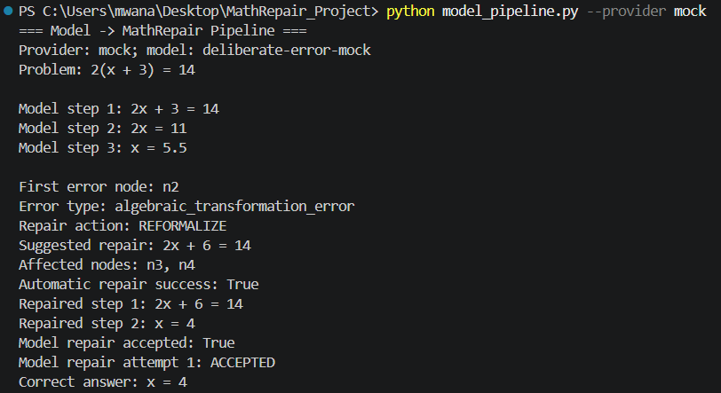
Demonstration screenshot: graph-integrated model trace using the mock provider. This is a system-validation example, not a benchmark result.

python reasoning_graph.py
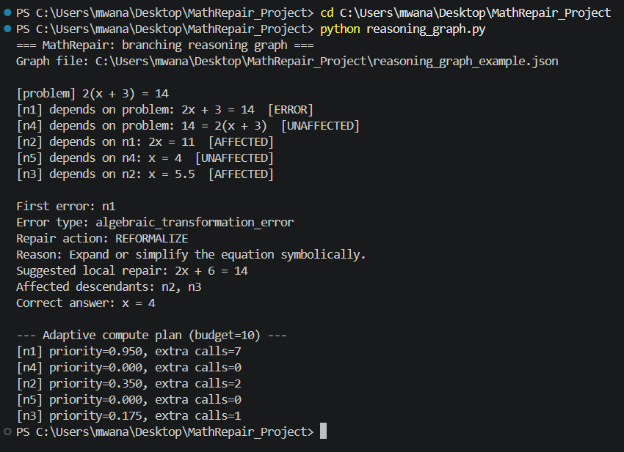
Demonstration screenshot: branching reasoning graph with first-error localization and selective propagation to affected descendants.
python run_repeated_experiments.py --aggregate-only --problems expanded_heldout_model_problems.csv --seeds 160500 180500 200500 --samples-per-problem 1
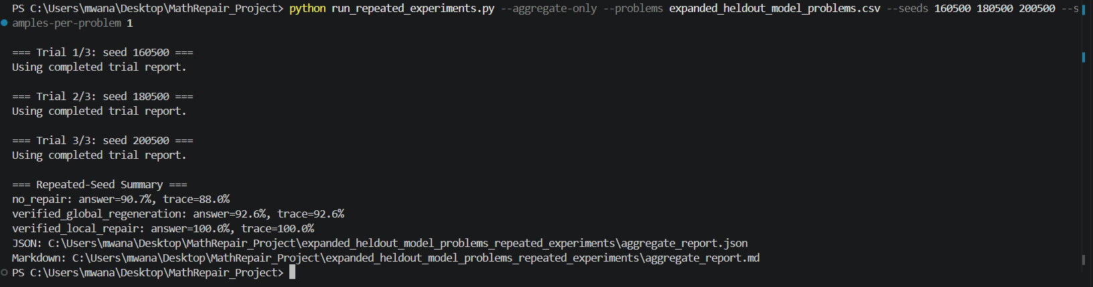
Earlier expanded repeated-seed evaluation. This result is separate from the fresh total-token-matched pilot reported in Section 12.
Conclusion: Tasks 1-7 establish the proposal-level infrastructure and reproducible pilot evidence. Current performance claims remain preliminary: the expanded accuracy result is limited to algebra, the MATH-500 run is processing-only, and the learned verifier and three ablation cells remain deferred.

12. Supervisor Tasks 1-7 Completion Update
This section records the seven methodology tasks requested after the earlier progress review. It supersedes older status statements where the graph, benchmark pilot, and ablation plan were still pending.
Task | Status | Evidence / current result | Artifact
1 | Completed | Real model traces now use the reasoning graph internally. Each node stores state, parents, verification, error impact, repair, and final status. | model_pipeline.py; reasoning_graph.py
2 | Completed within requested scope | A deterministic 40-problem MATH-500 subset has 17 level-4 and 23 level-5 problems across seven subjects. The smoke test processed 40/40 in text_unverified mode. | math500_pilot_40_manifest.json; math500_pilot_run.json
3 | Completed | Eight typed errors are frozen with definitions, positive and negative examples, detection contracts, and repair actions. | ERROR_TAXONOMY.md
4 | Completed within requested scope | The data generator produced 48 typed-verifier examples, six per error type, with error location, corrupted/correct steps, and preferred action. | typed_verifier_pilot.json
5 | Completed | Under a shared approximately 5,800-token ceiling, global regeneration reached 88.9% answer accuracy; uniform and adaptive local repair each reached 86.1%. Budget violations: zero. | matched_budget_report.md
6 | Completed within requested scope | The requested six-row structure is frozen. As explicitly allowed, two rows are measured, one is a rule-based proxy reference, and three future cells remain unfilled. | ablation_table.md
7 | Completed | The archive preserves exact model digests, prompt/parser versions, 432 raw-output records, generation failures, trace hashes, and normalized accuracy for four configurations. | output_contract_evidence.md

12.1 Fresh Matched-Budget Result
The fresh Task 5 run used 36 model calls as the initial sample, found seven error cases, and applied an approximately 5,800 additional-token ceiling to each repair strategy.
Strategy | Answer | Valid trace | Repair | Avg calls | Avg tokens | Total cost
No repair | 86.1% | 80.6% | 0.0% | 1.00 | 624.1 | 22,469
Global regeneration | 88.9% | 88.9% | 42.9% | 1.25 | 757.4 | 27,265
Uniform local | 86.1% | 83.3% | 14.3% | 1.25 | 772.1 | 27,796
Adaptive local | 86.1% | 86.1% | 28.6% | 1.17 | 721.5 | 25,975

Interpretation: adaptive local repair improved trace validity over uniform allocation and used fewer actual tokens, but it did not improve answer accuracy. Global regeneration was 2.8 percentage points more accurate in this small pilot.

12.2 Ablation and Learned-Verifier Status
The ablation matrix now contains Full MathRepair, no graph, no typed error, no adaptive compute, global regeneration instead of local repair, and no symbolic tool. Only no adaptive compute and global regeneration are currently marked measured. Full MathRepair is a rule-based proxy; the remaining cells stay explicit rather than receiving estimated values.

12.3 Output-Contract Sensitivity
Model | Prompt version | Parser version | Failures | Strict | Normalized
qwen2-math:1.5b | equation_json_default_v1 | equation_parser_default_v1 | 0/108 | 90.7% | 90.7%
qwen2.5:3b | equation_json_default_v1 | equation_parser_default_v1 | 24/108 | 47.2% | 59.3%
qwen2-math:7b | equation_json_default_v1 | equation_parser_default_v1 | 91/108 | 13.0% | 41.7%
qwen2-math:7b | equation_json_qwen2_v1 | equation_parser_qwen2_v1 | 10/108 | 75.0% | 79.6%

Normalized accuracy is an offline parser-only sensitivity analysis and does not replace the strict end-to-end result. Exact model digests, prompt/parser versions, trace hashes, and 432 raw-output records are preserved in output_contract_evidence.json and its raw archive.

12.4 Reproduction
- python show_experiments.py

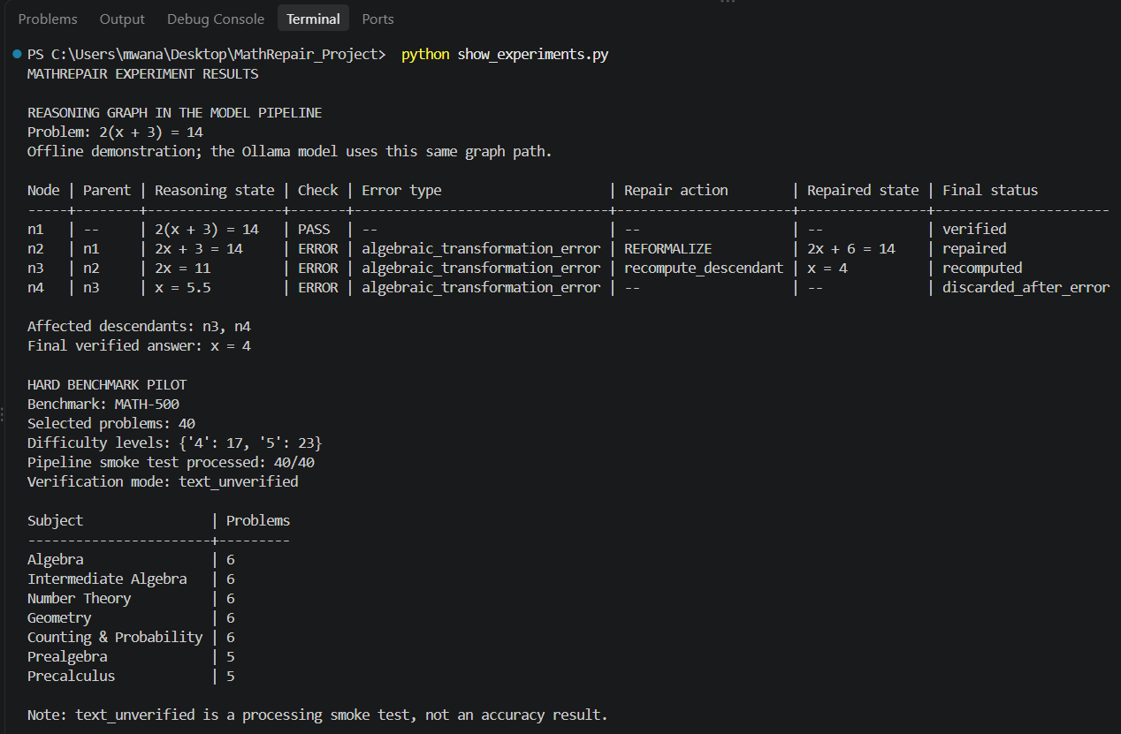
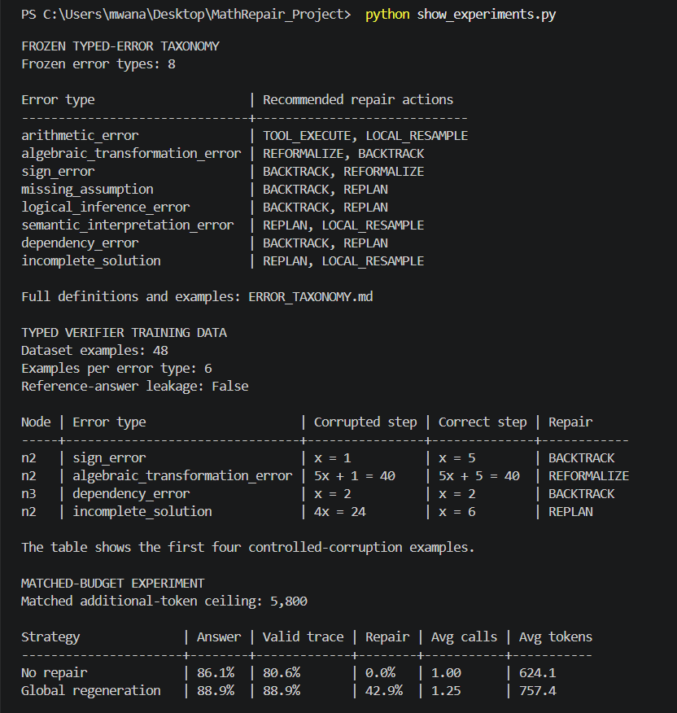
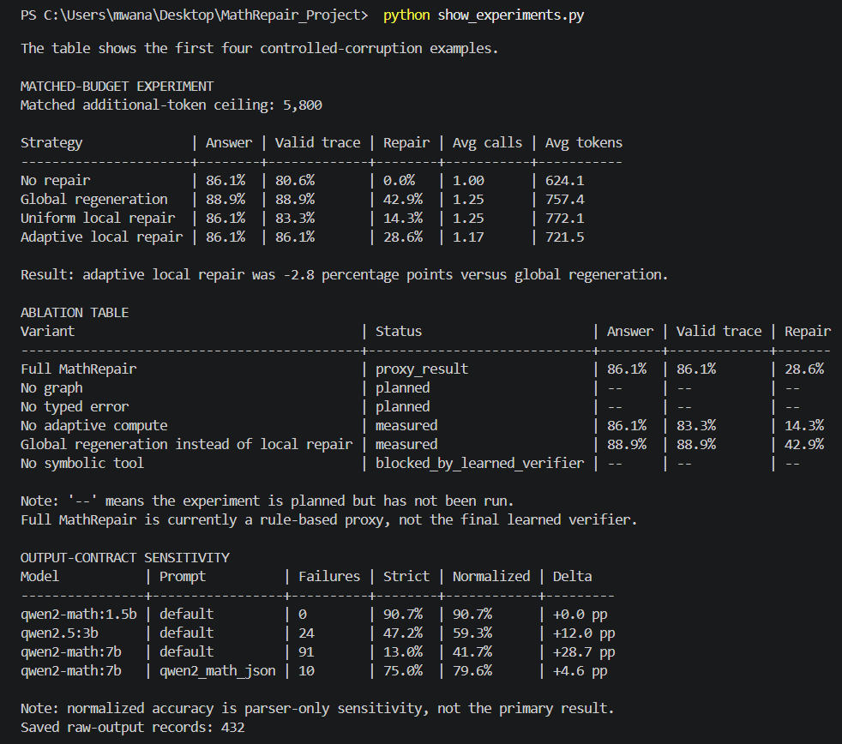

- python generate_verifier_dataset.py --count-per-type 6 --seed 42
- python matched_budget_experiment.py --reuse-global-results --reuse-local-results
- python ablation_table.py
- python output_contract_evidence.py
- python -m unittest discover -q
Current automated verification: 130/130 tests passing. The immediate research priority is the learned verifier and completion of the pending controlled ablations, not additional web-interface work.

