MathRepair Supervisor Demo

Preparation
Open PowerShell and enter the project directory:
cd C:\Users\mwana\Desktop\MathRepair_Project
This prototype runs with Python. PowerShell only starts the program; the
verifier and repair logic are implemented in Python files.
Run the complete demo with one command:
powershell -ExecutionPolicy Bypass -File .\run_supervisor_demo.ps1
The script uses the mock pipeline and saved reports; it does not rerun GPU
experiments.

1. Show error detection and symbolic repair
python mathrepair_demo.py
Use this example:
Original equation: 2(x + 3) = 14
Step to verify: 2x + 3 = 14
Explain that `2x + 3 = 14` is not equivalent to the original equation. The
system detects the distribution error, produces `2x + 6 = 14`, and obtains
`x = 4`.
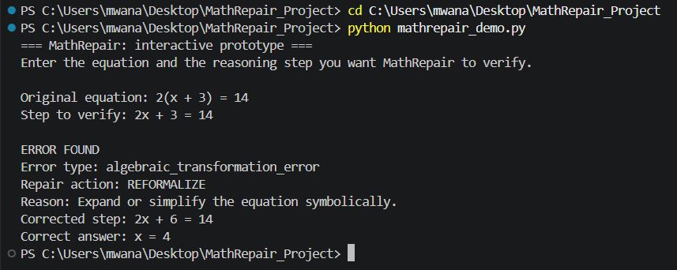

2. Show the model-to-verifier pipeline
This demo does not use Ollama, so it is safe and fast:
python model_pipeline.py --provider mock
The mock model deliberately produces an incorrect reasoning trace. MathRepair
shows the model steps, first error node, error type, repair action, affected
nodes, and correct answer.
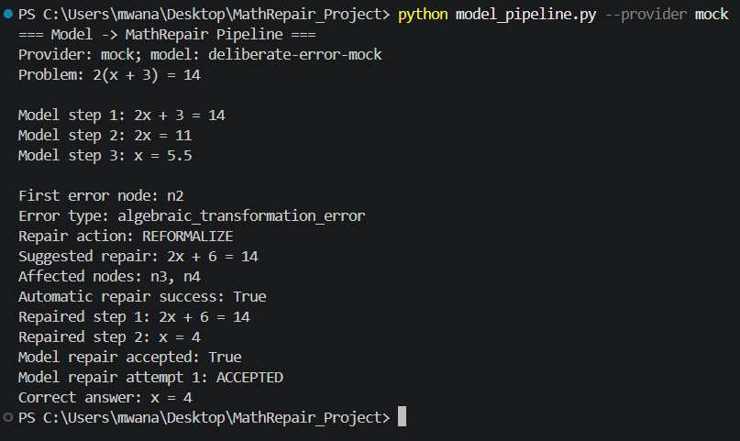

3. Show the completed stress evaluation
Do not rerun the GPU experiment during the presentation. Build the summary
from the saved reports:
python run_repeated_experiments.py --aggregate-only
Results from five seeds:
No repair: 84.4% answer accuracy
Global repair: 88.9% answer accuracy
Local repair: 97.8% answer accuracy
Open the report:
notepad .\repeated_experiments\aggregate_report.md
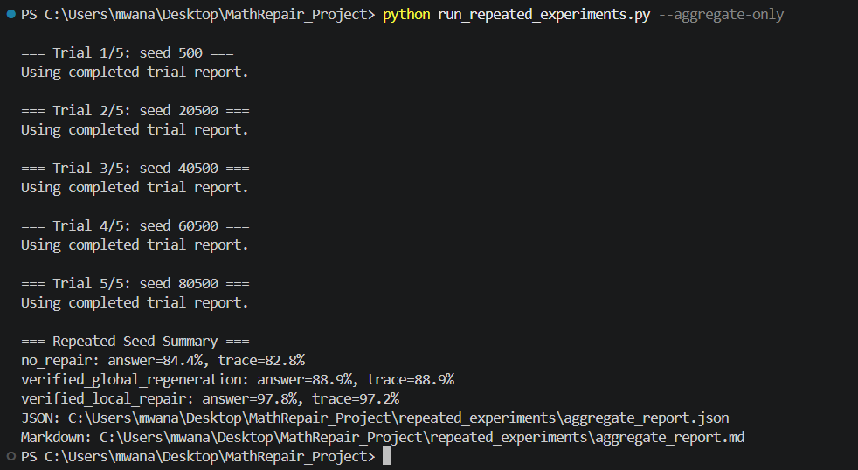

4. Show the held-out generalization check
The held-out set contains 18 new equations that were not used in the stress
set:
python run_repeated_experiments.py --aggregate-only --problems heldout_model_problems.csv --seeds 100500 120500 140500 --samples-per-problem 1
Results:
No repair: 96.3% answer accuracy
Global repair: 98.1% answer accuracy
Local repair: 100.0% answer accuracy
Open the report:
notepad .\heldout_model_problems_repeated_experiments\aggregate_report.md
Do not claim that local repair is proven superior on the held-out set. The
paired 95% confidence interval for local-minus-global is `[-6.1%, 9.8%]`, so
this result is an initial generalization check.
To show results by mathematics topic:
python category_analysis.py
python category_analysis.py --input-dir heldout_model_problems_repeated_experiments
notepad .\repeated_experiments\category_report.md
The stress report shows, for example, that nested distribution was difficult
for global regeneration while local repair recovered approximately `93.3%`
answer accuracy. Categories with few runs require cautious interpretation.
For the expanded 36-problem evaluation:
python run_repeated_experiments.py --aggregate-only --problems expanded_heldout_model_problems.csv --seeds 160500 180500 200500 --samples-per-problem 1
notepad .\expanded_heldout_model_problems_repeated_experiments\aggregate_report.md
The saved results are `90.7%` for no repair, `92.6%` for global regeneration,
and `100.0%` for local repair. The local-versus-global difference is `+7.4`
percentage points, with a 95% CI of `[3.4%, 11.4%]`. Explain that 18 rows in
this dataset were inherited from the earlier held-out set and 18 rows are new.
To show typed error analysis for the expanded set:
python error_analysis.py --input-dir expanded_heldout_model_problems_repeated_experiments
notepad .\expanded_heldout_model_problems_repeated_experiments\error_report.md
This set found 12 algebraic-transformation errors and 1 arithmetic error. All
13 repairs were accepted, 10 wrong answers were corrected, and no regressions
were observed.
To show adaptive compute allocation for the reasoning graph:
python allocation_report.py
notepad .\allocation_report.md
Explain that the error node and its descendants receive extra calls while the
unaffected branch receives `0`. This is the proposal's heuristic based on
`uncertainty * importance * propagation risk`.
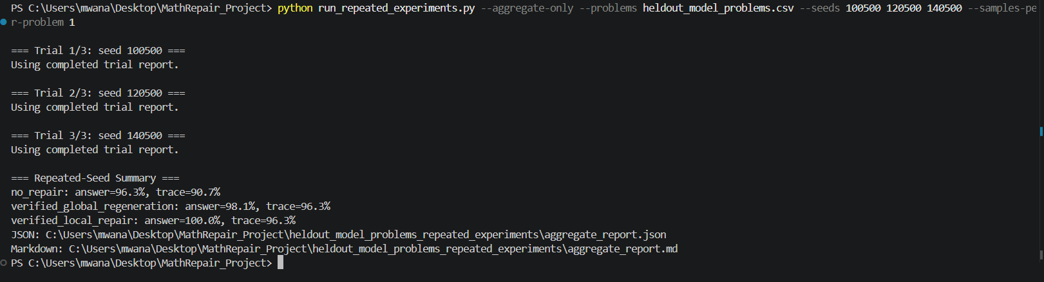

Short explanation to say
MathRepair does not accept a model answer by checking only the final answer.
It verifies every reasoning step symbolically, identifies the first invalid
step, and attempts to repair that local section. Local repair spends compute
on the erroneous part instead of regenerating the entire solution.

Prototype limitations
- It evaluates one-variable algebra equations, not all of mathematics.
- The model used is `qwen2-math:1.5b`.
- The problem sets are small and are not official benchmarks.
- The held-out confidence interval still has substantial uncertainty.
- The next step is to add independent datasets, larger models, and the full
proposal-level adaptive graph repair.

Do not do this during the demo
- Do not run `run_repeated_experiments.py` without `--aggregate-only`; it will
start many model calls and may take a long time.
- Do not put an API key in a screenshot, terminal, README, or presentation.
- Do not mix `repeated_experiments` with
`heldout_model_problems_repeated_experiments`; they are separate evaluations.

