**Practical assessment 1 - Creating UI elements**

**Time: 8:00 – 11:30**

In the past two week, we reviewed some important HTML/CSS concepts that are important in the design of web-based user interfaces. We developed a basic admin dashboard that we can use to develop full fledged system, in this exercise you are going to implement various components that we can find in a typical user interface like tables, form elements, buttons, alerts and cards.

**Steps**

* Download the base project from the google classroom
* Explore the project on your computer, you should have something similar to the following diagram.

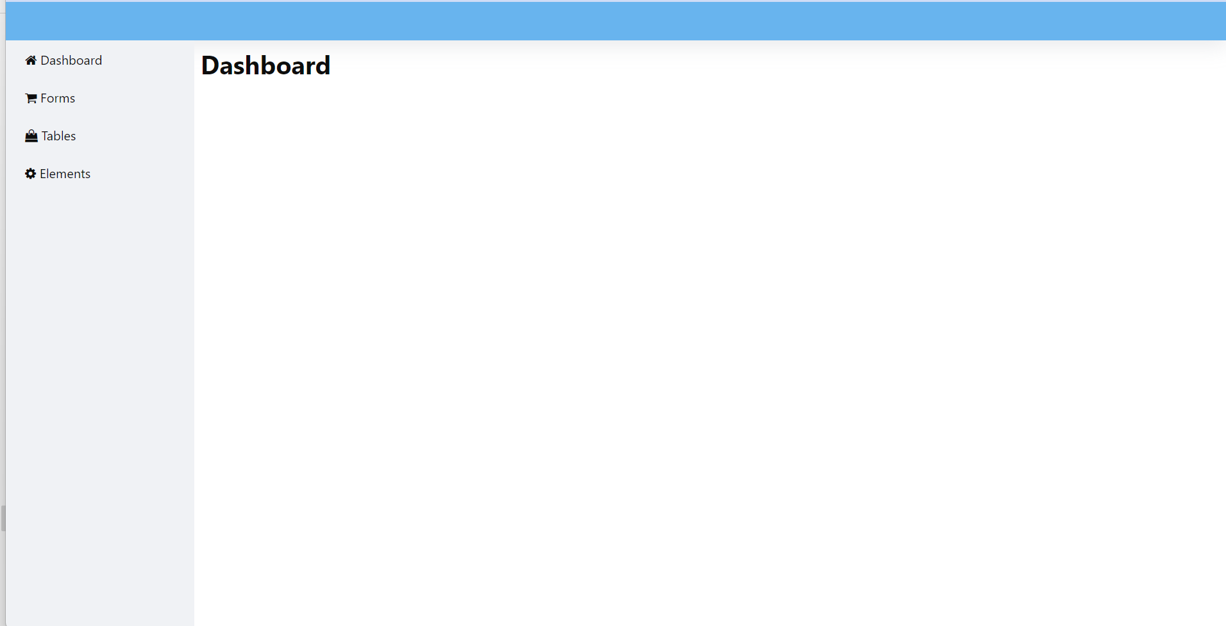

* For each of the side navigation links there is just a header, each link has a separate file that you need to add content.

**Task 1- implement the dashboard**

Implement the dashboard as in the following diagram, use the icons from <https://www.w3schools.com/icons/fontawesome_icons_webapp.asp>. You can request specific colours from your invigilator, but the room for creativity is wide open.

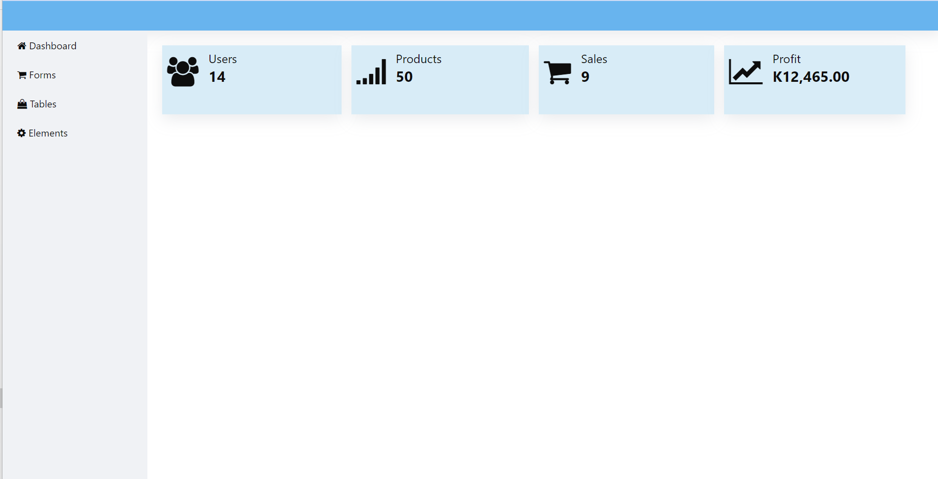

**Task 2 – implementing a table**

Implement a table as in the following diagram.

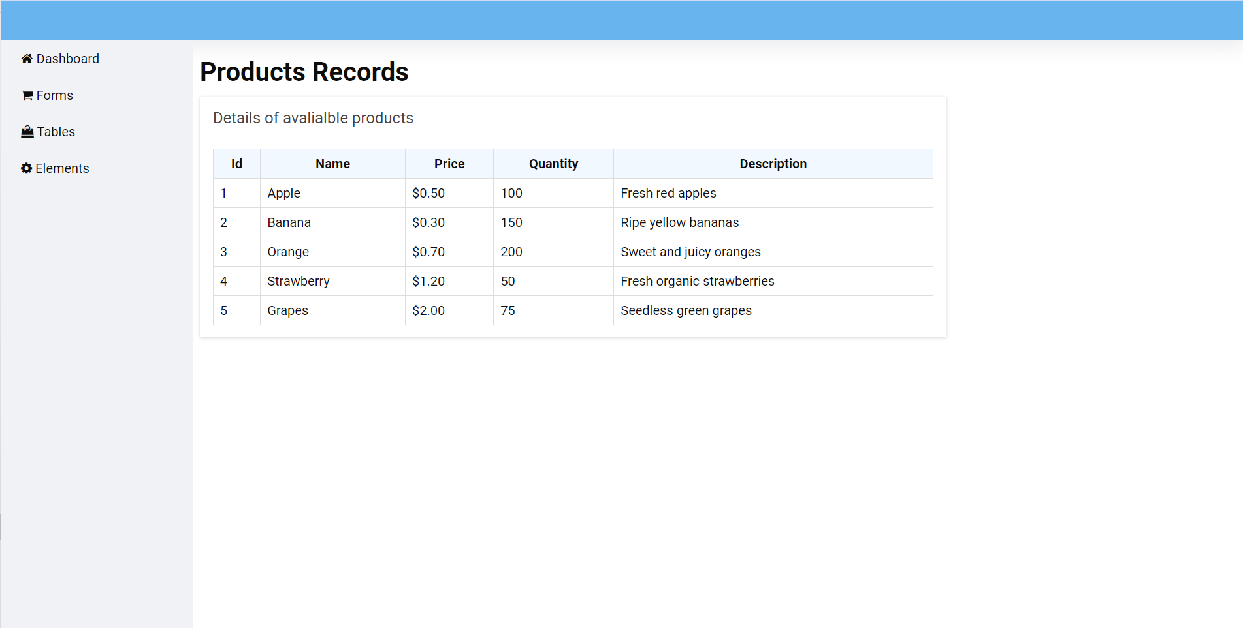

**Task 3- implement a form with and its elements**

Implement the following form in the form file.

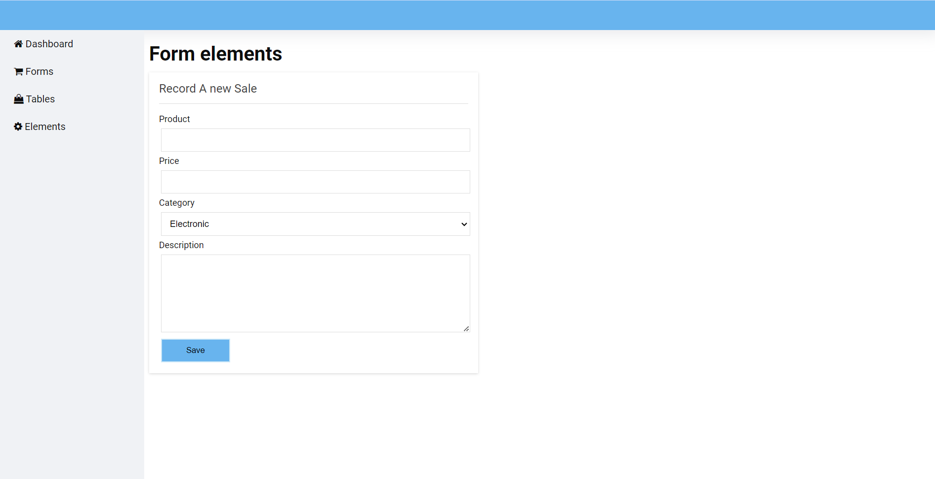

**Task 4 – implementing components**

Implement the following components in the elements file.

