Wednesday, August 05, 2009

Subversion Command Line

(download from http://subversion.tigris.org/getting.html)

https://www.hibernate.org/152.html
http://www.manning.com/bauer2/chapter2.pdf

extract hibernate src to D:\svnviews\hibernate_src http://anonsvn.jboss.org/repos/hibernate/core/trunk

mvn archetype:create -DgroupId=com.oreilly
-DartifactId=Oreilly
-DarchetypeArtifactId=maven-archetype-webapp

Check dependency with
http://repo1.maven.org/maven2

file:///D:/MyProg/hibernate-distribution-3.3.2.GA/documentation/manual/en-US/html_single/index.html#tutorial-firstapp-setup

Example 1:
mvn eclipse:eclipse to crate eclipse project

mvn compile
mvn exec:java -Dexec.mainClass="org.hibernate.tutorial.EventManager" -Dexec.args="store"
mvn -e exec:java -Dexec.mainClass="org.hibernate.tutorial.EventManager" -Dexec.args="list"

MySQL
CREATE TABLE Events (
EVENT_ID INT NOT NULL PRIMARY KEY AUTO_INCREMENT,
EVENT_DATE TIMESTAMP DEFAULT NOW(),
title VARCHAR(100)
);

Drop table events;

Status: successfully build and run first example

Example 2:
CREATE TABLE PERSON (
PERSON_ID INT NOT NULL PRIMARY KEY AUTO_INCREMENT,
age int,
firstname VARCHAR(100),
lastname VARCHAR(100)
);

CREATE TABLE PERSON_EVENT (
PERSON_ID INT,
EVENT_ID INT
);

Create table PERSON_EMAIL_ADDR (
PERSON_ID int,
EMAIL_ADDR VARCHAR(100)
);

<element type="string" column="EMAIL_ADDR"/> The lowercase name tells you it is a Hibernate mapping type/converter.
mvn package

<element type="string" column="EMAIL_ADDR"/> The lowercase name tells you it is a Hibernate mapping type/converter.
mvn package

adding following line to pom.xml, so mvn package will generate war file
<packaging>war</packaging>

Or just use mvn compile war:war

Deploy to C:\myapp\jboss-4.2.1.GA\server\mytest
http://localhost/web-tutorial/eventmanager

Thursday, August 06, 2009
Adding spring MVC, create home page,

1. Add pom
<!-- Spring MVC -->
<dependency>
<groupId>org.springframework</groupId>
<artifactId>spring-webmvc</artifactId>
<version>2.5.4</version>
</dependency>

2. Modify web.xml
3. Add myapp-servlet.xml
4. Create controller and home.jsp

http://localhost/web-tutorial/myapp/home

Adding GWT
In eclipse: right click on gwt.tutorial.homepage New → Other
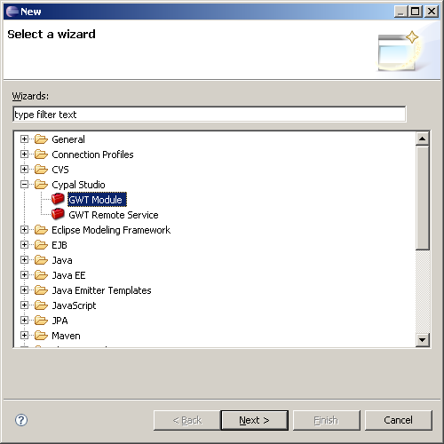

Select GWT Module and click Next
Fill in the form on New GWT Module page
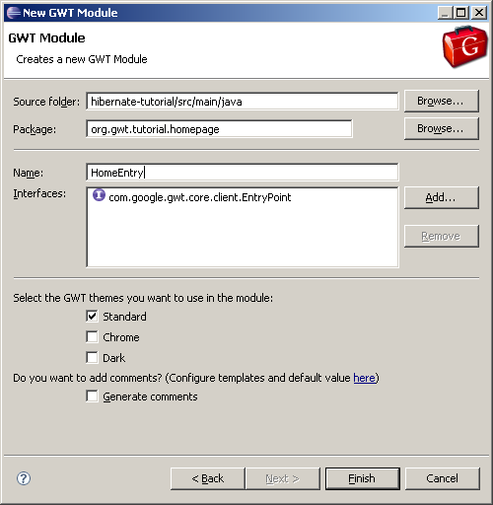

Ignore Error by clicking OK.

Add GWT

1. dependency to pom.xml
<!-- GWT -->
<dependency>
<groupId>com.google.gwt</groupId>
<artifactId>gwt-user</artifactId>
<version>1.5.3</version>
</dependency>

2. in command line:
mvn eclipse:clean
mvn eclipse:eclipse

3. adding following line to HomeEntry.onModuleLoad()
final Label l = new Label( "Press Button 'Click me!'" );
// Create Button Widget
Button b = new Button( "Click me!" );

// Add click listener to button widget
b.addClickListener( new ClickListener() {
public void onClick( Widget sender )
{
l.setText( "'Click me!' button clicked." );
}
} );

// Add widgets to the window
RootPanel.get().add( l );
RootPanel.get().add( b );

4. test in eclipse
Right click HomeEntry.gwt.xml then select run as → Gwt Hosted Mode Application

5. create gwthome page with Spring MVC to load gwt.
GWTHomeController.java under org.spring.tutorial.actions.common

6. add <div id="gwt_section" style="position: relative"></div> in HomeEntry.html
And gwt_home.jsp

International: http://localhost/web-tutorial/en/us/gwthome

Add Spring interceptor to retrieve env: contextPath, language, country etc

mvn process-resources

Monday, August 10, 2009

http://code.google.com/webtoolkit/doc/latest/DevGuideUiBinder.html

