http://127.0.0.1:8888/MyTestGWT.html?gwt.codesvr=127.0.0.1:9997
http://localhost/gwtbooking/en-US/gwtreservation?gwt.codesvr=127.0.0.1:9997
http://local.www.gogwt.com/gwtbooking/en-US/gwtreservation?gwt.codesvr=127.0.0.1:9997

GWT For Enterprise Application

GWT Programming
With Tutorials

Written by Michael Wang

Foreword / How to read this doc
This document was written for developers who have worked with Java before and want to start developing GWT application and/or who already work on GWT and try to tune up the GWT application to run with high performance.

I have been working as a lead developer for the passed few years to design, develop framework and implement business functions for the high traffic, high volume and high competitive websites using cutting edge technologies.

I try to turn on the reading of this book to be more hands on experience and will provide examples, some with in details. I also will list few real world difficulties/challenges regarding the design and implementation and how we address those.

Introduction
I would like ask a few questions to be the introduction of this book:

The first question:
Why companies rewrite existing application even though the existing application (website) is working fine to bring good revenue.

There may be many answers for this kind of questions.
My answer is very simple: they have to. That means that the companies want to be surviving in the highly completive environment, to get more revenues, to beat competitors. How to achieve this brings up another question.

The second question:
How the company achieve the goal list above.

The answer is technology. The technology provides more capabilities to attractive more users. That is the reason GWT comes to the picture.

The third question:
It is easy or hard to use GWT.

The answer depends on the application you are build. If simple, low traffic, then it is easy. With high traffic, high volume, then it is hard. Much like building house, compare to skyscraper, two storage house is much easier. As skyscraper must consider foundation even wind, rain factories.

GWT
Pro: User friendly, hide business logic, in normal Javascript, the logic can be got with view source, good conversion rate. Less worry about browser.

Con:

I will follow SCUM methodology to develop sample code and writing this ebook.

Part I: Before GWT

The goal of product website is to attractive more users to stay and book product through the website. Before GWT, website developer usually use third party Javascript library such as prototype to achieve user friendly website.

Encetail

Iterate 1 – Basic
Creating new project with Maven
First, download Eclipse 3.5 Galileo and install plug with m2eclipse Core Update Site: http://m2eclipse.sonatype.org/sites/m2e
Create working directory directory d:\ebook, we are going to create web application with Maven, just type in:
mvn archetype:create -DgroupId=com.egwt.app.booking -DartifactId=booking -DarchetypeArtifactId=maven-archetype-webapp

That will create booking application under ebook.

Build
Under d:\ebook\ebooking, type in
mvn clean install
That will create booking.war

Note: if there is resource bundle change, do following command first to generate resource java file.
mvn resources:resources

Copy booking.war into application server deploy directory, I used jboss with port set to 80 instead of default 8080 through server.xml. Please reference http://www.jboss.org for how to deploy application and change port.

Test:
http://localhost/booking/
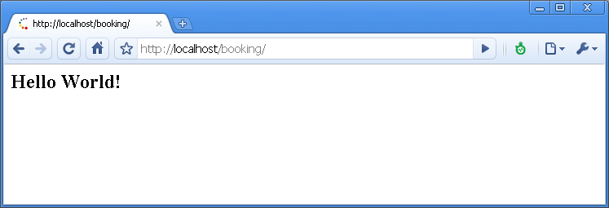

Source code: under iterate1

As practice, we can push the generated war file into deploy directory.

<project xmlns="http://maven.apache.org/POM/4.0.0" xmlns:xsi="http://www.w3.org/2001/XMLSchema-instance"
xsi:schemaLocation="http://maven.apache.org/POM/4.0.0 http://maven.apache.org/maven-v4_0_0.xsd">
<modelVersion>4.0.0</modelVersion>
<groupId>com.egwt.app.booking</groupId>
<artifactId>booking</artifactId>
<packaging>war</packaging>
<version>1.0-SNAPSHOT</version>
<name>booking Maven Webapp</name>
<url>http://maven.apache.org</url>
<dependencies>
<dependency>
<groupId>junit</groupId>
<artifactId>junit</artifactId>
<version>3.8.1</version>
<scope>test</scope>
</dependency>
</dependencies>
<build>
<finalName>booking</finalName>
<plugins>
<!-- deploy jboss runtime -->
<plugin>
<groupId>org.apache.maven.plugins</groupId>
<artifactId>maven-war-plugin</artifactId>
<version>2.1-alpha-2</version>
<configuration>
<packagingExcludes>${warExclude}</packagingExcludes>
<outputDirectory> ${JBOSS_HOME}/server/mytest/deploy </outputDirectory>
<outputFileNameMapping>
@{artifactId}@@{classifier}@.@{extension}@
</outputFileNameMapping>
</configuration>
</plugin>
</plugins>
</build>
</project>
Where mytest is the new server I create for test., you need to change it the server you use.

Source code: under iterate1a

Iterate 2 – Spring
Here I will provide step by step of how to add Spring MVC to above application we just created.
First we need to import booking project to Eclipse
mvn clean eclipse:eclipse
Then in Eclipse, File → Imports→ Existing Projects into Workspace →
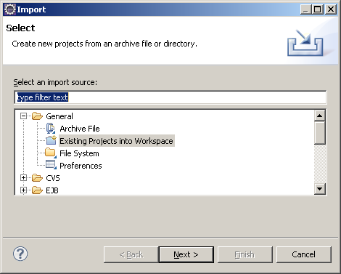

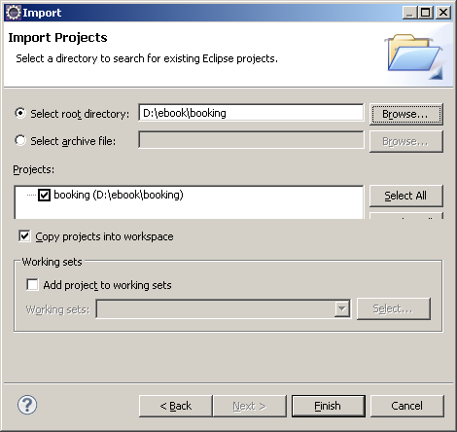

- Modify pom.xml by adding
<!-- Spring MVC -->
<dependency>
<groupId>org.springframework</groupId>
<artifactId>spring-webmvc</artifactId>
<version>2.5.4</version>
</dependency>
- Modify web.xml
<filter>
<filter-name>requestContextFilter</filter-name>
<filter-class>org.springframework.web.filter.RequestContextFilter</filter-class>
</filter>

<servlet>
<servlet-name>booking</servlet-name>
<servlet-class>org.springframework.web.servlet.DispatcherServlet</servlet-class>
<init-param>
<param-name>contextConfigLocation</param-name>
<param-value>/WEB-INF/classes/conf/booking-servlet.xml</param-value>
</init-param>
<load-on-startup>1</load-on-startup>
</servlet>

<servlet-mapping>
<servlet-name>booking</servlet-name>
<url-pattern>/en/*</url-pattern>
</servlet-mapping>

- Create booking-servlet.xml under resources/conf
- Create controller HomePageController.java within package of com.egwt.app.booking.controllers
- Test with

http://localhost/booking/en/home
So far, we create very simple Spring MVC project. See iterate2.zip

Adding log4j for logging by adding following section in pom.xml
<dependency>
<groupId>log4j</groupId>
<artifactId>log4j</artifactId>
<version>1.2.12</version>
<scope>compile</scope>
</dependency>

select count(*) from ahm_property where country='US' and property_type='OTH'

Iterate 3. Create database and apply hibernate, first we need database, I use MySQL in window as example.

1. Now we'll access the MySQL server. Type:
Create MySQL user and password
After install MySQL, login into MySQL client as root user
start mySql from windown start/programs/ or
Open a command prompt: mysql –u root -pYourRootPassword

2. Now we are ready for creating the ebooking database. Issue the command:
mysql>create database ebooking;

3. view the database just created
mysql>show databases;

4. Create user and grand permission for the ebooking database
An important point to note is that this database is created by the root and so will not be accessible to any other user unless permitted by the root. Thus, in order to use this database from my account (called myUser), I have to set the permissions by issuing the following command

mysql>grant all privileges on ebooking.* to 'myUser'@'localhost' identified by 'myPassword' with grant option;
mysql>grant all privileges on ebooking.* to 'myUser'@'%' identified by 'myPassword' with grant option;
mysqldump -u myUser -pmyPassword --database ebooking > ebook.sql
mysql -u myUser -pmyPassword ebooking < ebook.sql

- Quit and relogin with bookUser
mysql>quit;
C:\>mysql -u bookUser –p

6. Access the new database
mysql>use ebooking;

- Export database
- Create the tables we are going to use

Add hibernate and MySQL dependencies to pom.xml
<!-- Hibernate -->
<dependency>
<groupId>org.hibernate</groupId>
<artifactId>hibernate-core</artifactId>
<version>3.3.1.GA</version>
</dependency>

<!-- MySQL -->
<dependency>
<groupId>mysql</groupId>
<artifactId>mysql-connector-java</artifactId>
<version>5.0.5</version>
</dependency>

Create hibernate.cfg.xml under resources directory
Once you load the data to your MySQL database, you will see several tables:
- property table, lists all the
- state table, list US states for the languages of Spanish and English.

Next I will create sample application to let user to search for the properties (hotels) per location, user can select particular property, then provide personal info and finally book the property.
The technique will be used are: Spring MVC, hibernate, MySQL.

The URL of the page:
http://localhost/booking/en-US/home
http://localhost/booking/es-ES/home

http://localhost/booking/en-US/**/home/**
such as http://localhost/booking/en-US/atlanta/home/goodPlace

As you see we have two language-Region, one is en-US and one is es-ES.
I will create URL interceptor to extract the value of en-US and es-ES and apply Spring LocaleResolver to change the locale.

First create URLHandlerInterceptor.java, intercept is executed for each request.
Config defined in booking-servlet.xml
<bean name="urlMappingPart1"
class="org.springframework.web.servlet.handler.SimpleUrlHandlerMapping>
<property name="interceptors">
<list>
<ref bean="Booking:name=interceptor/config/URLHandlerInterceptor"/>
</list>
</property>

<property name="mappings">
<props>
<prop key="/**/home/**/">name=controller/reservation/HomeController</prop>
</props>
</property>
</bean>

BookLocaleResolver class to change locale
Add resource bundle definition to booking-servlet.xml

<bean name="messageSource"
class="org.springframework.context.support.ResourceBundleMessageSource">
<property name="basenames">
<list>
<value>com.egwt.app.booking.resources.i18n.view.LabelResources</value>
</list>
</property>
</bean>

Locate Spring managed bean
There are two ways to locate Spring container managed bean:
First, through IOC inject
like booking-servlet.xml
<bean name="urlMappingPart2" class="org.springframework.web.servlet.handler.SimpleUrlHandlerMapping">
<property name="interceptors">
<list>
<ref bean="Booking:name=interceptor/config/URLHandlerInterceptor"/>
</list>
</property>
Where Booking:name=interceptor/config/URLHandlerInterceptor is the bean defined with
<bean name="Booking:name=interceptor/config/URLHandlerInterceptor" class="com.egwt.app.booking.config.interceptor.URLHandlerInterceptor">
<property name="supportedLangRegion">
<map>
<entry key="en-US"><value>US English</value></entry>
<entry key="es-ES"><value>Español</value></entry>
</map>
</property>
</bean>

Second, through bean lookup. BeanLookupService is the util class to find the bean object. The API is:
public static Object getBean(final String beanName);

Add resource bundle to booking-servlet.xml

FAQ:

http://m2eclipse.sonatype.org/installing-m2eclipse.html
m2eclipse Core Update Site: http://m2eclipse.sonatype.org/sites/m2e

Reference:
http://oshyn.com/_blog/Software_Development/post/Project_Quickstart_with_Maven_2,_Hibernate,_Spring,_JUnit_and_log4j/

http://daisycms.org/daisydocs-2_2/13-cd.html

mysql> LOAD DATA LOCAL INFILE 'ahm_property.txt' into table ebooking_property FIELDS TERMINATED by '|';

==== export data from database =====
SELECT * INTO OUTFILE 'ad_hotel_location.txt' FIELDS TERMINATED BY '|' FROM ad_hotel_location;
The file is save to %MYSQL_HOME%\MySQL Server 5.0\data\eallhotelmotel

3. load data
LOAD DATA LOCAL INFILE 'ad_hotel_location.txt' into table ad_hotel_location FIELDS TERMINATED by '|' IGNORE 1 LINES;

mysqldump -u myUser -pmyPassword --database ebooking > ebook.sql

DROP USER user@host;
truncate table state_en
ALTER TABLE state_zh ADD id mediumint(9) FIRST;

CREATE TABLE state (
id mediumint(9) NOT NULL auto_increment,
state varchar(12) NOT NULL default '',
languageId varchar(5) NOT NULL default '',
state_name varchar(100) default NULL,
PRIMARY KEY (id)
)

${env.languageId}-${fn:toUpperCase(env.countryId)}

中文
http://claudiushauptmann.com/tutorial-gwt-maven-and-eclipse-with-m2eclipse.html
http://jefferyhaynes.net/2010/02/15/gwt-and-maven-oh-the-agony/

http://stackoverflow.com/questions/1894003/maven-gwt-2-0-and-eclipse
- Create a new project from Eclipse (New > Other... then select Maven Project and choose the gwt-maven-plugin archetype).
- Edit the generated pom.xml, update the gwt.version property to 2.0.0 (which has been released in the central repo), add the Codehaus Snapshot repository and set the gwt-maven-plugin version to 1.2-SNAPSHOT (the version 1.2 isn't released in central, this should happen soon) 1.2 (which has been released in central too).
- Add a <runTarget> to the gwt-maven-plugin configuration as documented in Using the Google Eclipse Plugin.
- Configure the maven-war-plugin as documented in the page mentioned in the previous step.
- Manually enable GWT on the project from project preference by setting the Use Google Web Toolkit checkbox

http://claudiushauptmann.com/tutorial-gwt-maven-and-eclipse-with-m2eclipse.html
- install helio eclipse
- install Google plugin http://dl.google.com/eclipse/plugin/3.6
- install m2eclipse: http://m2eclipse.sonatype.org/sites/m2e
- Create Maven Project
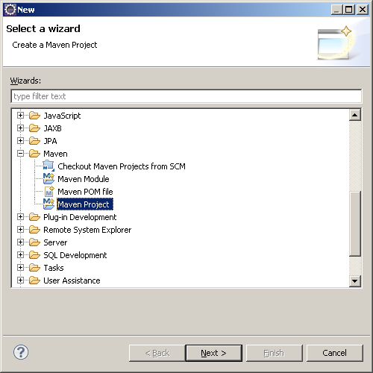
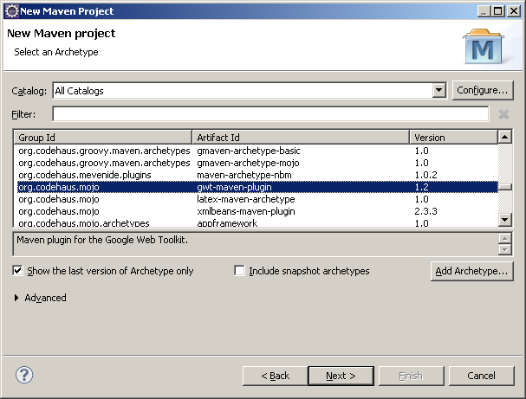

- Run/Debug,
Run As → Maven Install
- Debug
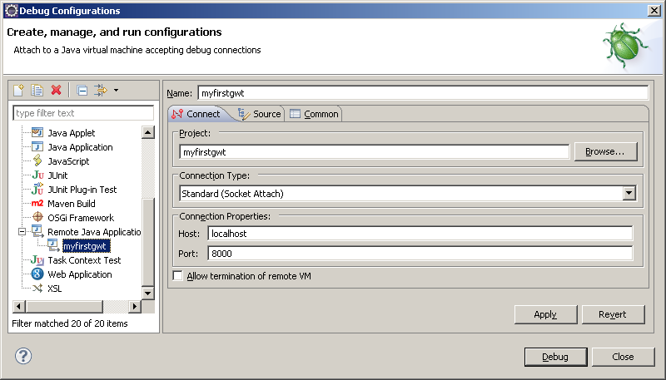

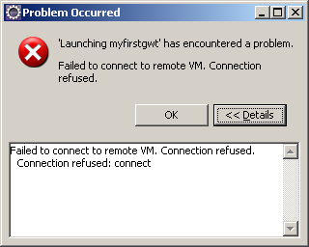 Has error, use -vm D:\MyProg\jdk1.6.0_20\bin\javaw.exe
D:\MyApp\my_helios_eclipse>eclipse -vm D:\MyProg\jdk1.6.0_20\bin\javaw.exe

- Select your project in the Project Explorer.
- Select Run/Run As/Maven build…
- Type gwt:debug as goal, give your launch configuration a name and clickRun:
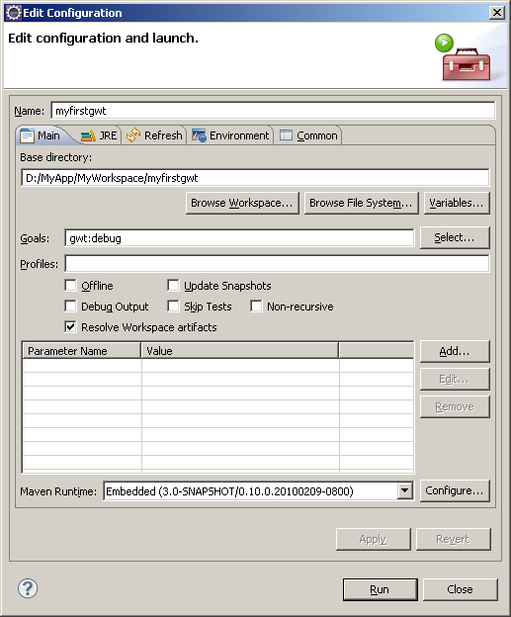

- Xxx

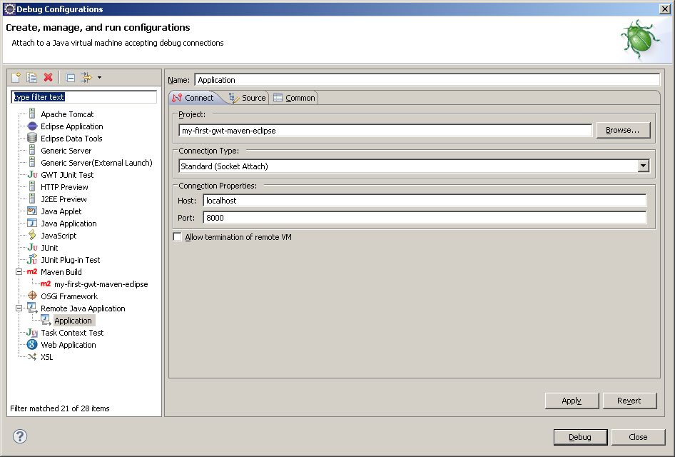

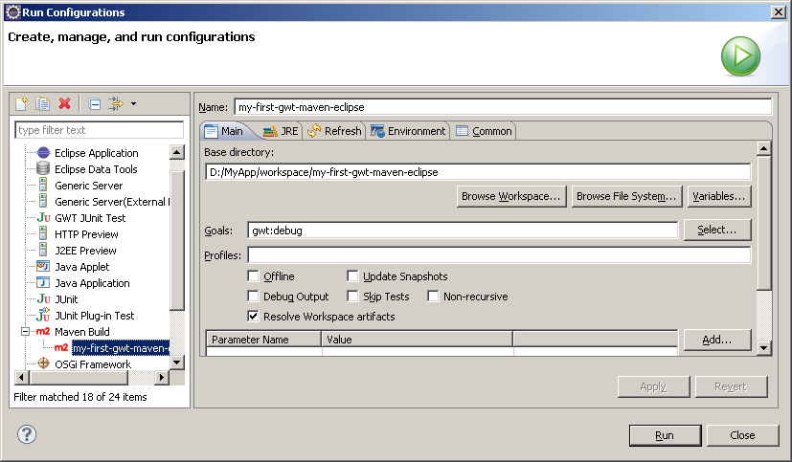

http://127.0.0.1:8888/com.egwt.app.my_first_gwt_maven_eclipse.Application/Application.html?gwt.codesvr=127.0.0.1:9997
http://127.0.0.1:8888/Myfirstwebapp.html?gwt.codesvr=127.0.0.1:9997

update gwt-maven-plugin version to "1.2". The 1.1-* don't support gwt 2.0

July 3, 2010
Now, we finish Spring application, we are going to create GWT project with similar function.
First, copy booking directory and rename to gwtbookhotel.
Edit pom.xml file by change artifactId to gwtbookhotel
Then, import the project to Eclipse after doing mvn eclipse:eclipse

Enable Use Google Web Toolkit by check the check box.
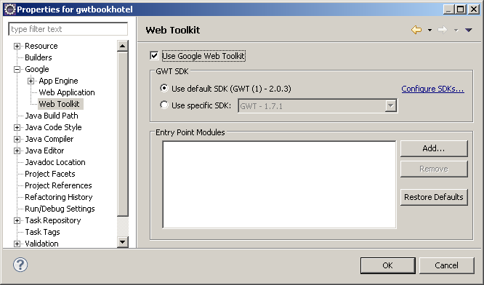

Let create GWT module, create gwt package under booking.
Right click gwt → new → Module, it will create
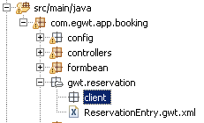

Right click client → new → Entry Point Class
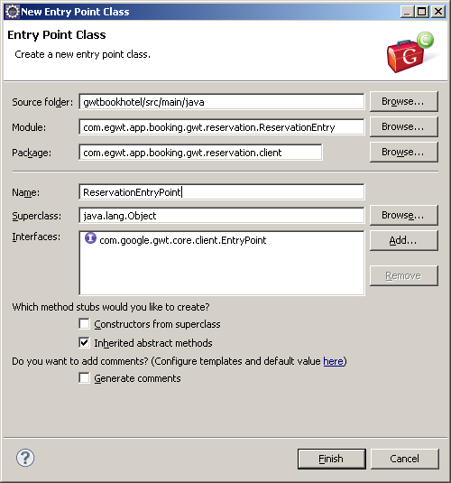

Import resource bundle to GWT module.
Create same directory under path of java, resources.i18n
Create I18NResources.gwt.xml under resources
<module>
<source path="i18n" />
</module>
Add I18NResources.gwt.xml to reservation GWT module

Edit pom.xml
<!-- XML parser Jdom,xerces,jaxen, saxpath -->
<dependency>
<groupId>org.jdom</groupId>
<artifactId>jdom</artifactId>
<version>1.1</version>
</dependency>
<dependency>
<groupId>xerces</groupId>
<artifactId>xercesImpl</artifactId>
<version>2.9.1</version>
</dependency>
<dependency>
<groupId>jaxen</groupId>
<artifactId>jaxen</artifactId>
<version>1.0-FCS</version>
</dependency>
<dependency>
<groupId>saxpath</groupId>
<artifactId>saxpath</artifactId>
<version>1.0-FCS</version>
</dependency>

For process gwt config file

We will create framework for GWT navigation with config file, much like Struts and Spring config file.

Temp solution of compile:
- mvn clean
- comment out
<!-- ViewConfigAccessor Code Generation -->
<generate-with
class="com.egwt.app.booking.gwt.rebind.ViewConfigAccessorInterfaceGenerator">
<when-type-assignable
class="com.egwt.app.booking.gwt.reservation.client.arch.navigation.ViewConfigAccessor"/>
</generate-with>
- mvn –o gwt:compile
- uncomment out
- mvn package

<generateDirectory>src/main/java</generateDirectory> in pom.xml instructs i18n generateDirectory

The step to create RPC:
- create remote interface, such ReservationProcessservice.java
- create corresponding Asnc interface, such ReservationProcessServiceAsync.java.
define URL constants, such as HOTEL_SEARCH_SERVICE_URI = "hotelSearch.rpc";
define utility method inside Util, such as ReservationProcessServiceAsync getLocationKeyWordsAsync()
- add defined url in 2.2 to rpcConfig.xml
- create corresponding endpoint class such as HotelReserveRPCController.java under services\reservation.
Note: class naming convention for RPC, the name should ended with RPCController. We will use it to generate performance matrices with AOP.
- RPCController will call DomainService
- (option) if use rpc proxy. Define method under proxy such as RPCReservationProxy
- Call RPC:
  - if use proxy, the caller class needs to implements

The steps to create new page
- Add view class and populators in processConfig.xml such as ReservationProcessConfig.xml
- Create defined class above such as ReservationConfirmationView.java under navigation package and extends AbstractView and create override method process()
- Create layoutWidget under correspond package, for example ReservationConfirmationView, its view class will be ReservationConfirmationLayoutWidget and under widgets/reservation package
- Under ReservationConfirmationLayoutWidget, create panel for layout.
Note: per GWT require, initWidget(layoutPanel); is needed, we put it under constructor.

How do I use the plugin with a GWT project built with Maven?
Although GWT projects typically use the Ant build system, it is also possible to use GWT and the Google Plugin for Eclipse with projects built with Maven. We recommend using Eclipse for Java EE when developing Maven projects, because it allows you to modify your source code and resources during a debugging session and have the changes automatically reflected in your running application. To enable this behavior, you'll need to convert your Maven project to an EclipseDynamic Web Project:
- Open the New Dynamic Web Project wizard. Set the Project name and any applicable options, then click Next.
- On the Java page, remove the default source folder (src) and add your Maven source folders (e.g. src/main/java, src/main/resources, andsrc/test/java). Click Next.
- On the Web Module page, set the Content directory to src/main/webapp and click Finish.
- Import your project's source code and resources into the newly-generated project, and set up your build path.
- Finally, follow the steps in the GWT + Eclipse for Java EE FAQ to enable GWT for the project and create a Web Application launch configuration.

http://code.google.com/eclipse/docs/faq.html#gwt_in_eclipse_for_java_ee

How do I use the plugin with a GWT Dynamic Web project in Eclipse for Java EE?
It's easy to develop and debug a GWT application in Eclipse for Java EE:
- In your project's properties dialog, select Google > Web Toolkit and check the box Use Google Web Toolkit.
- Switch to the Google > Web Application property page and change WAR directory as appropriate (WebContent is the default for Eclipse for Java EE) and uncheck the box Launch and deploy from this directory. Click OK to close the properties dialog.
- If your project uses the Apache Tomcat library, ensure that the GWT SDK library is above it on your project's classpath (project properties > Java Build Path > Order and Export). Otherwise, you may get a java.lang.NoSuchMethodError when launching your application in hosted/development mode.
- Start your project's server (Jetty, GlassFish, Tomcat, etc.) using your configured WTP server adapter.
- Create a new Web Application launch configuration for your project. On the Server tab, uncheck Run built-in server (since you want to use your configured WTP server adapter instead) and on the GWT tab change the URL field to point to your server (e.g. http://localhost:8080/WebApp).
- Run/Debug your new launch configuration. The first time you do this, you'll have to select the location of the WAR directory that WTP is publishing to (this is configurable, but by default it is <workspace>/.metadata/.plugins/org.eclipse.wst.server.core/tmp0/wtpwebapps/<project>).
GWT development/hosted mode is now running in your own server, and you can debug either server or client code. If you make changes, WTP's publishing mechanism will automatically copy the modified class files or static resources to your runtime WAR directory.

http://www.holidayinn.com/hotels/gb/en/reservation?sicontent=0&sicreative=4921531941&sitrackingid=10721110&cm_mmc=Google-PS-HI_UK-_-G%20B-Core-_-Exact-_-holiday%20inn|-|100000000000001977749&siclientid=1935#roomrate?sicontent=0&sicreative=4921531941&sitrackingid=10721110&cm_mmc=Google-PS-HI_UK-_-G%20B-Core-_-Exact-_-holiday%20inn|-|100000000000001977749&siclientid=1935

D:\MyProg\jdk1.6.0_14\jre\bin\java -Xmx512m -classpath "D:\ebook\gwtbookhotel\src\main\java";"D:\ebook\gwtbookhotel\src\main\resources";"D:\ebook\gwtbookhotel\target\classes";"D:\m2\javax\servlet\servlet-api\2.4\servlet-api-2.4.jar";"D:\m2\
org\springframework\spring-webmvc\2.5.4\spring-webmvc-2.5.4.jar";"D:\m2\commons-logging\commons-logging\1.1.1\commons-logging-1.1.1.jar";"D:\m2\org\springframework\spring-beans\2.5.4\spring-beans-2.5.4.jar";"D:\m2\org\springframework\spring
-core\2.5.4\spring-core-2.5.4.jar";"D:\m2\org\springframework\spring-context\2.5.4\spring-context-2.5.4.jar";"D:\m2\aopalliance\aopalliance\1.0\aopalliance-1.0.jar";"D:\m2\org\springframework\spring-context-support\2.5.4\spring-context-supp
ort-2.5.4.jar";"D:\m2\org\springframework\spring-web\2.5.4\spring-web-2.5.4.jar";"D:\m2\org\springframework\spring\2.5.4\spring-2.5.4.jar";"D:\m2\org\springframework\spring-aspects\2.5.4\spring-aspects-2.5.4.jar";"D:\m2\org\aspectj\aspectjr
t\1.5.4\aspectjrt-1.5.4.jar";"D:\m2\org\aspectj\aspectjweaver\1.5.4\aspectjweaver-1.5.4.jar";"D:\m2\org\slf4j\slf4j-api\1.5.6\slf4j-api-1.5.6.jar";"D:\m2\org\slf4j\slf4j-log4j12\1.5.6\slf4j-log4j12-1.5.6.jar";"D:\m2\log4j\log4j\1.2.14\log4j
-1.2.14.jar";"D:\m2\org\hibernate\hibernate-core\3.3.1.GA\hibernate-core-3.3.1.GA.jar";"D:\m2\antlr\antlr\2.7.6\antlr-2.7.6.jar";"D:\m2\commons-collections\commons-collections\3.1\commons-collections-3.1.jar";"D:\m2\dom4j\dom4j\1.6.1\dom4j-
1.6.1.jar";"D:\m2\xml-apis\xml-apis\1.3.04\xml-apis-1.3.04.jar";"D:\m2\javax\transaction\jta\1.1\jta-1.1.jar";"D:\m2\javassist\javassist\3.4.GA\javassist-3.4.GA.jar";"D:\m2\mysql\mysql-connector-java\5.0.5\mysql-connector-java-5.0.5.jar";"D
:\m2\commons-lang\commons-lang\2.3\commons-lang-2.3.jar";"D:\m2\com\google\gwt\gwt-user\2.0.3\gwt-user-2.0.3.jar";"D:\m2\org\jdom\jdom\1.1\jdom-1.1.jar";"D:\m2\xerces\xercesImpl\2.9.1\xercesImpl-2.9.1.jar";"D:\m2\jaxen\jaxen\1.0-FCS\jaxen-1
.0-FCS.jar";"D:\m2\saxpath\saxpath\1.0-FCS\saxpath-1.0-FCS.jar";"D:\m2\com\google\gwt\gwt-dev\2.0.3\gwt-dev-2.0.3.jar" com.google.gwt.dev.Compiler -gen "D:\ebook\gwtbookhotel\target\.generated" -logLevel INFO -style OBF -war "D:\ebook\gwtbo
okhotel\target\gwtbookhotel" -localWorkers 2 -soyc -extra "D:\ebook\gwtbookhotel\target\extra" com.egwt.app.booking.gwt.reservation.ReservationEntry

Saturday, July 10, 2010
Generate Google map key for http://gogwt.com
ABQIAAAAmdQW6A4k5xzDjjGKjkBoGxTNnYUpi0vJmWXtC66R5nqEvj2QuxSWoIfZsVFbr3by_GoWAub_tmLJLA

JavaScript Maps API Example
<script src="http://maps.google.com/maps?file=api&amp;v=2&amp;sensor=true_or_false&amp;key=ABQIAAAAmdQW6A4k5xzDjjGKjkBoGxTNnYUpi0vJmWXtC66R5nqEvj2QuxSWoIfZsVFbr3by_GoWAub_tmLJLA" type="text/javascript"></script>
...

Maps API for Flash Example
<maps:Map xmlns:maps="com.google.maps.*" id="map" mapevent_mapready="onMapReady(event)" width="100%" height="100%" key="ABQIAAAAmdQW6A4k5xzDjjGKjkBoGxTNnYUpi0vJmWXtC66R5nqEvj2QuxSWoIfZsVFbr3by_GoWAub_tmLJLA"/>

HTTP Service Example
http://maps.google.com/maps/geo?q=1600+Amphitheatre+Parkway,+Mountain+View,+CA&output=json&oe=utf8\
&sensor=true_or_false&key=ABQIAAAAmdQW6A4k5xzDjjGKjkBoGxTNnYUpi0vJmWXtC66R5nqEvj2QuxSWoIfZsVFbr3by_GoWAub_tmLJLA

