Use Google code to checkin/checkout code.

Svn https://gogwt.googlecode.com/svn/trunk/
https://gogwt.googlecode.com/svn/trunk/gwtarch
https://gogwt.googlecode.com/svn/trunk/gwtbooking

Wiki:

username/password: allhotelmotel/En9uh5BF8VF7
http://code.google.com/p/gogwt/

Wiki syntax
http://code.google.com/p/support/wiki/WikiSyntax

https://code.google.com/hosting/settings change password

mvn resources:resources
http://local.www.gogwt.com/gwtbooking/en-US/gwtreservation?gwt.codesvr=127.0.0.1:9997

<div class="errorMessage" ui:field="message" />

Install http://subversion.tigris.org/ for DOS svn

http://code.google.com/p/gogwt/
http://code.google.com/p/support/wiki/SubversionFAQ

Friday, August 13, 2010
Add ehcache for hibernate second cache.
http://www.javabeat.net/articles/37-introduction-to-hibernate-caching-1.html

1.1) First-level cache
First-level cache always Associates with the Session object. Hibernate uses this cache by default. Here, it processes one transaction after another one, means wont process one transaction many times. Mainly it reduces the number of SQL queries it needs to generate within a given transaction. That is instead of updating after every modification done in the transaction, it updates the transaction only at the end of the transaction.

1.2) Second-level cache
Second-level cache always associates with the Session Factory object. While running the transactions, in between it loads the objects at the Session Factory level, so that those objects will available to the entire application, don’t bounds to single user. Since the objects are already loaded in the cache, whenever an object is returned by the query, at that time no need to go for a database transaction. In this way the second level cache works. Here we can use query level cache also. Later we will discuss about it.

1. add pom library
<dependency>
<groupId>net.sf.ehcache</groupId>
<artifactId>ehcache</artifactId>
<version>1.4.1</version>
</dependency>

2. modify hibernate.cfg.xml
<!-- Enable the second-level cache -->
<property name="cache.provider_class">net.sf.ehcache.hibernate.EhCacheProvider</property>

<property name="cache.use_query_cache">true</property>
<property name="cache.use_second_level_cache">true</property>
<property name="hibernate.cache.use_structured_entries">true</property>

3. add ehcache.xml

Limitation of uiBinder
- Field nameSpan cannot appear multiple times in one template

Monday, September 13, 2010
In the uiBinder wizard there is an option: GwtWidget or Html...
If you write plain html you have to bind with the root element:
<div>
some html
</div>
interface MyBinder extends UiBinder<DivElement, YourWidget> {}
MyBinder binder = ...;
public YourWidget() {
setElement(binder.createAndBindUi(this));
}

java.util.ConcurrentModificationException
java.util.AbstractList$Itr.checkForComodification(AbstractList.java:449)
java.util.AbstractList$Itr.next(AbstractList.java:420)
com.gogwt.app.booking.businessService.domainService.ReservationBusinessService.findHotelsWithLocation(ReservationBusinessService.java:81)

if (result != null && !result.isEmpty()) {
for (HotelBean hotel : result) {
distance = EarthGeoUtils.arcDistance(centerGeocodeBean.getLat(), centerGeocodeBean.getLng(), hotel.getLat(), hotel.getLng() );
if (distance > searchFormBean.getRadius() ) {
result.remove(hotel);
continue;
}
hotel.setDistance(distance);

}
hotelSearchResponse.setHotelList(result);
}

http://code.google.com/p/gwt-log/wiki/GettingStarted

<!-- For production most teams prefer to set the default log level to `OFF` -->
<inherits name="com.allen_sauer.gwt.log.gwt-log-OFF" />
<!-- For development a default of `DEBUG` is recommended -->
<inherits name="com.allen_sauer.gwt.log.gwt-log-DEBUG" />
<!-- To compile at `DEBUG`, `WARN` and `OFF` log levels (at 3x compile time) -->
<inherits name="com.allen_sauer.gwt.log.gwt-log-OFF" />
<extend-property name="log_level" values="DEBUG,WARN"/>
<!--
Default `OFF` but allow selection of a specific log level, say `INFO`, via the `log_level` URL parameter, e.g.
http[s]://hostame:port/path/to/your/module/Module.html?log_level=INFO
-->
<inherits name="com.allen_sauer.gwt.log.gwt-log-OFF" />
<extend-property name="log_level" values="INFO"/>
<!--
Compile both `DEBUG` and `ERROR` log level, with level selection via a `gwt:property` meta tag in your HTML file, e.g.
<meta name="gwt:property" content="log_level=DEBUG">
-->
<inherits name="com.allen_sauer.gwt.log.gwt-log-ERROR" />
<extend-property name="log_level" values="DEBUG"/>
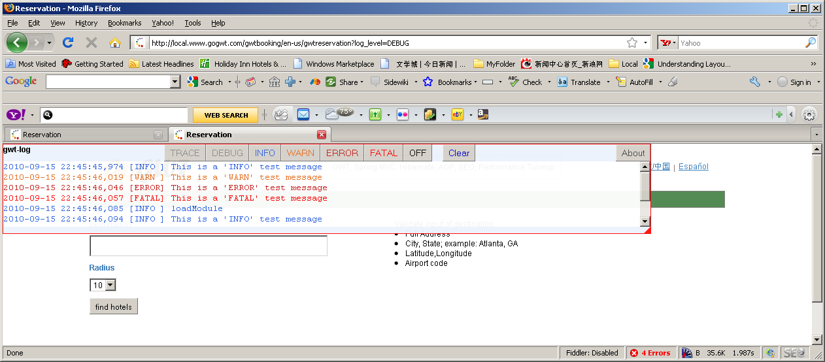

- When developing, you may wish to turn on enhanced web mode stack traces. Note this adds overhead to the resulting JavaScript so you generally don't want to leave this on for production. Then again, if you're debugging a production issue, you might need to anyway :)
<set-property name="compiler.emulatedStack" value="true" />
<set-configuration-property name="compiler.emulatedStack.recordLineNumbers" value="true"/>
<set-configuration-property name="compiler.emulatedStack.recordFileNames" value="true"/>

select * from dynamo.keywords_poprank_2 where locale='en_US' and search_key like '%UNITED%'

http://amitcodes.wordpress.com/2008/07/26/16/
I was using Hibernate with Apache Tomcat and MySQL with apache-commons-dbcp for a web application I was developping recently and I used to get this annoying `java.net.SocketException: Broken pipe` after about 8 hours of usage. I tried the following quick fixes:

sessions were closed (which acually were)
ensuring that the mysql connection url had autoreconnect=true attribute
But none of it fixed the issue. Finally after searching for a while on internet i found out the cause and here it is.

Cause: MySQL server has a default timeout period after which it terminates the idle connections. This period is 8 hours by default. Now here’s what happens. The dbcp creates a set of connections to database when the servlet container / application server starts up. If the connections are not used for the tinmeout period, the MySQL server assumes these to be dead connections and terminates them. The dbcp, however, is unaware of the fact that the connections have been terminated. So when a connection is demended from the connection-pool, these dead connections are returned and when a call is made on these dead connections – *BOOM* – you the java.net.SocketException: Broken pipe exception. Ok – so what’s the fix ??

Fix: If only the connection pool could check if the the connection it is about to return is live or not, the porblem is fixed. This can be done in apache-common-dbcp (I know this one coz I used it, please look into documentation of the connection-pool you are using). Here’s how you do it: You add the following properties to dbcp configuration.

validationQuery=”SELECT 1?
testOnBorrow=”true”
And that does the trick.

How it works:

Before returning the connection from pool to the application, dbcp runs the “SELECT 1 ” query on the connection to see it it is still live. That’s the job of validationQuery.
As for testOnBorrow, you tell dbcp to perform the check before returning the connection to application.
<Resource name="jdbc/cooldatabase"
description="Strandls.com license database"
auth="Container"
type="javax.sql.DataSource"
factory="org.apache.tomcat.dbcp.dbcp.BasicDataSourceFactory"
driverClassName="com.mysql.jdbc.Driver"
url="jdbc:mysql://localhost:3306/cooldatabase?autoReconnect=true"
username="cooluser"
password="coolpassword"
initialSize="0"
maxActive="20"
maxIdle="10"
minIdle="0"
maxWait="-1"
validationQuery="SELECT 1"
testOnBorrow="true"
poolPreparedStatements="true"
removeAbandoned="true"
removeAbandonedTimeout="60"
logAbandoned="true"/>

<bean id="dataSource" class="org.apache.commons.dbcp.BasicDataSource">
<property name="driverClassName" value="com.mysql.jdbc.Driver"/>
<property name="url" value="jdbc:mysql://localhost:3306/seppo"/>
<property name="username" value="xxx" />
<property name="password" value="xxx" />
</bean>

<value>jdbc:mysql://localhost:3306/javatest?autoReconnect=true</value>

Saturday, September 25, 2010
Create hoteldetail module:
1. create new module under gwt\hoteldetail
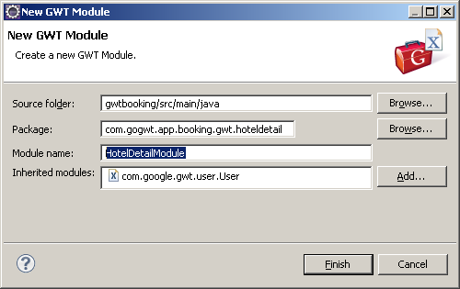

- Create entry class
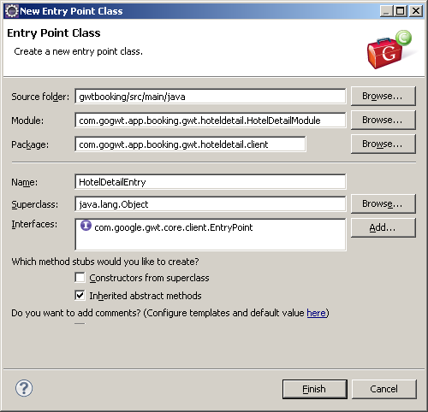

- create test html
HotelDetail_MVP.html under public
- Add Test code
RootPanel.get().add(new Label(" first test")); to onModuleLoad method

- add Spring MVC elements
4.1 add HotelDetailController to booking-servlet.xml
<bean name="name=controller/reservation/GWTHotelDetailController" class="com.gogwt.app.booking.controllers.action.gwt.GWTHotelDetailController"/>
<prop key="/**/mvphoteldetail/**/">name=controller/reservation/GWTHotelDetailController</prop> add mappings
4.2 Create GWTHotelDetailController.java similar GWTMVPHotelSearchController.java
4.3 declair target jsp of hotel_detail to GWTHotelDetailController
4.3 create hotel_detail.jsp to include GWT HotelDetailModule
5. Add HotelDetailModule to pom.xml
6. comile/deploy mvn –DskipTests=true clean install
7. start app server (Jboss)
8. Right click HotelDetailModel.gwt.html and click Debug As → Web Application
GWT Development Mode window will be popup.
- http://local.www.gogwt.com/gwtbooking/en-us/mvphoteldetail?gwt.codesvr=127.0.0.1:9997
- With debug mode, add GWT function
- HotelDetailEntryPoint extends AbstractEntryPoint to apply Token Manager.
- Return return GWT.create(HotelDetailMVPProcessConfig.class); for the method AbstractPageConfigAccessor obtainPageAccessor() to connect to xml page definition.
- Create HotelDetailMVPProcessConfig.xml with
<application>
<pages>
<page name="info"
class="com.gogwt.app.booking.gwt.hoteldetail.client.navigation.HotelInfoPage">
</page>
</pages>
</application>

- create HotelInfoPage.java
public class HotelInfoPage extends AbstractPage {

@Override
public void process() {
this.pagePanel.add(new Label("test HotelInfoPage"));
}
}

- Add header, menu, footer and main content to HotelDetailEntryPoints loadModule
@Override
protected void loadModule() {
// header
RootPanel.get("header").add(new HeaderLayoutWidget());

// menu
RootPanel.get("menu").add(new MenuLayoutWidget());

// show middle part of GWT body, wrapperContent is defined in JSP.
addPageManagerToRootPanel("wrapperContent");

// footer
RootPanel.get("footer").add(new FooterLayoutWidget());

}

- Test code so far, compile/deploy and test with browser
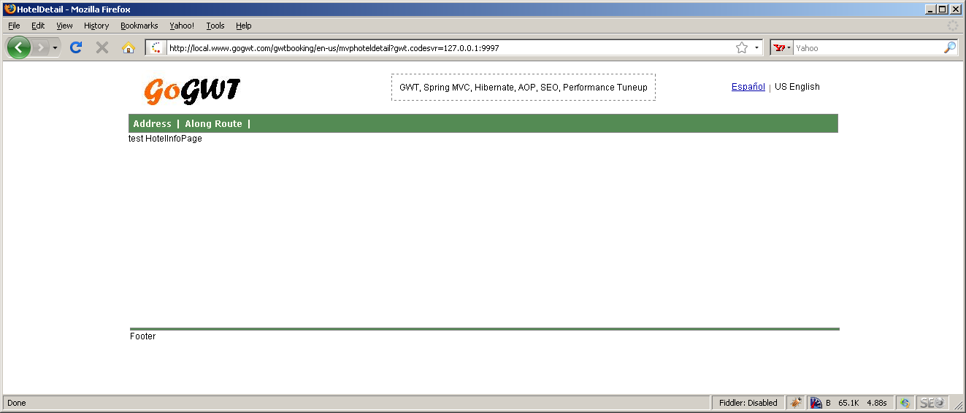

Next add uiBinder and MVP component

Under hoteldetail.client.widgets create info package. Note info is the token name defined under HotelDetailMVPProcessConfig.xml
Create view and presenter packages under info.

HotelDetailInfoView.java
package com.gogwt.app.booking.gwt.hoteldetail.client.widgets.info.view;

import com.google.gwt.user.client.ui.Widget;

public interface HotelDetailInfoView <T>{

public interface Presenter<T> {

}

/**
* Connect to presenter
* @param presenter
*/
void setPresenter(Presenter<T> presenter);

/**
*
* @return
*/
Widget asWidget();

void displayHotelDetail();
}

HotelDetailInfoViewImpl.java
package com.gogwt.app.booking.gwt.hoteldetail.client.widgets.info.view;

import com.gogwt.framework.arch.widgets.AbstractWidget;
import com.google.gwt.core.client.GWT;
import com.google.gwt.uibinder.client.UiBinder;
import com.google.gwt.uibinder.client.UiTemplate;
import com.google.gwt.user.client.ui.Widget;

public class HotelDetailInfoViewImpl<T> extends AbstractWidget implements HotelDetailInfoView <T> {
private Presenter<T> presenter;

@UiTemplate("HotelDetailInfoView.ui.xml")
interface HotelDetailInfoViewUiBinder extends UiBinder<Widget, HotelDetailInfoViewImpl> {}
private static HotelDetailInfoViewUiBinder uiBinder = GWT.create(HotelDetailInfoViewUiBinder.class);

/**
* Constructor
*/
public HotelDetailInfoViewImpl() {
initWidget(uiBinder.createAndBindUi(this));
}

public void setPresenter(
com.gogwt.app.booking.gwt.hoteldetail.client.widgets.info.view.HotelDetailInfoView.Presenter<T> presenter) {
this.presenter = presenter;

}

public Widget asWidget() {
return this;
}

public void displayHotelDetail() {
//todo: call presenter to call HotelDetail RPC.

}
}

HotelDetailInfoView.ui.xml
<!DOCTYPE ui:UiBinder SYSTEM "http://dl.google.com/gwt/DTD/xhtml.ent">
<ui:UiBinder xmlns:ui="urn:ui:com.google.gwt.uibinder"
xmlns:g="urn:import:com.google.gwt.user.client.ui"
xmlns:gm='urn:import:com.google.gwt.maps.client'>

<ui:style field='resStyle' src="../../../../../gogwt_mvp.css"/>

<g:HTMLPanel>
<br/>
<table> <tr> <td> <b> Hotel Detail</b></td> <td> </td></tr></table>

</g:HTMLPanel>
</ui:UiBinder>

HotelInfoPage.java
package com.gogwt.app.booking.gwt.hoteldetail.client.navigation;

import com.gogwt.app.booking.dto.dataObjects.common.HotelBean;
import com.gogwt.app.booking.gwt.hoteldetail.client.widgets.info.presenter.HotelDetailInfoPresenter;
import com.gogwt.app.booking.gwt.hoteldetail.client.widgets.info.view.HotelDetailInfoView;
import com.gogwt.app.booking.gwt.hoteldetail.client.widgets.info.view.HotelDetailInfoViewImpl;
import com.gogwt.framework.arch.widgets.AbstractPage;

public class HotelInfoPage extends AbstractPage {
private HotelDetailInfoView<HotelBean> theView;

public HotelInfoPage() {
super();
if (theView == null) {
theView = new HotelDetailInfoViewImpl<HotelBean>();
}
new HotelDetailInfoPresenter(theView).go(this.pagePanel);
}

@Override
public void process() {
//this.pagePanel.add(new Label("test HotelInfoPage"));
theView.displayHotelDetail();
}
}

After compile/deploy and start app server,
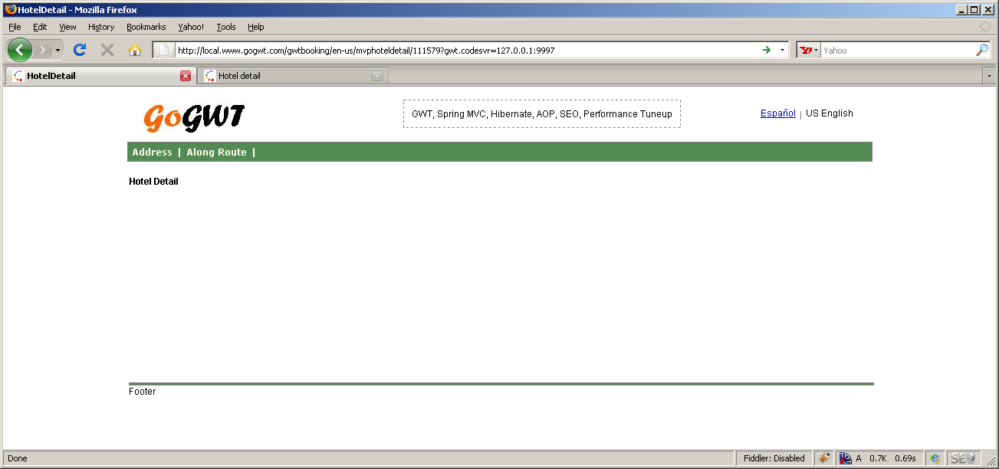

Next call hotel detail RPC and display hotel detail.
- Add void retrieveHotelDetail(); to HotelDetailInfoView like
public interface Presenter<T> {
void retrieveHotelDetail();
}

- Add fillHotelId(request, urlMappingElem); method to URLHandlerInterceptor.java to get hotelId from URL:
http://local.www.gogwt.com/gwtbooking/en-us/mvphoteldetail/128528

HotelDetailInfoPresenter implement retrieveHotelDetail method

HotelDetailInfoViewImpl in the method of displayHotelDetail
presenter.retrieveHotelDetail() relay responsibility to HotelDetailInfoPresenter

First we need create HotelDetailRPCController.java and setup in config file.
- define HotelDetailProcessService.java and
- create HotelDetailRPCController.java under

package com.gogwt.app.booking.rpc.interfaces.hotel;

public interface HotelDetailProcessService extends RemoteService {
HotelBean getHotelDetail(String hotelId, UserContextBean userContext) throws AppRemoteException;
}

package com.gogwt.app.booking.rpc.interfaces.hotel;

package com.gogwt.app.booking.rpc.proxy.hoteldetail;

import com.gogwt.app.booking.dto.dataObjects.UserContextBean;
import com.gogwt.app.booking.dto.dataObjects.common.CommandBean;
import com.gogwt.app.booking.dto.dataObjects.common.HotelBean;
import com.gogwt.app.booking.rpc.interfaces.hotel.HotelDetailProcessServiceAsync;
import com.gogwt.app.booking.rpc.proxy.RPCProxyInterface;
import com.google.gwt.user.client.rpc.AsyncCallback;

public class RPCHotelDetailProxy {
private static RPCHotelDetailProxy instance = new RPCHotelDetailProxy();

private RPCHotelDetailProxy() {
}

public static RPCHotelDetailProxy getInstance() {
return instance;
}

public void getHotelDetail(final int hotelId, final UserContextBean userContext,
final CommandBean command,
final RPCProxyInterface<HotelBean> callback) {

HotelDetailProcessServiceAsync service = HotelDetailProcessServiceAsync.Util.getHotelDetailAsync();

service.getHotelDetail(hotelId, userContext, new AsyncCallback<HotelBean>() {

//@Override
public void onFailure(Throwable caught) {
callback.handleRPCError(caught, command);
}

//@Override
public void onSuccess(HotelBean result) {
callback.handleRPCSuccess(result, command);
}
});
}
}
Where gethoteldetail.rpc is defined in rpcConfig.xml, which links to implementation of HotelDetailProcessService in server side.

Add following lines into rpcConfig.xml
<bean name="name=rpc/hoteldetail/HotelDetailEndPoint" class="com.gogwt.app.booking.rpc.services.hoteldetail.HotelDetailRPCController"/>

<bean name="name=rpc/hoteldetail/HotelDetailControllerExport" class="org.gwtwidgets.server.spring.GWTRPCServiceExporter">
<property name="service" ref="name=rpc/hoteldetail/HotelDetailEndPoint" />
</bean>

<prop key="/**/gethoteldetail.rpc/**/">name=rpc/hoteldetail/HotelDetailControllerExport</prop>

And create HotelDetailRPCController to implement interface.

public abstract class HotelDetailProcessServiceAdapter extends BaseService implements HotelDetailProcessService {

public HotelBean getHotelDetail(String hotelId, UserContextBean userContext)
throws AppRemoteException {

throw new UnsupportedException();
}

}

Define domain service in domainService.xml with
<!-- hoteldetail -->
<bean name="Booking:name=domain/hoteldetail/HotelDetailBusinessService" class="com.gogwt.app.booking.businessService.domainService.HotelDetailBusinessService">
<property name="commonDAO"><ref bean="name=dao/CommonDAO" /></property>
</bean>

Add LookupBusinessService.java
public static String HOTELDETAIL_DOMAIN_SERVICE = "Booking:name=domain/hoteldetail/HotelDetailBusinessService";

public static HotelDetailBusinessService getHotelDetailBusinessService() {
return (HotelDetailBusinessService) BeanLookupService.getBean(HOTELDETAIL_DOMAIN_SERVICE);
}

package com.gogwt.app.booking.rpc.services.hoteldetail;

public class HotelDetailRPCController extends HotelDetailProcessServiceAdapter {

/**
* Get HotelDetail
*/
public HotelBean getHotelDetail(int hotelId, UserContextBean userContext) throws AppRemoteException {

//1. call domain service
HotelDetailBusinessService hotelDetailBusinessService = LookupBusinessService.getHotelDetailBusinessService();
HotelBean hotelBean = hotelDetailBusinessService.getHotelDetail(hotelId, userContext);

return hotelBean;
}
}

public void retrieveHotelDetail() {
//1. check hotel Id is set or not
EnvMappingElem envMappingElem = GWTExtClientUtils.getMappingElem();
if (!StringUtils.isSet(envMappingElem.getHotelId())) {
ArrayList<String> errorList = new ArrayList<String>();
errorList.add("Please specify hotelId");
view.dispErrorMsg(errorList);
return;
}

//call RPC to get HotelBean

}

Completed: At revision: 72
Command: Commit
Adding: D:\gogwt\gwtbooking\src\main\java\com\gogwt\app\booking\businessService\domainService\HotelDetailBusinessService.java
Modified: D:\gogwt\gwtbooking\src\main\java\com\gogwt\app\booking\businessService\domainService\LookupBusinessService.java
Modified: D:\gogwt\gwtbooking\src\main\java\com\gogwt\app\booking\businessService\domainService\ReservationBusinessService.java
Modified: D:\gogwt\gwtbooking\src\main\java\com\gogwt\app\booking\businessService\geocode\google\GoogleGeocodeKMLParser.java
Modified: D:\gogwt\gwtbooking\src\main\java\com\gogwt\app\booking\businessService\geocode\google\GoogleGeocodeService.java
Modified: D:\gogwt\gwtbooking\src\main\java\com\gogwt\app\booking\config\interceptor\URLHandlerInterceptor.java
Modified: D:\gogwt\gwtbooking\src\main\java\com\gogwt\app\booking\config\urlmapping\UrlMappingElem.java
Adding: D:\gogwt\gwtbooking\src\main\java\com\gogwt\app\booking\controllers\BaseAbstractController.java
Modified: D:\gogwt\gwtbooking\src\main\java\com\gogwt\app\booking\controllers\action\ConfirmedController.java
Modified: D:\gogwt\gwtbooking\src\main\java\com\gogwt\app\booking\controllers\action\GuestInfoController.java
Modified: D:\gogwt\gwtbooking\src\main\java\com\gogwt\app\booking\controllers\action\HotelDetailController.java
Modified: D:\gogwt\gwtbooking\src\main\java\com\gogwt\app\booking\controllers\action\HotelSearchController.java
Modified: D:\gogwt\gwtbooking\src\main\java\com\gogwt\app\booking\controllers\action\HotelSearchResultController.java
Adding: D:\gogwt\gwtbooking\src\main\java\com\gogwt\app\booking\controllers\action\gwt\GWTHotelDetailController.java
Modified: D:\gogwt\gwtbooking\src\main\java\com\gogwt\app\booking\controllers\action\gwt\GWTHotelSearchController.java
Modified: D:\gogwt\gwtbooking\src\main\java\com\gogwt\app\booking\controllers\action\gwt\GWTMVPHotelSearchController.java
Modified: D:\gogwt\gwtbooking\src\main\java\com\gogwt\app\booking\controllers\helper\DisplayAmenitiesJSPHelper.java
Modified: D:\gogwt\gwtbooking\src\main\java\com\gogwt\app\booking\controllers\validation\BaseValidateAdapter.java
Modified: D:\gogwt\gwtbooking\src\main\java\com\gogwt\app\booking\controllers\validation\GuestInfoFormValidator.java
Modified: D:\gogwt\gwtbooking\src\main\java\com\gogwt\app\booking\controllers\validation\SearchFormValidator.java
Modified: D:\gogwt\gwtbooking\src\main\java\com\gogwt\app\booking\dto\dataObjects\common\EnvMappingElem.java
Modified: D:\gogwt\gwtbooking\src\main\java\com\gogwt\app\booking\gwt\common\Common.gwt.xml
Modified: D:\gogwt\gwtbooking\src\main\java\com\gogwt\app\booking\gwt\common\helper\DisplayAmenitiesGWTHelper.java
Modified: D:\gogwt\gwtbooking\src\main\java\com\gogwt\app\booking\gwt\common\helper\DisplayHelper.java
Adding: D:\gogwt\gwtbooking\src\main\java\com\gogwt\app\booking\gwt\common\i18n\TagsHotelDetailResources.java
Modified: D:\gogwt\gwtbooking\src\main\java\com\gogwt\app\booking\gwt\common\utils\GWTExtClientUtils.java
Adding: D:\gogwt\gwtbooking\src\main\java\com\gogwt\app\booking\gwt\common\widget\Presenter.java
Adding: D:\gogwt\gwtbooking\src\main\java\com\gogwt\app\booking\gwt\gogwt_mvp.css
Adding: D:\gogwt\gwtbooking\src\main\java\com\gogwt\app\booking\gwt\hoteldetail
Adding: D:\gogwt\gwtbooking\src\main\java\com\gogwt\app\booking\gwt\hoteldetail\HotelDetailModule.gwt.xml
Adding: D:\gogwt\gwtbooking\src\main\java\com\gogwt\app\booking\gwt\hoteldetail\client
Adding: D:\gogwt\gwtbooking\src\main\java\com\gogwt\app\booking\gwt\hoteldetail\client\HotelDetailEntryPoint.java
Adding: D:\gogwt\gwtbooking\src\main\java\com\gogwt\app\booking\gwt\hoteldetail\client\HotelDetailMVPProcessConfig.java
Adding: D:\gogwt\gwtbooking\src\main\java\com\gogwt\app\booking\gwt\hoteldetail\client\navigation
Adding: D:\gogwt\gwtbooking\src\main\java\com\gogwt\app\booking\gwt\hoteldetail\client\navigation\HotelInfoPage.java
Adding: D:\gogwt\gwtbooking\src\main\java\com\gogwt\app\booking\gwt\hoteldetail\client\widgets
Adding: D:\gogwt\gwtbooking\src\main\java\com\gogwt\app\booking\gwt\hoteldetail\client\widgets\common
Adding: D:\gogwt\gwtbooking\src\main\java\com\gogwt\app\booking\gwt\hoteldetail\client\widgets\common\view
Adding: D:\gogwt\gwtbooking\src\main\java\com\gogwt\app\booking\gwt\hoteldetail\client\widgets\common\view\FooterLayoutWidget.java
Adding: D:\gogwt\gwtbooking\src\main\java\com\gogwt\app\booking\gwt\hoteldetail\client\widgets\common\view\HeaderLayoutWidget.java
Adding: D:\gogwt\gwtbooking\src\main\java\com\gogwt\app\booking\gwt\hoteldetail\client\widgets\common\view\MenuLayoutWidget.java
Adding: D:\gogwt\gwtbooking\src\main\java\com\gogwt\app\booking\gwt\hoteldetail\client\widgets\info
Adding: D:\gogwt\gwtbooking\src\main\java\com\gogwt\app\booking\gwt\hoteldetail\client\widgets\info\presenter
Adding: D:\gogwt\gwtbooking\src\main\java\com\gogwt\app\booking\gwt\hoteldetail\client\widgets\info\presenter\HotelDetailInfoPresenter.java
Adding: D:\gogwt\gwtbooking\src\main\java\com\gogwt\app\booking\gwt\hoteldetail\client\widgets\info\view
Adding: D:\gogwt\gwtbooking\src\main\java\com\gogwt\app\booking\gwt\hoteldetail\client\widgets\info\view\HotelDetailInfoView.java
Adding: D:\gogwt\gwtbooking\src\main\java\com\gogwt\app\booking\gwt\hoteldetail\client\widgets\info\view\HotelDetailInfoView.ui.xml
Adding: D:\gogwt\gwtbooking\src\main\java\com\gogwt\app\booking\gwt\hoteldetail\client\widgets\info\view\HotelDetailInfoViewImpl.java
Adding: D:\gogwt\gwtbooking\src\main\java\com\gogwt\app\booking\gwt\hoteldetail\client\widgets\info\view\SubHotelDetailView.java
Adding: D:\gogwt\gwtbooking\src\main\java\com\gogwt\app\booking\gwt\hoteldetail\client\widgets\info\view\SubHotelDetailView.ui.xml
Adding: D:\gogwt\gwtbooking\src\main\java\com\gogwt\app\booking\gwt\hoteldetail\public
Adding: D:\gogwt\gwtbooking\src\main\java\com\gogwt\app\booking\gwt\hoteldetail\public\HotelDetail_MVP.html
Modified: D:\gogwt\gwtbooking\src\main\java\com\gogwt\app\booking\gwt\mvpreservation\client\ReservationMVPEntryPoint.java
Modified: D:\gogwt\gwtbooking\src\main\java\com\gogwt\app\booking\gwt\mvpreservation\client\navigation\HomePage.java
Modified: D:\gogwt\gwtbooking\src\main\java\com\gogwt\app\booking\gwt\mvpreservation\client\widgets\common\view\FooterLayoutWidget.java
Modified: D:\gogwt\gwtbooking\src\main\java\com\gogwt\app\booking\gwt\mvpreservation\client\widgets\common\view\HeaderLayoutWidget.java
Modified: D:\gogwt\gwtbooking\src\main\java\com\gogwt\app\booking\gwt\mvpreservation\client\widgets\common\view\MenuLayoutWidget.java
Modified: D:\gogwt\gwtbooking\src\main\java\com\gogwt\app\booking\gwt\mvpreservation\client\widgets\guestinfo\presenter\GuestInfoPresenter.java
Modified: D:\gogwt\gwtbooking\src\main\java\com\gogwt\app\booking\gwt\mvpreservation\client\widgets\guestinfo\validate\GuestInfoValidate.java
Modified: D:\gogwt\gwtbooking\src\main\java\com\gogwt\app\booking\gwt\mvpreservation\client\widgets\home\presenter\HomePresenter.java
Modified: D:\gogwt\gwtbooking\src\main\java\com\gogwt\app\booking\gwt\mvpreservation\client\widgets\home\validate\SearchValidate.java
Modified: D:\gogwt\gwtbooking\src\main\java\com\gogwt\app\booking\gwt\mvpreservation\client\widgets\reservation\view\ReservationConfirmationViewImpl.java
Modified: D:\gogwt\gwtbooking\src\main\java\com\gogwt\app\booking\gwt\mvpreservation\client\widgets\searchresult\view\ResultDetailItemSubView.java
Modified: D:\gogwt\gwtbooking\src\main\java\com\gogwt\app\booking\gwt\reservation\client\widgets\common\ErrorPanel.java
Modified: D:\gogwt\gwtbooking\src\main\java\com\gogwt\app\booking\gwt\reservation\client\widgets\common\HeaderLayoutWidget.java
Modified: D:\gogwt\gwtbooking\src\main\java\com\gogwt\app\booking\gwt\reservation\client\widgets\common\MenuLayoutWidget.java
Modified: D:\gogwt\gwtbooking\src\main\java\com\gogwt\app\booking\gwt\reservation\client\widgets\common\ProgressBarWidget.java
Modified: D:\gogwt\gwtbooking\src\main\java\com\gogwt\app\booking\gwt\reservation\client\widgets\guestinfo\GuestInfoFormEntry.java
Modified: D:\gogwt\gwtbooking\src\main\java\com\gogwt\app\booking\gwt\reservation\client\widgets\guestinfo\GuestInfoLayoutWidget.java
Modified: D:\gogwt\gwtbooking\src\main\java\com\gogwt\app\booking\gwt\reservation\client\widgets\guestinfo\GuestInfoValidate.java
Modified: D:\gogwt\gwtbooking\src\main\java\com\gogwt\app\booking\gwt\reservation\client\widgets\home\HomeFormEntry.java
Modified: D:\gogwt\gwtbooking\src\main\java\com\gogwt\app\booking\gwt\reservation\client\widgets\home\SearchValidate.java
Modified: D:\gogwt\gwtbooking\src\main\java\com\gogwt\app\booking\gwt\reservation\client\widgets\searchresult\SearchResultItemWidget.java
Modified: D:\gogwt\gwtbooking\src\main\java\com\gogwt\app\booking\resources\i18n\view\LabelResources.java
Adding: D:\gogwt\gwtbooking\src\main\java\com\gogwt\app\booking\rpc\interfaces\hotel\HotelDetailProcessService.java
Adding: D:\gogwt\gwtbooking\src\main\java\com\gogwt\app\booking\rpc\interfaces\hotel\HotelDetailProcessServiceAsync.java
Modified: D:\gogwt\gwtbooking\src\main\java\com\gogwt\app\booking\rpc\interfaces\reservation\ReservationProcessServiceAsync.java
Adding: D:\gogwt\gwtbooking\src\main\java\com\gogwt\app\booking\rpc\proxy\hoteldetail
Adding: D:\gogwt\gwtbooking\src\main\java\com\gogwt\app\booking\rpc\proxy\hoteldetail\RPCHotelDetailProxy.java
Adding: D:\gogwt\gwtbooking\src\main\java\com\gogwt\app\booking\rpc\services\hoteldetail
Adding: D:\gogwt\gwtbooking\src\main\java\com\gogwt\app\booking\rpc\services\hoteldetail\HotelDetailProcessServiceAdapter.java
Adding: D:\gogwt\gwtbooking\src\main\java\com\gogwt\app\booking\rpc\services\hoteldetail\HotelDetailRPCController.java
Deleting: D:\gogwt\gwtbooking\src\main\java\com\gogwt\app\booking\utils\StringUtils.java
Adding: D:\gogwt\gwtbooking\src\main\java\com\gogwt\app\booking\utils\ToStringUtils.java
Modified: D:\gogwt\gwtbooking\src\main\resources\com\gogwt\app\booking\resources\i18n\view\LabelResources.properties
Modified: D:\gogwt\gwtbooking\src\main\resources\com\gogwt\app\booking\resources\i18n\view\LabelResources_es.properties
Modified: D:\gogwt\gwtbooking\src\main\resources\conf\booking-servlet.xml
Modified: D:\gogwt\gwtbooking\src\main\resources\conf\domainService.xml
Adding: D:\gogwt\gwtbooking\src\main\resources\conf\gwt\HotelDetailMVPProcessConfig.xml
Modified: D:\gogwt\gwtbooking\src\main\resources\conf\rpcConfig.xml
Modified: D:\gogwt\gwtbooking\src\main\webapp\WEB-INF\goGWTlUtils.tld
Modified: D:\gogwt\gwtbooking\src\main\webapp\index.jsp
Adding: D:\gogwt\gwtbooking\src\main\webapp\jsp\gwt\reservation\hotel_detail.jsp

Thursday, September 30, 2010
Add Google Analytics to gogwt.com
<script type="text/javascript">

var _gaq = _gaq || [];
_gaq.push(['_setAccount', 'UA-1237384-29']);
_gaq.push(['_trackPageview']);

(function() {
var ga = document.createElement('script'); ga.type = 'text/javascript'; ga.async = true;
ga.src = ('https:' == document.location.protocol ? 'https://ssl' : 'http://www') + '.google-analytics.com/ga.js';
var s = document.getElementsByTagName('script')[0]; s.parentNode.insertBefore(ga, s);
})();

</script>

Friday, October 01, 2010
http://www.mikeduncan.com/named-anchors-are-not-sent/
When a browser requests a url with a named anchor at the end, the named anchor is NOT part of the request!

http://groups.google.com/group/google-web-toolkit/browse_thread/thread/519268620ed4e100
*Cross Site Scripting (XSS)*
With GWT, the attack vectors for XSS are restricted to the following -
1. Host html/jsp page that has reflected XSS
2. Custom Javascript libraries
3. JSNI code that you have written within GWT
4. Places where you have called eval(), or have used built-in JSONParser
to parse untrusted JSON
5. Code that assigns window.location on untrusted strings
6. Code that uses setInnerHtml on untrusted data
This isn't an exhaustive list, but represents the most common attack vectors
for a GWT app. If you do a manual code-review for these patterns, you will
catch most of your XSS problems. And if you are GWT app follows best
practices, you really won't be using most of the above patterns.
*SQL Injection*
This is largely outside the scope of GWT, but there are a couple of things
you can do.
- Do a manual code-review for SQL Injection. OWASP website has good
code-review checklists, that's the best resource.
- Use an automated scanner to perform the tests. The problem is that GWT
RPC doesn't play well with automated scanners. You may find the following
blog posts useful to get around this problem -
http://www.gdssecurity.com/l/b/2010/05/06/fuzzing-gwt-rpc-requests/
http://www.gdssecurity.com/l/b/2010/07/20/gwtenum-enumerating-gwt-rpc...
*Cross Site Request Forgery*
If you are using the latest GWT version, you are largely protected from
CSRF. GWT includes a custom http header in each RPC request, and that takes
care of CSRF on most browsers. The only vulnerable ones are people with
outdated versions of Flash Player.
If you are paranoid and want to protect the users who don't upgrade their
browsers, read this post on Lombardi's blog <http://jectbd.com/?p=1351>.
IMHO, you should do that only if you are using an older version of GWT and
can't upgrade.
Lastly, if you want to de-obfuscate some of GWTs code to perform security
analysis, you might want to check out degwt<http://code.google.com/p/degwt/>.
It has a bunch of useful notes and a couple of bookmarklets, but I am still
working to complete that library.

