Create skelenton for javaapp, webapp and gwtapp, first create working directory d:\test

1. create skelenton javaapp
D:\test> mvn archetype:create -DgroupId=com.skeleton.example -DartifactId=skeleton_javaapp
Result: create skeleton_javaapp directory

2. create skelenton webapp
D:\test>mvn archetype:create -DgroupId=com.skeleton.example -DartifactId=skeleton_webapp -DarchetypeArtifactId=maven-archetype-webapp
Result: create skelenton_webapp directory

2.1 add java package to skelenton_webapp
Copy src\main\java from skeleton_javaapp to same directory under skeleton_webapp
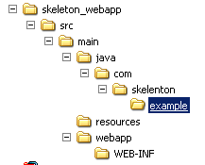

2.2 generate skeleton_webapp eclipse project files
d:\test\skeleton_webapp>mvn eclipse:eclipse

2.3 import skeleton_webapp project to eclipse
From eclipse menu bar, select File >Import >Existing Projects into Workspace
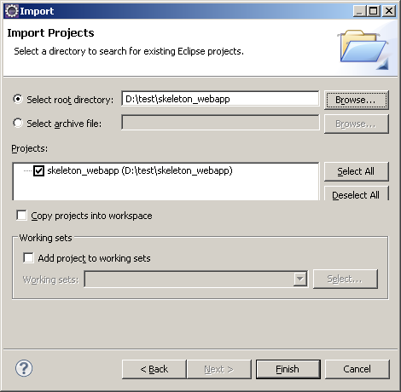

From eclipse, we will get project skeleton_webapp

2.4 create test Servlet
2.4.1 add pom.xml with
<dependency>
<groupId>javax.servlet</groupId>
<artifactId>servlet-api</artifactId>
<version>2.4</version>
</dependency>

Doing mvn eclipse:eclipse again, then refresh the project

2.4.2 create servlet of MyFirstServlet under package of com.skelenton.example.servlet

package com.skelenton.example.servlet;

import java.io.IOException;
import java.io.PrintWriter;

import javax.servlet.ServletException;
import javax.servlet.http.HttpServlet;
import javax.servlet.http.HttpServletRequest;
import javax.servlet.http.HttpServletResponse;

public class MyFirstServlet extends HttpServlet {
public void service(HttpServletRequest request, HttpServletResponse response)
throws IOException, ServletException {

PrintWriter out = response.getWriter();
out.println("Hello: this is MyFirstServlet ");

}
}

2.4.3 add servlet mapping to web.xml
<?xml version="1.0" encoding="UTF-8"?>
<web-app version="2.4"
xmlns="http://java.sun.com/xml/ns/j2ee"
xmlns:xsi="http://www.w3.org/2001/XMLSchema-instance"
xsi:schemaLocation="http://java.sun.com/xml/ns/j2ee http://java.sun.com/xml/ns/j2ee/web-app_2_4.xsd">

<display-name>Archetype Created Web Application</display-name>

<servlet>
<servlet-name>myfirstservlet</servlet-name>
<servlet-class>com.skeleton.example.servlet.MyFirstServlet</servlet-class>
</servlet>

<servlet-mapping>
<servlet-name>myfirstservlet</servlet-name>
<url-pattern>/firstservlet</url-pattern>
</servlet-mapping>

</web-app>

2.5.3 build/deploy
mvn clean package
from skeleton_webapp.war will be generated under D:\test\skeleton_webapp\target
deploy skeleton_webapp.war to web server deploy directory. For JBoss, just copy that war file under deploy directory.

Note: with server plugin, the generated war file can be copied:
<plugins>
<!-- deploy jboss runtime -->
<plugin>
<groupId>org.apache.maven.plugins</groupId>
<artifactId>maven-war-plugin</artifactId>
<version>2.1-alpha-2</version>
<configuration>
<packagingExcludes>${warExclude}</packagingExcludes>
<outputDirectory> ${JBOSS_HOME}/server/default/deploy </outputDirectory>
<outputFileNameMapping>
@{artifactId}@@{classifier}@.@{extension}@
</outputFileNameMapping>
</configuration>
</plugin>
</plugins>

Add <hr>
<a href="<%=request.getContextPath()%>/firstservlet"> my first servlet </a>
To index.jsp

2.5.4 Test
Start web server, and execute URL with http://localhost:8080/skeleton_webapp/firstservlet
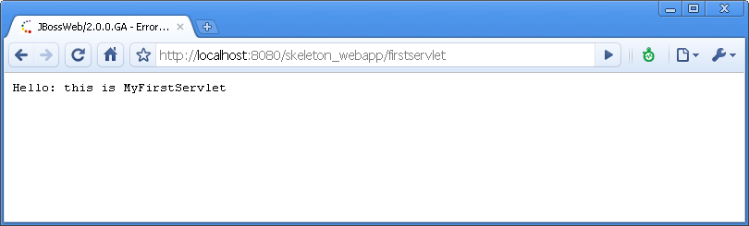

3. create skeleton gwtapp
D:\test>mvn archetype:create -DgroupId=com.skelenon.example -DartifactId=skeleton_gwtapp -DarchetypeArtifactId=maven-archetype-webapp

Copy web.xml and MyFirstServlet.java from skeleton_webapp to skeleton_gwtapp.
Copy jboss plugin and servlet dependency from pom.xml of skeleton_webapp to the pom.xml skeleton_gwtapp.

3.1 import skeleton_gwtapp to eclipse
mvn eclipse:eclipse

3.2 add gwt-maven-plugins and GWT dependencies to pom.xml
<project xmlns="http://maven.apache.org/POM/4.0.0" xmlns:xsi="http://www.w3.org/2001/XMLSchema-instance" xsi:schemaLocation="http://maven.apache.org/POM/4.0.0 http://maven.apache.org/maven-v4_0_0.xsd">
<modelVersion>4.0.0</modelVersion>
<groupId>com.skeleton.example</groupId>
<artifactId>skeleton_gwtapp</artifactId>
<packaging>war</packaging>
<version>1.0-SNAPSHOT</version>
<name>skeleton_gwtapp Maven Webapp</name>
<url>http://maven.apache.org</url>

<properties>
<!-- convenience to define GWT version in one place -->
<gwt.version>2.0.3</gwt.version>
<gwt-pluginVersion>1.2</gwt-pluginVersion>

<!-- tell the compiler we can use 1.6 -->
<maven.compiler.source>1.6</maven.compiler.source>
<maven.compiler.target>1.6</maven.compiler.target>
</properties>

<build>
<finalName>skeleton_gwtapp</finalName>

<plugins>

<!-- deploy jboss runtime -->
<!--
<plugin>
<groupId>org.apache.maven.plugins</groupId>
<artifactId>maven-war-plugin</artifactId>
<version>2.1-alpha-2</version>
<configuration>
<packagingExcludes>${warExclude}</packagingExcludes>
<outputDirectory> ${JBOSS_HOME}/server/default/deploy </outputDirectory>
<outputFileNameMapping>@{artifactId}@@{classifier}@.@{extension}@</outputFileNameMapping>
</configuration>
</plugin>
-->
<plugin>
<groupId>org.apache.maven.plugins</groupId>
<artifactId>maven-compiler-plugin</artifactId>
<version>2.0.2</version>
<configuration>
<source>${maven.compiler.source}</source>
<target>${maven.compiler.target}</target>
</configuration>
</plugin>

<!--Maven GWT plugin goes here-->
<plugin>
<groupId>org.codehaus.mojo</groupId>
<artifactId>gwt-maven-plugin</artifactId>
<version>${gwt-pluginVersion}</version>

<configuration>
<logLevel>INFO</logLevel>

<runTarget>com.skeleton.example.gwt.MyFirstGWTModule/MyFirstGWT.html</runTarget>

<compileTargets>
<value>com.skeleton.example.gwt.MyFirstGWTModule</value>
</compileTargets>

<i18nMessagesBundles>
<i18nMessagesBundle>com.skeleton.example.resources.i18n.LabelResources</i18nMessagesBundle>
</i18nMessagesBundles>

<generateDirectory>src/main/java</generateDirectory>
</configuration>

<executions>
<execution>
<phase>process-resources</phase>

<goals>
<goal>compile</goal>
<goal>i18n</goal>
</goals>
</execution>
</executions>
</plugin>

<!-- resource bundle -->
<plugin>
<groupId>org.codehaus.mojo</groupId>
<artifactId>native2ascii-maven-plugin</artifactId>
<executions>
<execution>
<goals>
<goal>native2ascii</goal>
</goals>
<configuration>
<encoding>utf-8</encoding>
<src>src/main/resources</src>
<dest>target/classes</dest>
<includes>
**/*_ja.properties,**/*_zh.properties
</includes>
</configuration>
</execution>
</executions>
</plugin>
</plugins>

</build>

<dependencies>
<dependency>
<groupId>junit</groupId>
<artifactId>junit</artifactId>
<version>3.8.1</version>
<scope>test</scope>
</dependency>

<!-- Because this is a web app, we also have a dependency on the servlet api. -->
<dependency>
<groupId>javax.servlet</groupId>
<artifactId>servlet-api</artifactId>
<version>2.4</version>
</dependency>

<!-- GWT dependencies (from central repo) -->
<dependency>
<groupId>com.google.gwt</groupId>
<artifactId>gwt-servlet</artifactId>
<version>${gwt.version}</version>
<scope>runtime</scope>
</dependency>
<dependency>
<groupId>com.google.gwt</groupId>
<artifactId>gwt-user</artifactId>
<version>${gwt.version}</version>
<scope>provided</scope>
</dependency>

</dependencies>

</project>

3.3 Update library with mvn eclipse:eclipse, we will see gwt library under Eclipse

3.4 Enable Eclipse Google Web Toolkit, right click skeleton_gwtapp → properties
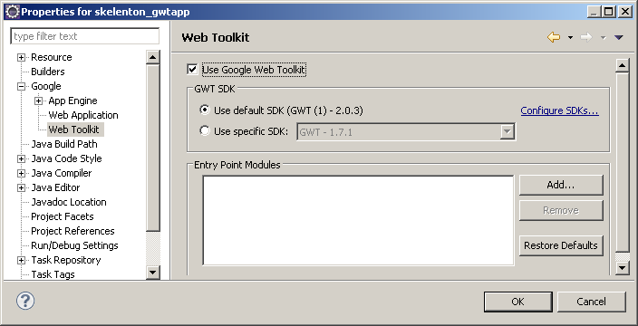

3.5 Create GWT module
First create GWT module
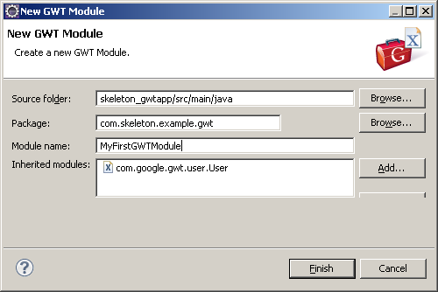

Create entry point
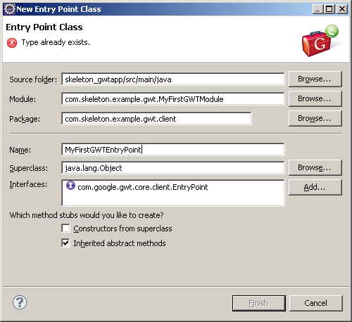

Create module html for GWT.

3.6 Create resource bundle for international website ready
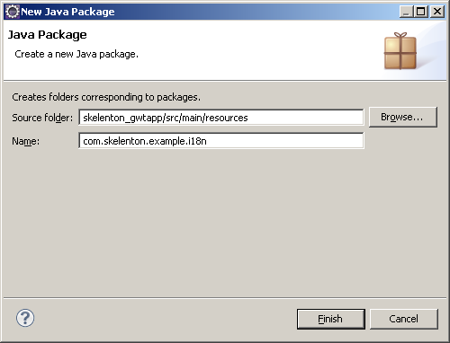

And create LabelResources.properites and LabelResources_es.properties files under i18n

And create LabelResources.properites and LabelResources_es.properties files under i18n

Generate resource Java file, option
D:\test\skeleton_gwtapp>
mvn process-resources

Import to eclipse and enable Google Web Tool from project property.
Debug: right click MyFirstGWTModule.gwt.xml and Debug As → Web Application
Make break point MyFirstGWTEntryPoint.java

http://localhost:8080/skeleton_gwtapp/myfirstgwt.jsp?gwt.codesvr=127.0.0.1:9997

import

FAQ:
D:\test\skelenton_gwtapp>mvn process-resources
[INFO] Scanning for projects...
[INFO] ------------------------------------------------------------------------
[INFO] Building skelenton_gwtapp Maven Webapp
[INFO] task-segment: [process-resources]
[INFO] ------------------------------------------------------------------------
[INFO] [native2ascii:native2ascii {execution: default}]
[INFO] [resources:resources]
[WARNING] Using platform encoding (Cp1252 actually) to copy filtered resources, i.e. build is platform dependent!
[INFO] Copying 3 resources
[INFO] Copying 3 resources
[INFO] [gwt-maven:i18n {execution: default}]
[INFO] establishing classpath list (buildClaspathList - scope = COMPILE)
[INFO] google.webtoolkit.home (gwtHome) *not* set, using project POM for GWT dependencies
The target source's directory 'D:\test\skelenton_gwtapp\src\main\java\com\skelenton\example\i18n' must be an existing directory
[INFO] ------------------------------------------------------------------------

A:
Create i18n package under src\main\java\com\skelenton\example.

http://claudiushauptmann.com/tutorial-google-maps-with-java-gwt-and-eclipse.html
http://www.cypal.in/studio

Installation
Download the required version from here and unzip it into your eclipse/plugins folder. Open Eclipse (remember to run Eclipse on a Java 1.5 VM!). Select Window->Preferences->Cypal Studio and set GWT home to the directory where you have installed the Google Web Toolkit.
You are all set to code now.

Download the required software and sign for a Google Maps API-key.
- Download and install the Java SE Development Kit
You need the JDK to run Eclipse, the GWT Hosted Mode-Browser and the GWT-Compiler. On MacOS the JDK is installed by default, for other operating systems you can download the JDK from Sun.
- Download and unzip the Eclipse IDE for Java EE Developers
Download Eclipse for EE Developers. You can unzip Eclipse to whereever you like, for example into the folder applications or programs.
- Download the Google Web Toolkit
GWT is available at code.google.com. Download and unzip it to whereever you like.
- Download und install Cypal Studio for GWT
Cypal Studio is a Eclipse plugin that integrates GWT into Eclipse the build process and the launch process. Unzip the plugin jars into <Eclipse home>/dropins/Cypal/plugins. You have to manually create the Cypal and plugins directories (installation manual).
- Download and unzip the Google Maps-library for GWT
The Google Maps-library for GWT wrappes the javascript necessary to run Google Maps on your website. Download and unzip the library to whereever you like.
- Sign up for a Google Maps Api-Key
This step is optional for development on your local computer (localhost). You can sign up for a key here.

