[**http://www.allhotelmotel.com/gwtbooking**](http://www.allhotelmotel.com/gwtbooking)

This small app demonstrates the usages of GWT, Spring, Hibernate and JQuery. A flow of reservation of property is presented. Search can be performed by full address, airport code or geocode (latitude and longitude). The search result is displayed in the list as well as in Google map.

The same flow is given by four different technologies:

1. Pure Spring App
2. JQuery + Spring App
3. GWT + Spring App
4. GWT MVP + Spring App.

**GWT features:**

* **GWT latest version**: 2.4.0
* **Multi-modules**: total having 3 modules
* **Multi-language** (internationalization): English and Spanish
* **Google Map**: display result with Google map.
* **Suggestion Box**: display the locations for the input.
* **Code splitting**: performance enhance for display home page quickly
* **MVP**: apply GWT formal MVP pattern.
* **Deferred Binding**: generate page flow.
* **GWT Linker**:
* **GWT Spring SL**: Used for integrating GWT RPC call with Spring MVC framework.
* **SEO Consideration:** set page title, page description, page meta data
* **Performance Consideration:** inline nocache.js, code splitting, Load Google Map on demand with Google AjaxLoader
* **Client Session backup:** to support the action such as page refresh. For example, in search result page, when user clicks refresh button in browser, the search result data will be gone, so user will not see the search result anymore, in this app, a session backup RPC call will get data from server session and re-display data in browser.

**Spring features:**

* **Spring MVC**
* **Spring IOC**
* **REST**
* **AOP:**

1. injecting to reservation flow, and create pipeline functions with different thread such as for sending email, send sms etc.
2. collecting data for performance metrics

* **Multi-thread**: send email in different thread.
* **JSON:**
* **Hibernate:**

**JQuery:**

User JQuery library

**Screen demo:**

Home page: http://www.allhotelmotel.com/gwtbooking/

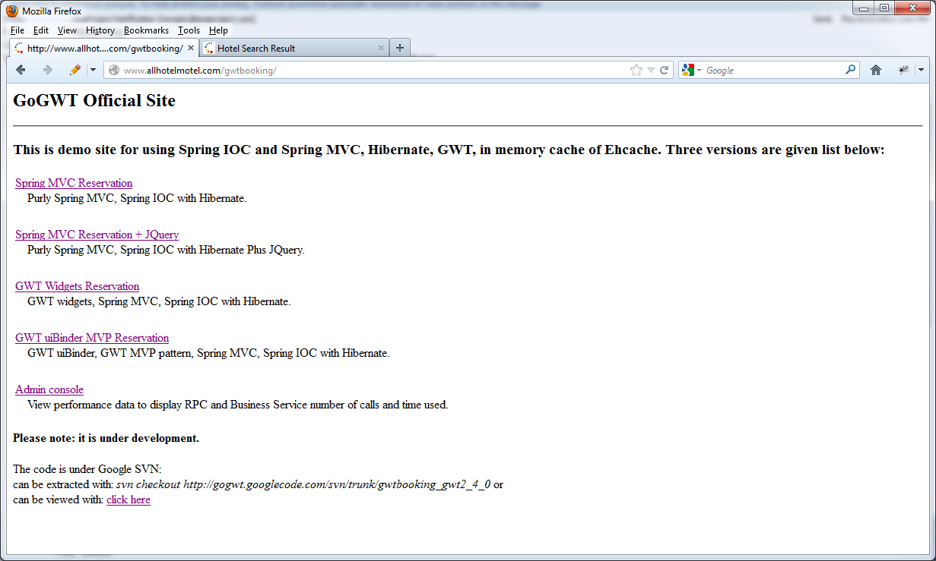

Suggestion box, Page title:

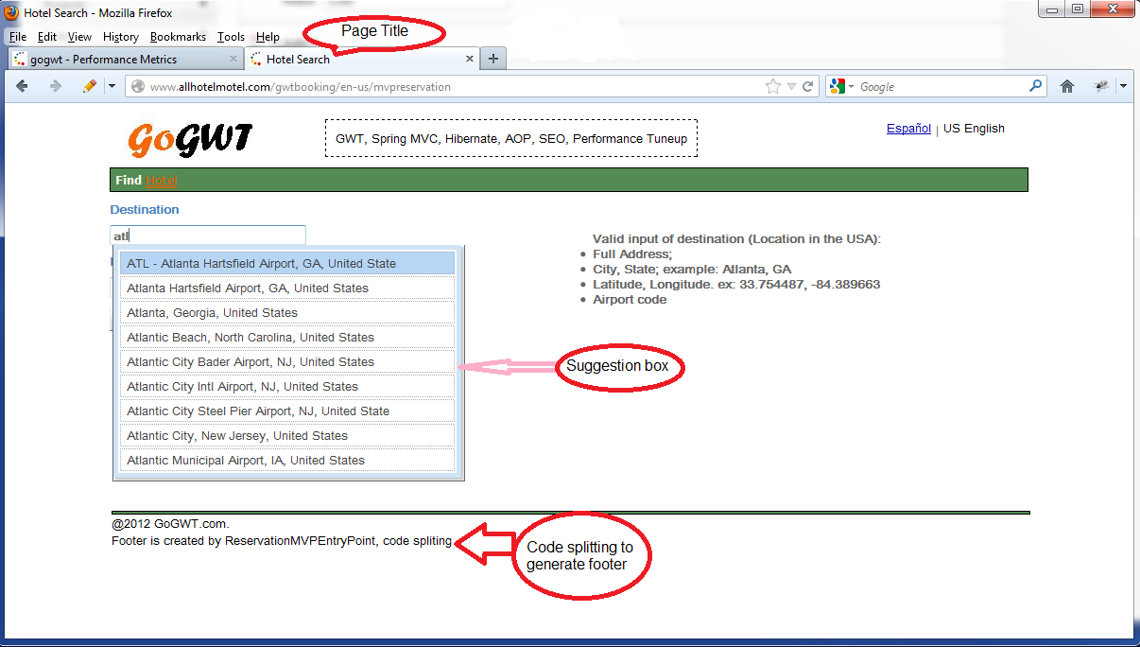

Search Result: with Google Map

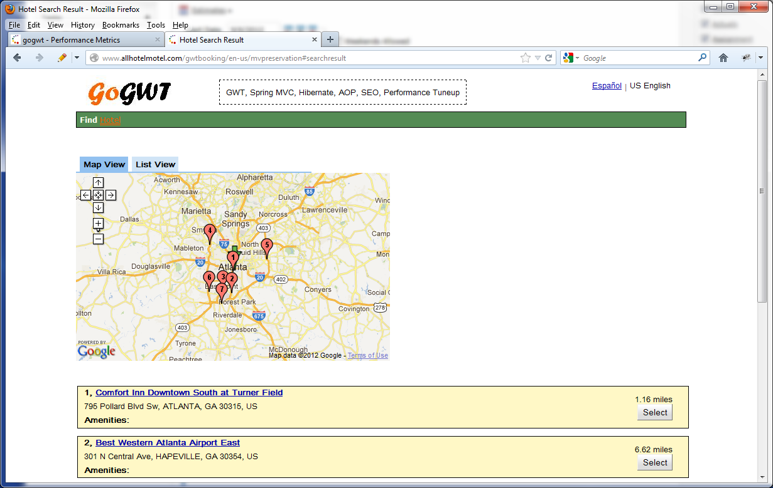

Performance Metrics: http://www.allhotelmotel.com/gwtbooking/en-us/admin/metrics

