IANSOFT

IANSOFT COMPANY   LTD

IANSOFT E-BOARD

Table of Contents

Iansoft Eboard Documentation 1

Introduction 1

Customized document organization. 1

Document Collaboration 1

E-Calendar 1

Android Interface 1

Alerts 2

Secure Application Programing Interface (API) 2

A glance at E-board Interface 2

Figure 1: Eboard Dashboard 3

Figure 2:Eboard Admin Document Manager 3

Figure 3: Eboard Document Management 4

Figure 4: Dashboard Event Manager 4

Figure 5: User Management 5

Figure 6: Event with Responses (RSVPs) 5

# Iansoft E-board Documentation

## Introduction

The E-board solution is a product geared toward bringing efficiency in enterprise communication by offering the following benefits:

### Customized document organization.

Company documents can be arranged within parent folders and subfolders relating to various user groups. E.g. users in Finance or procurement or board members can have their own document folders with rights assigned for access such that you can only access documents with folders you have access to.

## Document Collaboration

Users accessing similar documents can give remarks / annotations on the same document, hence a file can be interrogated by multiple users at the same time.

Sensitive documents like minutes can be shared selectively with concerned members for their input right after a meeting.

## E-Calendar

The E-board has a calendar modules that facilitates creation of meeting and events. Invited users can give timely responses of attendance or otherwise (RSVP). Appropriate notifications are sent to event owners in a timely fashion via in app (web) notifications.

Event calendar dates can be integrated with outlook calendar and google calendar.

## Android Interface

The E-board systems is not restricted to web access only as it can be accessed via an android applications installed on smart phones and tablets powered by android OS.

## Alerts

E board users can be notified easily on applications activities like arrival of a new document in their folders or creation of new events in the e-calendar via push notifications on android clients and emails on web clients.

## Secure Application Programing Interface (API)

The E-board possesses an API that allows an enterprise to programmatically perform operations like managing users, document organization and events.

## A glance at E-board Interface

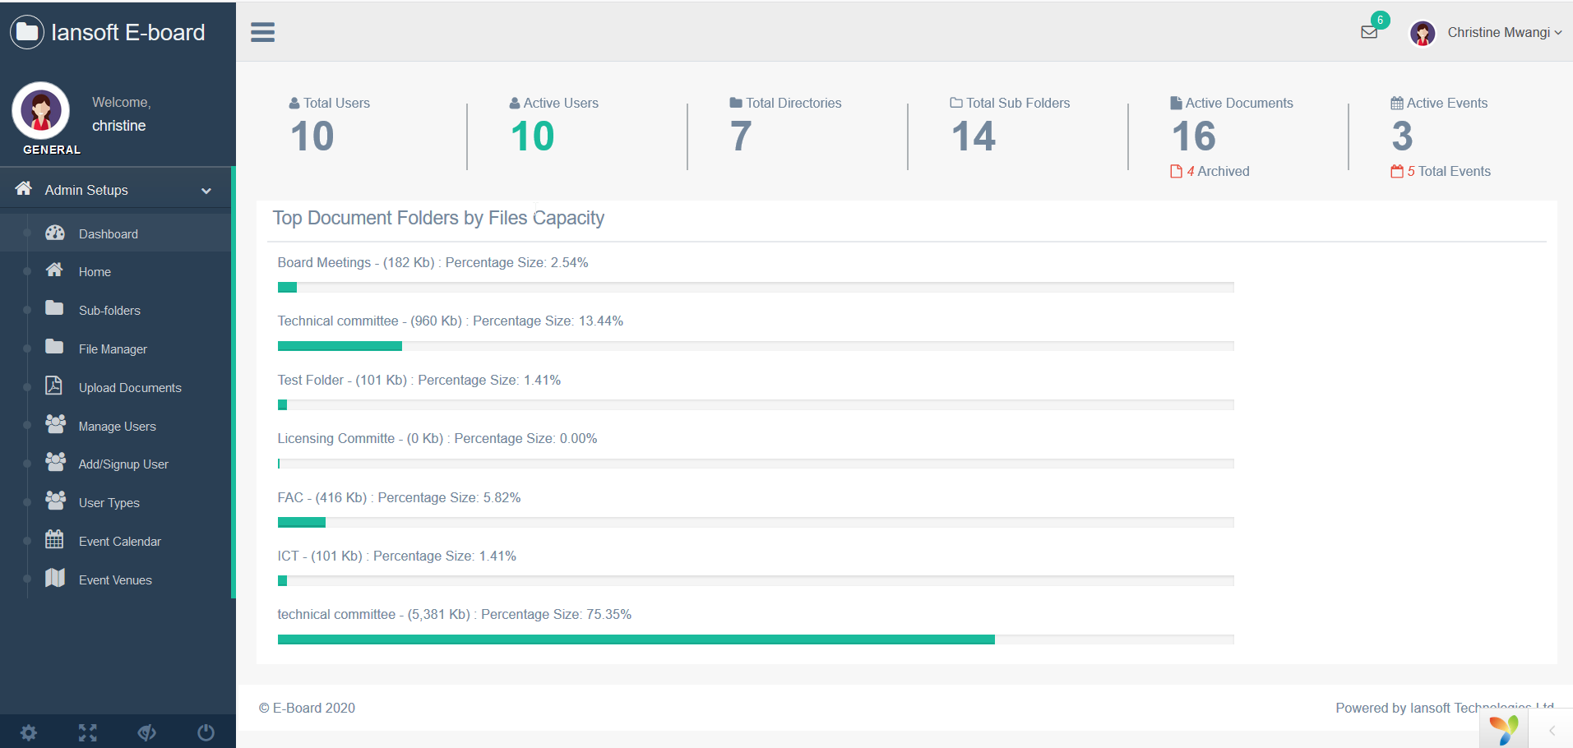

Figure : Eboard Dashboard

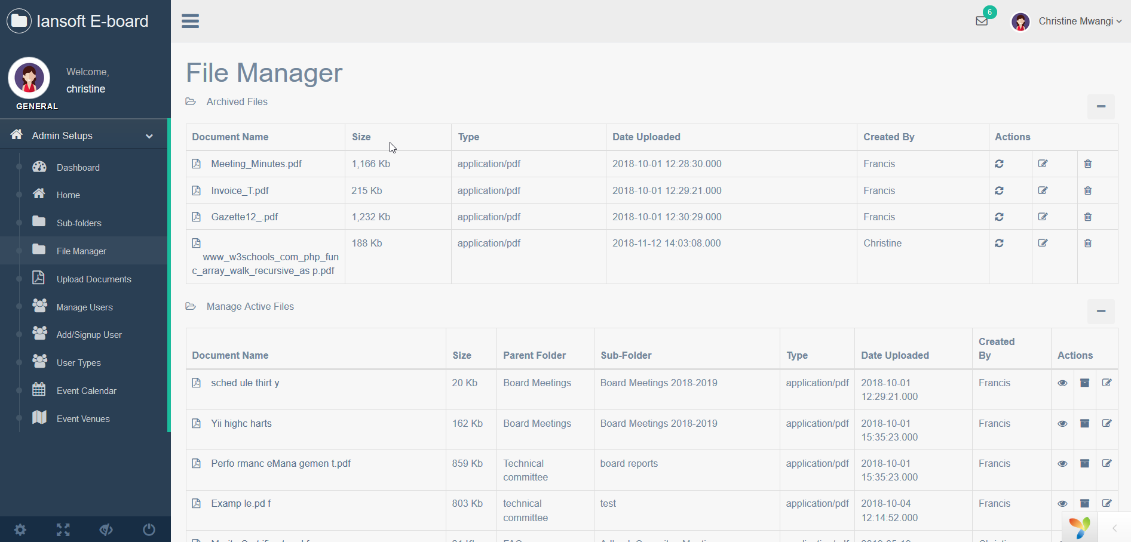

Figure :Eboard Admin Document Manager

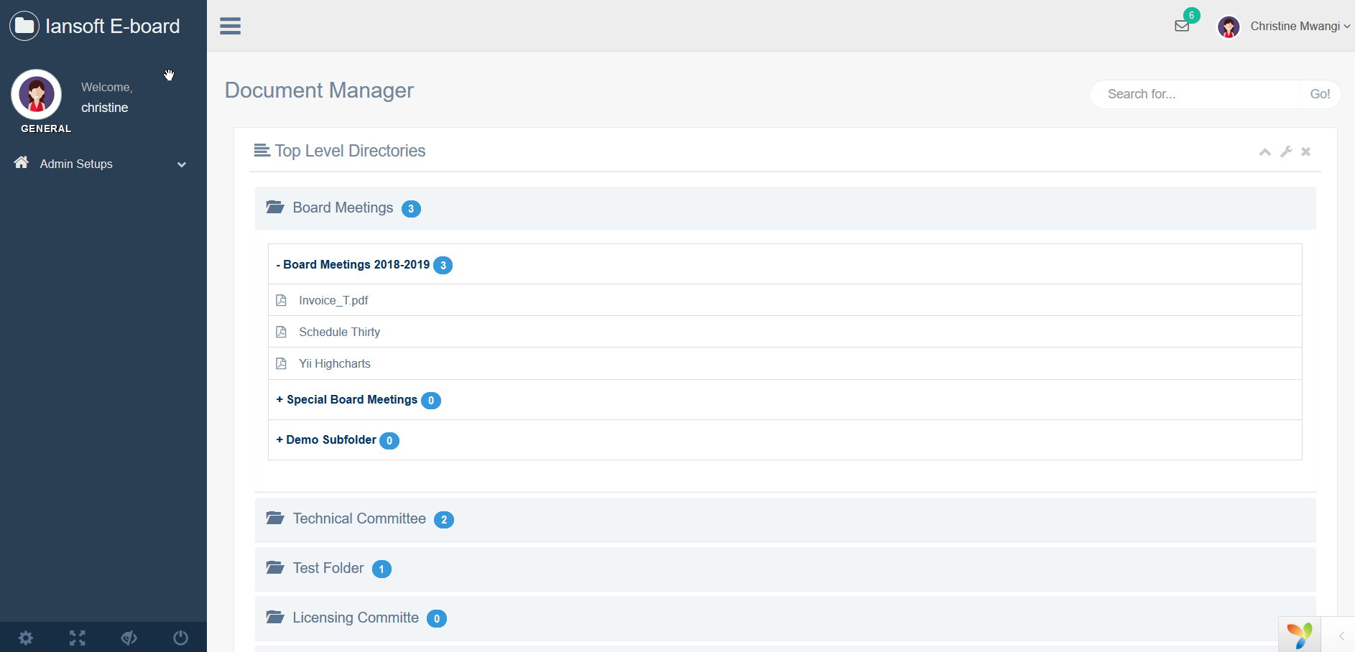

Figure : Eboard Document Management

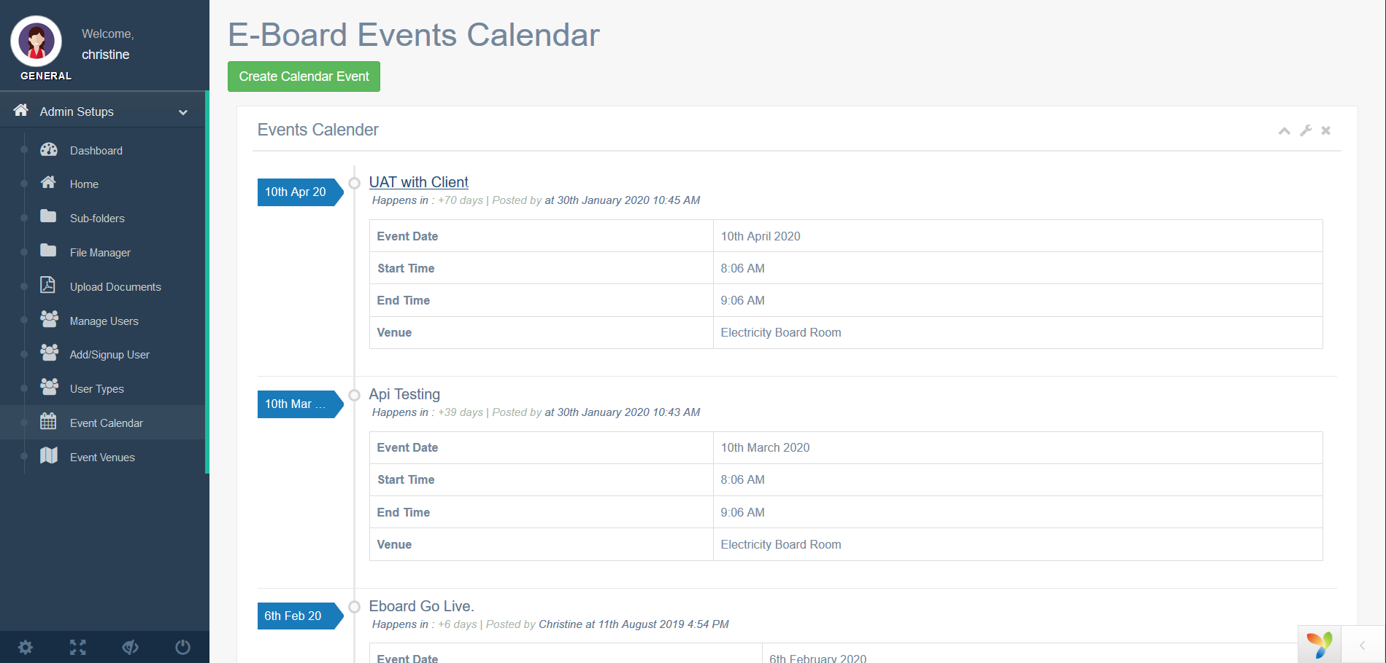

Figure : Dashboard Event Manager

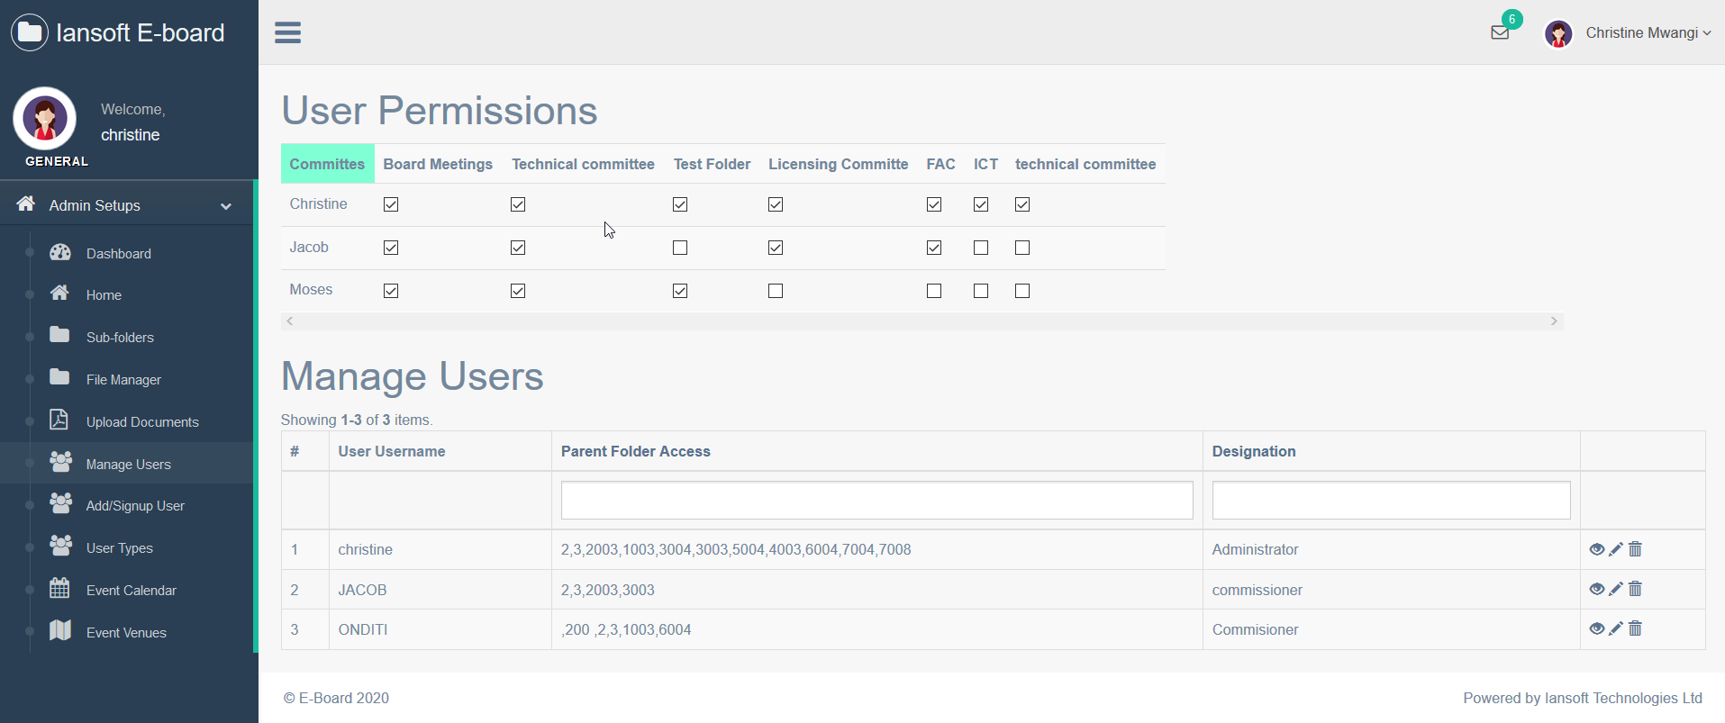

Figure : User Management

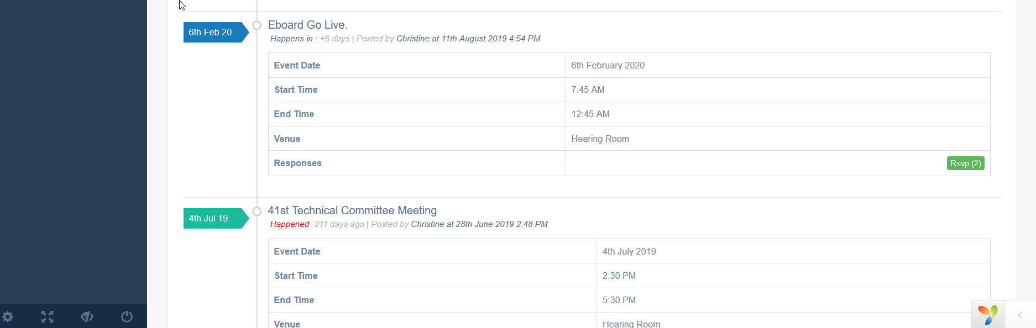

Figure : Event with Responses (RSVPs)