BrokerKnow

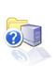

User manual

Version 1.1

COPYRIGHT
This manual was written for use with BrokerKnow© 2005. This manual and the BrokerKnow system described in it are copyrighted with all rights reserved.
No parts of this publication may be reproduced, transmitted, transcribed, stored in a retrieval system, or translated into any language in any form or by any means without the permission of Knowing limited or its suppliers or any of its affiliates.

LICENCE INFORMATION
License Agreement
NOTICE TO ALL USERS: THE SYSTEM CAN ONLY BE INSTALLED IN THE COMPANY IN WHICH IT WAS DEVELOPED FOR OR BY ANY OF ITS SUBSIDIARY BRANCHES.

ACKNOWLEDGEMENTS

The BrokerKnow software was developed by Knowing Limited. This manual was written by Karen Sowon. Thanks to all users and testers of BrokerKnow whose suggestions have made it a much better program than it would otherwise have been.

Contents

User manual 1
Contents 1
Introducing BrokerKnow 1
System requirements 1
Starting and Quitting BrokerKnow 1
BrokerKnow Menus 4
New, Delete, Edit, Sort, Filter and Search Commands 4
Management Menu 12
Accounts Menu 13
Supplier Menu 14
Fixed Assets Menus 14
Payroll Menu 14
IPOs and Rights Issues Menu 15
Bonds Menu 16
International Valuation Menu 16
Local Valuation Menu 17
Over the Counter Menu 18
Administration Menu 18
Audit Log Menu 21
Reports Menu 21
BrokerKnow Reports 23
To Generate a Report 23
Front Office Reports 24
Operations Reports 25
Management Reports 30
Accounts Reports 31
Supplier Reports 37
Fixed Assets Reports 38
Payroll Reports 39
IPOs and Rights Issues Reports 40
International Valuation Reports 40
Local Valuation Reports 40
Over the Counter Reports 41
Administration Reports 41
To Customize a Report 42
To Print a Report 43
Other Functions 44
Using BrokerKnow e-mail Option to send reports 44
Importing Files 45
Setting BrokerKnow Preferences 46
Accessing BrokerKnow Help 46
BrokerKnow Tasks Guide 0
Customer Service 0
Registering a Client 2
Modifying an Existing Client 3
To Delete 3
To Edit 5
To Sort 6
To Filter 7
Notes 9
Registering an Order 11
Modifying an Existing Order 14
To Delete 14
To Edit 15
To Sort 16
To Filter an Order 17
Notes 19
Printing a Receipt 21
Operations 0
To Register an Agent 1
Generating a Schedule 2
Importing Trades 4
Dealing with Unmatched Trades 6
Commit Trades 7
Generating Client Contract 8
Compounding an Order 11
Generating a Compounded Client Contract 13
Generating an Agent Contract 15
Generating an Agent Compounded Contract 16
Notes 17
The Management Menu 0
Assigning an Agent to a Client 1
Registering Agents 3
Notes 4
Accounts 0
To Post a Payment 1
To Enter a Journal 2
To Delete a Journal Entry 4
Committing Journals 6
To Release Journals 7
Generating a P&L 8
Generating a Balance Sheet 8
Generating the Trial Balance Report 9
Creating a new account 10
To Edit 11
To Sort 12
To Filter 12
Generating an account history 13
Bank Reconciliation 13
Reconciling a bank account 13
Reconciling the CDS Bank Account 14
Generating the Reconciliation Statement 15
Generating the Cleared Effects Statement 16
Generating the Un-cleared Effects Statement 16
Notes 17
Portfolio Valuation 0
Modifying Opening Balances 1
To Edit 1
To Sort 2
To Filter 2
Notes 3
The Trading History 4
Generating the Holdings Valuation Report 7
Portfolio Gain and Loss 8
Portfolio Summary 9
Portfolio Transactions 10
Trading Sales Analysis 11
Trading Summary 13
Managing Orders 1
Duplicate orders 2
Excluded purchase orders 2
Excluded Sales order 4
Expired Orders 4
Matched Orders 5
Odd lots 5
Order List 6
Notes 7
Order List (Odd Lots) 8
Order List (Without Odd Lots) 10
Order List ATS 11
Order List ATS (Best) 11
Order List ATS (Custodian) 11
Purchase orders 11
Sales orders 11
Notes 12
Administrational Tasks 1
Managing Account managers 2
To Register an Account manager 2
Modifying Account Manager Information 3
To Delete 3
To Edit 3
To Sort 3
To Filter 3
Managing Brokers 4
To Register a Broker 4
Modifying Brokers 5
To Delete 5
To Edit 5
To Sort 6
To Filter 6
Manage Bonds/Issues 6
To Register a Bond 6
Modifying Bonds 7
To Delete 7
To Edit 8
To Sort 8
To Filter 9
To Register an Issue 9
Modifying Issues 10
To Delete 10
To Edit 10
To Sort Issues 11
To Filter 11
System Configuration 0
Activity types 1
Banks 1
Client types 2
Commissions 3
Corporate types 4
Gender 5
Holidays 5
Invoice types 6
Invoice terms 6
Levies 6
Levy ordering on reports 8
Location 9
Mail settings 10
Market sectors 10
Online users 11
Order hold options 12
Order types 13
Payment types 14
Residencies 14
Time limits 15
User Security 15
Managing User Groups 1
Managing Group members 1
Company Configuration and Audit Log 1
Audit Log 2
Customer Service Online Operations 1
New Users Online Registration 2
Applying for an online account for existing Users 4
Logging In 6
Entering an Order 7
Suggestion Box 8
Viewing Transaction History 9
Viewing CDS Holdings 9
Viewing CDS Holdings Valuation 9
Viewing your Order Status 10
To Print the Order Status 11
To Email the page 12
Viewing Online Instructions 12
Changing User Details 13
Logging Off 14
Add New Online Users 14
Changing Online user details 17
Confirming Online Orders 19
Opening New Accounts for Existing Clients 19
Glossary of Terms 1

Chapter
1

Introducing BrokerKnow

Welcome to BrokerKnow! With the increase in complexity of the brokerage procedure it is vital to have a system that automates most if not all the processes involved in the business.

Broker Know is a comprehensive brokerage system well designed to meet the needs of your company and make efficient all the operations required for a properly working brokerage process.

This user manual has been written for the purpose of aiding the users towards their understandability of the system- Brokerknow for their benefit to contribute to their better performance and friendly working environment.

Find out more by reading through the manual!

System requirements

In order to use BrokerKnow, you must have the following:
P4 or windows 2002 or higher

Starting and Quitting BrokerKnow

To Start BrokerKnow

1. Enter your username and password in the text boxes provided.
2. Click login
BrokerKnow starts up

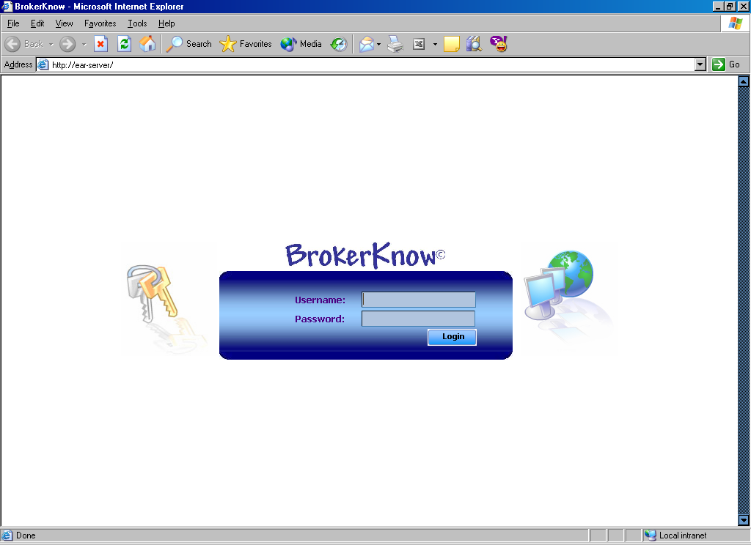

The main window will appear as shown below.
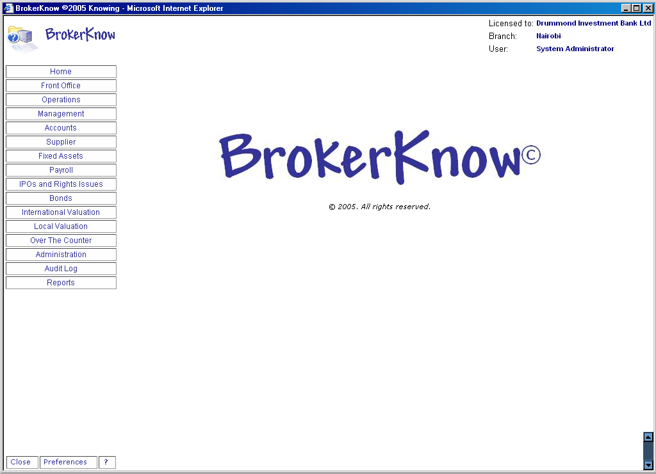

To Quit BrokerKnow

- Choose the close button at the top of the bottom of the page.
- Click OK
BrokerKnow closes

Chapter
2

BrokerKnow Menus

This section describes BrokerKnow menu commands used in the Input/Modify function. Each interface under the menu is described

New, Delete, Edit, Sort, Filter and Search Commands

To Add a New Record

- Click the New command button
- Fill in the information on the add Client Information dialogue box that appears.
- Click Save
The new record will be saved

To Delete a Record

- Select the record you want to delete
- Click the Delete command button
A warning will appear requiring you to confirm the deletion.
- If you are sure you want to delete click Yes else click No

To Edit a Record

- Select the record you would like to edit
- Click Edit
An Edit Client Information dialogue box appears on your screen
- Edit the Information as required
- Click Save to retain the changes else click Cancel to maintain the information’s original state.
To Sort Records

- Click Sort
A Sort web page dialog appears
- Specify the sort criteria as desired
- Click on the Sort command on the Sort web page dialog
The records appearing on the screen will be sorted
- Click Close to close the web page dialog box

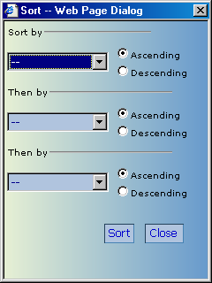

To Filter Records

- Click Filter
A Filter web page dialog appears
- Fill in your filter qualification details
- Click on Filter on the filter web page dialog
- Click Close to close the web page dialog

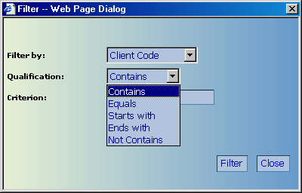

To Cancel a Filter

- Click the Cancel Filter command at the bottom of the screen
This returns the records to their original view before the filter.

To Search

BrokerKnow search function is designed to meet both simple and complex searches by allowing the users to use up to three fields to perform a search.

- Click the Search command button
- Specify the criteria for the search in the Search web page dialog.
- Click the Search command on the web page dialog
A search web page dialog like the one below appears.

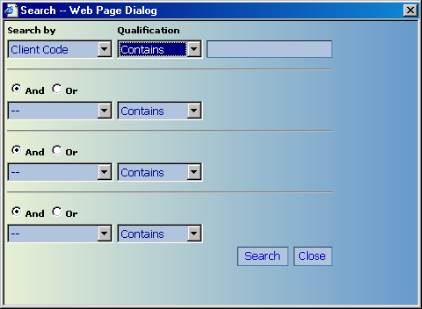

Note: All new, delete, edit, sort, filter and search tabs will function in the same way as discussed above.

This menu provides basic Front Office functions which are described in interfaces.

Online Clients – Is an interface that allows the user to manage online clients.

Online Activities – Is an interface where online client issues are viewed and addressed.

Online Orders – Is an interface where online orders can be viewed and addressed.

Accepted Users – Is an interface where details of online users are modified.

Register clients – Is an interface where clients are created on the system.

Register Orders – Is an interface where orders are created on the system.

User security - Provides an interface where users of the system are added.

Cheque Collections – Provides an interface where cheques that have been collected by clients are recorded.

Enter Receipts – Provides an interface where receipts are created on the system.

Pending Cheques – Provides an interface where cheques awaiting collection by clients are listed.

Release Orders – Provides an interface where orders are released for trading.

Enter Payment Request – An interface that allows the user to view and manage requests for payments.

Client Documents - Enables the user to use the system to generate different client documents by agent, client or by document number.

By default the system will generate client documents based on the client

The client documents to be produced are specified by the tabs provided in the interface as follows:

Generate order status – generates an order status of the clients transactions

Generate client contract - generates a client contract document according to which the client will pay.

Generate an agent contract – generates an agent contract based on a client only if the latter is registered under an agent. If the client is not registered under any agent the system will return an error message that there are no contracts based on the specified criterion.

Generate client statement – generates a specific client’s statement and portfolio summary to indicate all the credit and debit (purchase and sales) transactions based on the specified time interval and the portfolio summary based on the same time interval.

Generate compounded client contract –generates a document that merges all the different contracts that were undertaken to meet the client’s order, in order to present to the client just one document.

Generate compounded agent contract – is used to generate a document that merges the different agent contracts into one document. The system will generate this document only if the client is registered under an agent.

Generate parent client compounded statement – will generate a document based on the different client accounts merged to one main client account.

Online Cancellations – will be used to manage all online cancellations.

Operations Menu

Register Agents – Provides an interface where agents are created on the system

Register Clients/Orders – Performs exactly the same functions as the register clients and orders interfaces in the front office menu.
Register Clients has 3 more interfaces which are:

Client instructions – is a sub-interface where client’s purchase and sales instructions are contained.

Client sub accounts – is an interface used to maintain client parent and sub-account details.

External Trades – is an interface used to maintain information regarding all external trades.

Release Orders – Refer to Front Office-Release Orders.

Broker Commissions - This interface keeps track of contracts and commissions chargeable on each one of them.

Duplicate Orders – Interface where duplicate orders are created on the system.

Release Proposal – Provides an interface where proposals are released on the system.

Settlement Dates – Interface that lists contracts and their respective settlement dates.

Purchase Deliveries – Interface where purchase transfer information is entered to the system.

Sale Deliveries – Provides an interface where sale transfer information is entered to the system and managed.

Incoming Certificates – Interface where certificate information for purchase contracts is entered to the system.
.
Cancel Orders – The interface shows the details of all orders that have been cancelled.

Client Documents - This interface provides the same functions as the Client Documents menu in Front Office. Refer back to Front Office- Client Documents.

Contracts – Keeps track of all contracts details.

Equity Prices - BrokerKnow provides this interface to basically help the user add and modify the market details of equities as determined by market forces.

Executed Orders - An interface used to view all orders that have already been executed.

Match Clients – Provides an interface to match the daily trades with the CDS file.

Modify Clients – An interface for modification of client details.

Modify Orders – An interface to be used to effect changes on orders that have been placed on the system.

Recent Contracts – An interface showing all recent trades that have been made.

Order Headers – An interface allowing the user to modify order headers.

Management Menu

The menu provides basic functions for managers. This menu will provide a higher level
of access rights for users. Refer to the BrokerKnow Task Guide under the Management Menu for more information as regards this.

Cancel Orders – An interface used to cancel client orders.

Executed Orders – Refer to Operations-Executed Orders.

Register Agents/ clients/ orders will basically allow management to manage information as regards agents, clients and orders respectively.

Accounts Menu

This menu provides basic functions for use by the accounts department.

Register Clients – Refer to Front Office-Register clients

Chart of Accounts – Provides an interface where accounts are created on the system.

Broker Commissions – Keeps track of contracts and commissions chargeable on them.

Enter Journals – An interface where journals are created on the system.

Release Journals – Provides a control interface where journals are released on the system.

Enter Payments – Interface where payments are created on the system.

Enter Receipts – Provides an interface where receipts are created on the system.

Opening Balances – Interface that lists opening balances for entities e.g. clients, agents and accounts.

Process Requests – An interface that allows the user to process payment requests.

Approve Requests – Allows the user to approve payment requests.

Approved Requests - Allows the user to view all approved requests.

Bank Reconciliation – Provides an interface where non-CDS reconciliations are done on the system

CDS Bank Reconciliation – Is a sub-interface under the bank reconciliation where only CDS reconciliations are done on the system.

Budget Estimates – Provides an interface where monies will be assigned to assets.

Confirm Sales – Is an interface where confirmed sales are kept track of.

Inter-bank Transfer – Provides an interface where inter-bank transfers are created on the system.

Supplier Menu

Register supplier/invoices provides an interface for creating and managing supplier and invoice information respectively on the system.

Supplier payments –Is an interface for creating payments to suppliers on the system.

Complete assets – Is an interface where registration of assets is done on the system.

Fixed Assets Menus

This menu provides basic functions for managing fixed assets.

Register Asset – Provides an interface for registration of fixed assets.

Move Asset – Provides an interface for storing and managing information regarding movement of assets.

Depreciate Asset – Provides an interface for managing the depreciation details of fixed assets.

Dispose Asset – Provides an interface for managing disposal of assets.

Depreciation Rate – Provides an interface to store and manage depreciation rates for different assets.

Payroll Menu

Use the payroll menu to manage all employee salary and wages information.
The payroll menu has interfaces to input and manage deductions and tax information

Register employees - provides an interface where employees are created on the system.

Run payroll - provides an interface to either run or fine tune the payroll.

Payroll – Shows the details of all employee earnings.

Payroll items – Provides an interface for registration of all payroll items i.e. employment income deductions.

KRA codes – Provides an interface for creating and managing codes for KRA items.

Payroll details – Provides an interface for managing and modifying payroll details.

IPOs and Rights Issues Menu

Register Clients – Interface where clients are created on the system

Enter Receipts – Interface where receipts are created on the system

Applications – Is an interface where all applications are created on the system.

Batch Application – Provides an interface where application is done in batches.

Batch Forwards – Used to manage all application batches whose payments have been made directly to the offeror.

Enter Payments – Provides an interface where payments are created on the system.

KCB Schedules – Is a menu used to manage all KCB schedules.

Manage Offerings - Interface where IPOs and rights issues are recorded.

Register Applications – Interface where IPOs and rights issues are recorded for clients.

Register Forward – Interface where forward payments are recorded.

Bonds Menu

Provides interfaces where basic tasks regarding brokerage of bonds are carried out.

All interfaces under the Bonds menu have already been discussed in the operations menu.

Refer to Operations Menu.

International Valuation Menu

The menu provides interfaces to allow for managing brokerages of international securities.

Enter Contracts – Is an interface where contracts for international securities are entered to the system.

Enter Trade – Provides an interface where trades for international securities are created on the system.

Exchange Rates – Provides an interface for storing and managing exchange rates on the system.

Manage Contract Items – Provides an interface for creating and managing contract items for international valuations on the system.

Manage Sectors – Is an interface for creating sectors for international securities.

Register Clients – Is an interface for creating clients of international securities on the system.

Register Currencies – Is an interface for registering currencies to be used for international valuations on the system.

Register Securities – Provides an interface for registering international securities on the system.

Register Valuation – Provides an interface for creating valuations on the system.

Local Valuation Menu

BrokerKnow provides the local valuation menu to work with registrations and trades of securities that are based in Kenya.

Enter Trades – Provides an interface where trades for local securities are created on the system.

Register Equities – In an interface where local securities are registered on the system.

Register Bonds – Is an interface where bonds are created on the system.

Equity Sectors - Is an interface where sectors for equities are created on the system.

Bond Sectors – Is an interface where sectors for bonds are created on the system.

Client Documents – Allows the user to generate several client reports. Refer to Front Office-Client Documents.

Calculate Recommendation -

Investment Recommendation - Provides an interface for creating recommended buys on the system.

Holdings Valuation (combined) – Manages international and local client holdings.

Holding Valuation (combined) generates a report of all local and international client holdings.

Recommendation generates a list of recommended buys.

Recommendation Summary is a summary of the recommendation report.

Over the Counter Menu

Is a menu that allows the user to deal with the brokerage process of securities that are not registered with the Nairobi Stock Exchange.

Refer to Operations menu for descriptions of most of the interfaces.

Interfaces not in the discussed in the operations menu are:

Register Levies – Is an interface for registering all levies to be used for OTC transactions.

Register Securities – Provides an interface for creating OTC securities on the system.

Administration Menu

Is a menu that allows for basic administration related tasks.

Account Managers - provides an interface for creating account managers on the system.

Register Brokers – Provides an interface for creating brokers on the system.

Fund Managers – Is an interface for creating fund managers on the system.

Manage Accounts – Is an interface for creating accounts on the system.

Entities - Is a sub-interface for creating entities on the system.

Entity Types – Provides a sub-interface for specifying the entity types.

Account Types – Provides an interface for setting account types on the system.

Generic Settings – Provides an interface for creating generic entities on the system e.g. agents and clients.

Manage Bonds – Is an interface for creating and managing bonds on the system.

Issues – Provides an interface for creating and managing issues of bonds on the system.

Manage Securities – Is an interface that stores security information.

Announcements – Is an interface that stores specific security announcements.

Reverse Approvals

Bond Proposals – Is an interface for creating bond proposals on the system.

Submit Applications – Stores submitted applications.

System Configuration

Activity types – Is a sub-interface where activities are created on the system

Banks – Is a sub-interface where banks are created on the system.

Client types – An interface where client types are created on the system.

Commissions –Provides an interface where commission rates are entered and managed in the system.

Corporate types – Is an interface where corporate types are created on the system.

Gender – Is a sub-interface where the gender types are entered into the system.

Holidays – Keeps a records all the holidays

Invoice types – Keeps a record of invoice types e.g. credit or debit note.

Invoice terms – Keeps a record of invoice terms.

Levies – Provides an interface for creating levy information in the system.

Levy ordering on reports – Is an interface used to create levy orders on the system.

Location – Is an interface used to enter locations.

Mail settings – Is an interface used to create mail settings.

Market sectors – Is used to register market sectors.

Online users – An interface used to create online users on the system.

Order hold options – provides an interface for creating order hold options on the system.

Order types – provides a sub-interface where order types e.g. sale or purchase are created on the system.

Payment types – Is an interface where payment types are specified on the system.
Residencies – Is an interface where residency information (e.g. regarding withholding tax amounts) is stored on the system.

Time limits – An interface where time limits are specifies in the system.

User Security – Allows for basic functions to manage user security.
Groups – Is an interface where user groups are created on the system.

Group members – Is an interface where members of each system user group are created on the system.

Access rights – Is an interface that helps define the access rights that each user has got on the system.

Company Configuration – Provides an interface for setting up company configurations

Audit Log Menu

Is a menu that records system user actions on different entities in the system. It allows for traceability of actions on the system.

Agent – Is an interface that keeps track of system user actions on agent details.

Client - Is an interface that keeps track of system user actions on client details.

Contract - Is an interface that keeps track of system user actions on contract details.

Order Header - Is an interface that keeps track of system user actions on order headers.

Order Item - Is an interface that keeps track of system user actions on order items.

Reports Menu

This menu contains reports of different entities.

Client Reports

Clients Listing
Above credit limit
Trade volume totals
Status Summary
Statements
Debtors and Creditors
Portfolio statements
Account manager totals
(All the reports have been discussed before)
Refer to

Agents Reports

Agents listing will generate a list of all agents.

Balance List will generate agent balances for the specified period

Trade Volume Totals will generate the total trades of an agent

Statements will generate agent statements

Broker Reports

Brokers listing will generate a list of all brokers.

Balance Listing will generate broker balances for the specified period.

Trade Volume totals will generate the total trades of brokers.

Statements will generate broker statements.

Securities Reports

Securities listing will generate a list of all securities.

Client Trade Volume by security will generate totals of clients’ trades by security.

Accounts Reports

Chart of accounts generates a report showing all the details of the existing accounts.

Journal entries will generate all the details of all specified journals for the specified time period.

**History**

Trial balance generates a trial balance for the specified period.

Profit and Loss generates a profit and loss statement for the specified period.

Balance sheet will generate asset and liability balances as at the specified date.

Chapter
3

BrokerKnow Reports

To Generate a Report

- Select the menu for which you want to view the reports.
E.g. Front Office
- Click the Reports tab on the web page (By default the system will always open the menus in the Input/Modify form)
- Click the double arrows to expand the view of a reports menu.

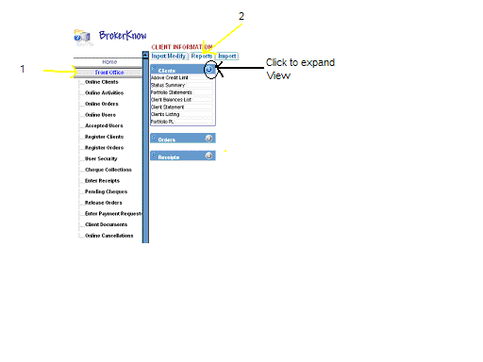
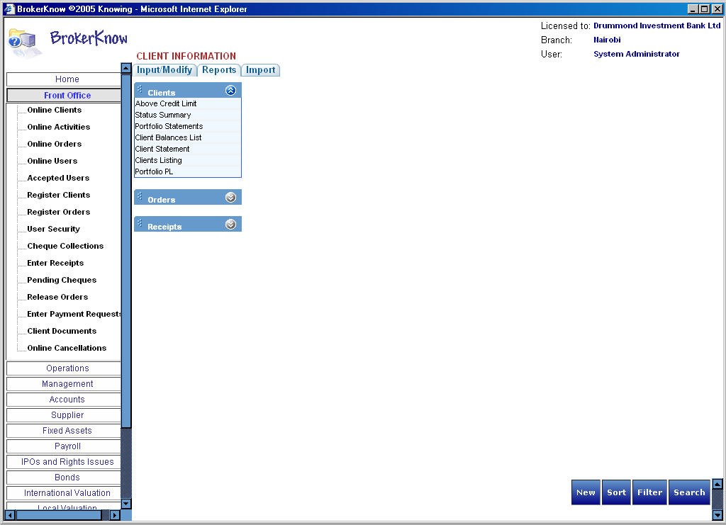

- Select the specific report that you want
- Enter the details required for the report if any.
- Click generate
The report will be generated wherefrom you can print or e-mail it.

Front Office Reports

The reports under each of the menus are discussed below.
Contains three interfaces:

Clients – An interface containing several client reports

Above credit limit generates a report of all clients who have exceeded their credit limit

Status summary will generates a summary of client orders and contracts.

Portfolio statements will generate current portfolio statements.

Client balances list will generate a list of clients under an agent or account managers and their balances.

Client statement generates a client statement for a selected period.

Client listing generates a list of all clients on a system.

Portfolio PL will generate a selected client’s portfolio profit or loss.

Orders – An interface containing reports related to orders placed on the system

Canceled Orders generates a list of all cancelled orders.

Completed Orders will generate order that have been fully executed.

Held Orders will generate all orders that have not yet been released for trading.

Outstanding Orders will generate a list of all orders that are still pending.

Purchase/Sales Orders generates a list of all purchase and sales orders respectively.

Receipts – An interface containing receipts reports.

Receipts listing will generate a listing of all receipts on the system.

Receipts schedule will generate all the receipts on the system as of a certain date.

Operations Reports

Trading - An interface containing reports on transactions arising from orders on the system.

Agent compounded will generate compounded agent contracts for a specified date

Agent contracts will basically generate agent contracts.

Allocation Schedule will generate all allocations as of a specified date.

Client compounded will generate compounded client contracts for a specified date.

Contract note will generate client contracts for a specified date.

Contract note (compounded) will generate compounded client contacts for a specified date.

Contract schedule will generate all contracts and their levies for a specified date.

Delivery slip will generate all sale deliveries for a specified date.

Expected deliveries will generate all sales deliveries that are expected to have been made by certain time limit.

Matched trades will generate matched trades for the current date.

Settlement reminder generates settlements due for a specified date.

Settlement slips generates amounts due to brokers by the NSE.

Trades in arrears will generate arrears arising from purchase of shares for clients.

Uncommitted trades will generate all trades that have not yet been committed.

Unmatched holdings

Unmatched trades will generate all unmatched trades for the current day.

Client volumes – An interface containing various reports based on client investment volumes.

Bonds will generate a volume report of bonds transacted in by clients.

Bonds and shares will generate a volume report of bond and shares transacted in by clients.

By Security generates a report of each of the security volumes by client.

Per Client generates a report of the volume of all the transactions that a client has engaged in, in a specified time period.

Per Client per Date generates a report of the volume of transactions per date that a client has engaged in, in a specified time period.

Shares will generate a volume report of shares transacted in by clients.

Clients - An interface containing various client reports.

Above credit limit generates clients that have exceeded their credit limit.

Active clients will generate a list of all active clients as of a certain date.

Active debtors will generate a list of all active debtors as of a certain date.
CDS Holdings will generate shares a client has as of a certain date.

CDS Valuation generates all shares a client has and their worth as of a current date.

Zero holdings will generate clients that hold no securities as of a current date.

Debtors and creditors will generate the balances of debtors and creditors of the firm as of the current date.

Batch Clients Statements is a report providing several client statements.

Batch receipts will generate a report providing several receipts to be issued to the respective clients.

Charges will generate charges for all non-custodian/normal clients.

Charges Custodian generates a list of all custodian charges

Client Balances List generates all clients and their balances.

Clients Listing will generate all current clients on the system.

Commissions will generate broker commissions earned from a client.

Commissions by date will generate the commissions due to a broker by date.

Contract note price will generate client contracts ordered by price.

Creditors will generate a list of all creditors in the system.

Debtors will generate a list of all debtors in the system.

Order contracts compounded generates compounded orders that have contracts as of a certain date.

Statement generates client’s statement as from the specified date.

Supplier statement generates a supplier’s statement as from the specified date.

Trade confirmation generates a trade confirmation of the securities.

Orders – An interface containing various order reports.

Duplicate orders will generate a list of duplicated orders.

Excluded purchase orders will generate all purchase orders that have been excluded in trading.

Excluded Sales order generates all sales orders that have been excluded in trading.

Expired Orders will generate all orders that have expired as of a certain date.

Matched Orders will generate all orders that have been matched with the CDS file.

Odd lots will generate a list of all orders less than 100.

Order List generates a list of all orders that have been placed.

Order List (Odd Lots) generates a trading schedule of all orders less than 100

Order list (summary) generates a summary of all orders on a certain date by security.

Order List (Without Odd Lots) will generate a trading schedule that has no shares less than fifty.

Order List ATS will generate a trading schedule that is in accordance with the format specified by the ATS.

Order List ATS (Best) will generate a trading schedule of all orders that are to be traded at best price.

Order List ATS (Custodian) will generate a trading schedule of all orders made by custodian clients.

Purchase orders will generate all purchase orders by client as of a certain date.

Sales orders will generate all sales orders by client as of a certain date.

Portfolio reports – contains various client portfolio analysis.

Trading history generates a report showing an analysis of a selected client’s trading history for a specified period.

Holdings Valuation will generate an analysis indicating the holding’s of a client as of a certain date.

Portfolio gain and loss generates a profit or loss analysis for transactions carried out by clients over a specified period of time in the specified security

Portfolio summary generates a summary of a client's transactions over a specified period of time.

Portfolio Transactions generates an analysis of all of a client's transactions over a specified period

Trading sales analysis will generate an analysis of all sale contracts for a client for a specified period.

Trading Summary will generate a summary of a client's transactions for a specified period of time.

Management Reports

BrokerKnow provides three interfaces under which reports are generated. The reports under each interface are described below:

Accounting – An interface containing selected accounting, broker and agent reports.

Agent Trade Volume Totals will generate agent volumes and commissions earned for a specified period.

History generates balances for entities and levies for a specified period.

Broker Trade Volume Totals will generate broker volumes and commissions earned for a specified period.
Profit and Loss generates company’s profit and loss statement for the specified period.

Balance Sheet generates company’s balance sheet for the specified period.

Account Manager –Interface containing account manager reports.

Account manager commissions will generate commissions earned by a selected account manager for a specified period.

Account manager statement generates a selected account manager’s transactions and balances for a specified period.

Account manager totals will generate broker volumes and commissions earned for a specified period.

Clients – An interface containing selected client reports.

Above credit limit generates clients that have exceeded their credit limit.

Client trade volume by security generates clients’ transaction volumes and commissions for a specified period.

Client trade volume totals will generate client transaction volumes and commissions for a specified period.

Status summary generates summary of client orders and contracts.

Accounts Reports

The accounts reports interfaces are described below:

Accounts – An interface containing accounts reports that mainly impact on the company.

Above credit limit generates a list of clients that have exceeded their credit limits.

Chart of accounts will generate a listing of all nominal accounts and their balances.

Approved journals will generate a list of all journal entries that have been approved.

Pending journal generates all journals that have not yet been released.

History generates balances for entities e.g. clients and levies for a specified period.

Debtors and creditors will generate a list of all debtors and creditors.

Receipts schedule generates schedule of all receipts as at a specified date.

Annual budget generates the company’s budget for the year.

Balance sheet will generate the company’s balance sheet for the specified period.

Bond market performance will generate the details of bond sales.

Commission exceptions will generate commission exemptions for entities within a specified period.

Creditors (parent) will generate a list of all parent creditors.

Debtors and Creditors (Parents) will generate a list of all parent debtors and creditors.

Debtors (parent) will generate all parent debtors.

Monthly budget generates the company’s monthly budget.

Opening Balances generates opening balances for clients, brokers and nominal accounts.

Payments listing generates list of all payments.

Profit and Loss account generates company’s profit and loss statement for the specified period.

Quarterly budget generates company’s quarterly budget.
Receipts listing will generate a list of all receipts.

Settlement schedule generates a report of the settlement position for transactions of the specified date.

Share Market Breakdown generates an analysis of market performance for the company.

Share Market final generates a final analysis of company’s market performance.

Share Market performance generates an analysis of market performance for top clients.

Share Market Summary generates a summary of company’s market performance.

Trading Account statement generates a company’s trading account statement for the specified period.

Walk In debtors generates a list of all non-custodial client debtors.

Walk In creditors generates a list of all non-custodial client creditors.

Clients – Is an interface containing several client reports.

Client balances list generates all clients and their balances.

Client details will generate a list of all the clients’ e-mail addresses at a current date.

Holdings valuation generates all shares a client has and their worth as of a current date.

Opening balances generates opening balances for clients, brokers and nominal accounts.

Payment vouchers will generate payment vouchers.

Portfolio BS generates a selected client’s portfolio balance sheet.

Portfolio gain and loss generates an analysis of profit and loss for transactions for a specified security for a specified period.

Portfolio PL generates a selected client’s portfolio profit and loss statement.

Portfolio Summary generates a summary of client’s holdings and their worth for a specified period of time.

Account Manager – is an interface containing account manager reports.

Creditors will generate a list of agent creditors for a specified period.

Debtors will generate a list of agent debtors for a specified period.

Account manager commissions will generate commissions earned by a selected account manager for a specified period

Account manager listing generates a list of all account managers.

Account manager statement generates a selected account manager’s transactions and balances for a specified period.

Account manager totals will generate broker volumes and commissions earned for a specified period.
Agent – An interface containing agent reports.

Balances will generate a list of agents and their balances for a specified period.

Commissions will generate agent’s commissions earned for a specified period.

Contracts will generate agent contracts.

Contracts compounded will generate compounded agent contracts for a specified date.

Creditors will generate a list of agent creditors for a specified period.

Debtors will generate a list of agent debtors for a specified period.

Listing generates a list of all agents.

Statement generates a selected agent’s transactions and balances for a certain date.

Volumes will generate agent transactions for a specified period.

Brokers – Interface containing broker reports

Balances will generate a list of brokers and their balances for a specified period.

Listing will generate a list of all brokers.
Statement generates a selected broker’s transactions and balances as of a specified date.

Volumes will generate broker transactions for a specified period.

Client Volumes – Interface containing reports relating to trading volumes for clients.

Bonds will generate client transaction volumes for bonds for a specified period

Bonds and Shares will generate total client transaction volumes for a specified period

By Security generates clients’ transaction volumes sorted by security for a specified period

Per Client generates all a specific client’s transaction volumes for a specified period of time.

Per Client by date generates a specific client’s transaction volumes by date.

Shares will generate client transaction volumes for shares for a specified period.

General ledger – contains several general ledger reports.

Profit and loss statement generates a profit and loss statement for the specified period.

Accounts statement generates a list of balances of the specified nominal accounts for a specified period of time.

Active clients will generate a list of all active clients on a specified date.

Active debtors will generate a list of all active debtors as of a specified date.

Bank balances will generate a list of all bank balances as at a certain date.

CDS bank account statement generates a cds bank account statement.

Creditors will generate a list of all creditors as of a certain date.

Debtors will generate a list of all debtors as of a certain date.

Trial Balance will generate a trial balance for a specified time period.

Xl25 Creditors will generate a list of all creditors in the old system.

Xl25 Debtors will generate a list of all creditors in the old system.

Levies – Interface containing reports related to levies charged on contracts.

Contract Stamp generates a monthly schedule of contract stamps payable to KRA

Levies report generates amounts for a selected levy for a specified period.

Traded levies will generate monthly levy amounts.

CMA compensation fund levies will generate monthly CMA levy amounts.

Non CDA levies report generates non-cda levies for a specified period.

NSE Compensation Fund levies generates monthly NSE levy amounts

Levies by Date – Contains levy reports using a specified date criterion.

Contract stamp by date generates a monthly schedule (by date) of the contract stamps payable too KRA.

Levies report by date generates a specific levy amounts for a specified period by date.

Non-CDA Levies report by date generates non-cda levies for a specified period by date.

Reconciliation – Interface containing reconciliation reports.

Cleared effects will generate a report of reconciled items for a selected account within a specified period of time.
Reconciliation statement generates a bank reconciliation statement.

Un-cleared effects will generate a report of non-reconciled items for a selected account within a specified period of time.

CDS bank cleared effects reports on reconciled items for the CDS account within a specified period of time.

CDS bank un-cleared effects reports on un- reconciled items for the CDS account within a specified period of time.

Schedules – Interface containing various schedule reports.

Bond and Equity settlements will generate the settlement position for normal trades occurring on the selected date.

Bond and Equity trades will generate a list of all trades related to bonds and equities for a specific date.

Bond trades will generate a list of trades related to bonds for a specified date.

Bond settlements will generate a report showing the bonds traded, that are to be settled by a specified date.

Equity settlements will generate an initial settlement position according to a CDS for a selected date.

Final settlements (CDS) will generate a final settlement position according to a CDS for a selected date.

Inter-bank settlements will generate a schedule for inter-bank transactions.

Payment Voucher schedule by settlement date generates payments to be made to clients according to settlement dates.

Payment Voucher Schedule by Settlement Date (Not Payable) generates payments made to clients according to settlement dates.

Payment Vouchers Schedule (Not Payable) generates a list of payments made to clients.

Payment schedules will generate a list of payments to be made to clients.

Prompt trades will generate a list of all prompt dates settling on the elected date.

Receipt schedule generates a list of monies expected from clients on the selected date.

XL25 –

Debtors and creditors will generate all debtors and creditors inn the old system.

Matched Brokerknow will generate a list of all clients that are in the old system and also in BrokerKnow.

Matched XL25 will generate old clients who have been matched to BrokerKnow.

Unmatched Brokerknow will generate a list of clients in BrokerKnow who are not in the old system.

Unmatched XL25 generates old clients who do not have BrokerKnow codes

Supplier Reports

Suppliers – Is a menu that contains different supplier reports.

Supplier statements will generate the specified supplier’s statement for the specified time period.

Supplier Balances will generate all the supplier balances as of a certain date.

Aging analysis will generate an aging analysis for suppliers.

Fixed Assets Reports

Fixed Assets – Is a menu containing several fixed asset reports.

Asset Statement generates a specified asset’s statement as for a specified period of time.

Asset Balances will generate a list of all asset balances to the specified date.

Asset Acquisition will generate a list of all assets acquired during a specified period.

Asset Depreciation will generate the depreciation information of the selected asset over the period specified.

Asset Movement will generate the movement information of an asset over the specified period.

Disposed Assets will generate a list of all assets disposed over a specified period of time.

Payroll Reports

Employee – Contains various employee reports.

Deductions report generates employees’ deductions over a specified period of time for the specified payroll item.

Earnings report generates employees’ earnings for the specified period.

Earnings/deductions will generate a schedule of the earnings or deductions per month for the current year.

Employee statement generates employee statements as of a certain date.

Payroll ledger generates a specific month’s payroll ledger for the specified year.

Pay-slip will generate an employee’s pay-slip for the month and year specified.

KRA-Reports – Contains various KRA reports.

Employee certificate generates the employer’s annual certificate.

Fringe benefit generates the employer’s fringe benefit tax return for the year.

Tax deduction card generates a specified employee’s tax deduction card.

IPOs and Rights Issues Reports

Batched applications will generate batches of applications that have been made.

Batched applications by date will generate the batch applications made by date.

Batched forward will generate all applications whose payment has been made directly to the offeror.

Batched forwards by date will generate batched forward categorizing them by date.

Chequed batches will generate all applications that have been paid for by the agent.

Client statement generates a client statement for the specified period.

Un-batched applications will generate all applications that have not been batched.

Un- Chequed batches will generate all applications that have not yet been paid for.

International Valuation Reports

Contract Note will generate a contract note of a client who has traded in international securities.

Local Valuation Reports

There are 4 local valuation reports.
Calculation

Holding Valuation (combined) generates a report of all local and international client holdings.

Recommendation generates a list of recommended buys.

Recommendation Summary is a summary of the recommendation report.

Over the Counter Reports

Client Statement generates OTC client’s statements.

Contract Note – generates contract note for over the counter trades.

Administration Reports

Securities Listing will generate a list of all securities

Account Manager Listing will generate a list of all account managers on the system

Agents Listing generates a list of all agents

Brokers Listing generates a list of all brokers registered on the system

Clients Listing will generate a list of all clients or active and inactive clients as specified by the user.

To Customize a Report

BrokerKnow allows the user to customize the reports to suit their needs.

- Select the report that you want to customize
- Check the ‘Customize this Report ’ check box
A web dialog box appears as shown below

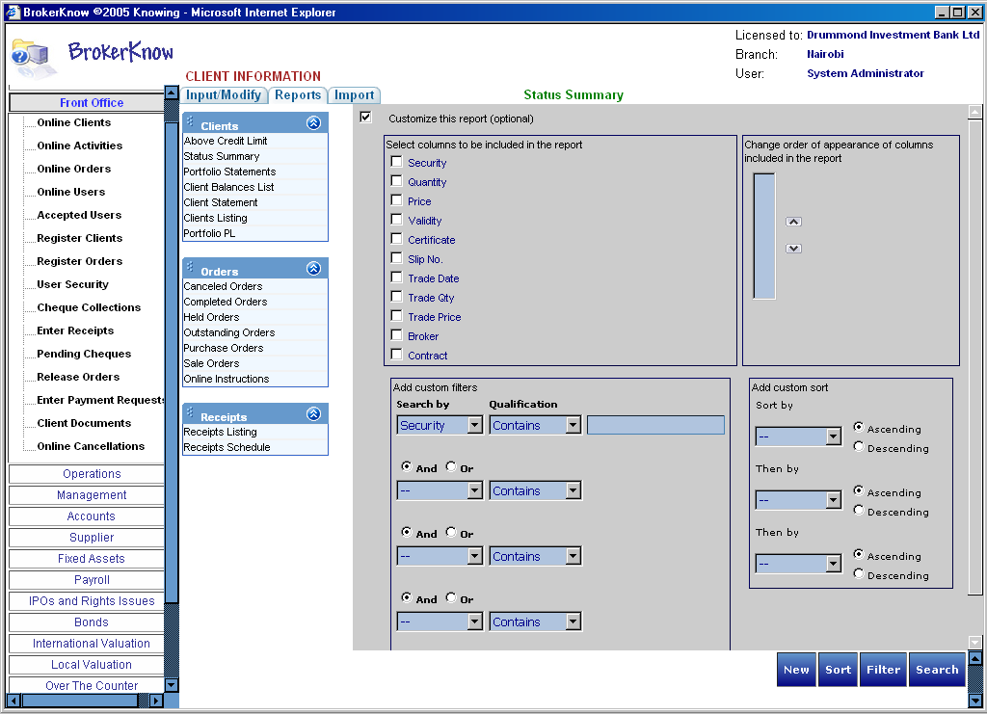

- Specify all customization details as required
- Click Customize

To Print a Report

- Click the Print command button
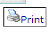
- A print dialog box like the one below appears on your web page.

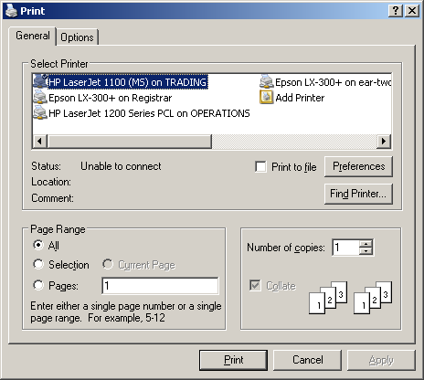

- Specify the printer and all other printing details.
- Click on the print button on the dialog box.

Other Functions
Chapter
4

Using BrokerKnow e-mail Option to send reports

Using the e-mail command, BrokerKnow will allow you to send a report via e-mail.
- Click on the E-mail this page command button
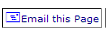
- A send page as E-mail web page dialog will appear as shown below.

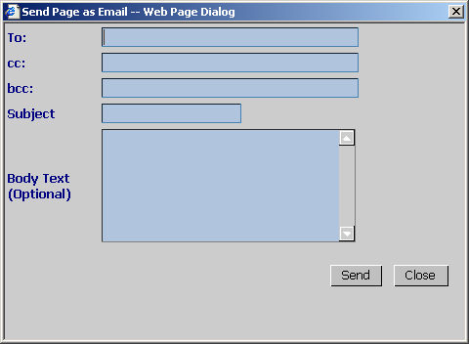

- Enter all the e-mail details

To – Is the e-mail address of the recipient
Cc – The email addresses of the people to whom a copy of the message is to be sent
Bcc – (Blind Carbon Copy) The email addresses of the people to whom a blind copy of the message is to be sent. These recipients will not be displayed in the message header and the recipients in the To and Cc fields will not know that a copy of the message was sent to other addresses. Use Bcc to send a copy of a message to someone without showing the other recipients.

Subject – Is some brief text indicating the contents of the message
Body Text – Is the content/detail that you want to send

- Click Send.
You will receive a successful email delivery message if the email is successfully delivered to the recipient.

Importing Files
How to Import

- Click the Import command button on the web page.
- Select the type of document that you want to import for example Daily Trades if you are importing trades or Client Holdings if you want the holdings file.
- Click on Browse

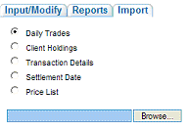
- Locate the file from the file browser window and click Open

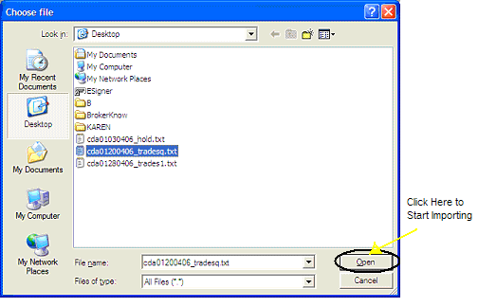

Setting BrokerKnow Preferences

On the menu window click Preferences.
You can set the window preferences to either full screen or normal screen.

Accessing BrokerKnow Help

To access BrokerKnow help file click the ‘?’ at the bottom of the menu window.

BrokerKnow Tasks Guide

Customer Service

Contents

Registering a Client 2
Modifying an Existing Client 3
To Delete 3
To Edit 5
To Sort 6
To Filter 7
Notes 9
Registering an Order 11
Modifying an Existing Order 14
To Delete 14
To Edit 15
To Sort 16
To Filter an Order 17
Notes 19
Posting a Receipt 20
This section will discuss tasks that are possible in the front office and Operations menus that have to do with registration and management of clients and orders.

The Brokerage process will normally start with registration of a client

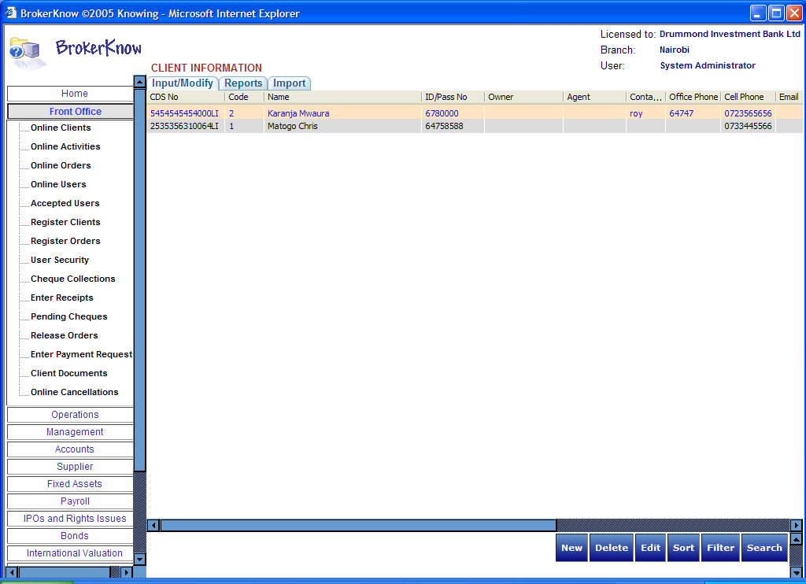
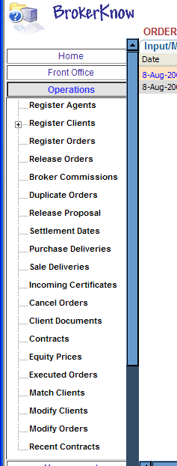

Registering a Client

- Under Front Office or Operations go to Register Clients
- To add a new client click New
An add client dialog box appears. Notice the areas marked as inactive
Refer to notes for more information regarding these fields

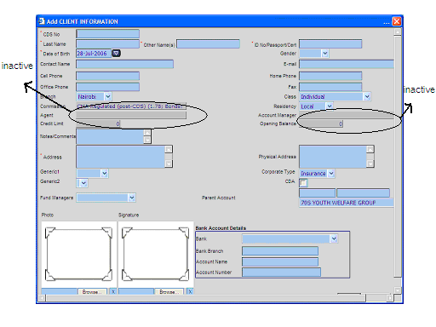

- Enter all details of the new client as required

CDS Number (CDS No) - An account number issued by the central depository system.
Last Name – Client’s last name
Other Names – Client’s other names
Contact Name – The person to be contacted if the client is a corporate or an institution
Branch – The branch of the brokerage firm
Commission – The commission to be paid by the client.
Agent – The person who carries out transactions on behalf of the agent.
Credit Limit – The amount over which the client should not exceed in terms of credit.
Notes/Comments - A field for any other comments as regards the client.
Address – The client’s postal address.
Fund managers – another person other than the bank
Photo and Signature – Client’s photo and signature
ID No / Passport / Cert – Client’s personal identification documents
Class – The client type whether individual or any other type
Residency – Where the client is legally a resident of
Account Balance /Opening Balance – The client’s account balance at the time of applying for the shares
Physical Address – The client’s physical address
Corporate Type – The corporate type of the client
CDA – Client Depository agent refers to the person who deals with CDS accounts on behalf of the client.
Parent Account – The main account under which there are child accounts
The bank accounts details that a client will be expected to have are:
Bank – The name of the bank
Bank Branch – The specific branch
Account Name – The client’s bank account name
Account Number – The client’s bank account number.

- Click Save
The new record will be saved and should appear in the list of clients.

Modifying an Existing Client

To Delete

- Select the client that you want to delete.
The selected record will normally be high lit

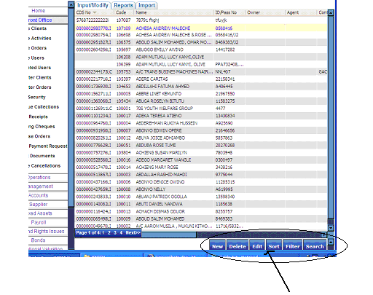

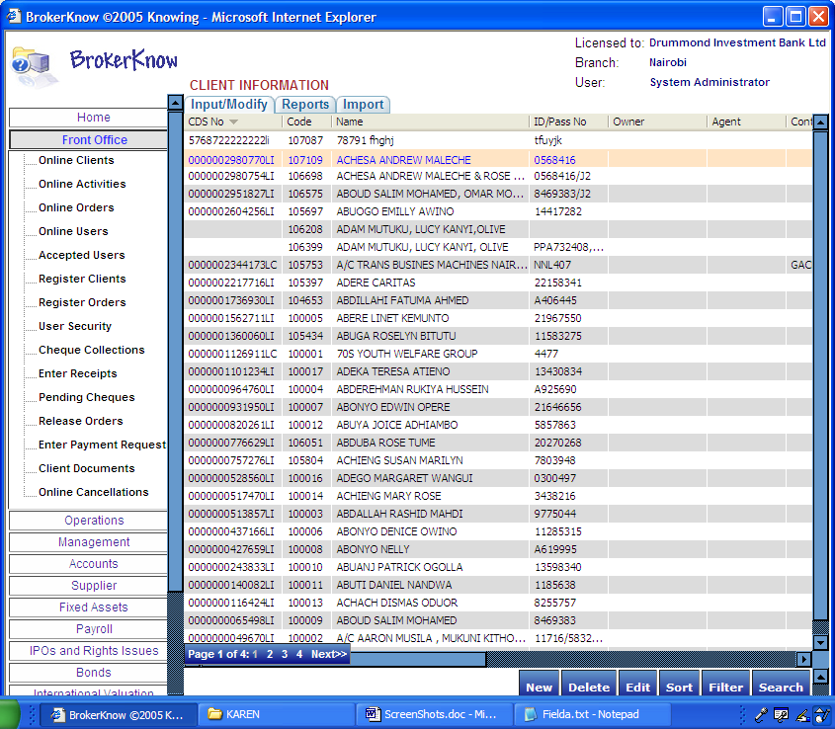

- Click Delete
A delete confirmation message will appear

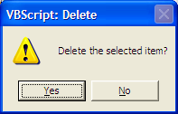

- Confirm Deletion by clicking Yes else Click No
The selected client will be deleted from your list of clients.

To Edit

- Select the client that you want to Edit

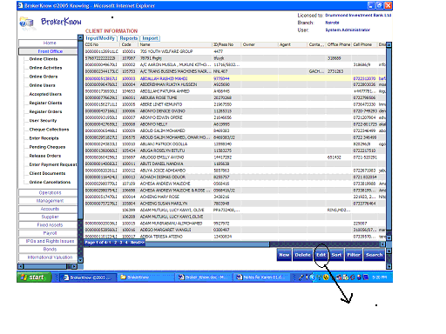
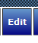

The selected client’s details appear on the ‘Edit Client Information’ dialog box

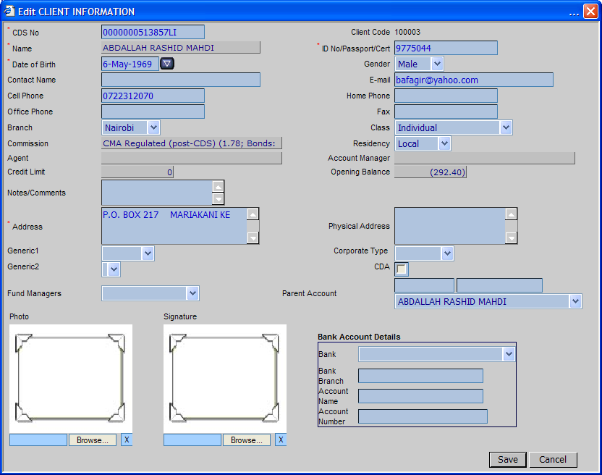

- Edit the information required and click on Save to save the changes
- To discontinue from saving the changes click on Cancel

To Sort

- Click Sort
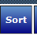
- Specify the criteria for the sort in the Sort web page dialog
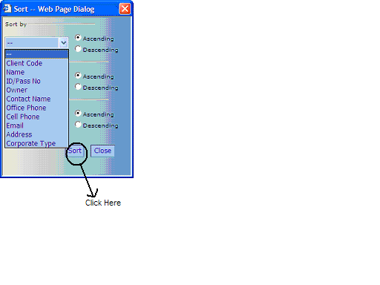

- Click Sort on the web page dialog

BrokerKnow allows you to sort Clients by the fields shown above.

To Filter

- Click Filter
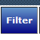
- Select the field by which you want to filter in the filter by field.

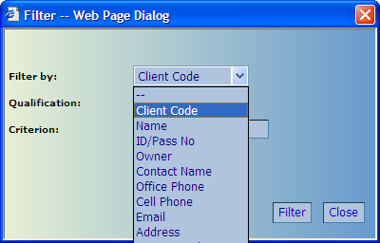

BrokerKnow allows you to filter by the fields shown above. Other additional fields by which you can filter are:

Corporate type
Opening Balance
Agent Name
Agent Code
CDS Number

- Enter the qualification and the criterion
- Click Filter

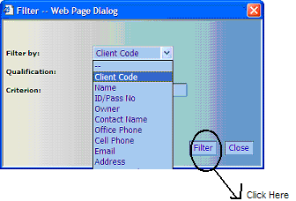

Notes

The CDS number of the client should be unique, 15 characters long (1st 13 being numeric and the last two being alphabetic)

Where the client has multiple accounts on the CDS file, the same accounts should reflect on BrokerKnow

Note: The mandatory fields will be marked with stars. In this case they will be the CDS Number, Last Name, Other Names, Date of Birth, Address, ID Number/Passport/Certificate

The mandatory fields will differ with the type of client being registered. Below are discussed the type of each client and the fields that are mandatory for each of them.

Individual clients - These are clients who trade on behalf of themselves. I.e. No second party trades on their behalf.
We must have the CDS Number, Last Name, Other Names, Date of Birth, Address and ID or Passport Number.

Joint Clients – These are clients who trade in shares under a joint account. The names of both the joint account holders should appear separated by AND.
The CDS Number, Last Names, Other Names, Date of Birth, Address (One address for the joint account) and ID Number or Passport numbers are a must have

Corporate Clients – Refers to corporate bodies. These are companies that have been registered under the corporate act.
The CDS Number, Last Name, Other Names, Date of Incorporation, Address and Certificate of incorporation number will be mandatory.

Institution – Refer to any other big company that does not fall under corporate.
CDS Number, Last Name, Other Names, Date of establishment, Address and a number that uniquely identifies them if they do not have a Certificate number.

For corporate bodies and institutions, a contact name will be required.

If a client is marked as CDA it means that the client will only be charged broker commission and non- CDS levy charges, as these clients do not settle through the broker.

BrokerKnow provides an added client verification procedure where the signature or the photo of a client can be uploaded.

Notice that when registering a client in the Front Office and Operation menus, there are some fields that are inactive. These fields can only be viewed by the users of these menus but cannot be modified. These fields are:
Commission
Agent
Credit Limit
Opening Balance and
Account Manager

The fields mentioned above can only be viewed and modified by the user of the Management menu.
Refer to the document Management Tasks

After a client has been registered, then his/her order can be created on the system.

Registering an Order

- Under Front Office go to Register Orders
- To add a new order click New

The system prompts you to enter the client code
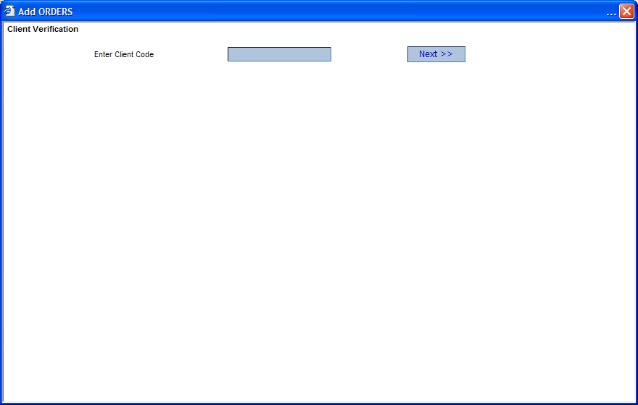

- Enter the client’s code for which you are creating an order and click Next
The system prompts you again to verify client information
- Enter the ID number or passport number or certificate number of the client and click Next

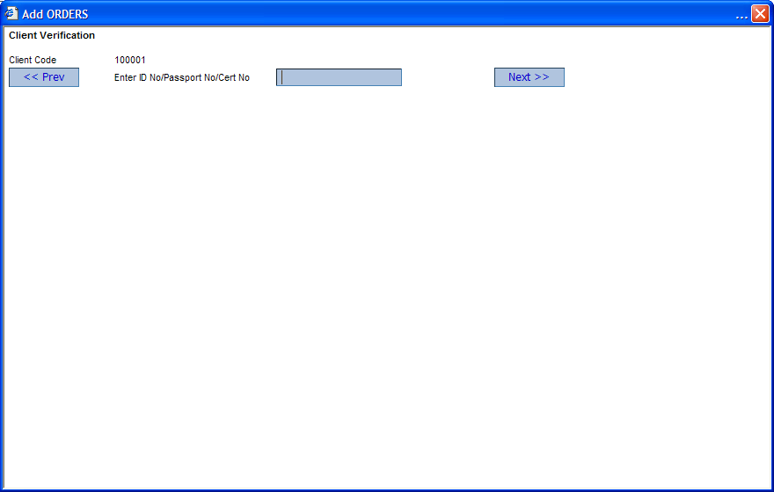

The system will once again prompt you to enter the client’s CDS account
- Enter the CDS number and click Next

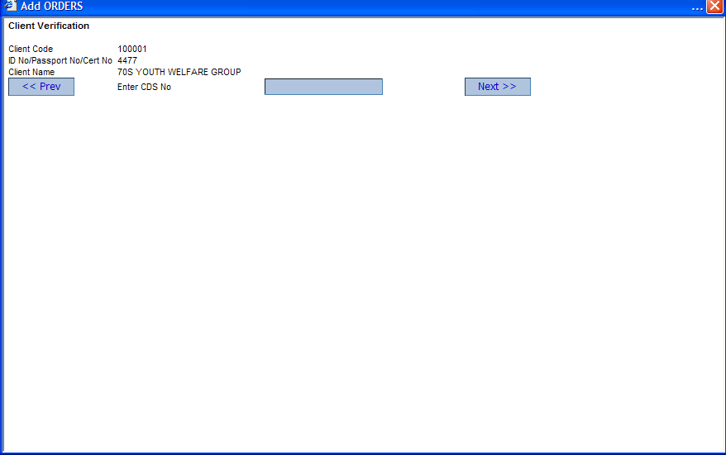

The Client verification process is now complete and you can provide the details of the new order in the Add Orders dialog box.

Branch – The branch of the brokerage firm
Date – The date that the order is being made
Order Type – Specifies whether the order is a Purchase or Sale
Security type – Whether it’s a normal security or a fixed security
Hold – Indicates the held state of the order. An order that has been held is one that has not yet been released for trading.
Held Date – The date on which the order is held
Compound –Whether the order should be compounded. Compounding an order means that many orders are amalgamated to one at the end of the day.
Inter Bank – Whether it is an inter-bank transaction. Inter-bank allows for payment when payment is not made through the broker.
Client – The client who is making the order
Current Balance – The client’s current balance as shown on the client’s statement
Available credit – The amount of money that the client can spend (Balance on the Statement – (minus) Amount for Outstanding Orders)
Account Manager – An employee of the brokerage firm who is responsible for bringing clients for a fee.
Agent – The client’s agent who actually carries out transaction on behalf of the client.
(In some instances the above 4: agent, account manager, available credit and current balance will be inactive)
Contact Name – The person to be contacted as regards any correspondence regarding the order being made
Ref Number - The reference number of the order
To Pay – A checkbox indicating the status of payment. i.e. that the payment should be made when the order is executed.
Fund Manager – The client’s fund manager
Remarks/Comments – Any comments regarding this order
Security – The specific security for which the order is being made
Current – will show the current balance of the specific security
Available – Will show the available amount of the selected security
(The above two fields will normally be inactive)
Quantity – The number of shares being applied for
Price – The price that the shares are being offered for
Amount – The total amount to be paid
Validity – The amount of time given before the order expires.

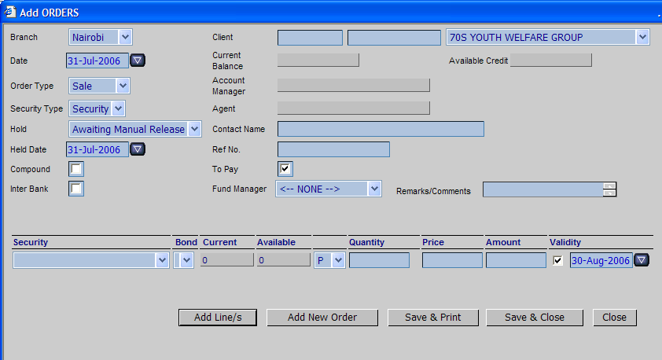

Click Save & Close or any of the other options that appear in the command buttons

Add line(s) – Adds a new line (If you want to make a new order item)
Add New Order – Is for simply adding a new order
Save and Print – Will save the order the print it
Close – Will close the add orders dialog box

Modifying an Existing Order

To Delete

- Select the order that you want to delete
- Click Delete

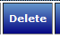

A delete confirmation message appears

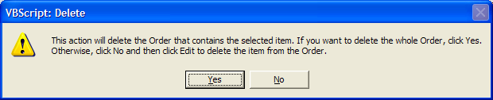

- Confirm deletion by clicking Yes
The selected order will be deleted.
- However, if you want to delete a specific item of the order, confirm deletion by clicking No
- Then, for the order you selected click Edit
- Select the specific item that you want to delete and click Delete
The specific item of the order will be deleted

To Edit

- Select the order that you want to Edit
- Click Edit
The selected order’s details appear on the ‘Edit Order’ dialog box as shown below

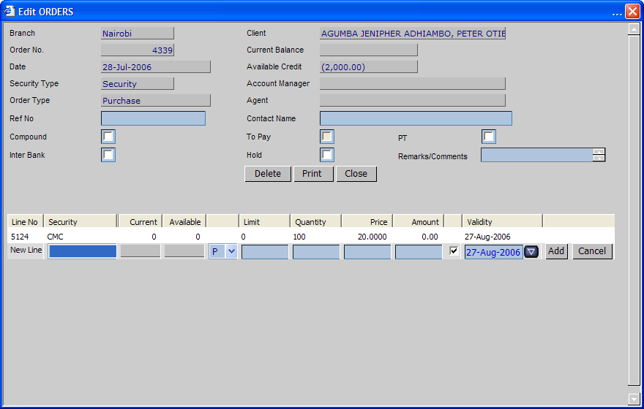

- To Add a new item on the order enter all the details of the new item on the provided line and click Add

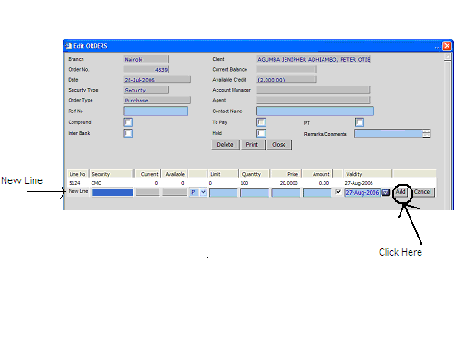

- To discontinue from saving the changes click on Cancel

Print – Opens the purchase order or sales invoice that you want to print
Close – Closes the Edit Orders dialog box

To Sort

- Click Sort

- Specify the field that you want to sort by and the order as either as Ascending or descending

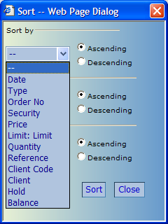

BrokerKnow allows you to sort Order details by the fields shown above
- Click Sort on the sort web page dialog

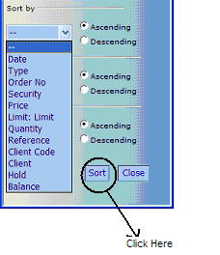

To Filter an Order

- Click Filter

- Select the field by which you want to filter
- Select the qualification and the criterion

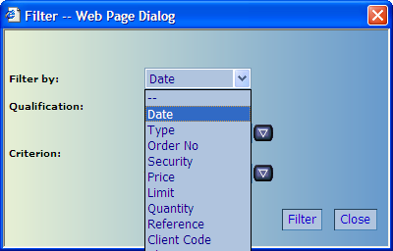

BrokerKnow allows you to filter orders by fields shown above. Additional fields that you can filter by are:

Client
Hold
Date Released
CDS Number and
Balance

4. Click Filter on the Filter web page dialog

After a client has been registered and the client order made, we are now ready to post any receipts from the clients.

Notes

Notice that there are some fields that can only be viewed by the user of the Front Office and Operations menu in registering an order, but are not modifiable by him/her. These fields however can be modified under Register Orders in the Management Menu.

The fields are: Current Balance
Account Manager
Agent and
Available Credit

The procedure of registering Orders on Operations will differ slightly. The registration of an order will be direct as contrasted to the step b y step process of verifying client details in Front office.

Duplicate Orders will not be accepted by the system. A duplicate Order occurs when you try to enter another order for the same security for the same client as an order already existing in the system that is not yet executed.
Refer to Portfolio Valuation Notes section for more information regarding Duplicate Orders.
Posting a Receipt

- On Front Office go to Enter Receipts
- Click New to enter a new receipt

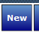

An add receipt information dialog box appears
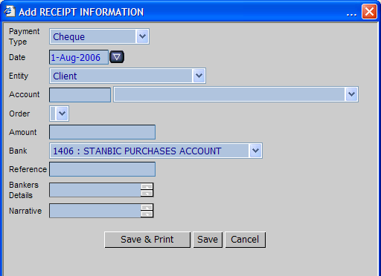

- Fill in all the required details of the new receipt

Payment Type – Is the mode of payment of the receipt e.g. cheque, cash etc
Date – Is the date of receipt
Entity – Is the entity that paying
Account – The account that the receipt is affecting
Order – The order for which payment is being made
Amount – The amount of the receipt
Bank – The payer’s bank
Reference – The receipt reference number
Banker’s Details – Details of the person presenting the cheque to the bank
Narrative – Brief description of the payment

- Click Save to effect the details or Save & Print to print the specific receipt.

Printing a Receipt

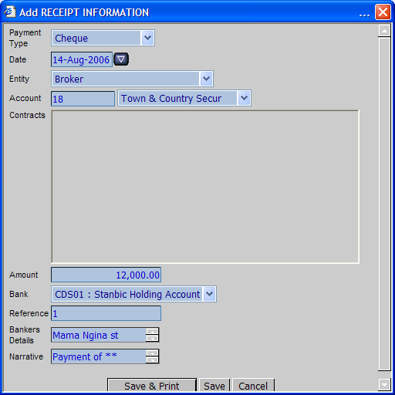

Since we can now register a clients and orders and post client receipts it would be important to be able to deal with the actual trade of the securities. The operations menu will give a clearer view of this.

Operations

Contents

Operations Error: Reference source not found
To Register an Agent Error: Reference source not found
Generating a Schedule 2
Importing Trades 3
Dealing with Unmatched Trades 6
Commit Trades 7
Generating Client Contract 8
Compounding an Order 11
Generating a Compounded Client Contract 13
Generating an Agent Contract 15
Generating an Agent Compounded Contract 16

The Operations menu provides a menu where issues regarding agents, clients and other issues arising from the trade of securities for clients on the system are handled.

To Register an Agent

- On the Operations Menu go to Register Agents
- Click New
An add agent Information dialog box appears. Notice that the Commission field is inactive. Refer to Notes.

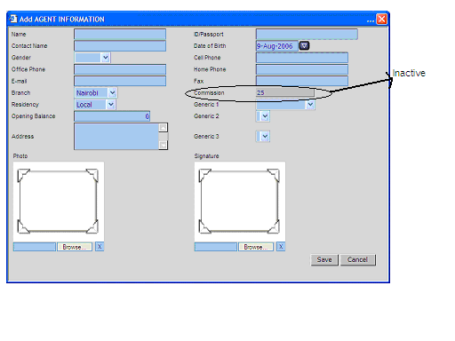

- Enter all the details of the new agent

Name – Is the name of the agent
Contact Name – Is the name of the agent’s correspondent
Gender – Is the gender type of the correspondent
Office Phone – Is the office number of the agent firm
E-mail – Is the electronic mail of the agent
Branch – Refers to the branch of the agency firm
Residency – Refers to the residential information of the agent either as local or Foreign.
Opening Balance – Refers to the agent’s balance as per his statement.
Address – Is the contact information of the agent
ID/Passport – Is the personal identification of the agent
Cell phone – Is the mobile number of the agent
Home Phone – Is the home contact number of the agent
Fax – Is the fax number of the agent
Commission – Is the commission that should be paid to the agent
Generic 1, Generic 2, Generic 3 – Are attributes specified by the company.
Photo – For uploading the agent photo if any
Signature – For uploading the agent’s signature for purposes of identification

- Click Save

Generating a Schedule

The schedule is sometimes referred to as the Order List or Trading Schedule
- Go to Operations Reports
- Click the Orders option that contains order reports.
- Under the Orders reports click Order List
- Select the type of order list that you want to generate as Buy or Sell.

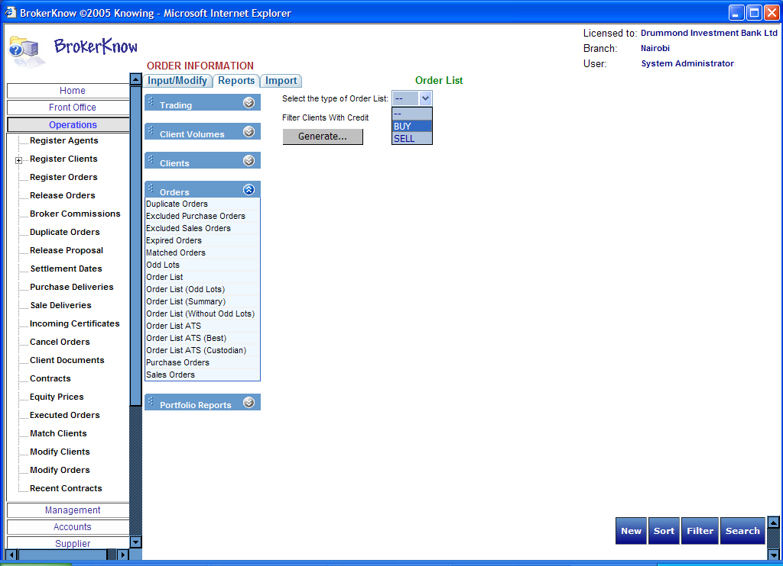

You could filter clients with credit by checking the checkbox
- Click Generate
The report will appear as shown below
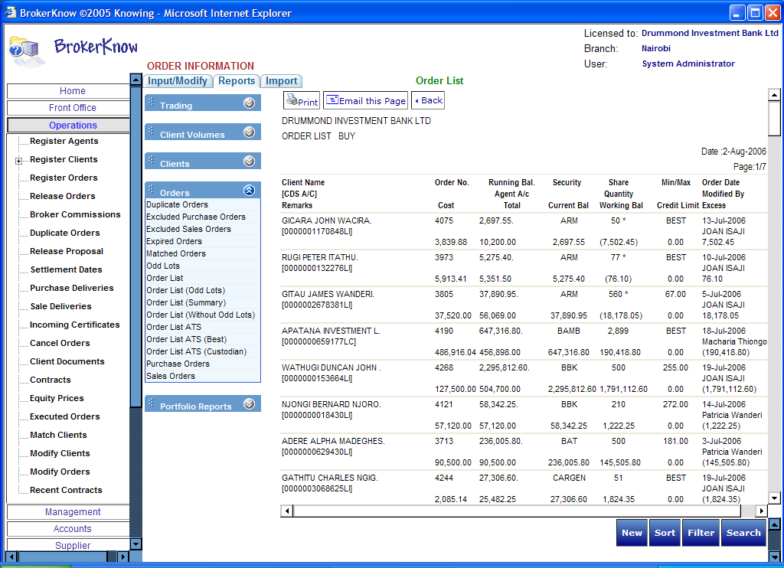

Importing Trades

- Click the Import tab at the top of the web page
- Select Daily Trades
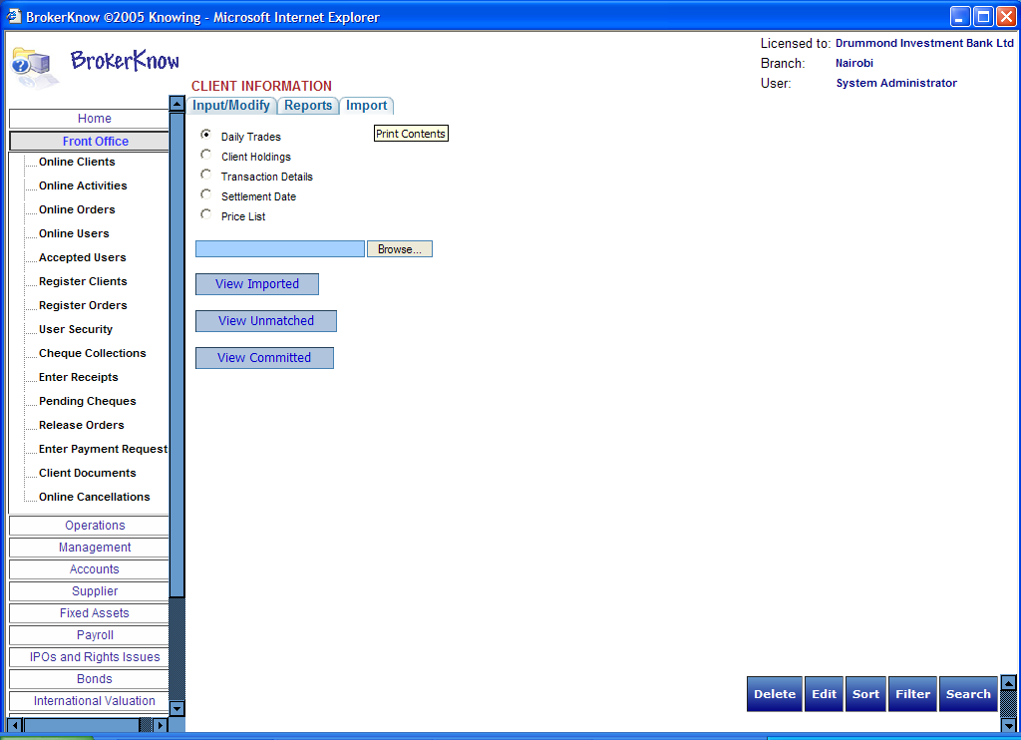

- Click Browse
The browse window appears

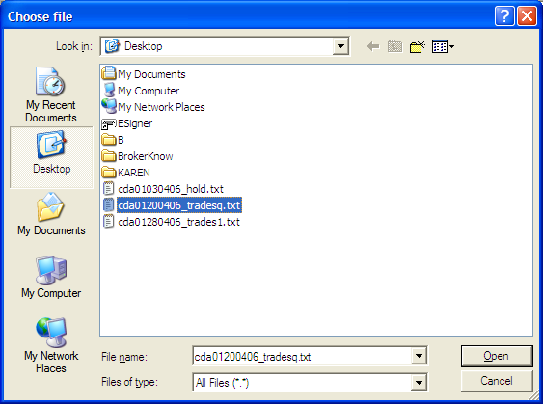

- Select the document/file that you want to import from where it has been saved.
- Click Open
The trades file will be downloaded

Dealing with Unmatched Trades

After the trade of securities on the floor, there might be trades that do not appear on the CDS file (Unmatched trades) but appear on BrokerKnow. Other discrepancies may also exist and this calls for sorting out trades.

To be able to view unmatched trades
- On Operations Reports, select Daily Trades
- Click the View Unmatched Command button

There will be several reasons why the trade is unmatched:

- The order balance is less than or equal to zero
- Trade quantity is greater than order balance
- Invalid client CDS
- Invalid Security Code
- Order Held
- Broker not found

- Consider the reason why the trade is unmatched
- Solve the situations accordingly

Case 1: Order Balance < = 0, means that there is no pending order. i.e. that all orders have been executed.

Solution: Register a new order
Follow the steps for registering an order. Refer to Customer Service>Registering an Order

Case 2: Trade Quantity > Order Balance means that the balance on an order in BrokerKnow is greater than what was traded.

Solution:
Increase the balance on the order to reflect what was traded.

Case 3: means that the client’s CDS cannot be found on the system

Solution:
Register the client on the system or change the client CDS account on the system accordingly.
Follow the steps of registering a client. Customer Service>Registering a Client

Case 4: means that the security code cannot be found on the system i.e. that the security code on the file is different from that in the system.

Solution:
Change the security code on the system accordingly

Case 5: The trade is unmatched because the order is still held.

Solution:
Release the order
  - On Front Office, Operations or Management menus go to Release Orders
Orders that have been held will normally appear on the grid
  - Check the checkbox of the order that you want to release.
The order should no longer appear in the list of held orders.

Case 6: Means that the Broker code on the file cannot be found in BrokerKnow
Solution: Register the Broker

Orders that are to be traded will normally have to be released for trading, a process known as committing trades. Released orders will appear in the trading schedule or the order list.

Commit Trades
- Click the Import tab at the top of the web page
- Select the Daily Trades option button

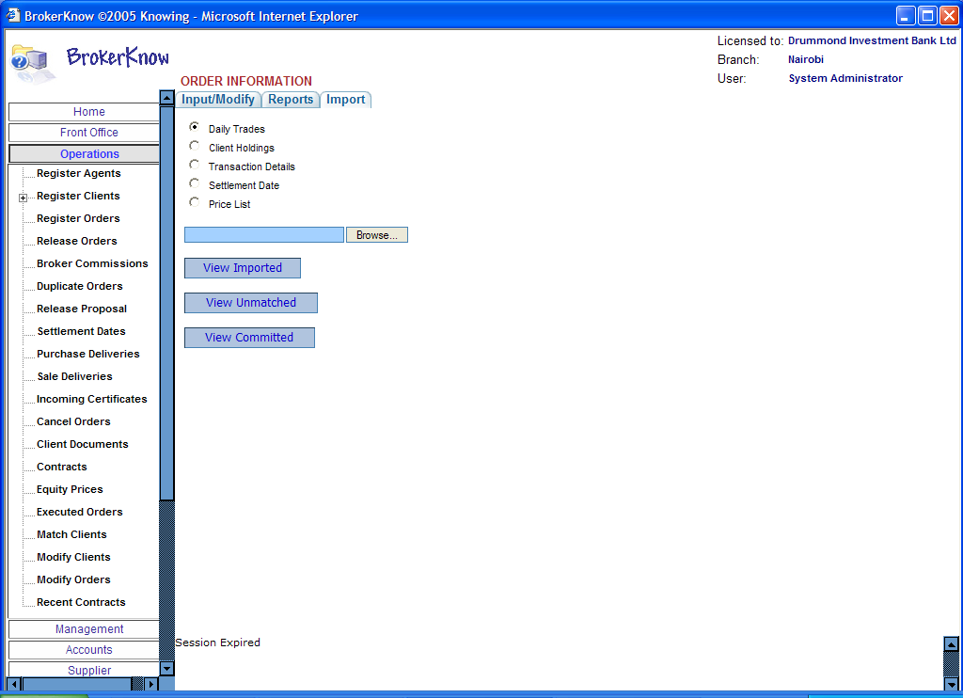

- Click on the View Imported tab

A list of all imported trades will appear

- Click the button on the left of the list
The trades will be committed

After client orders have been traded in accordance with client requests it is important to have a document that indicates the amount that will be debited or credited to the client’s account depending on whether the trade was a purchase or a sale.

The contract will indicate all levies and legal fees chargeable on the client.

Generating Client Contract

- On the Operations Menu click Client Documents
- Select the Generate by Client option

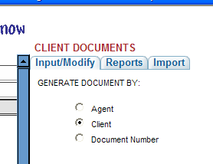

- Specify the client whose contract you want to generate from the drop down list

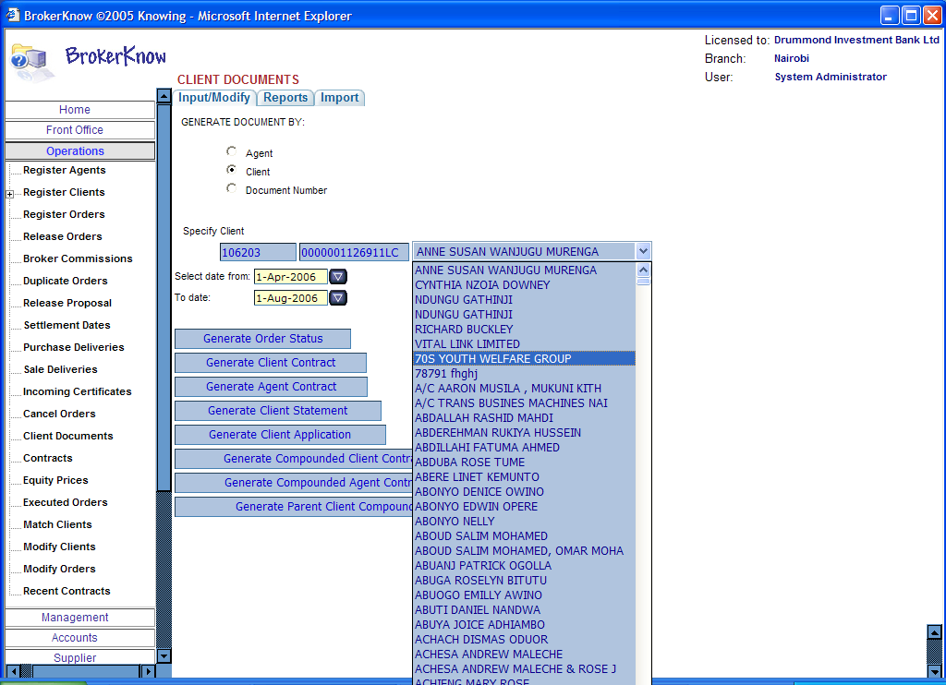

- Specify the period for which you want the client contract
- Click the Generate Client Contract tab

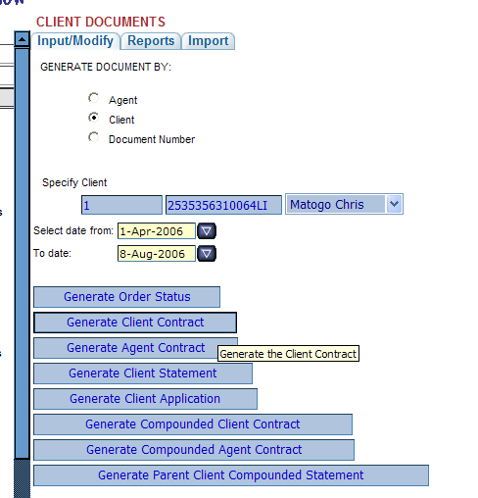

The report is likely to be as shown below containing the details of every contract that was entered to by the client

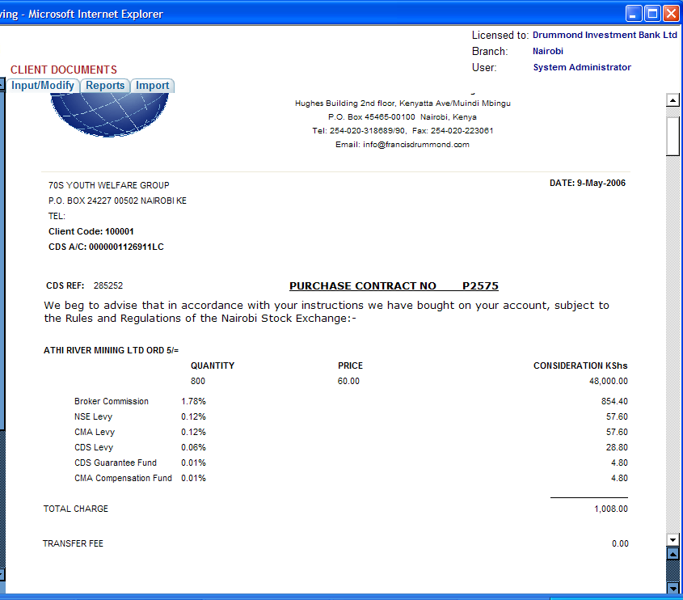

Compounding an Order

If the Order already exists:

- On Front office, Operations or Management menus go to an existing order by clicking Register Orders on any of the above mentioned menus.
- Select the Order that you want to compound
- Click on the Edit command button

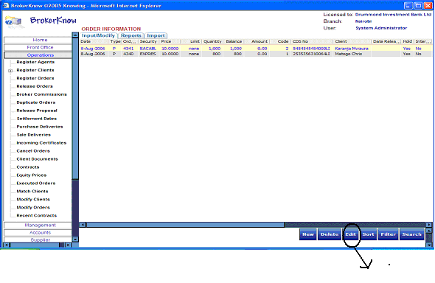

The Edit Order Information dialog appears with the details of the selected order in their respective fields.

- Check the Compound checkbox as shown below.

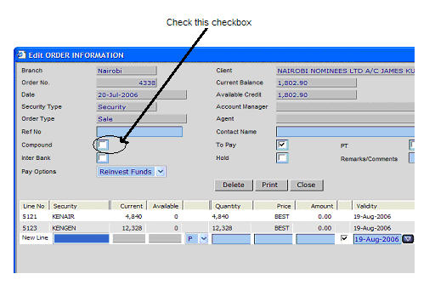

If you want to compound a new Order:

Simply check the Compound checkbox as shown above to compound the order that you are adding. Refer to Customer Service > Registering an Order

Generating a Compounded Client Contract

- On the Front Office or Operations Menus click Client Documents
- Select the Generate by Client option
- Specify the client whose compounded contract you want to generate from the drop down list
- Specify the period for which you want the compounded client contract
- Click the Generate Compounded Client Contract tab

The steps have been shown in the diagram below.
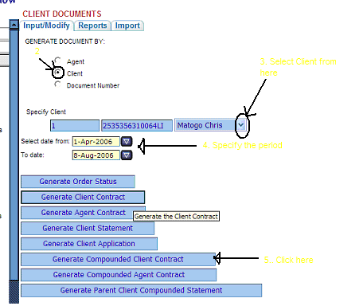

Generating an Agent Contract

- On the Front Office or Operations Menu click Client Documents
- Select the Generate by Agent option
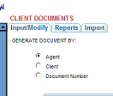
- Specify the agent whose contract you want to generate from the drop down list

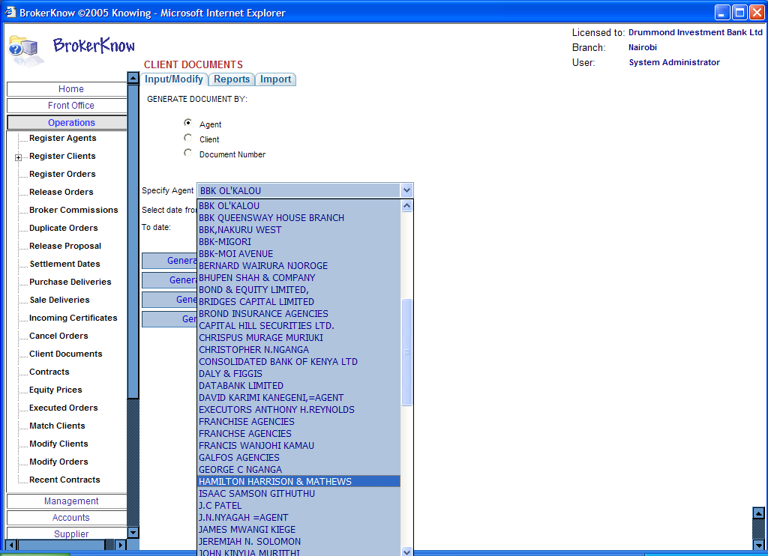

- Specify the period for which you want the agent contract
- Click the Generate Agent Contract tab

Generating an Agent Compounded Contract

- On the Operations Menu click Client Documents
- Select the Generate by Agent option

- Specify the agent whose compounded contract you want to generate from the drop down list
- Specify the period for which you want the compounded agent contract

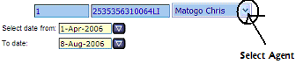

- Click the Generate Compounded Agent Contract tab

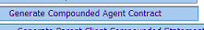

Notes

When registering an Agent under the Operations menu, notice that the commission field is inactive. The user can only view the information of this field but the information cannot be modified by him.
Compare this to Registration of an agent under the Management menu.

Refer to Management Tasks-Notes section for more information regarding this field.

The trading schedule or Order List specifies all the orders, their quantities and their types as either purchase or sale orders and is what is used to trade shares on the floor.

The Management Menu

Contents

The Management Menu 0
Assigning an Agent to a Client 1
Registering Agents 3
Notes 4

The access rights in the management menu are slightly different from those of the Front Office and Operations Menus to for purposes of ensuring validity, security and accuracy of information.

Refer to notes for more information.

Assigning an Agent to a Client

- Under the Management Menu go to Register Clients
- Click on New if you are registering a new client with an agent or Edit if you want to register an existing client under an agent.
- Enter the client details (this includes the client’s agent which you will select from a drop down list of existing agents)

Notice now that the Commission, agent, Credit Limit, Account Manager and Opening Balance fields are activated.

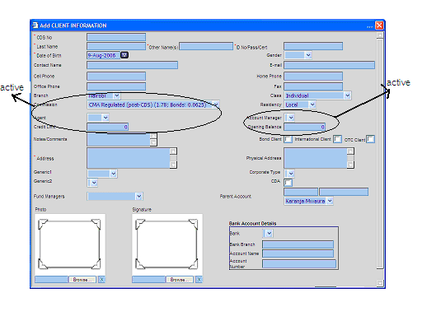

Commission – Specifies the commission chargeable to the Client
Agent – The client’s agent if the client is being registered under the agent.
Credit Limit – The amount that the client can readily spend (Amount on Statement – Amount for pending orders)

Registering Agents

- Go to Management > Register Agents
- Click New
An add agent information dialog box appears.
- Enter all the agent’s information
(All fields have already been discussed in Operations under Registering Agents)
Notice that the commission field is now active.
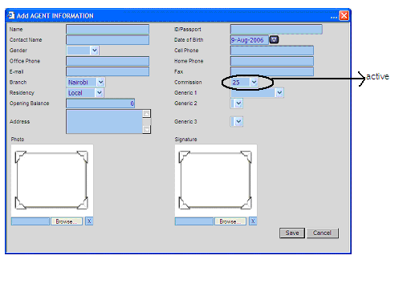

Receipts from the different entities e.g. clients will be captured by entering the details of the receipt in to the system. It is important to be able to manage such information and any other information regarding finances. BrokerKnow provides an accounts menu which is what we discuss next.

Notes

When registering a client under the Front Office and the Operation menus you noticed that the user was not able to Assign and agent to a client because the field there is inactive. Such assignment is made possible in the management menu.
(Compare client registration in Front Office and Operations to Client registration in Management.)

Apart from being able to assign an agent to a client in registering clients under the management menu, notice also that the user can modify Commission, agent, Credit Limit, Account Manager and Opening Balance fields’ information. This was not possible in registering a client under the Front Office and Operations menus.

Compare the registration of agent in Operations to the registration of agents in Management. Notice that the commission field in registering agents under the Management menu is active meaning that the user can modify the details of this field, by specifying the amount of commission payable to the agent. In Operations, the same field is inactive meaning that the user can only view the details of that field.

Accounts

Contents

Accounts 0
To Post a Payment 1
To Enter a Journal 2
To Delete a Journal Entry 4
Committing Journals 6
To Release Journals 7
Generating a P&L 8
Generating a Balance Sheet 8
Generating the Trial Balance Report 9
Creating a new account 10
To Edit 11
To Sort 12
To Filter 12
Generating an account history 13
Bank Reconciliation 13
Reconciling a bank account 13
Reconciling the CDS Bank Account 14
Generating the Reconciliation Statement 15
Generating the Cleared Effects Statement 16
Generating the Un-cleared Effects Statement 16
Notes 17
Posting of receipts has already been discussed under Customer Service

Payments to an entity will be captured by entering the details of the payment in to the system.

To Post a Payment

- Under the Accounts Menu go to Enter Payments
- Click on New
An add payments dialog box appears

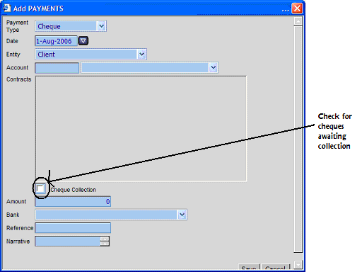

- Enter all the details of the new payment as required
- Click on Save
Payment Type – The mode of payment
Date – The date of the payment
Entity – The entity making the payment
Account - The account that the payment is affecting
Contracts – Shows all the contracts that the selected entity has entered into
Cheque Collection – The status of the payment-the check box will be checked if the cheque for example is awaiting collection.
Amount – The amount that is being paid
Bank – The bank making the payment
Reference – The reference detail of the payment
Narrative – A brief description of the payment

The payment posted will appear as the first item on the list after you click the save button.

Payments and Receipts will normally have to be posted to the journals recording the nominal accounts affected by the different transactions

To Enter a Journal

- Under the accounts menu go to Enter Journals
- Click New

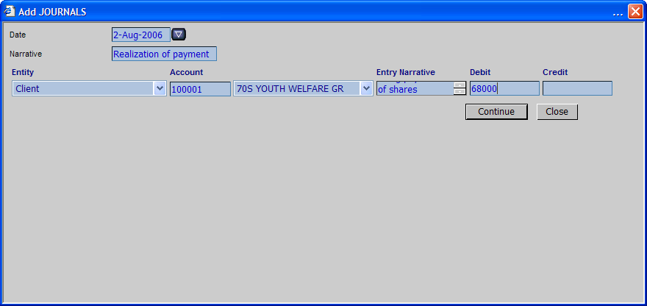

- Enter the field information as required

Date – The date when the journal entry is being made
Narrative – A brief description of the whole journal
Entity – The entity that the journal entry is affecting
Account – The account that is being affected by the journal entry
Entry Narrative – A brief description explaining the journal entry
Debit – The debiting figure
Credit – The crediting figure

Journals are posted using double entry thus clicking Continue opens the other account
- Click on Add Line/s command button

Notice that the journal will now have a new line where you can enter the details of the double entry.

- Enter the details of the other entry as shown below

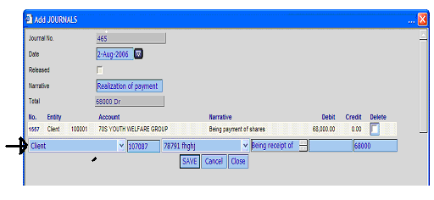

- Click Save
The journal entry you have just made will be saved and the journal will appear as shown below

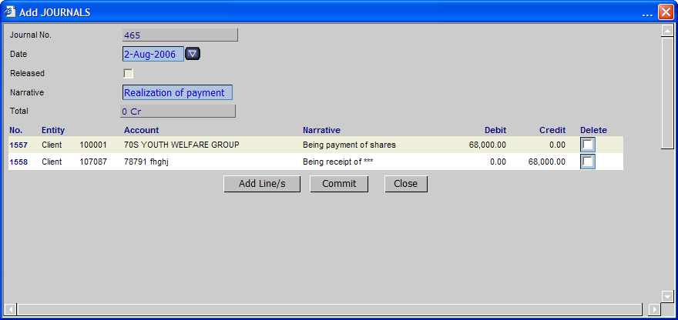

Notice that if the 1st journal entry affects more than one account you can make the rest of the entries by Clicking on the Add Lines/s command button

To Delete a Journal Entry

- Select the journal entry that you want to delete
- Check the Delete checkbox
The selected journal entry will be deleted.
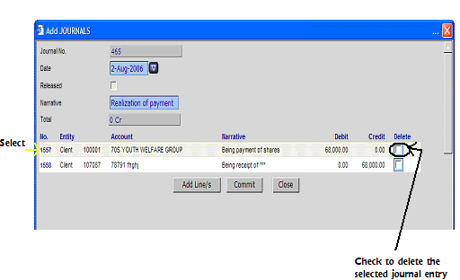

Committing Journals

After the double entry process has been completed as shown above the journals can then be committed.

Click the Commit command button

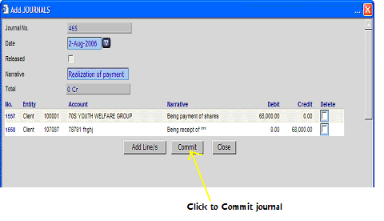

Committed journals should now appear in the Release Journals Interface
Under the Accounts Menu go to Release journals and check for the journal you have just posted.

To Release Journals

- On the Accounts Menu go to Release Journals

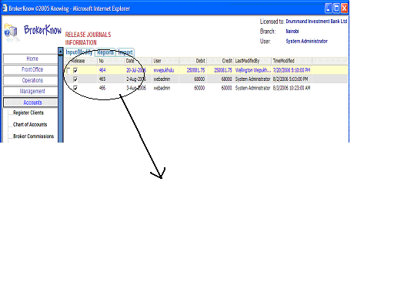
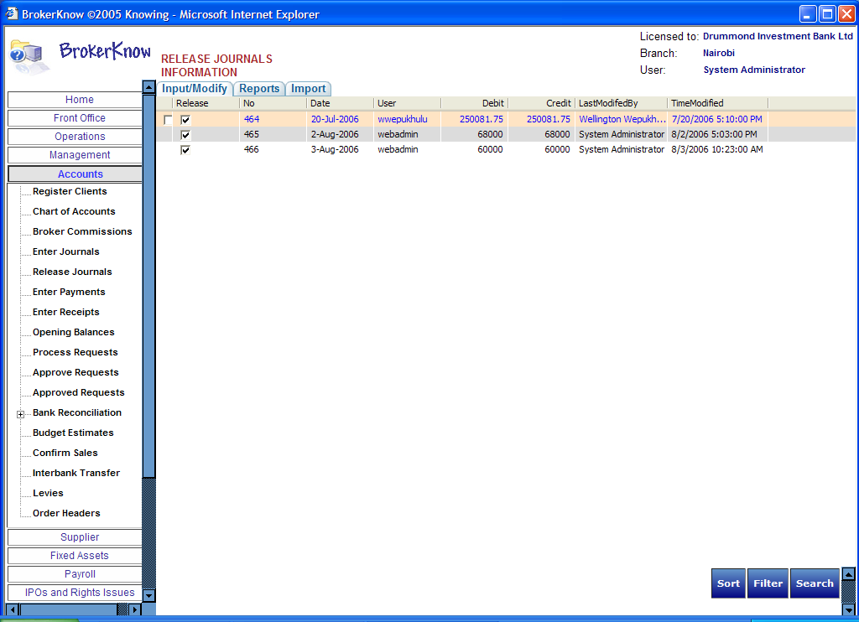

- Check the Check box that appears on the left side of the journal entries
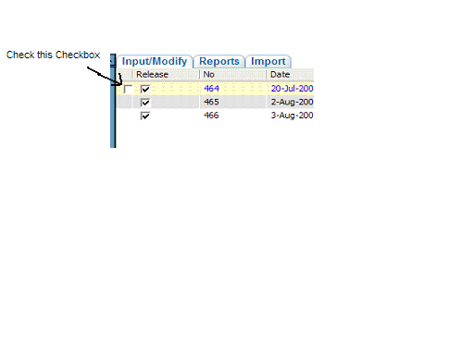

After being able to manage all accounts it should be possible to be able to produce statements that show the financial position of the company. BrokerKnow will be able to generate your profit and loss and balance sheet statements on a click of a button!

A profit and loss statement will be generated for the period ending on the specified date.

Generating a P&L

- Under management reports, choose the Accounting reports
- Click on Profit and Loss
- Specify the period for which you want the profit and loss statement using the From and To fields
- Click Generate
The profit and loss statement will be generated

OR

- Go to Accounts Reports
- Expand the view for Accounts or General Ledger
- Click on Profit and Loss and follow steps 3 and 4 of the previous procedure.

Generating a Balance Sheet

A Balance sheet will show all the balances of assets and liabilities as at a certain date.

- Under management reports, choose the Accounting reports
- Click on Balance Sheet
- Specify the date for which you want the balance sheet.
- Click Generate

OR

- Go to Accounts Reports
- Expand the view for Accounts
- Click on Balance Sheet and follow steps 3 and 4 of the previous procedure.

Generating the Trial Balance Report

A trial balance will simply be a list of all nominal accounts that appear on the balance sheet and profit and loss statement.

- Under Accounts Reports go to the General Ledger option
- Click Trial Balance
- Specify the period for which you want the trial balance
- Click Generate

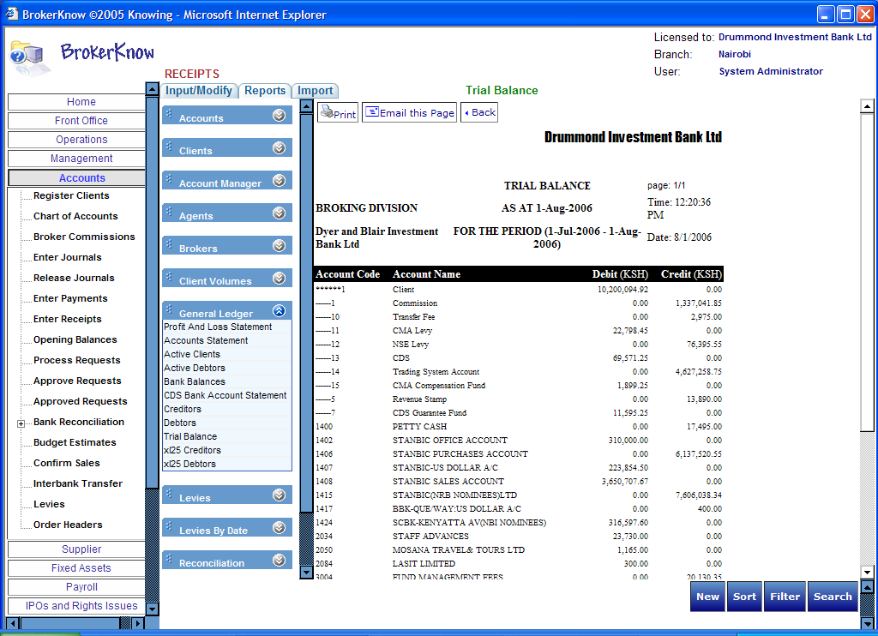

Creating a new account

The chart of accounts maintains all the accounts that exist in the company.
To create a new account
- Go to the Accounts Menu
- Click on Chart of Accounts
- Click on the New Command button
An Add Chart of Accounts dialog box appears

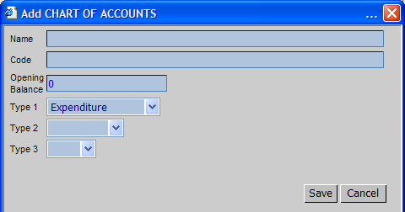

- Enter all the details required in the dialog box

Name – The name of the account
Code – The account code
Opening Balance – The starting amount of the new account
Type – The account type

- Click Save
Cancel cancels the changes

To Edit

- Select the Account that you want to edit
- Click Edit
An Edit chart o f accounts dialog appears with the details of the account you selected

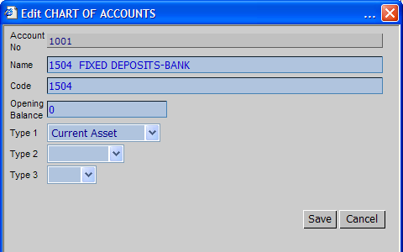

- Edit the information as required and Click Save
Note that the account number of the account cannot be changed

To Sort

- Click Sort and enter the criteria for the sort in the sort web page dialog
BrokerKnow allows you to sort the chart of accounts by

Account Number
Account Name
Account Code
Account Type1

- Click Sort again on the web page dialog
- Cancel Sort to return to the initial view before the sort

To Filter

- Click Filter
A filter web page dialog appears
- Enter the criteria for the filter
BrokerKnow allows you to filter the chart of accounts by
Account Number
Account Name
Account Code
Account Type1

- Click Filter again on the web page dialog
- Click Cancel Filter to return to the original view before the filter

Generating an account history

- Under the Accounts Reports click the Accounts tab
- Select History under the list of reports in accounts
- Click the Generate command button

Bank Reconciliation

Under the Accounts menu go to Bank Reconciliation

Reconciling a bank account
- Select the entry that you want to reconcile
- Click Edit
An Edit Reconciliation Information dialog box appears

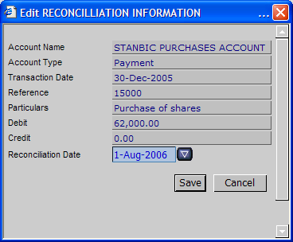

Reconciliation will normally be done by checking the entries in BrokerKnow against the entries in the Bank Statement.

- Check the date that appears on the item you want to reconcile on the system against the date appearing for the same transaction on the Bank Statement.
- Reconcile the date on the system accordingly.
- Click Save

Reconciling the CDS Bank Account

Use this sub-interface to reconcile CDS bank accounts specifically
Follow steps 1-5 of reconciling normal bank accounts
Generating Reconciliation Reports

Open Accounts Reports and go to the Reconciliation Reports

Generating the Reconciliation Statement

- Click Reconciliation Statement
- Specify the account for which you want the reconciliation statement and the date
- Click Generate

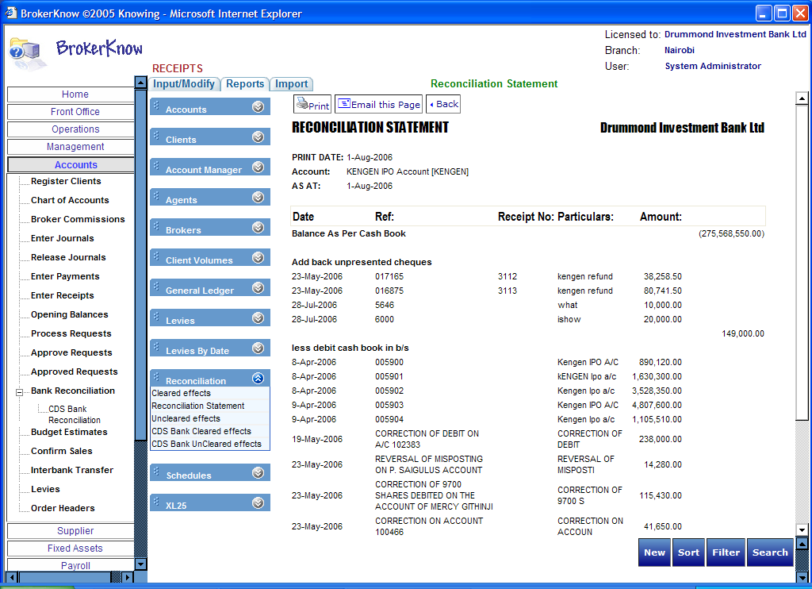

Generating the Cleared Effects Statement

The cleared effects statement generates a report of all items that have been reconciled.

- Click on Cleared effects
- Select the account for which you want to view the reconciled items
- Click Generate
For CDS Bank Cleared effects, simply click on CDS Bank cleared effects, specify the date and click Generate

Generating the Un-cleared Effects Statement

The cleared effects statement generates a report of all items that have not been reconciled.

- Click on Un-cleared effects
- Select the account for which you want to view the un-reconciled items
- Select the date as of which you want to view the un-reconciled item(s)
- Click Generate

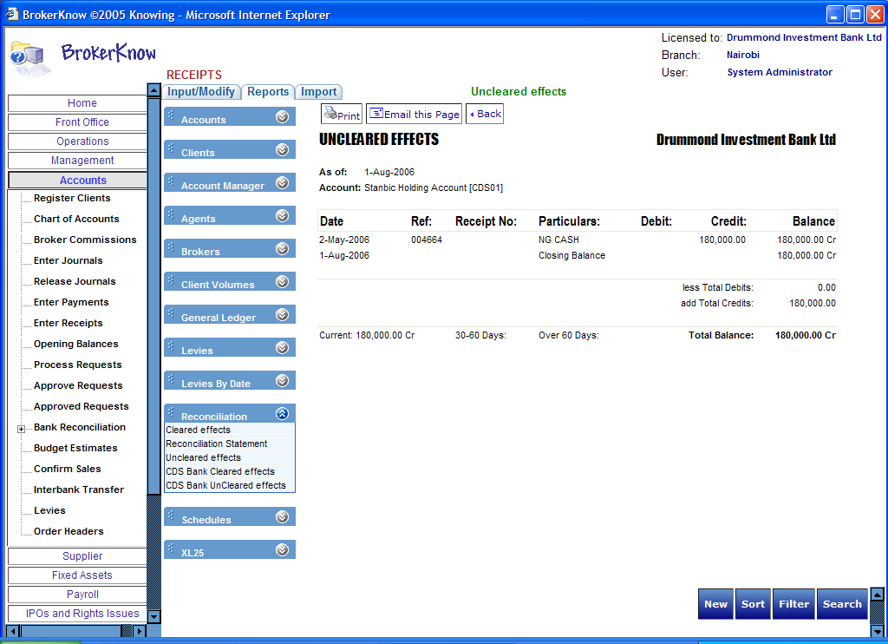

Notes

Posting Payments

All payments due for collection will also appear under the Front Office Menu -pending cheques. This are cheques which when posting was being done the Cheque Collection cheque box was checked.

Releasing Journals

Once the journals have been committed, they will not appear on the client statements until they have been released.
For control purposes BrokerKnow provides a separate interface where journals are released.

Bank Reconciliation
You will have noticed that on the Bank Reconciliation interface you are not able to Add New.
Whenever you post a receipt, payment, journal etc, such transactions are posted directly to the Bank Reconciliation Interface.
This interface therefore, is only used to reconcile bank accounts.

Portfolio Valuation

Contents

Under Operations Reports go to Portfolio Reports

This section starts with the description of how to modify Opening Balances. Refer to notes to understand where Opening Balances are effected on the system.

Modifying Opening Balances

To Edit

- Under the Accounts menu go to Opening Balances
- Select the entity’s opening balance that you want to edit
An Edit Opening Balances dialog box appears

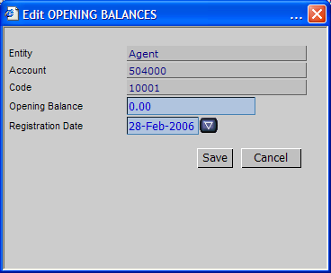

- Edit the information as required
Registration date refers to the date that the entity was registered
- Click Save
The Opening Balance relating to the entity will be saved.

To Sort

- Click Sort and enter the criteria for the sort in the sort web page dialog

BrokerKnow allows you to sort the Opening Balances by:
Entity
Account
Code
Opening Balance
Registration Date

- Click Sort again on the web page dialog
- Cancel Sort to return to the initial view before the sort

To Filter

- Click Filter

A filter web page dialog appears
2. Enter the criteria for the filter
BrokerKnow allows you to filter Opening Balances by:
Entity
Account
Code
Opening Balance
Registration Date

3. Click Filter again on the web page dialog
4. Click Cancel Filter to return to the original view before the filter

Notes

Opening Balances will normally be input when the entity is being registered e.g. An Opening Balance of an agent will be input when registering an agent. This however, will only be possible when using the management menu to register an agent.

The Name, account and code of the entity cannot be changed when editing Opening balances.

Portfolio Reports

In Operations Reports go to Portfolio Reports

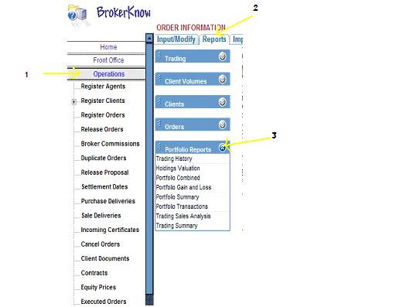

The Trading History

Trading History – Generates a report showing all the securities that the selected client has traded in within the specified period of time.

- Click Trading History
- Specify the client whose trading history you want and the time period for which you want the trading history as shown below

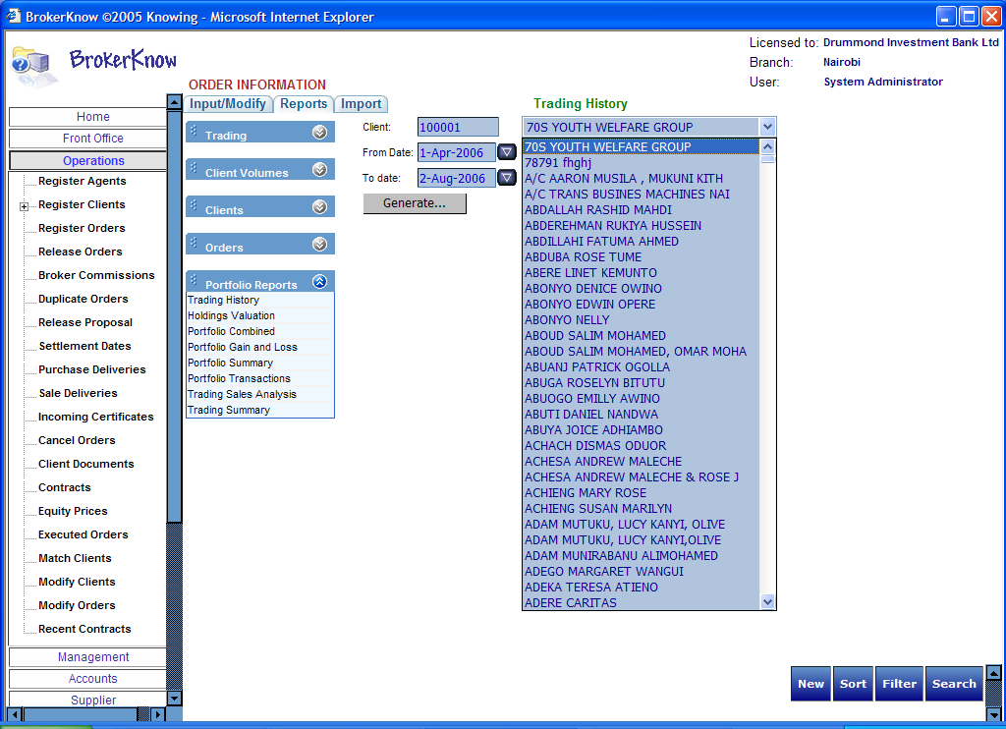

- Click Generate
The report will appear as shown below

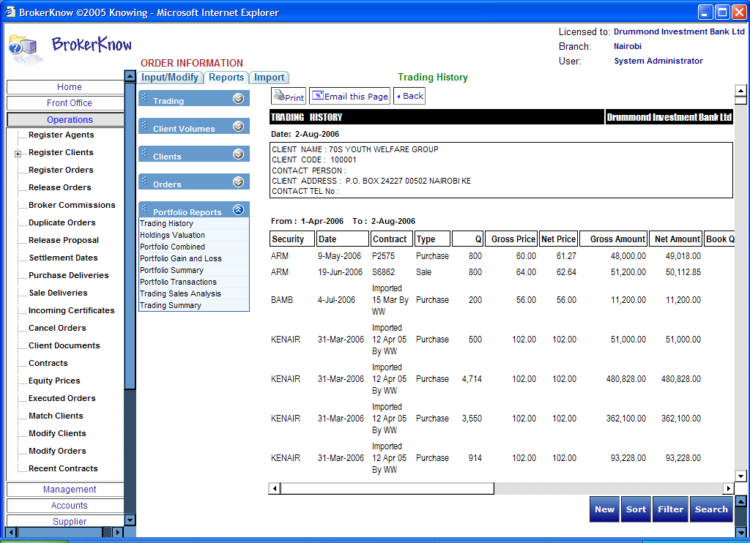

Generating the Holdings Valuation Report

1. Click Holdings Valuation
2. Select the client whose holdings you want to view
3. Select the time period for which you want the holdings valuation.
4. Click Generate

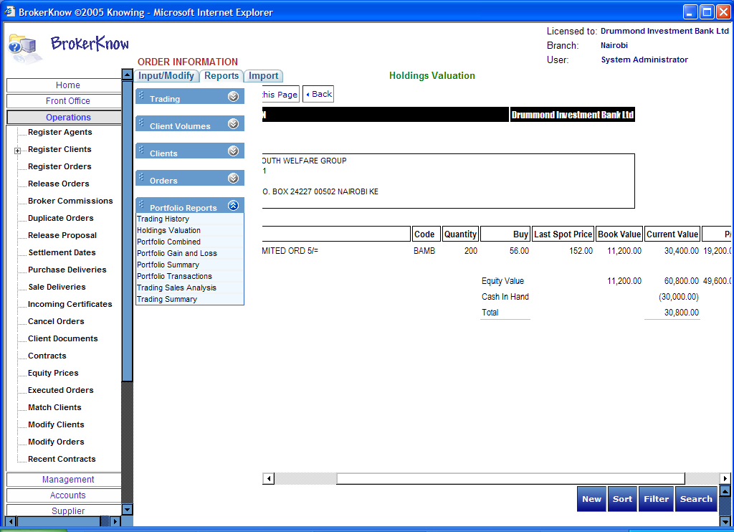

Portfolio Gain and Loss

1. Click Portfolio gain and Loss
2. Specify the security for which you want the portfolio gain and loss
3. Select the time period
4. Click Generate

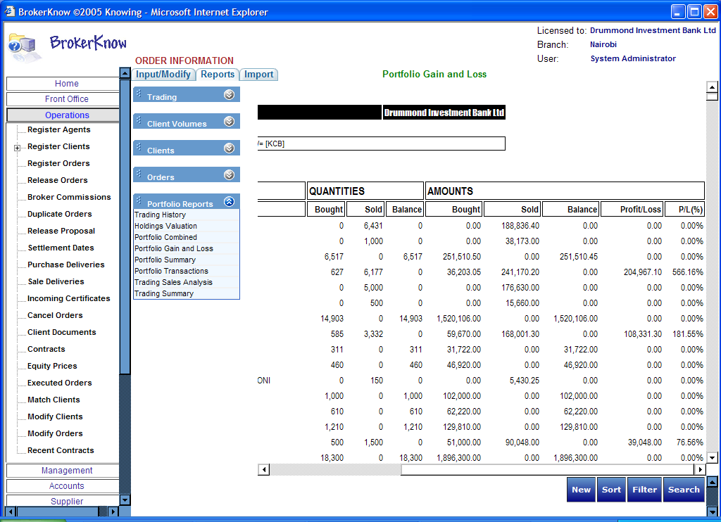

Portfolio Summary

1. Under Portfolio reports, Click Portfolio Summary
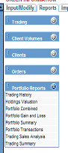

2. Specify the client for which you want the portfolio summary
3. Specify the date
4. Click Generate

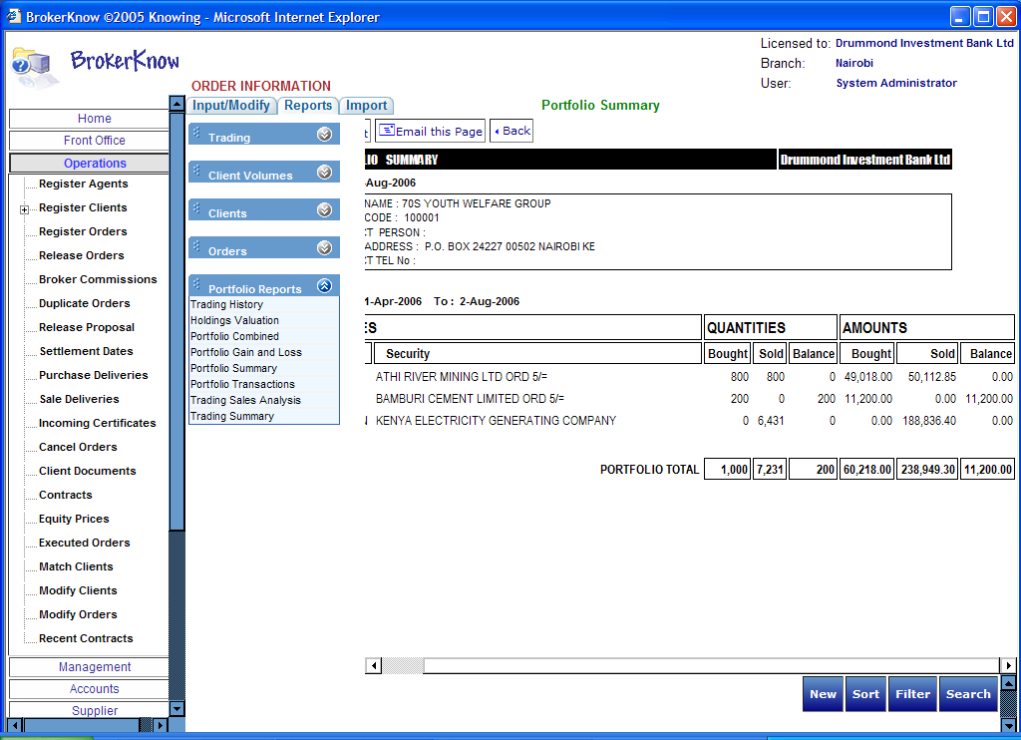

Portfolio Transactions
1. Click Portfolio Transactions
2. Specify the client whose portfolio you want to generate
3. Specify the date
4. Click Generate

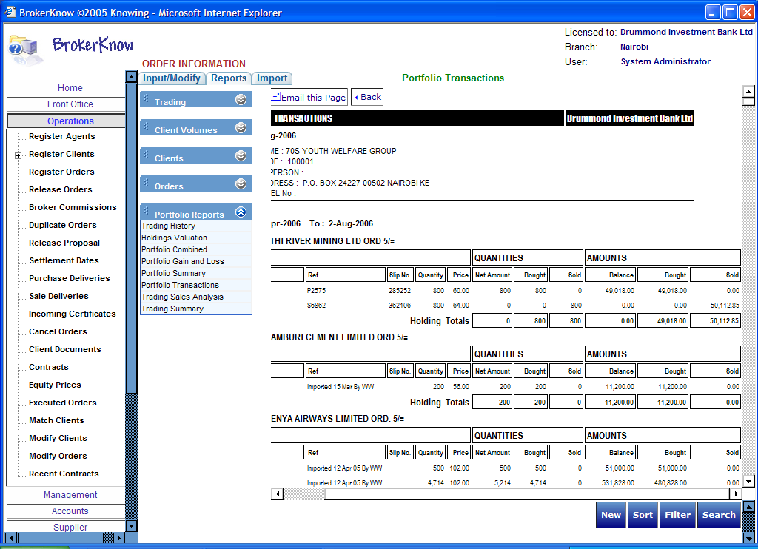

Trading Sales Analysis

1. Click Trading Sales Analysis
2. Select the client
3. Specify the time period
4. Click Generate

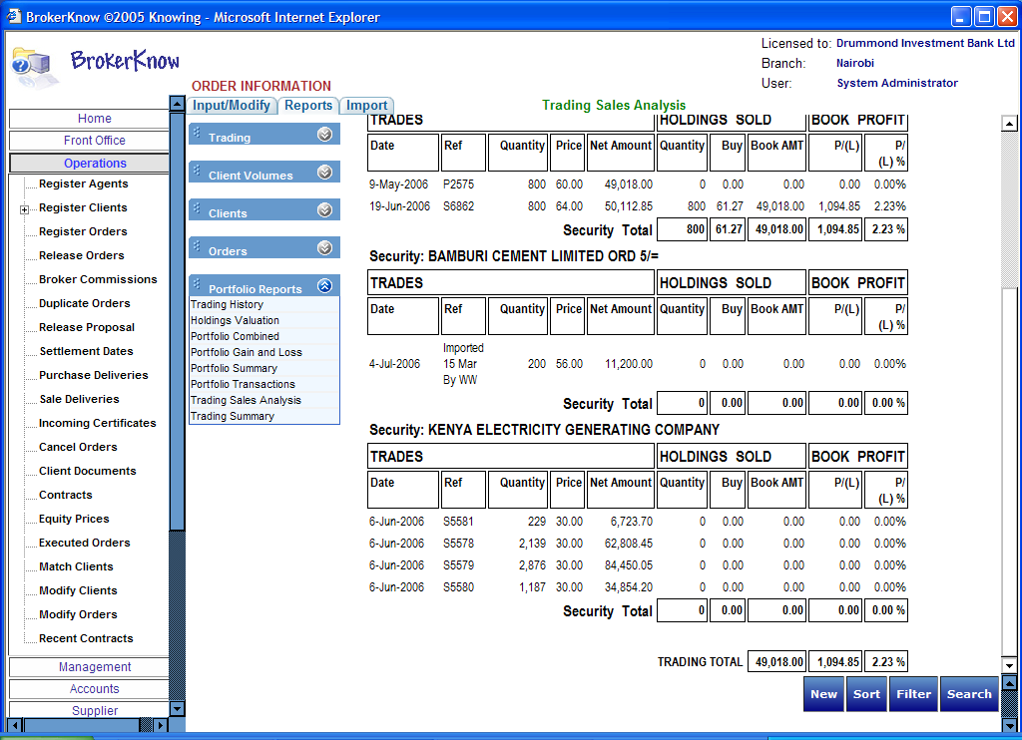

Trading Summary

- Click Trading Summary
- Specify the client
- Specify the time period
- Click Generate

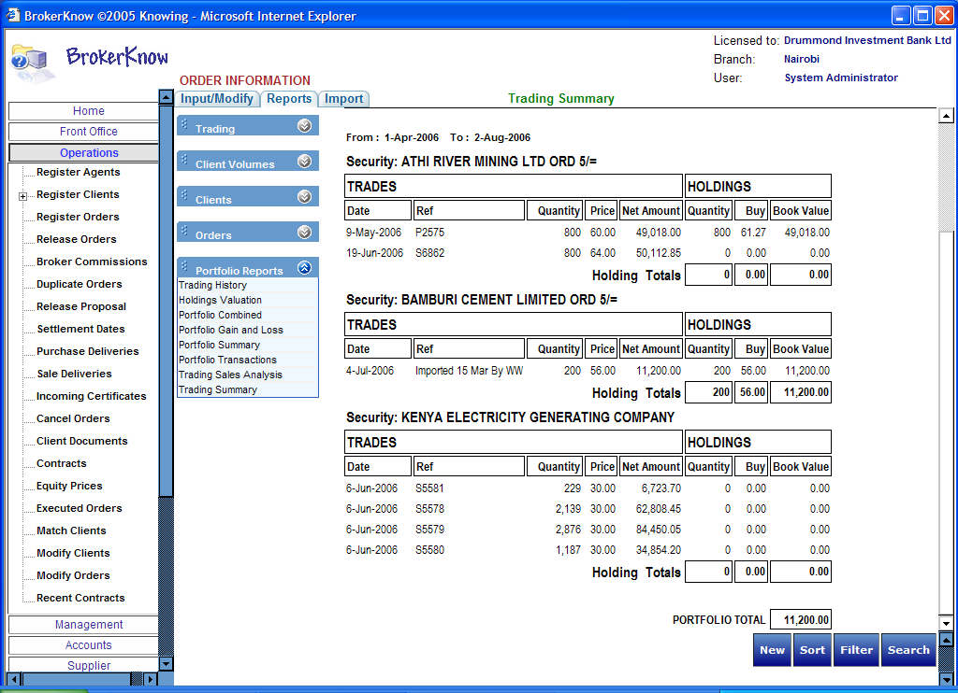

Managing Orders

Contents

Managing Orders 1
Duplicate orders 2
Excluded purchase orders 2
Excluded Sales order 4
Expired Orders 4
Matched Orders 4
Odd lots 5
Order List 6
Order List (Odd Lots) 8
Order list (summary) 9
Order List (Without Odd Lots) 10
Order List ATS 11
Order List ATS (Best) 11
Order List ATS (Custodian) 11
Purchase orders 11
Sales orders 11
On Operations Reports go to Orders Reports

Duplicate orders

Duplicate Orders will generate duplicated orders only when such exist. Refer to notes for more understanding regarding this.

Excluded purchase orders

Will generate all purchase orders for purchases that have been excluded in trading. I.e. those that do not appear in the trading schedule

The report can be filtered by User
Check the ‘Filter by User’ check box and specify the user before you click generate.

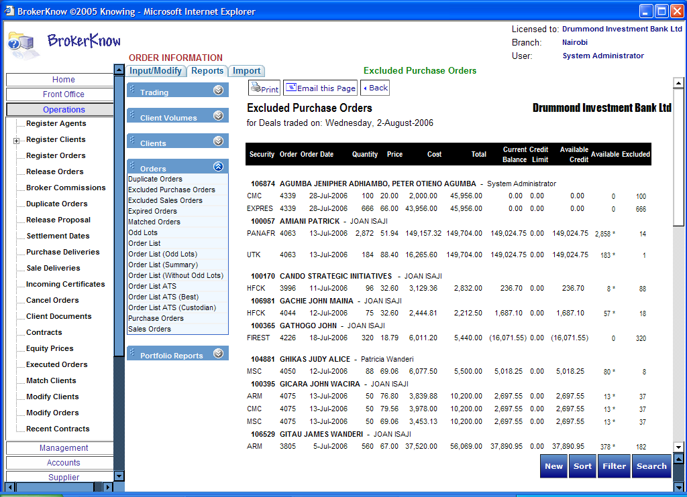

Excluded Sales order

This report will generate all sales orders for sales that have been excluded in trading and will appear exactly like the Excluded Purchase Order.

Under Order Reports on the Operations Menu just click Excluded Sales Order

Expired Orders

Expired Orders will generate all orders whose validity period has elapsed.

Notice that when registering Orders, a validity period for the order is specified as illustrated below.

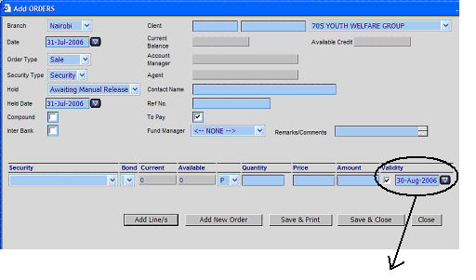
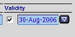

Matched Orders

Matched Orders will generate all orders in the system that have a corresponding order in the CDS trades file.

Odd lots
Odd Lots will generate a list of all orders less than 50 that were not transacted from the whole order. (Note that the number may differ as set by the company)

Refer to notes for more explanations as regards Odd lots

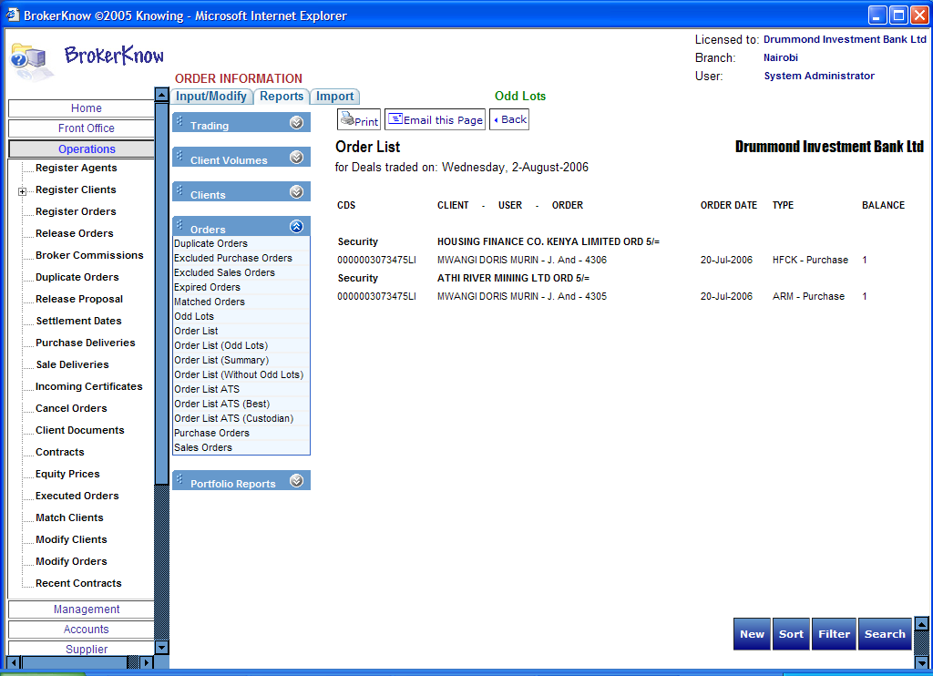

Order List

The Order List will generate a list/schedule of all orders that have been released for trading. The order list will sometimes be referred to as the trading schedule.

- Click Order list under the Order Reports
The system allows you to specify one of the two types of order lists
- From the drop down menu specify the type of Order List/Trading schedule either as buy or sell.

- Click Generate

Notes
Notice the Share Quantity field. Some entries appear in stars. This indicates that what shows on the report is not the whole order but part of it, say what was not transacted previously

Order List (Odd Lots)

Will show the trading schedule of all orders less than 50

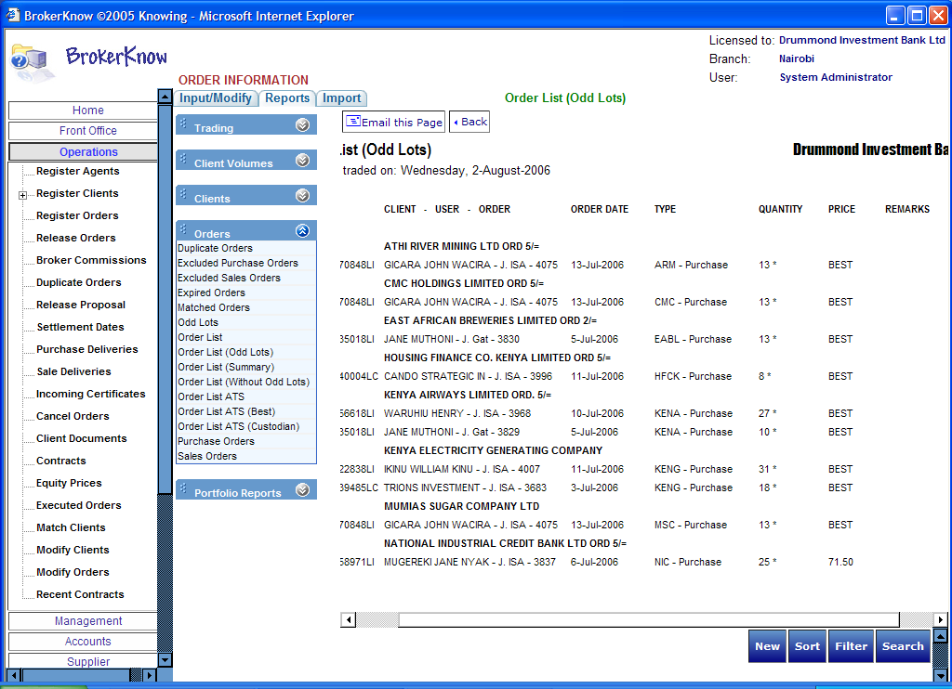

Note that the Orders appearing with stars indicate that the amount shown on the report is not the whole order as originally made.
Order list (summary)

This will generate a summary of the trading schedule by security, with both odd lots and uncompleted orders appearing on the report.

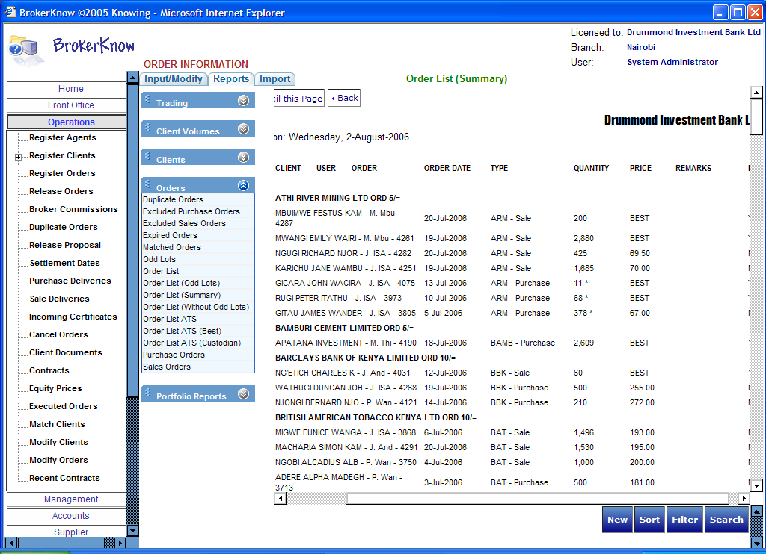

Order List (Without Odd Lots)

This will generate a trading schedule without orders that are less than 50.
The Order list (Summary) is almost similar to the Order list (Without Odd Lots) with the only difference being that the latter does not show the Odd Lots.

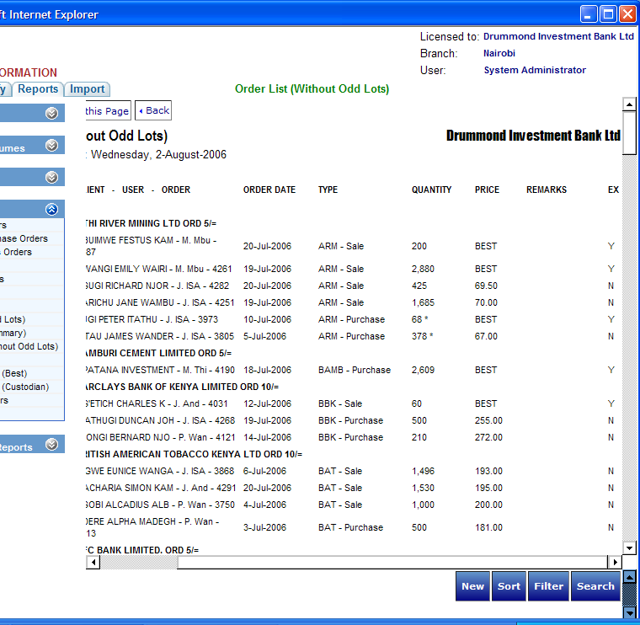

Order List ATS

Will generate a report whose format is according to that specified by the Automated Trading System.

Order List ATS (Best)

This will generate an ATS format compliant trading schedule showing all orders that are to be traded at best price.
Orders are traded at best when the client has not specified the prices.

Order List ATS (Custodian)

Order List ATS will generate an ATS format compliant trading schedule showing all orders that belong to custodian clients.

Purchase orders

This will generate all purchase orders that have appeared on the trading schedule by client as of a certain date.

Sales orders

This will generate all sales orders that have appeared on the trading schedule by client as of a certain date.

Notes

Notice: that those appearing in stars indicate that not the whole order appears there.

Duplicate Orders
Duplicate Orders are explained using a scenario. For example client A makes a purchase Order for Kengen shares today and the order is still outstanding. The same client makes an order for Kengen shares tomorrow and the first order has not been executed. This second order will be referred to as a duplicate order.

Ideally the system does not accept duplicate orders. However, if for an unusual reason it does, BrokerKnow provides the Duplicate Order function to detect such orders.

Using the same scenario above, if the first order has been cancelled the system should be able to accept the second order.

Odd lots
If for example there is an order for 530 shares. Only 500 shares of the order are transacted on the floor. The remaining 30 shares will be regarded as Odd lots.

Administrational Tasks

Contents

Administrational Tasks 1
Managing Account managers 2
To Register an Account manager 2
Modifying Account Manager Information 4
To Delete 4
To Edit 4
To Sort 4
To Filter 4
Managing Brokers 5
To Register a Broker 5
Modifying Brokers 6
To Delete 6
To Edit 6
To Sort 7
To Filter 7
Manage Bonds/Issues 7
To Register a Bond 7
Modifying Bonds 8
To Delete 8
To Edit 9
To Sort 9
To Filter 10
To Register an Issue 10
Modifying Issues 11
To Delete 11
To Edit 11
To Sort 12
To Filter 12

Open the Administration Menu

Managing Account managers

Administration > Account Managers

To Register an Account manager

- Click Account Managers
- Click New
An add account manager information dialog box appears.

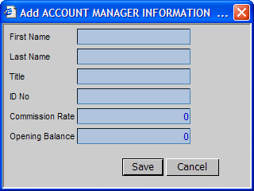

- Enter the account manager’s information

First Name – Is the account manager’s first name
Last Name – Is the account manager’s last name
Title – Mr. /Miss/Ms etc
ID No – Is the account manager’s identification number
Commission Rate – Is the rate with which the account manager is to be paid
Opening Balance – Is the cash balance in the account manager’s statement at the beginning of trading.

- Click Save

Modifying Account Manager Information

To Delete

- Select the Account Manager that you want to delete
- Click Delete
A confirmation message appears requiring you to confirm the deletion
- To delete click Yes
The selected Account manager will be deleted and should no longer appear in the list of account managers.

To Edit

- Select the account manager that you want to edit
- Click Edit
An Edit Account Manager Information dialog appears with the details of the account manager you selected
- Edit the information as required and Click Save

To Sort

- Click Sort and enter the criteria for the sort

BrokerKnow allows you to sort brokers by
Owner
ID Number

To Filter

- Click Filter
A filter web page dialog appears
- Enter the criteria for the filter
BrokerKnow allows you to filter by
Owner and
ID Number

- Click Filter again on the web page dialog
- Click Cancel Filter to return to the original view before the filter

Managing Brokers

To Register a Broker

- On the Administration Menu go to Register Brokers
- Click New
An add broker information dialog box appears as shown below

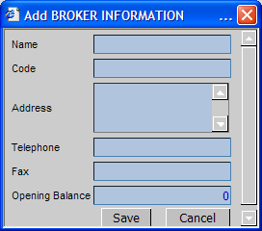

Enter all the required Broker details

Name – Indicates the name of the broker
Code – Indicates the broker’s identification code
Address – Is the Broker’s address
Telephone – Is the Broker’s telephone number
Fax – Is the Broker’s fax number
Opening Balance – Is the Broker’s current account balance

Click Save

Modifying Brokers

To Delete

- Select the broker that you want to delete
- Click Delete
A confirmation message appears requiring you to confirm the deletion

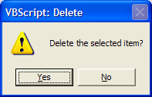

- To delete click Yes
The selected broker will be deleted and should no longer appear in the list of brokers.

To Edit
- Select the Broker that you want to edit
- Click Edit
An Edit Broker Information dialog appears with the details of the broker you selected

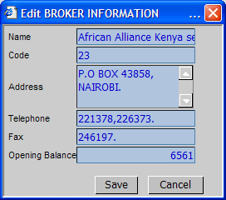

- Edit the information as required and Click Save

To Sort

- Click Sort and enter the criteria for the sort

BrokerKnow allows you to sort brokers by
Name
Office Phone
Fax and
Address

To Filter

- Click Filter
A filter web page dialog appears
- Enter the criteria for the filter
BrokerKnow allows you to filter by
Name
Office Phone
Fax
Address

- Click Filter again on the web page dialog
- Click Cancel Filter to return to the original view before the filter

Manage Bonds/Issues

To Register a Bond

- Click Manage Bonds
- Click New
An Add Bonds Information dialog box appears
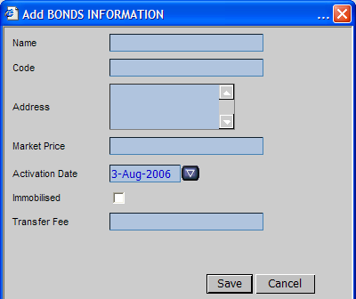

- Enter all the details of the new bond

Name - Is the name of the new bond
Code – Is the code that identifies the bond
Address – The address where the bond is from
Market Price – Is the market value of the bond
Activation Date – Is date when the bond is activated
Immobilized – The check box indicates whether the bond
Transfer fee – Indicates the value at which the bond is transferred

- Click Save

Modifying Bonds

To Delete

- Select the bond that you want to delete
- Click Delete
A confirmation message appears requiring you to confirm the deletion
- To delete click Yes
The selected bond will be deleted and should no longer appear in the list of bonds

To Edit

- Select the bond that you want to edit
- Click Edit
An Edit bond Information dialog appears with the details of the bond you selected

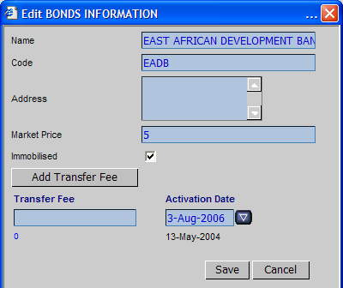

- Edit the information as required and Click Save

To Sort

- Click Sort and enter the criteria for the sort

BrokerKnow allows you to sort bonds information by
Code
Name
Market price
Transfer Fee and
Address

- Click Sort again on the dialog box
- You can Cancel Sort to return to the view before the sort.

To Filter

- Click Filter
A filter web page dialog appears
- Enter the criteria for the filter
BrokerKnow allows you to filter by
Code
Name
Market price
Transfer Fee and
Address

- Click Filter again on the web page dialog
- Click Cancel Filter to return to the original view before the filter

To Register an Issue

- Click Manage Bonds
- Click on the Issues sub interface
- Click New
An Add Issue Information dialog box appears

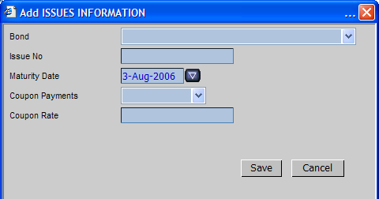

Enter all the details of the new issue

Bond - Is the name of the bond that is being issued
Issue No – Is the unique identification of an issue
Maturity Date – The date when the bond is due to be paid back
Coupon Payments – Is the periodic amount at which the bond will be paid back.
Coupon Rate - Is the rate at which the payments will be made back.

- Click Save

Modifying Issues

To Delete

- Select the issue that you want to delete
- Click Delete
A confirmation message appears requiring you to confirm the deletion
- To delete click Yes
The selected issue will be deleted and should no longer appear in the list of issues

To Edit
- Select the issue that you want to edit
- Click Edit
An Edit issue Information dialog appears with the details of the issue you selected

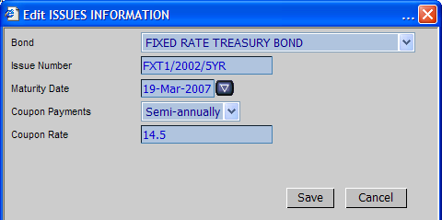

- Edit the information as required and Click Save

To Sort Issues

- Click Sort and enter the criteria for the sort

BrokerKnow allows you to sort issues information by
Code
Name
Bond
Issue Date
Maturity Date
Determination
Life
Coupon Payment
Coupon Rate

- Click Sort
- Click Cancel Sort to return to the initial view before the sort

To Filter

- Click Filter
A filter web page dialog appears
- Enter the criteria for the filter
BrokerKnow allows you to filter by
Code
Name
Bond
Issue Date
Maturity Date
Determination
Life
Coupon Payment
Coupon Rate

- Click Filter again on the web page dialog
- Click Cancel Filter to return to the original view before the filter

System Configuration

Contents

Activity types 1
Banks 1
Client types 2
Commissions 3
Corporate types 4
Gender 5
Holidays 5
Invoice types 6
Invoice terms 6
Levies 6
Levy ordering on reports 7
Location 9
Mail settings 10
Market sectors 10
Online users 11
Order hold options 12
Order types 13
Payment types 14
Residencies 14
Time limits 15
Under the Administration menu go to System Configuration

Each type of configuration will be discussed below.

Activity types
Use this sub-interface to add and configure activities on the system

To Add a New Activity Type

- Click Activity Types
- Click New

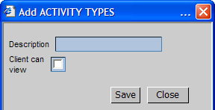

- Enter the new activity name
Checking the client can view check box makes the activity type unseen by online clients
- Click Save

Banks
Use this sub-interface to configure bank information on the system

To Add a Bank

- Click Banks
- Click New
- Enter the bank information

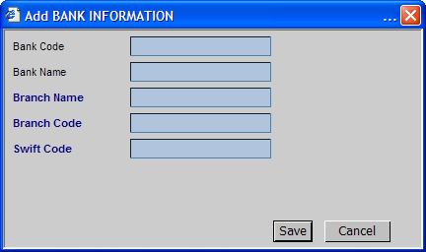

Bank Code – Is the code representing the bank
Bank Name – The bank’s name
Branch Name – The bank’s branch
Branch Code – Code representing the bank’s branch
Swift Code – The code to allow for swift transfers

Client types
Use this interface to specify client types on the system

To Add a Client Type

- Click Client Types
- Click New
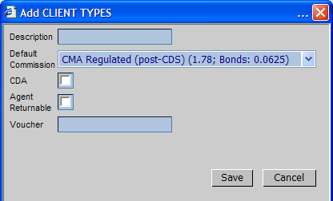

- Add the client type
- Click Save

Description – Is the description of the client e.g. Individual, Over the Counter etc
Default Commission – Is the commission that will be assumed if no other commission is specified.
CDA – Checked if a client is registered under an agent.

Commissions
Use this sub interface to enter and configure commissions’ information into system.

- Click on Commissions
- Click New
- Enter the Commissions information

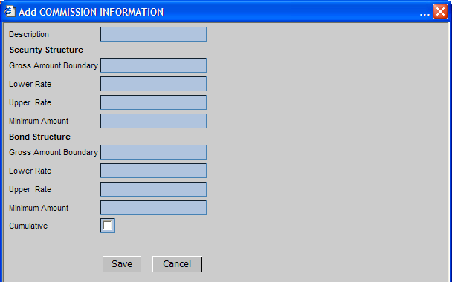

Description – Is the description of the commission type
Security Structure defines the different type of securities
Gross Amount Boundary –
Lower Rate – The lowest possible rate of the commission that can be charged on securities.
Upper Rate – The highest rate of the commission that can be charged on securities
Minimum Amount – The minimum amount of commission that can be charged on securities affected.
(The same descriptions apply for the bonds)
Cumulative – Indicates whether the commission can be cumulated

Corporate types
Use this interface to specify the corporate types that exist on the system

- Go to the corporate types interface
- Click New

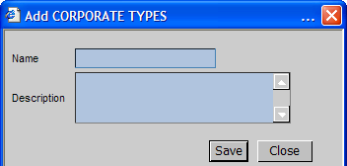

- Enter the new corporate type name
- Enter the description
- Click Save

Gender
Is a sub-interface where the gender types are entered into the system

Holidays
Keeps a record all the holidays

- Enter the name of the holiday(description)
- Enter the date of the holiday
- Click Save

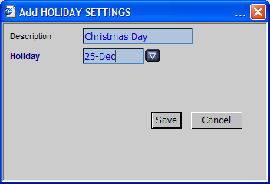

Invoice types

Use this sub-interface to specify invoice types e.g. credit or debit note.

- On Invoice Types, click New
- Enter the description of the invoice type
- Click Save

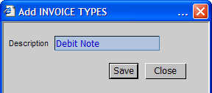

Invoice terms

Use the interface to specify invoice terms i.e. the amount of time given for invoices to be due.

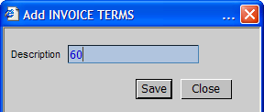

Levies
Provides an interface for registering levies in the system

- On Levies click New
- Add the levies information
- Select the securities that the levy applies to and Add
To specify the securities that are affected by the levy, select the security from the listing on the left, and click the Next > command button

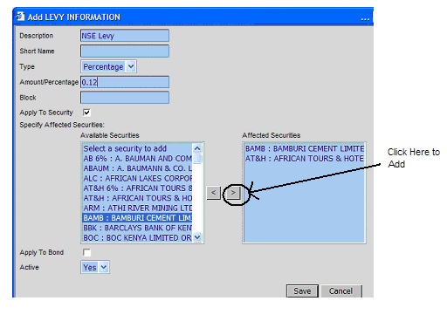

Description – Is the description of the levy type
Short name – Is the shorter name identifying the levy
Type – Specifies whether the levy is a percentage or schedule kind of levy
Amount/Percentage – Is the rate payable of the levy
Apply to security – Indicates whether the levy affects securities
Apply to bond – Indicates whether the levy should be applied to the bonds of the specified security

3. Click Save when you are done

Levy ordering on reports
Use this sub-interface to specify the order in which levies appear on reports

Adding a Levy Ordering

- On the sub-interface levy ordering on reports click New
There will be a list of all available levies on the list box on the left
- Select the levy from the left
- Click the > command button
- The selected levy moves to the List box on the right under the selected levies
- Click Save

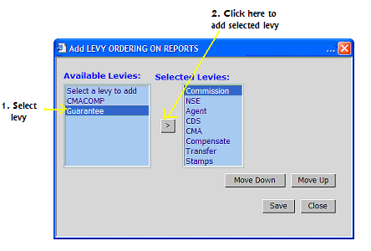

To Modify the Order of a Levy

- Select one of the levies from the Selected levies list box on the right
- Click the move up or move down command buttons as desired
- Click Save

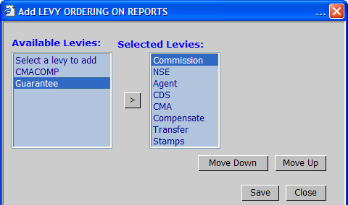
Move Up – Takes the selected levy a level lower
Move Down – Takes the selected levy a level lower

Agent – This is a levy charged by an agent
NSE – The brokerage fee charged by the Nairobi Stock Exchange
Stamps - Legal fee arising due to the cost of transferring shares from one client to another

Location
Is an interface used to specify the locations of offices
- Click New
- Enter the description of the new location
- Click Save

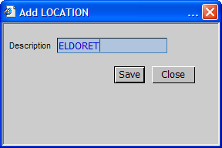

Mail settings

This interface is used to configure mail settings.

- Click Edit and modify the mail settings as desired.

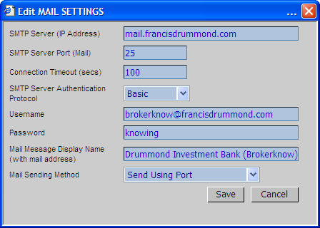

Market sectors
Is used to register market sectors on the system

To Add a Market sector
- Click New
- Enter the description of the new market sector
- Click Save

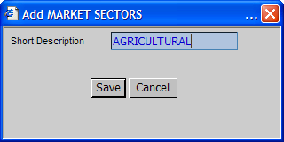

Online users

Online Users provides an interface for registering online users of the system
To Add New Users
- Click New
- Enter the online user’s details in the Add Online Users dialog box
- Click Save

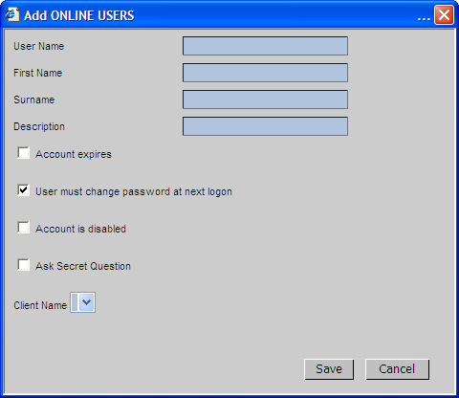

User Name – Is the user’s user name on the system for purposes of authentication
First Name – Is the users first name
Surname – Is the user’s surname
Description – Is a brief description of the user
Account expires – Indicates whether the user account should expire after some time
User must change password on next log on – Simply configures the system so that the next time the user logs on, he/she is prompted to change the password.
Account is Disabled – Indicates the state of the user’s account as either enabled or disabled.
Ask Secret Question – Indicates whether the user should be asked a secret question for example in circumstances where the user has forgotten their password.

Order hold options

Provides an interface for specifying hold order options on the system
To Add a New Order Hold Option
- Click New
- Enter the description of the new order hold option

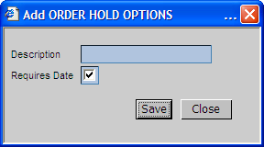

Requires Date indicates whether the option will require a date entry to be input when the description is used.

- Click Save

Order types
Provides a sub-interface where order types e.g. sales or purchases are specified on the system.
- Click New
- Specify the order type information

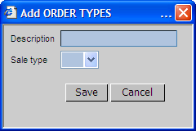

Description – Simply specifies the order type
Sale Type – Indicates the sale state of the order type. I.e. whether the order is a purchase or a sale

- Click Save

Payment types
Is an interface where modes of payment are specified on the system.
- To Add a New payment type
- Click New
- Enter the Information on the Add Payments dialog box

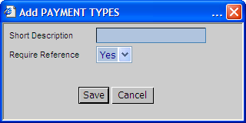

Short Description – Is the name of the mode of payment
Require Reference – Indicates whether the mode of payment requires any reference

- Click Save

Residencies
Is an interface where residency information (e.g. regarding withholding tax amounts) is specified on the system
To add new residency information,
- Click New
- Enter the description of the residency e.g. as local or foreign
- Enter the withholding tax rate of the residency type

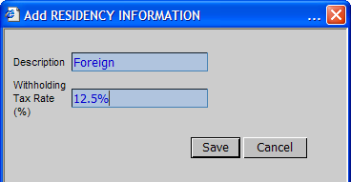

- Click Save

Time limits
An interface where time limits are specified for different actions on the system.
To edit the time limit information
- Click Edit
- Specify the time limits

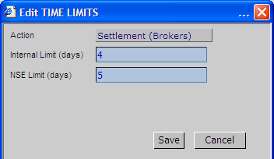

Internal Limit – Is that that has been set internally by the company
NSE Limit – Is that which has been specified by the by the Nairobi Stock Exchange

- Click Save

User Security

Contents

Managing User Groups 1
Managing Group members 1

The User Security menu provides interfaces to help manage user security on the system

Managing User Groups

Is an interface where user groups are created on the system. The type of group a user belongs to will specify the system access rights of that user.

- To add a new user group
- Click New
- Add the group and give it a short description

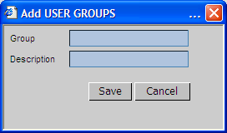

- Click Save

Managing Group members

This interface helps to specify the system users and the group category that they fall into.

To make a User a member of a certain User Group:

1. Click New

A list of system users appear on list box on the left as shown below
Note that the list boxes on the right indicate the group members of each user group

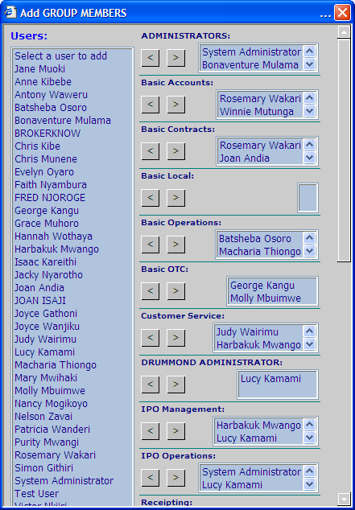

2. Select the user that you want to add to a certain group from the list box on the right.

E.g. To add System Administrator to the administrators group select System administrator

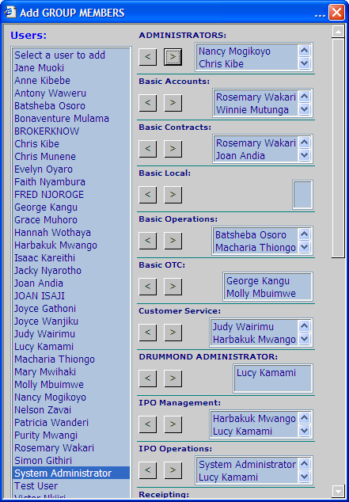

3. On the User group section where you want to add the system user, click the Next arrow (>) as shown below.

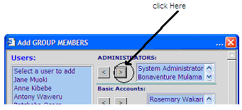

The new user will be added to the selected group

To undo the changes or to remove any other user from a group he/she is currently in,

Select the user from list box on the right e.g. to remove System administrator from the administrators group, select system administrator

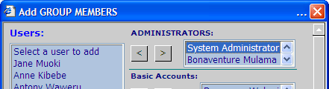

Click the back (<) arrow as shown below
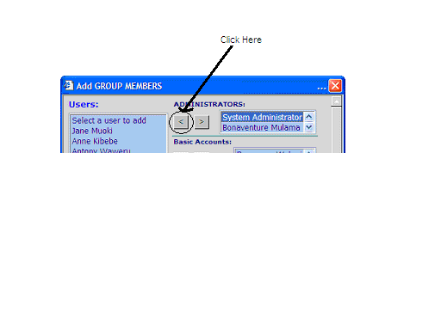

The selected user is removed fro the user group and will no longer appear in the list box of the group members.

Modifying Group Members

To Edit

- Select the User group that you want to edit
- Click Edit
A dialog box appears listing all system users on the left list box and all the group members of the selected group in the list box on the right
- Select the user that you want to edit either to add to the group or remove from the group.

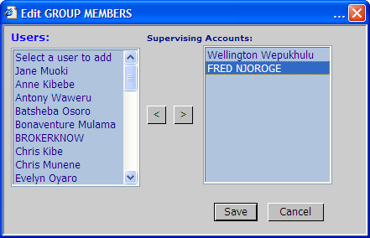

- Click the < arrow to remove a user from the user group or the > arrow to add a new user as a member of the user group.

Access rights
Is an interface that helps define the access rights that each user has got on the system. These rights specify which person can view what interface.

To add a new group Access right:
- Click New

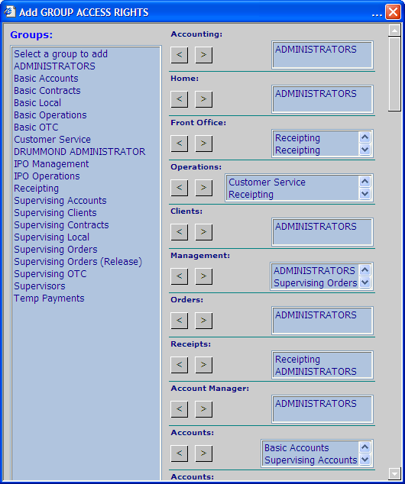

- Select a group from the list box on the right

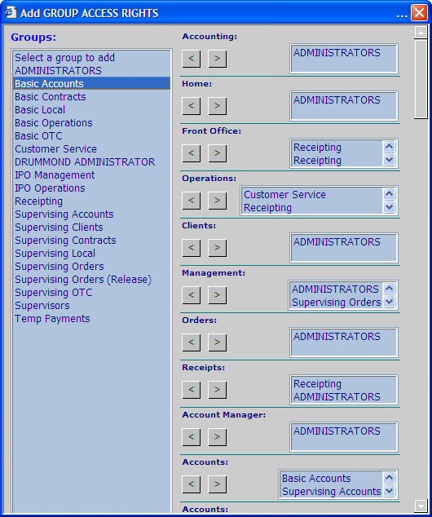

- Add the selected group to the different access right groups on the right list box by clicking the ‘>’ as shown below

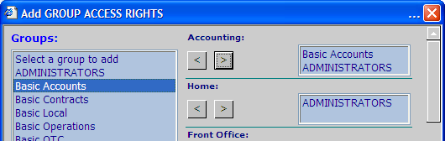

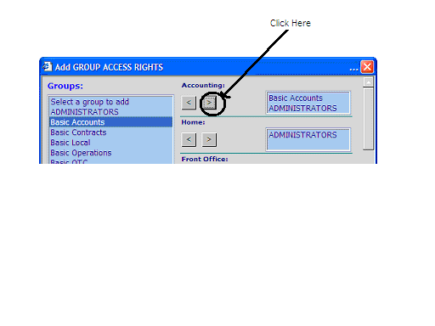

Company Configuration and Audit Log

Company Configuration 1
Audit Log 3

Provides an interface for specifying company information

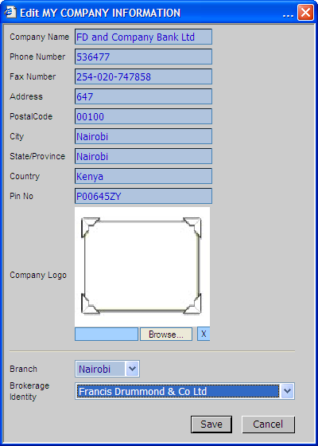

Audit Log

The Audit log keeps track of all system user actions on the different entities. I.e. who last did what on the system?

To view the Audit Log for a specific entity, just select the entity under the Audit Log Menu.

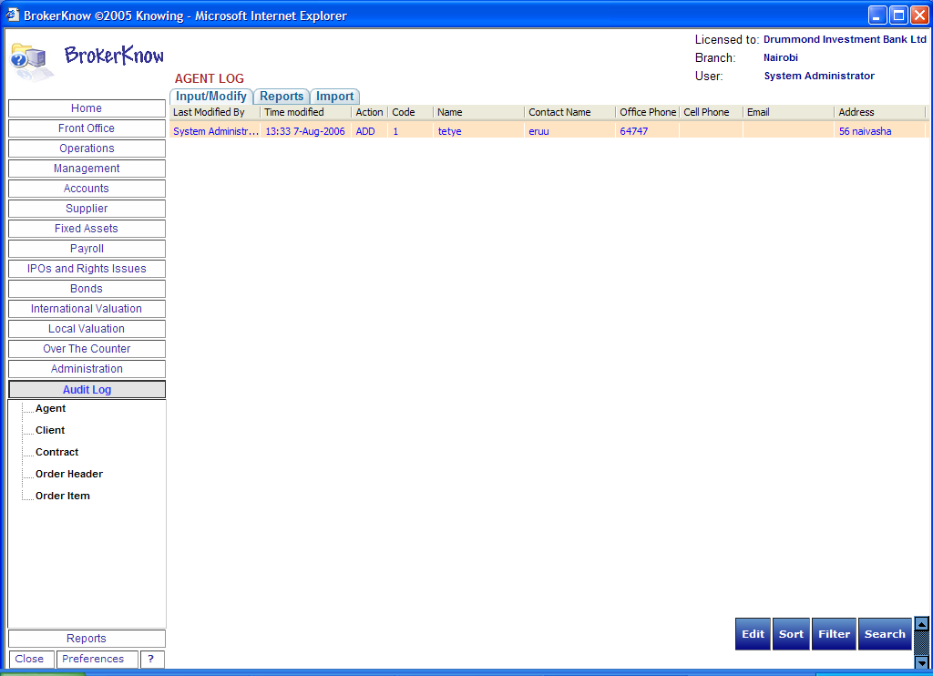

Customer Service Online Operations

Customer Service Online Operations 1
New Users Online Registration 2
Applying for an online account for existing Users 4
Logging In 6
Entering an Order 7
Suggestion Box 8
Viewing Transaction History 9
Viewing CDS Holdings 9
Viewing CDS Holdings Valuation 9
Viewing your Order Status 10
Viewing Online Instructions 11
Changing User Details 13
Logging Off 14
Add New Online Users 14
Changing Online user details 17
Confirming Online Orders 19
Opening New Accounts for Existing Clients 19

This section of the user manual discusses issues regarding the use of the online version of BrokerKnow.

New Users Online Registration
New online users will first have to register before they can access the system online.

- On the Log in window click New Users Online Registration

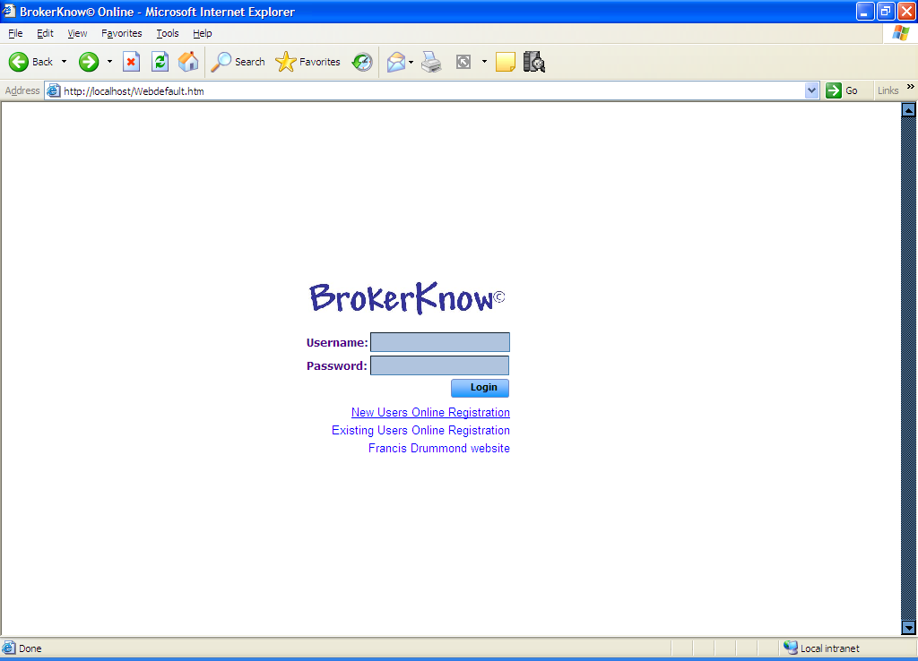

A web form appears as shown below

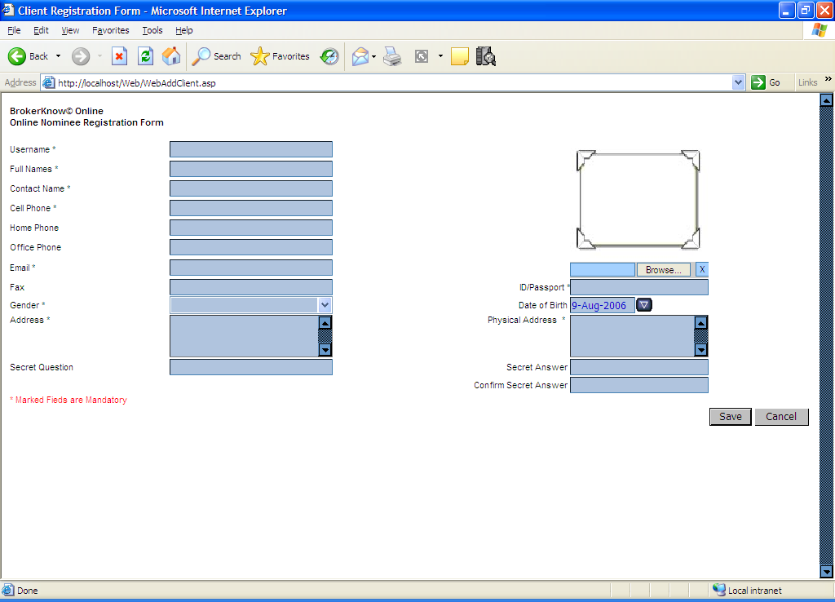

- Fill in all the details ensuring that you provide details for the mandatory fields.
- Click Save

Username – Is the user name of the new online user
Full name – Is the full name of the online user
Contact name – Is the name of the correspondent
Cell Phone – Is the mobile number of the of the new online user
Home phone – Is the residence of the of the new online user
Office Phone – Is the office number of the new user
Email – The email address of the new online user
Fax –The fax number of the new online user
Gender – The new online user’s gender
Address – The contact address of the new user
Secret Question – A secret question that is asked to the user incase he/she forgets the password.
ID/ Passport – The Passport or ID number of the new user
Date of Birth – The date of birth of the new user
Physical address – The Physical address of the new user
Secret answer – The answer to the secret question
Confirm Secret answer – A confirmation of the secret answer

Marked fields are mandatory and they appear in stars.

Applying for an online account for existing Users

- Click on Existing Users Online Registration

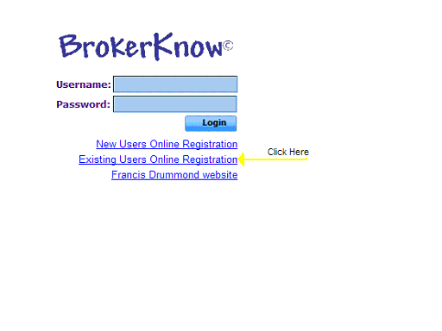

- An online client verification appears as shown below

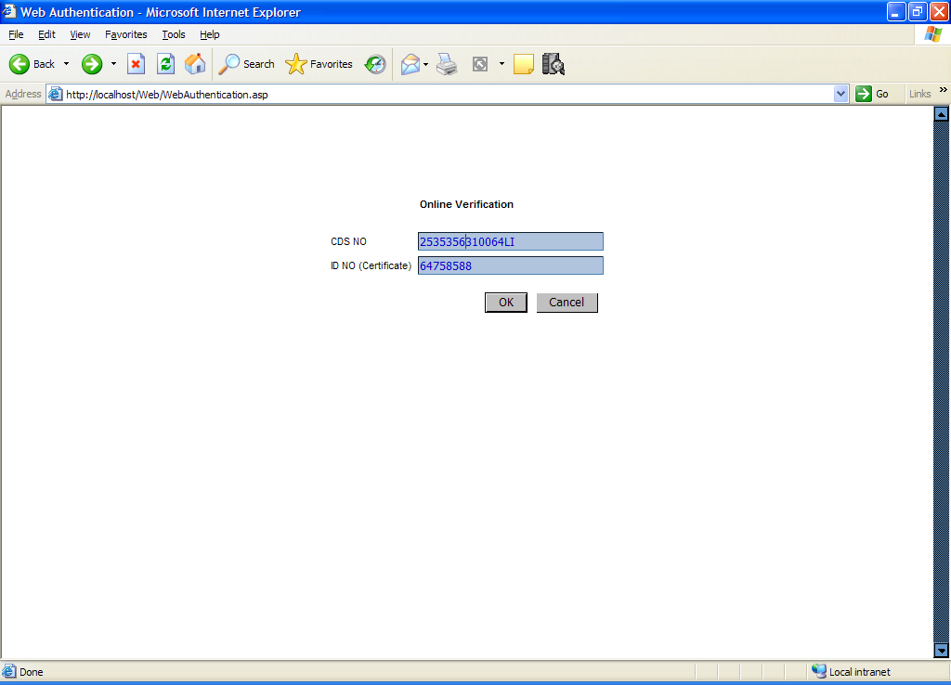
- Enter the details required as shown above

- Click OK

An online form appears as shown below with the details of the existing user who is applying for an online account

Note that the information from the database previously provided can only be viewed but cannot be modified. Only the addresses can be modified.
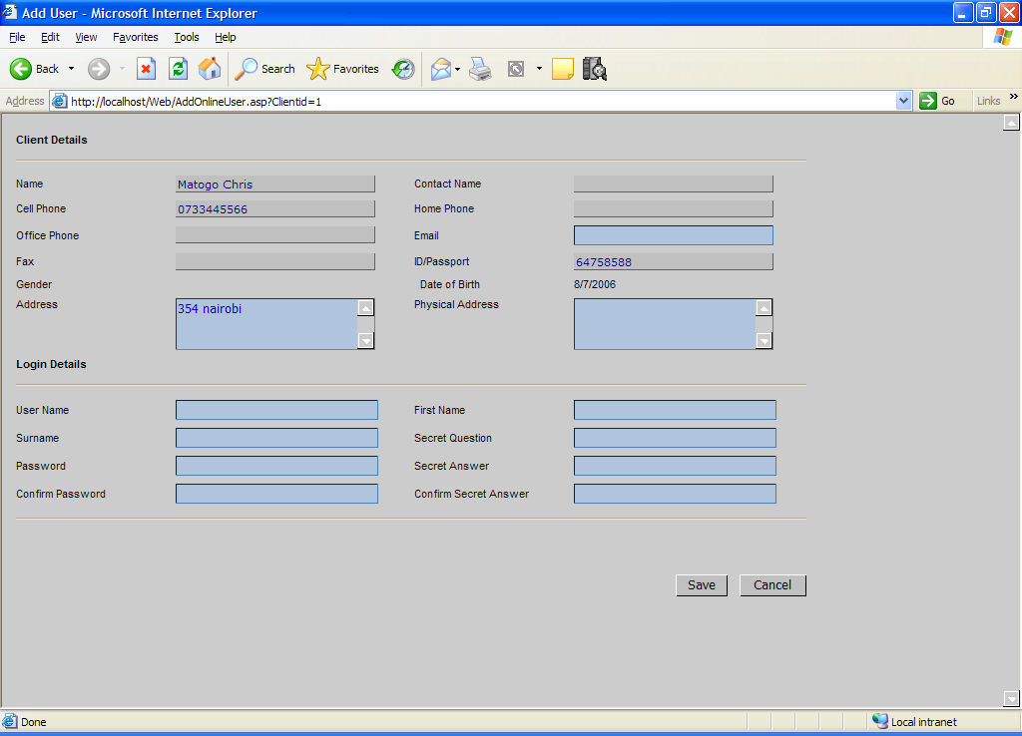

- Enter the required details

Username – Is the user name of the new online user
Password – Refers to the password of the new user
Surname – Is the surname of the online user
First Name – Refers to the first name of the user
Email – The email address of the new online user
Secret Question – A secret question that is asked to the user incase he/she forgets the password.
Secret answer – The answer to the secret question
Confirm Secret answer – A confirmation of the secret answer

- Click Save

The user will receive a message confirming the receipt of his/her information

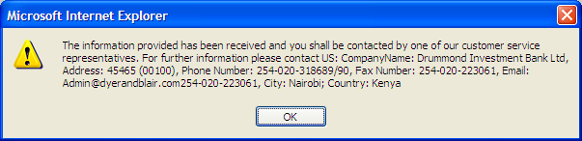

Logging In

When you access the site, you will be prompted to enter the username and password
Click Login

Entering an Order

- Click Make an Order

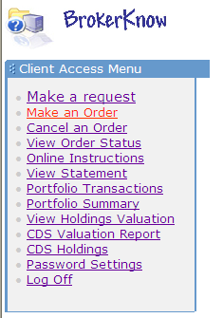

A form like one shown below opens
- Enter the details of the new order

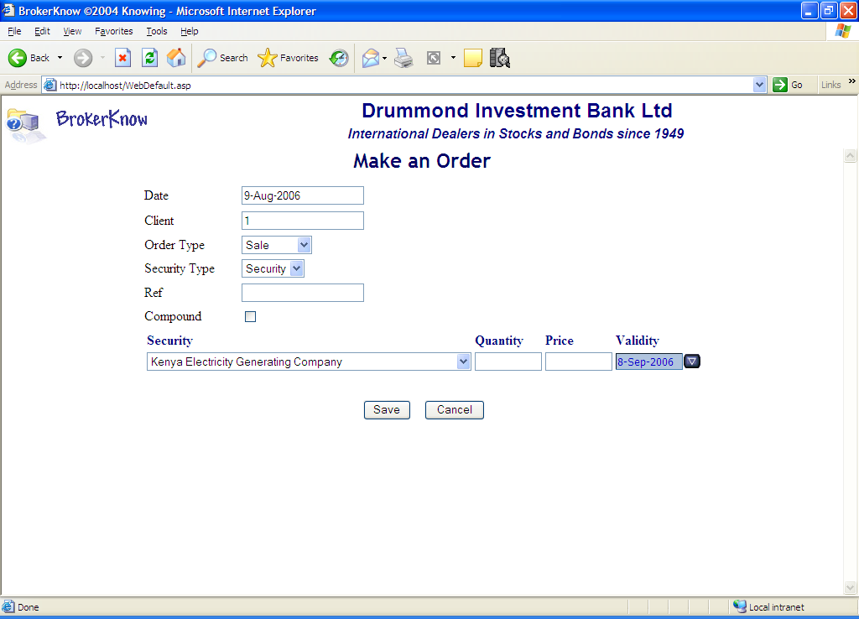

Date – Will be the current date generated by the system
Client – The client number, which will be automatically generated by the system
Order type – The type of the order i.e. purchase or Sell
Ref – The reference detail of this order.
Compound – Indicates whether the order should be compounded or not
Security – Specifies the type of security that the client is trading in.
Quantity – The quantity of security being traded in
Price – The price of the security
Validity – The validity period of the order

- Click Save to save the Order
(Cancel if you do not want to effect the changes made on the system)

Suggestion Box
The online version of BrokerKnow enables you to make requests, forward complaints, complements, questions and suggestions.

- On the Online menu click Make a Request

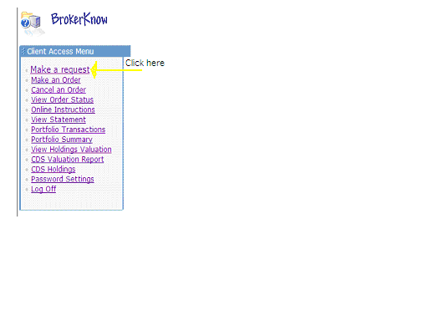
A make Request form opens

- Enter all the details required

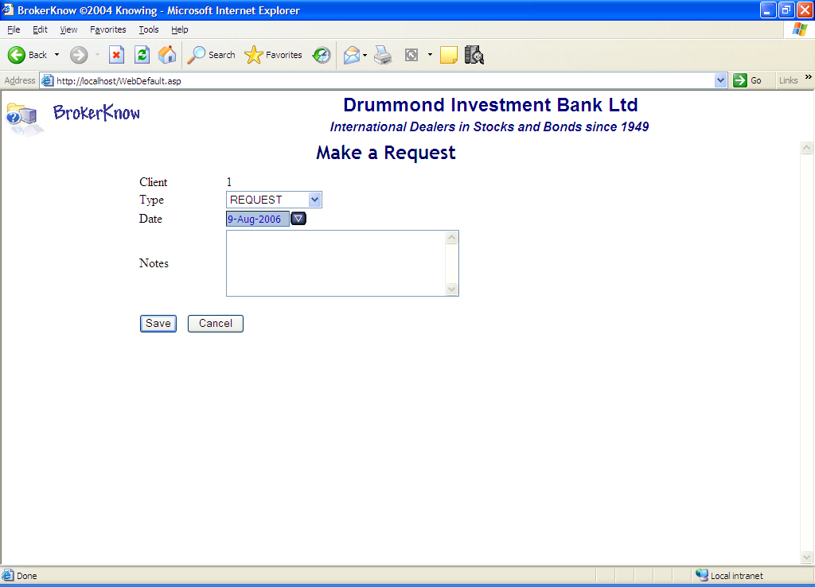

Client – Identifies the client who is currently logged in
Type – Select the type of request from the drop down list
Date – Specifies the request that is being made from the drop down list
Notes – Any notes regarding the request being made.

- Click Save

Viewing Transaction History

Viewing CDS Holdings

Viewing CDS Holdings Valuation

Viewing your Order Status

For an Online Client to view their order Status, on the client access menu they will click View Order Status as shown below
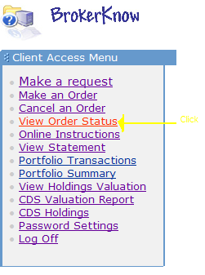

The Order Status of the Online Client will appear as shown below.

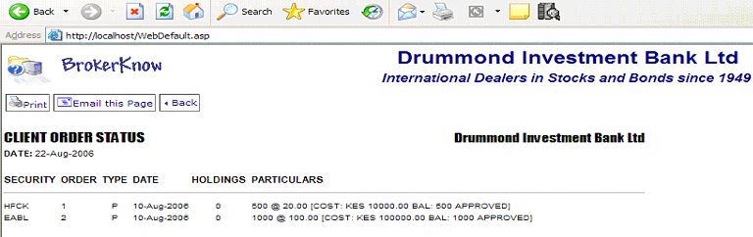

To Print the Order Status

- Click on the Print command button

The Print dialog box appears as shown below
- Specify the Printer and the rest of the printing options
- Click Print on the Print dialog box.

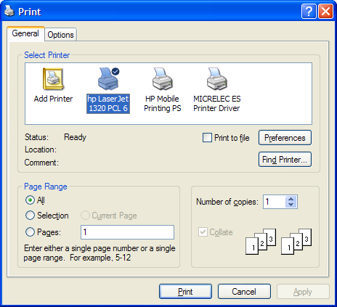

To Email the page

- Click the Email this Page command button

- Enter all the details and click Send

Viewing Online Instructions

Changing User Details

- On Front Office go to Online Users
- Select the user whose details you want to change
- Click Edit

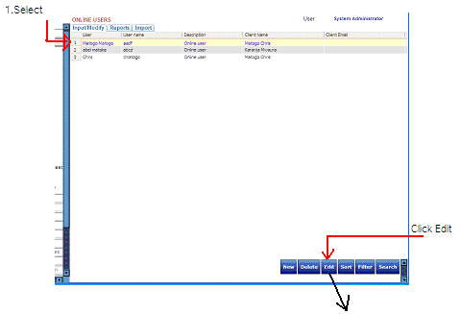

Logging Off

Click Log Off

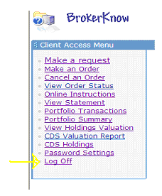
You will be logged off

Add New Online Users
- On Front Office, go to User Security
- Click New
An add Users dialog box appears as shown below

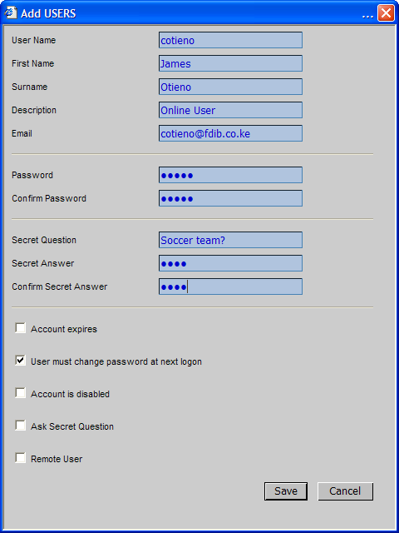

- Click Save

Username – Is the user name of the new user
First Name – Is the first name of the new user
Surname – Is the surname of the new user
Email – The email address of the new user
Password – The password of the new user

Confirm Password – A field that requires you to retype the password so that it is actually confirmed.
Description – A brief description of the online user to describe the type of user he/she is e.g. online user or system administrator
Secret Question – A secret question that is asked to the user incase he/she forgets the password.
ID/ Passport – The Passport or ID number of the new user
Date of Birth – The date of birth of the new user
Physical address – The Physical address of the new user
Secret answer – The answer to the secret question
Confirm Secret answer – A confirmation of the secret answer

Changing Online user details

- On Front Office go to Online Users

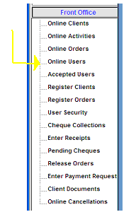

All online users will appear on the grid
- Select the online user whose details you want to change.
- Click Edit

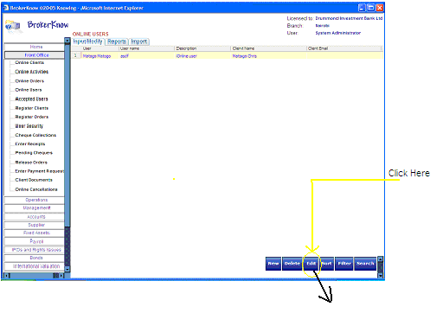

The details of the online user will appear in a form as shown below

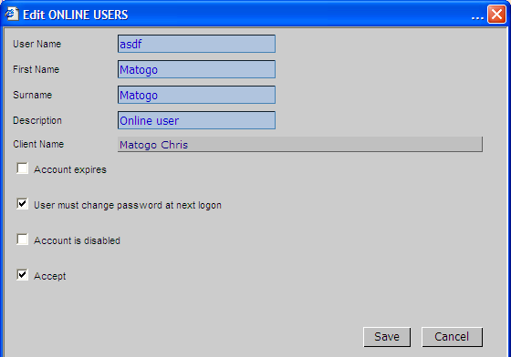

Note that the client name cannot be modified here.

Confirming Online Orders

On Front Office go to Online Orders
All the orders that have been made online will appear on the grid

Opening New Accounts for Existing Clients

- On Front Office go to Online Users
- Click New
Add the details of the new online user

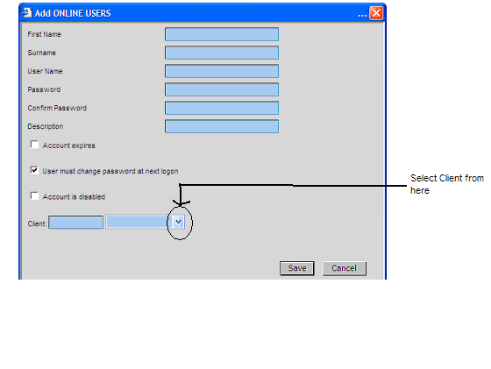

First Name – The first name of the person you want to register as online user
Surname - The first name of the person you want to register as online user
Username – The username of the online user
Password – The password of the online user
Confirm Password – A field that requires you to retype the password so that it is actually confirmed.
Description – A brief description of the online user
Account expires – Indicates whether the user account should expire after sometime
User must change password on next log on – When checked, indicates that the user must change the password the next time he is logging in.
Account is disabled – Indicates that the user’s account is not accessible because it has been disabled.
Client – Allows you t select the client that you want to make an online client from the already existing clients in the system.

Click Save

Glossary of Terms

IPO (Initial Public Offer) is a method of issue of shares where these shares are offered for sale to the public at a lower price.
KRA - Kenya Revenue Authority, a Kenyan body concerned with the assessment, collection, administration and enforcement of laws relating to revenue in Kenya.
CMA - Capital Market Authority, a regulatory body for all financial markets
CDA - Central depository Agent, agent who deals with CDS accounts on behalf of the client.
NSE - Nairobi stock Exchange, A regulatory body in Kenya that governs stock brokerage activities CDS Account- A securities account opened on behalf of a shareholder with the CDSC for purposes of reconciling the deposit and dealing of immobilized shares. CDSC- Central depository and Settlement Corporation limited, a company incorporated in accordance with the act and licensed by the CMA operator and managing agent of the CDS. CMA-Central Market Authority is a body regulating the all financial markets. KRA-Kenya Revenue Authority is a governmental body that regulates and ensures the proper collection of revenue from its citizens. Assets – Any item of monetary value owned by an individual or a corporation. Bond – A long-term debt security of the government or a corporation with a maturity of 10 years or more from the issue date. International Security – The stocks of a company that is based outside Kenya. Custodian Client – One who does not trade on his/her own behalf. Someone else trades on their behalf. - What template did you use as a guide to the manual [industry standard] - Do you intend to include a table of contents or a glossary of terms - Are you going to separate your data into chapters - What techniques will ensure that your manual reads like an interesting novel?
CDS-Central Depository System, an electronic share transfer facility to facilitate the deposit and dealing of immobilized listed shares at the NSE.

