**lab Report**

Install an operating system (OS) in a virtual machine (VM), need virtualization software VirtualBox, or Hyper-V. Steps for installing an OS in a virtual machine using VirtualBox, which is a popular free and open-source virtualization software.

**Step 1: Download and Install VirtualBox:**

1. Go to the VirtualBox website (<https://www.virtualbox.org/>) and download the latest version of VirtualBox that is compatible with your host operating system (the OS on your physical computer)

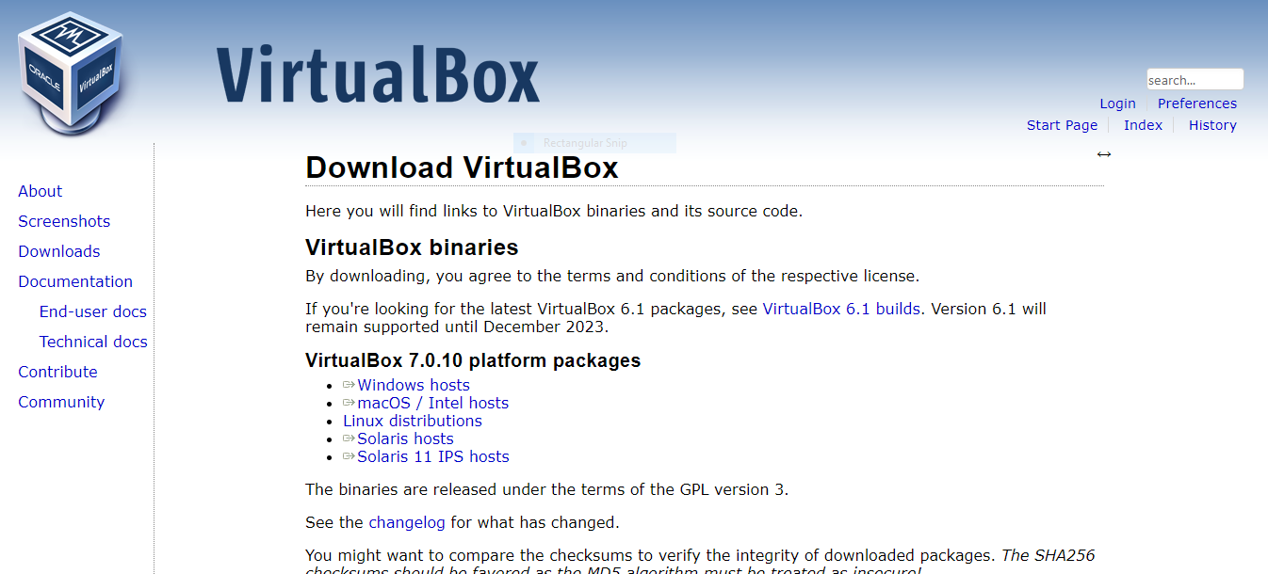

2. Install VirtualBox by following the on-screen instructions.

**Step 2: Download the OS Installation ISO**

1. You need an ISO image of the operating system you want to install in the virtual machine. You can often download these from the official website of the OS or obtain them through other legitimate means.

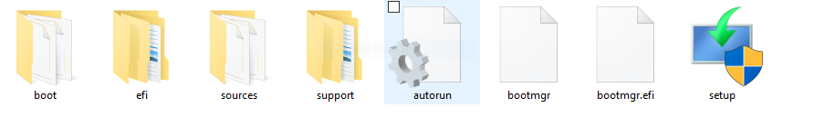

**Step 3: Create a New Virtual Machine**

1. Open VirtualBox after installation.

2. Click the "New" button to create a new virtual machine.

3. Provide a name for your VM and select the type and version of the OS you're installing. VirtualBox usually provides presets for popular OSes, making it easier to configure settings

4. Assign memory (RAM) to your VM. Ensure that you allocate enough memory for the OS to run smoothly but leave enough for your host OS

5. Create a virtual hard disk. You can create a new one or use an existing one. Allocate sufficient disk space for your virtual machine.

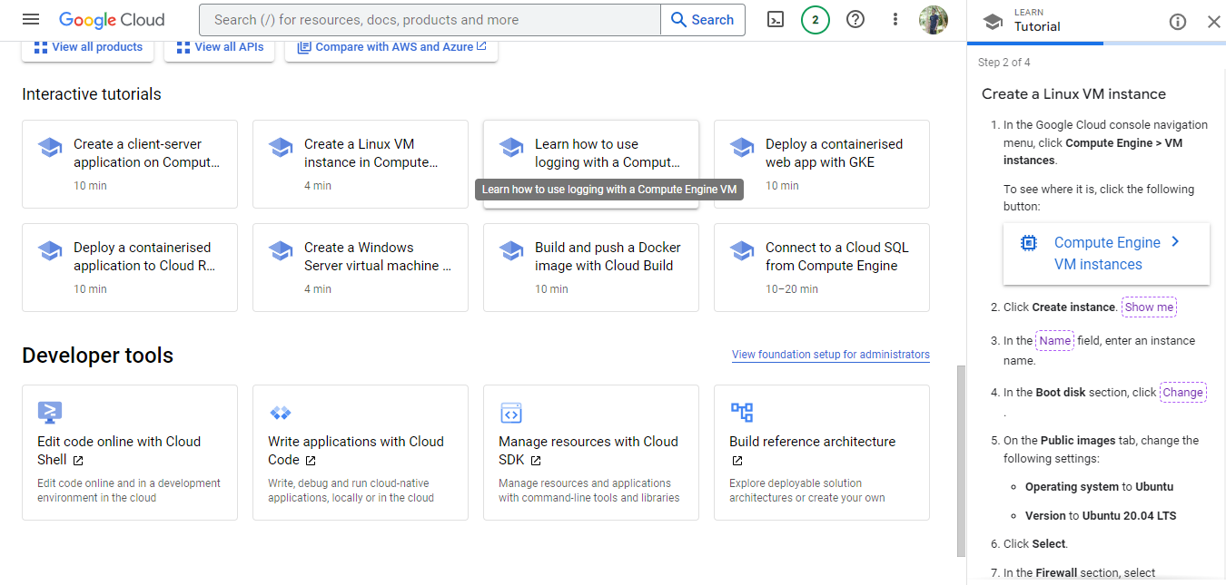

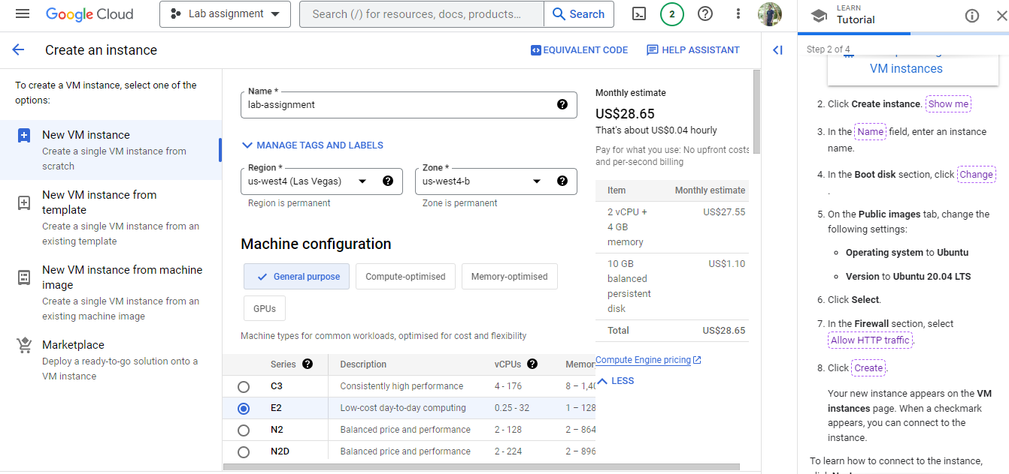

**Step 4: Configure VM Setting**s:

1. Select your newly created VM in the VirtualBox Manager.

2. Click the "Settings" button to configure the VM's settings.

3. In the "Settings" window, go to the "Storage" section and add the OS installation ISO as a virtual optical disk under the "Controller: IDE" or "Controller: SATA" section, depending on your setup.

**Step 5: Install the OS:**

1. Start the VM by clicking the "Start" button in the VirtualBox Manager.

2. The VM will boot from the ISO image you attached. Follow the on-screen instructions to install the OS, just as you would on a physical computer

3. During the installation process, you'll be asked to choose a location for the OS installation, configure settings, and create user accounts. Follow the prompts accordingly.

4. Once the installation is complete, remove the ISO image from the virtual optical drive (you can do this in the VM's settings) to prevent the VM from booting from it again

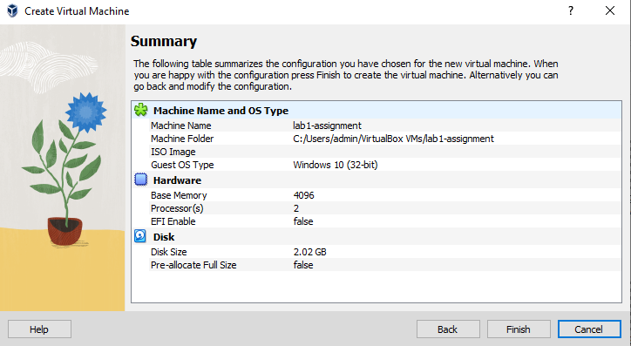

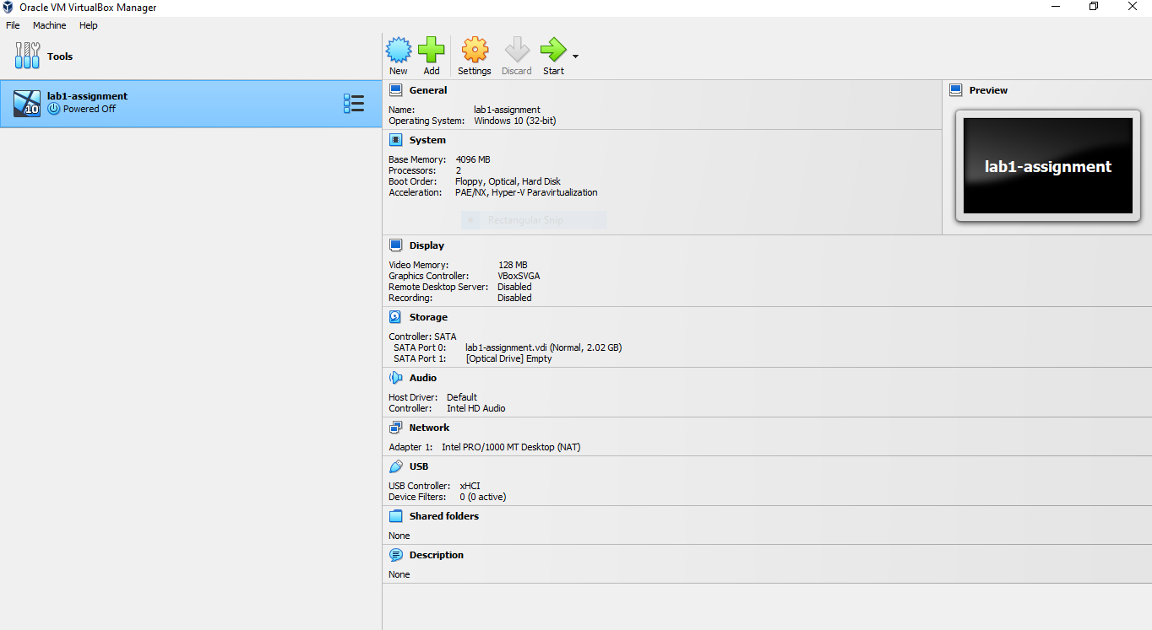

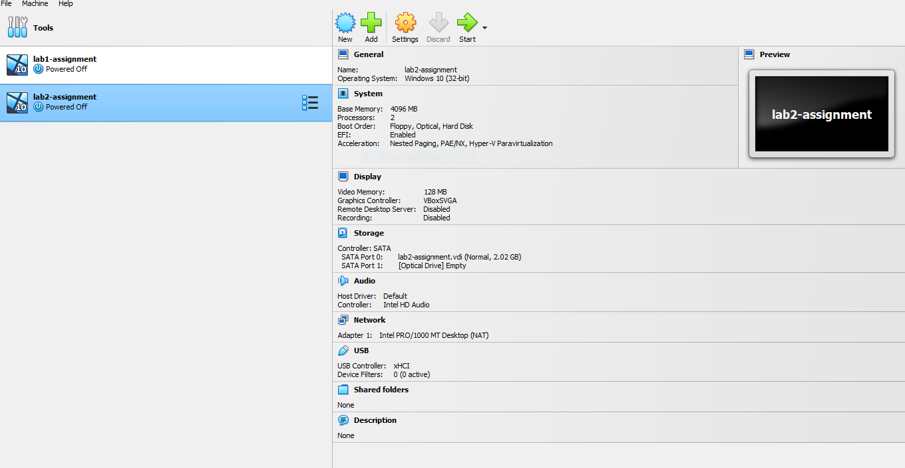

**Step 7: Use Your Virtual Machine**

Now that your OS is installed, you can start and use your virtual machine just like a physical computer.

1. Install VirtualBox:

download and install Oracle VM VirtualBox on your host computer.

2. Create a Testing Environment:

- Identify the specific testing scenarios

- Create multiple VMs within VirtualBox, each representing a different testing environment.

3. Networking Configuration:

- Depending on your testing needs, configure networking for your VMs. VirtualBox offers different network modes, including NAT, Bridged, Host-Only, and Internal networks, which you can use based on your requirements.

- Consider setting up VirtualBox internal networks or Host-Only networks for isolated testing environments, or use Bridged networking to simulate connections to your physical network.

4. Monitoring and Logging:

- Implement monitoring and logging solutions within your VMs to track the performance and behavior of the systems under test. This helps in identifying issues and gathering data for analysis.

A network diagram for virtual machines (VMs) in Oracle VM VirtualBox is a visual representation of the network configuration and connectivity between VMs and external networks. 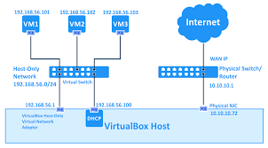

Components of the Network Diagram

1. Virtual Machines (VMs): Represent each VM in your diagram using shapes like rectangles or ovals. Label each VM with its name and specify the guest operating system if necessary.

2. VirtualBox Host: Indicate your physical computer (the host) in the diagram. You can use a simple shape like a rectangle to represent it.

3. VirtualBox Include the VirtualBox software icon to represent the virtualization platform.

4. Network Elements: Represent network components like routers, switches, or access points as appropriate. Use icons or symbols that match these devices.

5. Lines and Arrows: Use lines to connect VMs to each other and to network components. Arrows indicate the direction of network traffic. Dashed lines or different line styles can denote different types of connections (e.g., NAT, Bridged, Host-Only).

2. Created a Testing Environment:

Ping Test

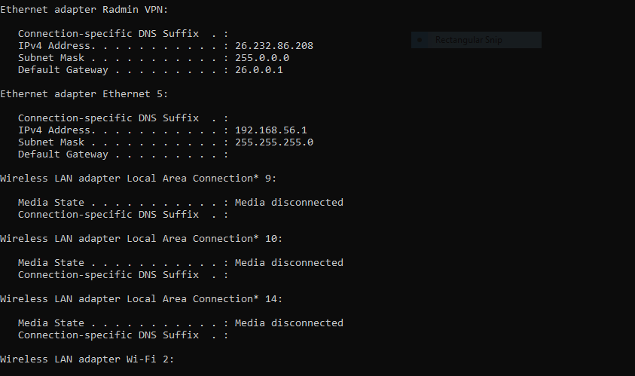

Network created

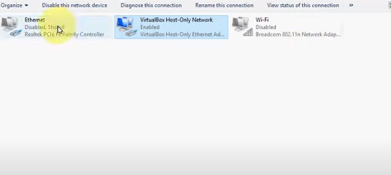

A ping test, short for Packet Internet Groper, is a widely used network diagnostic tool that measures the round-trip time (RTT) for data packets to travel from a source computer or device to a target host, such as a virtual machine (VM), and back. This test utilizes the Internet Control Message Protocol (ICMP), specifically ICMP Echo Request and Echo Reply messages. Here's how a ping test for a virtual machine works and why it's valuable:

The ping test process begins with the source computer or device sending an ICMP Echo Request packet to the IP address of the target VM. This packet contains a timestamp and a sequence number. When the VM receives the Echo Request, it processes it and responds by sending an ICMP Echo Reply packet back to the source.

The source machine calculates the RTT by measuring the time elapsed from sending the Echo Request to receiving the Echo Reply. This RTT provides valuable information about network performance, as shorter RTTs indicate lower latency and faster communication.

Ping tests serve several critical purposes. First, they are a quick and straightforward way to check if a VM is online and responsive. When administrators need to verify connectivity to a VM, a successful ping indicates that the VM is reachable. If the VM fails to respond to pings, it may suggest network issues, misconfigurations, or even VM downtime.

ping tests are essential for network troubleshooting. If a VM is experiencing connectivity problems, ping tests can help diagnose the issue. For example, a lack of response may indicate a firewall blocking ICMP traffic, incorrect IP configurations, or network adapter problems. Monitoring ping responses can also be part of a broader network monitoring strategy, enabling administrators to track VM availability and response times. If a VM becomes unresponsive, it can trigger automated alerts, allowing administrators to address issues promptly.

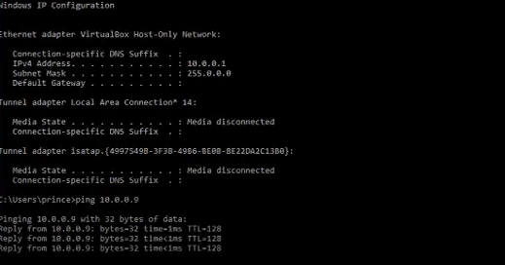

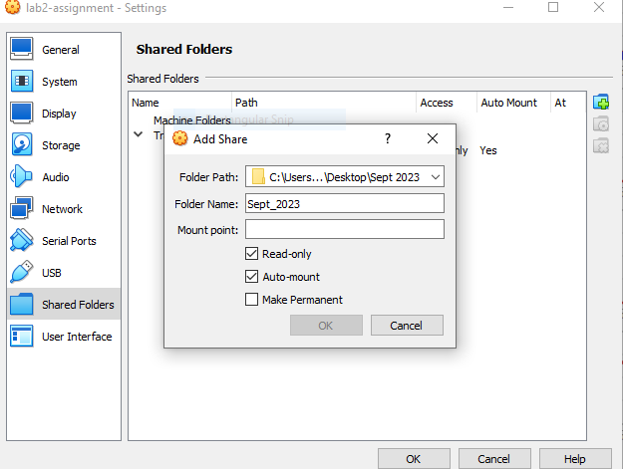

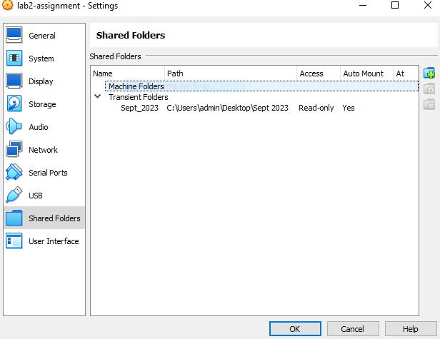

4. Security Policies and Procedures:

Develop clear security policies and procedures that define acceptable use, access control, data protection, incident response, and other security-related guidelines.

Read only access

Auto-mount

Make permanent