FINAL PROJECT REPORT for Phase-I
Research & Development Milestone Summary
FAST-PETase Enzyme Feasibility Study
Prepared for
PlastiBioFuels LLC
Prepared by
Prof. Shengqian Ma, University of North Texas
Report Date: August 7, 2026
Period of Performance: January 01, 2026 – June 30, 2026
CONFIDENTIAL — Prepared exclusively for the recipient named above

Table of Contents
1. Executive Summary 3
2. Project Overview 3
2.1 Background 3
2.2 Objectives 3
2.3 Scope of Work 3
3. Milestone Summary 4
4. Milestone Results 4
4.1 Milestone 1 — [Title] 4
4.2 Milestone 2 — [Title] 5
4.3 Milestone 3 — [Title] 6
5. Overall Conclusions & Recommendations 7
6. Appendices 7
Note: page numbers are placeholders — update after finalizing content, or regenerate a Word TOC field from the heading styles.

1. Executive Summary
The goal of this research project is to evaluate and develop novel techniques and optimization for the breakdown of waste products including plastics into a renewable energy resource by leveraging a combination of an enzyme (PETase) and COFs (covalent-organic frameworks) porous material supports.

2. Project Overview

2.1 Background
The widespread use of plastics has led to a compounding issue of plastic waste streams that often end with these materials in landfills and in the environment as pollutants. These plastics are difficult for nature processes to break down due to their strong chemical bonds. Additionally, the existence of microplastics presents a direct threat to the health of both animals and humans. Because of this, the removal of these materials from waste streams and eradication of their ability to cause harm is a chief concern.
Recent advancements in technology have allowed for the rapid breakdown of these materials into fuel through the modification of naturally occurring bacteria and enzymes. These reactions have shown great promise by performing the complex breakdown of plastics from their polymeric chain form to combustible materials like ethanol in a matter of minutes using a series of enzyme reactions in a biofermentation process. Due to the nature of proteins and biologic cellular environments, this process suffers from susceptibility to changes in temperature, various organic solvents, acidic or basic pH, and challenges with membrane permeability or translocation.
Porous materials, specifically covalent-organic frameworks, offer a unique solution to address these challenges and improve catalytic efficiency. These crystalline materials are comprised of organic molecule sub-units with selected symmetry that can covalently bind to one another to create complex 3-dimensional structures. These structures provide nano-scale scaffolding that can be functionalized for reactions or can be leveraged to immobilize enzymes within their pores while allowing for unfettered access of reactants and release of reaction products. Through immobilization, enzymes have been shown to be protected from environmental factors that would otherwise lead to loss of function via denaturing while retaining or even enhancing kinetic efficacy. These conditions include high temperature, acidic or basic pH, and presence of organic solvents. Because of the modular and biocompatible nature of COFs, these scaffolds can be fine-tuned for specific pore geometry and interactions to create an optimized local environment for enzyme catalysis.
Based on our experience developing COFs for enzyme immobilization and improved kinetics, we plan to use a combination of COFs, the proposed modified enzymes, and the expertise of the Ma group, to target a common waste plastic named PET (polyethylene terephthalate) for upcycling using novel immobilization techniques and reactor design for the bio-recycling synthesis of ethanol from plastic waste. To achieve this research goal, the following steps will be taken and are outlined in our milestones below.

2. Scope of Work & Milestone Summary
The table below summarizes the scope of work and all milestones requested under this project. Full results for each milestone are detailed in Section 4.
# | Milestone Description | Planned Date | Completion Date | Status | Deliverable(s)
1 | Enzymatic PET breakdown feasibility | 06/30/2026 | 05/11/2026 | Complete | Enzyme successfully breaks down PET, Confirmed via HPLC & standards.
2 | Evaluation enzyme immobilization with COFS | 06/30/2026 | 05/15/2026 | Complete | Enzyme was successfully loaded at/near 100%.
3 | Evaluation of enzyme reactions while immobilized with COF | 06/30/2026 | 05/15/2026 | Complete | Enzyme successfully performed reactions after loading at comparable rates to unloaded enzyme.

3. Milestone Results

3.1 Milestone 1 - Enzymatic PET breakdown feasibility
Milestone Objective | To evaluate whether the selected enzymes will perform the breakdown of PET into ethanol, preliminary testing will be conducted with enzymes free in solution with the products of each reaction analyzed via high-pressure liquid chormatography (HPLC) to separate solution components and mass spectrometry (MS) to identify products.
Planned Completion | 06/30/2026
Actual Completion | 05/11/2026
Status | Complete

Results
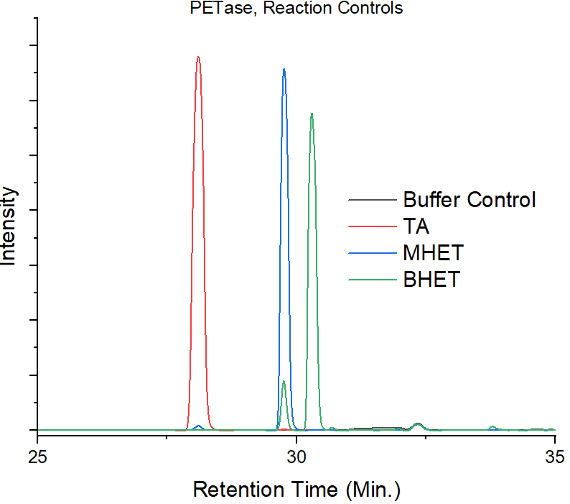
Figure 1: Graph depicting product controls and their retention time as they pass through the HPLC column. An important note is that the retention time is conditional on the system settings used and peaks may appear at different times depending on protocol.

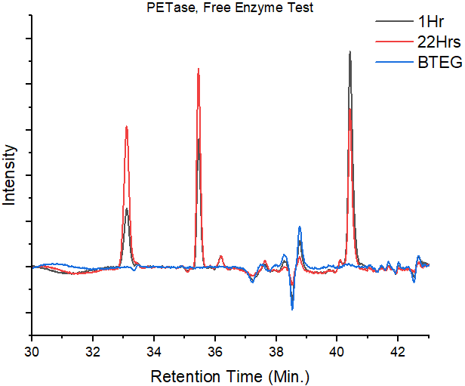
Figure 2: Results indicate that the free PETase enzyme successfully breaks down PET in solution.

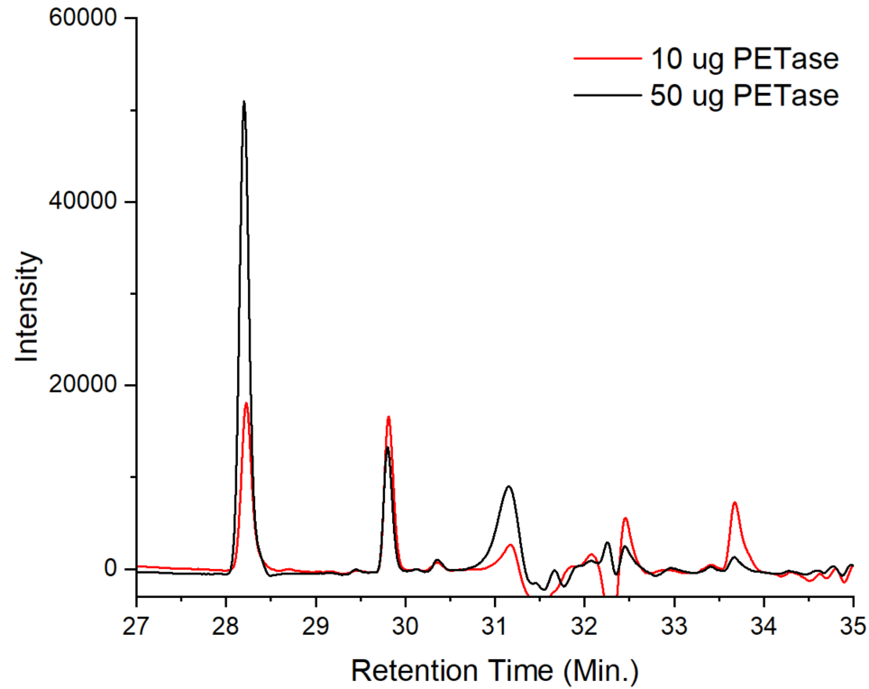
Figure 3: Increasing concentration of PETase leads to a proportional increase in reaction products. Results suggest that the reaction rate is limited by access to substrate.

Discussion
Unless otherwise stated, all reactions were undertaken under standard conditions in pH 8 100mM Phosphate buffer, at a volume of 1 mL, with 100 mg of PET, 0.05% Tween-20, and at a temperature of 65 °C. When we analyze our results, we can see that the enzyme successfully performs the desired reaction, breaking down polymeric PET into smaller polymers and the final monomeric Terephthalic acid (Figure 1 & 2). When the amount of enzyme was increased from 10 ug to 50 ug, there was a substantial shift in the proportion of products toward the final product while the other intermediates showed little change (Figure 3). This indicates that as the product is formed, the enzyme interacts with other, longer polymeric substrates to continue breaking down PET into smaller parts. During analysis, these longer polymeric chains were observed in HPLC, but remain to be quantified. Gaining access to an HPLC-MS would better facilitate the product analysis steps.

4.2 Milestone 2 - Evaluation enzyme immobilization with COFS
Milestone Objective | To evaluate the effectiveness of the COF immobilization, free enzymes will be combined with synthesized COFs in solutions and allowed to absorb within the porous scaffold of the COF. The solution will then be replaced, and the supernatant of each solution will be analyzed for protein concentration to determine the loading and if there is any leaching of protein from the framework. This will allow us to determine if the enzymes remain immobilized or if they will require anchoring to the COF structure.
Planned Completion | 06/30/2026
Actual Completion | 05/15/2026
Status | Completed

Results
Absorbance of loading solution at 280 nm after 24 hours of loading did not exceed the control (A <= 0).

Discussion / Interpretation
Loading was conducted with 50 ug of enzyme and 1 mg of COF (TAPB-BPDA-COF) at a volume of 0.5 mL. The amount of enzyme within the COF was determined using UV-Visible spectroscopy. During analysis, absorbances were measured at 280 nm to observe the absorption from the aromatic groups of the protein’s amino acid residues. When measured, we observed that there was no measurable amount of protein in solution, indicating that all enzymes had been adsorbed into the interior of the COF pores. This is not surprising as we used an excess of COF in an effort to completely absorb the enzyme within the COF pore and allow freedom of movement or prevent confinement due to crowding from other enzymes.

3.3 Milestone 3 - Evaluation of enzyme reactions while immobilized with COF
Milestone Objective | To evaluate whether the enzymes are active in their immobilized state, we will perform a range of activity assays to determine the effectiveness of enzyme activity. This will allow us to determine whether the enzyme remains active, and if there are any changes (positive or negative) in the efficiency of the enzyme reaction upon immobilization.
Planned Completion | 06/30/2026
Actual Completion | 05/15/2026
Status | Complete

Results
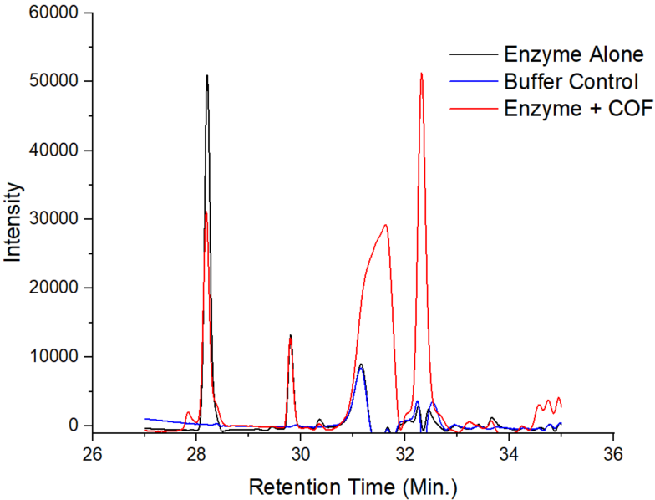
Figure 4: HPLC results from the initial test of immobilized enzyme within the COF pores.

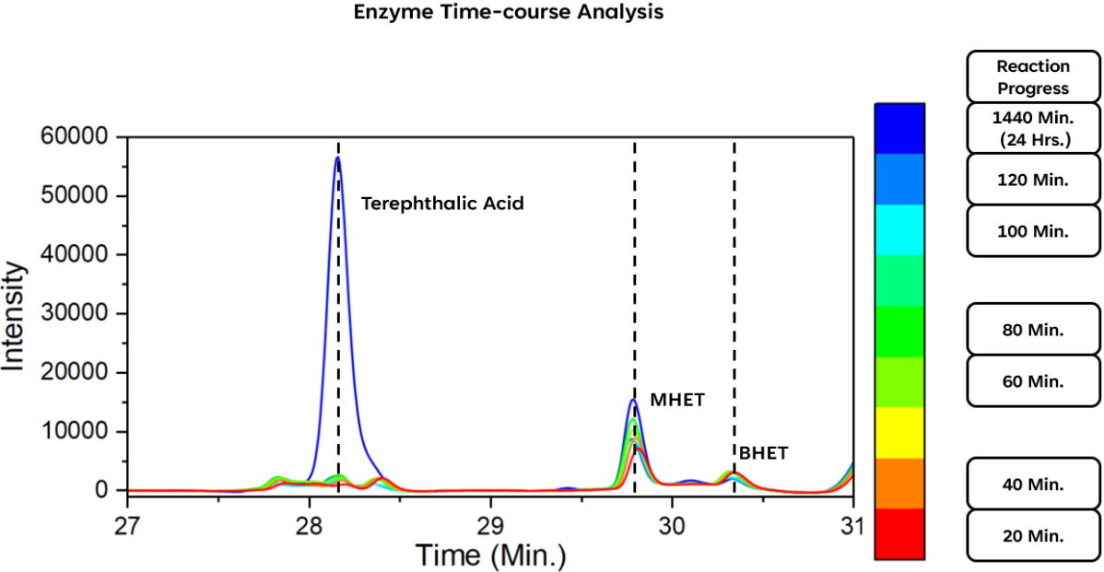
Figure 5: Time-course analysis of products from immobilized enzyme within COF reaction.

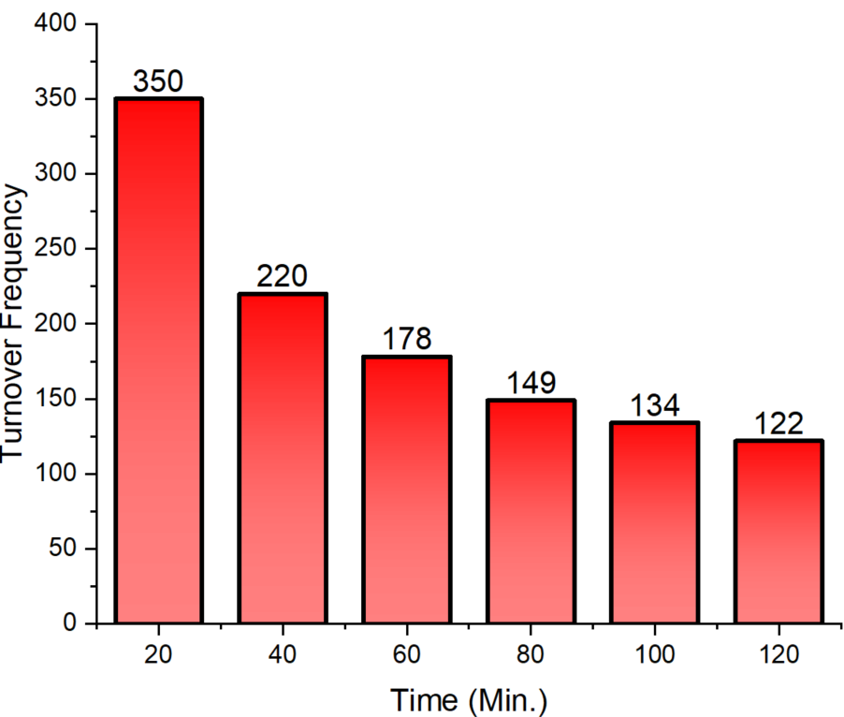
Figure 6: Calculated turnover frequency of immobilized FAST-PETase immobilized within COF.

Discussion
Following the success of enzyme immobilization within the pores of the COF, we performed reactions under our previously stated standard conditions. The first reaction, when compared to our free enzyme (Figure 4) showed similar, although somewhat diminished activity compared to that of the free enzyme. This can be expected because of the difficulty that comes with the immobilization of the enzyme within the channel pore of the COF. Within this space, the enzyme substrate must enter through the end of the channel to reach the active site of the enzyme, a mass transfer obstacle that is common among these types of reactions. Next, we further tested the immobilized enzyme over time. We then calculated the turnover frequency at 24 hours which we noticed was sluggish at 122 umol h⁻¹ mg⁻¹ (Figure 5). This slow reaction rate can be attributed to the poor pre-treatment of the PET flake substrate. This is clear when we observe the rate of reaction as time progresses (Figure 6). This data shows that as the reaction progresses, the rate of the enzyme catalysis decreases, indicating that as the PET in solution is broken down, its concentration and availability decreases. Thus, slowing the reaction. This is evident from the negative slope of the bar graph above. However, the initial turnover frequency is expected at 350, reaching the top range on the free enzyme in literature which has an expected range of between 246-348. Together, this data clearly shows that while the enzyme has the capacity to perform well, the current pre-treatment protocol is insufficient to meet the required demands of the reaction.

4. Overall Conclusions & Recommendations

4.1 Summary of Outcomes
Together, these results clearly show that the enzyme in functional for the desired reaction to break down PET into a final product of Terephthalic Acid and by extrapolation, Ethylene Glycol while immobilized with a COF protective housing. While this fulfills the scope of work for this study, further research is necessary to optimize the reaction, its conditions, and the pre-treatment steps in order to fully leverage the combination of the enzyme and framework coupling.

4.2 Recommendations
Recommended items for study include, but are not limited to: pre-treatment procedure, enzyme:COF ratio, enzyme concentration, pet concentration, reaction temperature, recyclability of enzyme@COF, reaction vessel shape/size, reaction volume, duration of reaction, buffer type & concentration, solution pH, and solution composition including various solvents or solubilizing agents.

