Data Analysis

Part 1:

1. From the data collected the more you move away from the equator latitude 0 the colder it gets and if you start at the pole’s latitude 80, -80 and move to the equator it gets warmer. From both the southern hemisphere vs max temp and northern hemisphere vs max temp scatter plots you can see this is true.

When looking at the northern hemisphere vs max temp scatter plots the data is being looked at from latitude 0 to latitude 80. This would be starting place of the equator which is warm and moving to the North Pole which is cold there is a strong negative R-value -0.89 which supports the idea that as you move north away from the equator it gets colder.

When looking at the southern hemisphere vs max temp scatter plots the data is being looked at from latitude -80 to latitude 0. This would be starting place of the South Pole which is cold and moving to the equator which is warm there is a strong positive R- value 0.71 which supports the idea that as you move north away from the south pole it gets warmer.

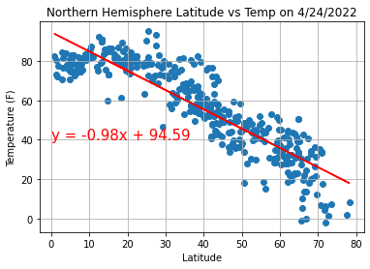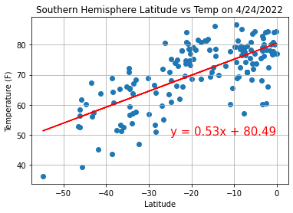

1. From the data collected the latitude you are at does not seem to affect the level of cloudiness you will experience as you travel north or south. From the Northern Hemisphere Latitude vs Cloudiness scatterplot, the R-Value is 0.18 which shows no correlations between the two. Also, for Southern Hemisphere Latitude vs Cloudiness scatterplot the R-Value is 0.19 which shows even less of a correlation between the two factors in question.

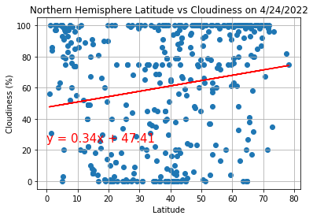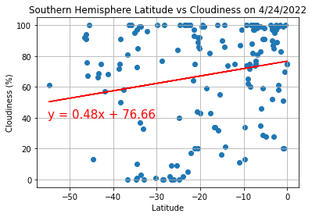

1. From the data collected the latitude you are at does not seem to have any strong correlation to the humidity that you might experience. There are extremely weak correlations that might hint that the more north you head the more humid it will be. Looking at Northern Hemisphere Latitude vs Humidity R-Value of 0.27 and Southern Hemisphere Latitude vs Humidity R-Value 0.37. You can see that both don’t have very strong R-Values, but both are moving in the positive direction. So, this leads me to believe there could be a weak correlation that as you move from -80 latitude to +80 latitude you might get more humidity.

0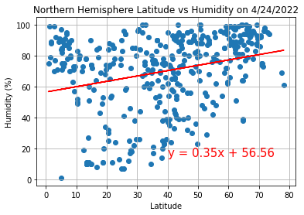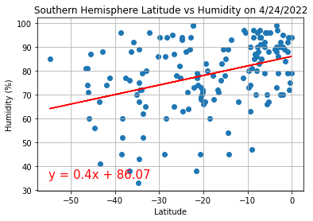

Part2:

Heat Map