This tool is designed to help a user determine the amount of greenhouse gases emitted from seaweed aquaculture production. Specifically, a user can input materials and quantities used for the production of propagules, aka seed, and the construction, deployment, and operation of a long-line seaweed farm. A collection of input values is then used to populate a life cycle contribution model (Fig. 1) to determine the total equivalent amount of kilograms of carbon dioxide (CO2-eq) emitted per hectare of farm per year, otherwise known as the annual global warming potential (GWP).

Use the “Input” tab to populate the model with your data. All inputs should be recorded per hectare of farm per year. Inputs are reported in two stages: “Propagule Production” (on the left) and “Ocean Cultivation and Harvesting” (on the right). Inputs are selected from drop down menus, and quantities are specified using a slider bar (constrained by published values, and set to the average reported value for a given category) or manually. Note that some materials are assumed to last longer than one year. The GWP from producing these materials is then divided by the total life-time to estimate the annual GWP of each material, for example

$(10 kg CO2/kg steel/20yr life time = 0.5 kg CO2/kg steel/yr)$

Examples of material life-times are as follows: culture string = 1yr; long-lines = 5yrs; anchor = 20yrs; chains = 20yrs; support-line = 5yrs; buoys = 10yrs; buoy weights = 20yrs; buoy rope = 5yrs.[1]

After inputting all data, click the “Run Simulation” button at the top of the “Input” tab and go to the “Results” tab. Here, you will see the GWP (kg CO2-eq/ha/yr) for each input organized by stage, the percent contribution of each input’s GWP to the total GWP (propagule production + ocean cultivation and harvesting), and the total annual GWP. At the bottom of this page are two interactive figures to visually display results.

At any point a user can return to the “Input” tab and either manually change input values or click the “Reset Input” button at the top of the “Input” page to reset all of the input values to 0.

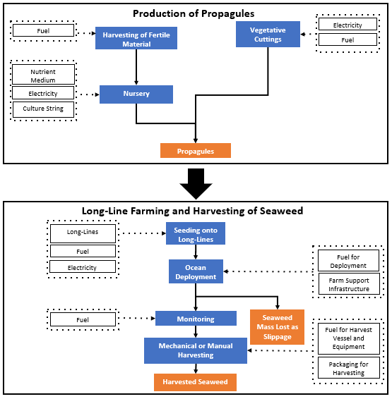

**Figure 1.** A conceptual model of propagule production and long-line ocean farming used to determine the annual global warming potential (GWP) from each input used. The blue boxes are life cycle processes, orange boxes are outputs, and white boxes are inputs modeled for each process.

1. Aitken, D., Bulboa, C., Godoy-Faundez, A., Turrion-Gomez, J. L., & Antizar-Ladislao, B. (2014). Life cycle assessment of macroalgae cultivation and processing for biofuel production. *Journal of Cleaner Production*, *75*, 45–56.