
Student Name: Fred Mwangi
Admission Number: BSCCS/2024/74352
Course/Class: BSCCS
Unit Code: BIT3208
Unit Name: Advanced Web Design and Development
Lecturer: Mr. Nyoro Michael
Semester/Academic Year:Year III, Sem II
Project Title: MediTrack Clinic Management System
Selected Technologies: Node.js + Express + MySQL
GitHub Link: https://github.com/mwas999-ux/BIT3208-MediTrack

Table of Content
Week 1 : Environment Setup 5
Fig 1.1 : Screenshots of installation ( node.js downoaded ) 5
Fig 1.2 : Screenshots of localhost running 5
Fig 1.3 : Screenshot of database connection success 5
Fig 1.4 : Basic project folder structure 6
Student Reflection 6
Week 2 : UI/UX and Design Foundations 6
Fig 2.1: Create a hand-drawn wireframe 7
Fig 2.2 : Insert the designed GUI 8
Fig 2.3 : Showing the mobile mockup 9
Project proposal summary 10
Student Reflection 10
Week 3: JavaScript and PHP Basics 11
Step 1: JavaScript Form Validation 11
Fig 3.1 : Form all validation errors showing 11
Fig 3.2 : Form phone validation error 12
Fig 3.3 : Form validation success 12
Step 2: Password strength checker 12
Figs 3.4 : Password strength checker showing Weak/Fair/Good/Strong 13
Step 3 : PHP Syntax Practice /Node.js equivalent: 13
Fig 3.5 : Node.js equivalent 13
Step 4 : Database Connection Script 14
Fig 3.6 : Database connection 14
Student Reflection: 14
Week 4: Server-side components 15
Fig 4.1 : Login form screenshots 15
Fig 4.2 :Form validation screenshots 15
PHP processing/Node.js/Express processing 16
Database connection screenshots 16
Code snippets 16
Screenshot of auth.js JWT middleware code 16
Folder structure 17
Student Reflection 18
Week 5 :Database Components 18
Fig 5.1 : Database screenshot 18
Fig 5.2 : Table Creation 18
CRUD operations 19
Login database integration 20
GitHub updates 20
Student Reflection 20

Week 1 : Environment Setup

Fig 1.1 : Screenshots of installation ( node.js downoaded )

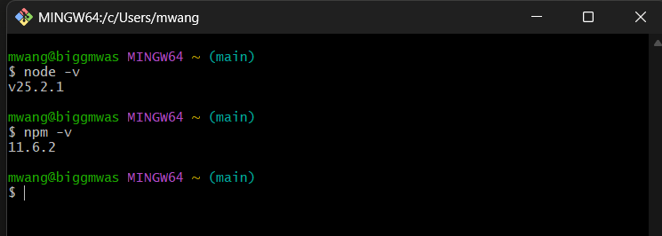

Fig 1.2 : Screenshots of localhost running

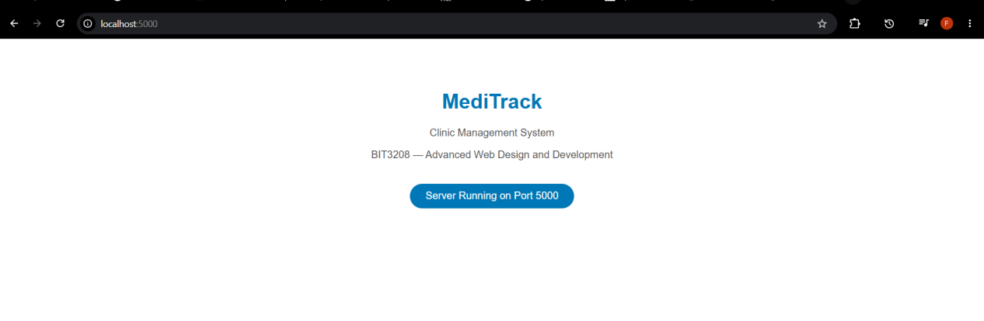

Fig 1.3 : Screenshot of database connection success

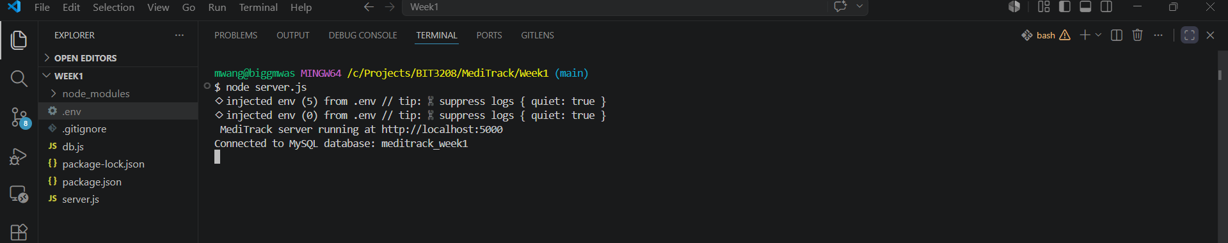

Fig 1.4 : Basic project folder structure

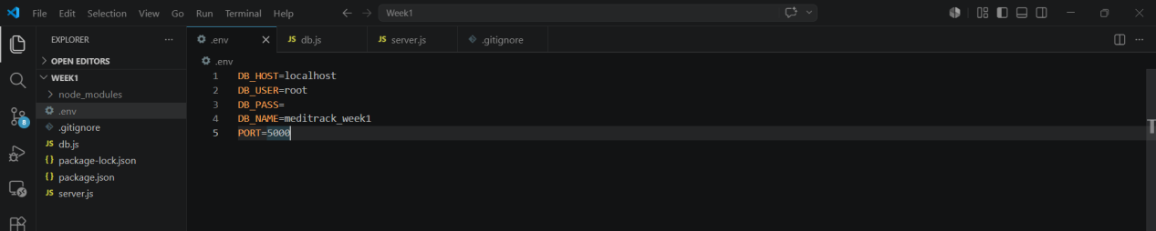

Student Reflection
This week involved setting up the local development environment for the MediTrack Clinic Management System. Node.js and MySQL were installed and tested successfully. A project folder structure was created at C:/Projects/BIT3208/MediTrack with separate folders for each week. A GitHub repository was initialized for version control.

Week 2 : UI/UX and Design Foundations

Fig 2.1: Create a hand-drawn wireframe
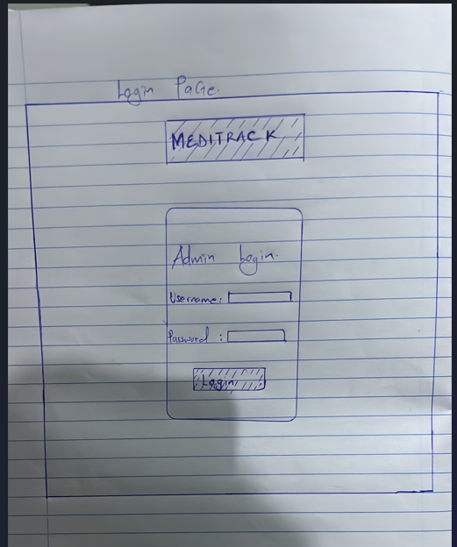

Fig 2.2 : Insert the designed GUI
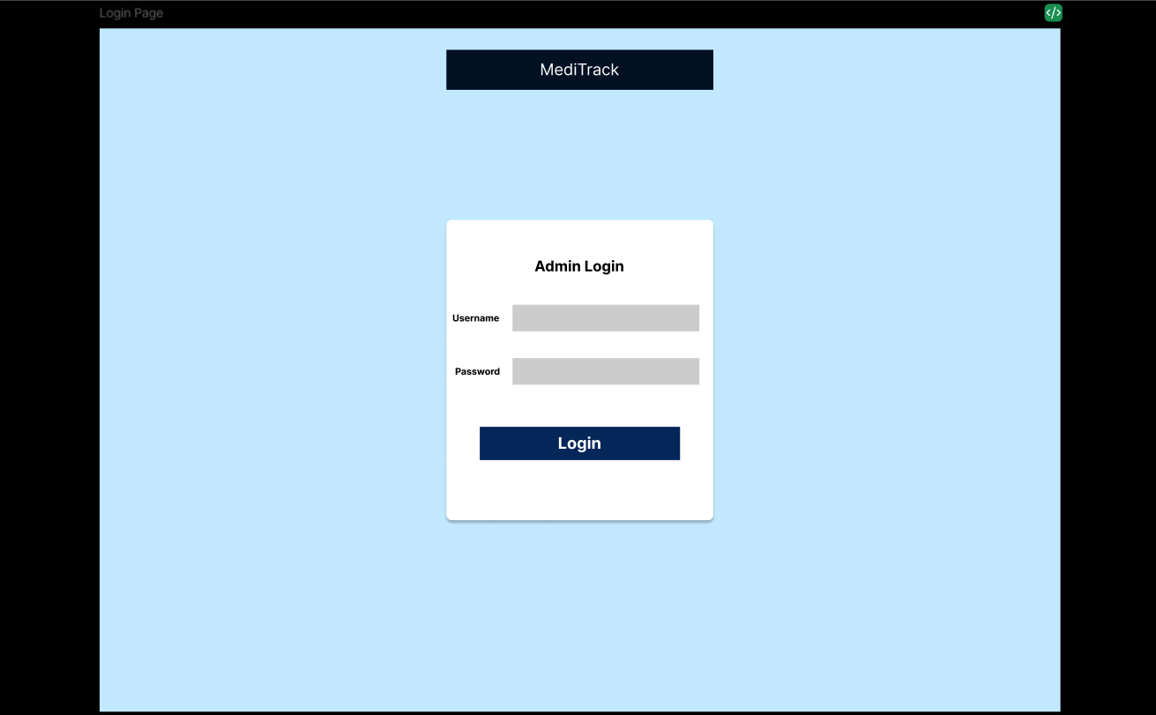
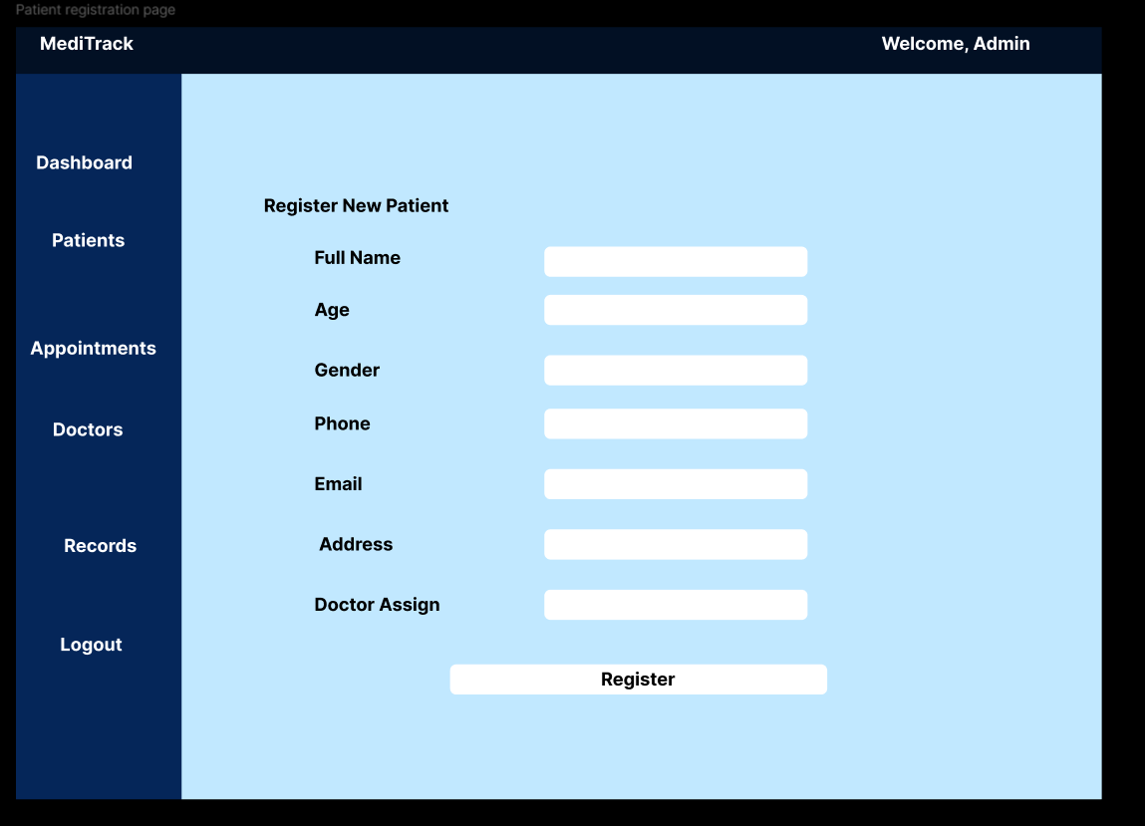
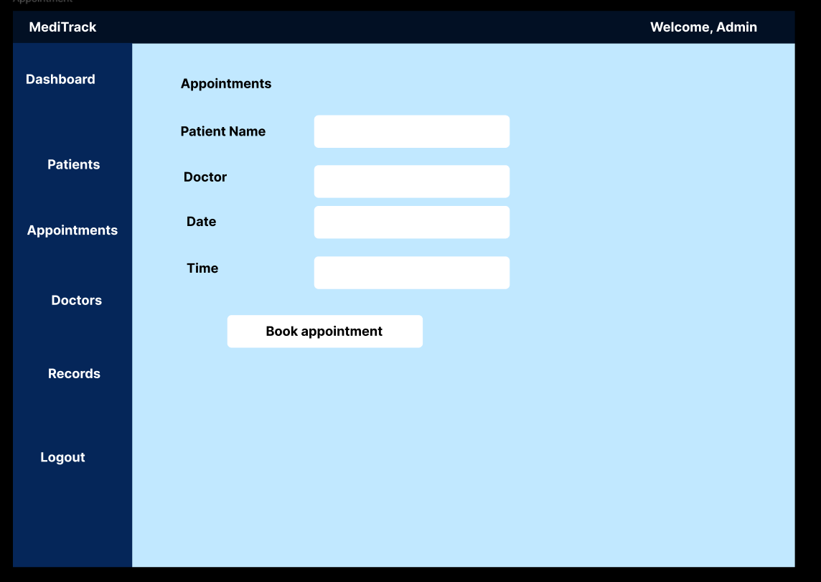

Fig 2.3 : Showing the mobile mockup
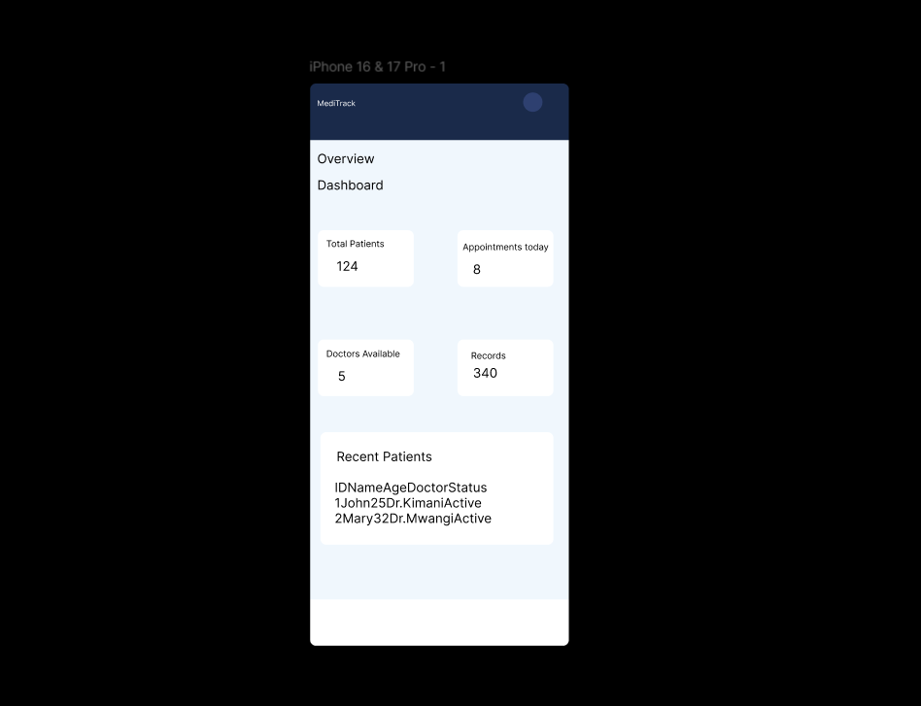

Project proposal summary
Project Name: MediTrack Clinic Management System
Objective: To develop a web-based clinic management system that enables efficient management of patients, doctors, appointments and medical records.
Selected Technologies:
- Frontend: HTML, CSS, JavaScript
- Backend: Node.js + Express.js
- Database: MySQL
- Version Control: GitHub
- Design Tool: Figma
Key Features to be Developed:
- Admin login and authentication
- Patient registration and management
- Doctor management
- Appointment booking system
- Medical records management
Target Users: Clinic administrators, doctors and receptionists
Step 4 : Folder planning
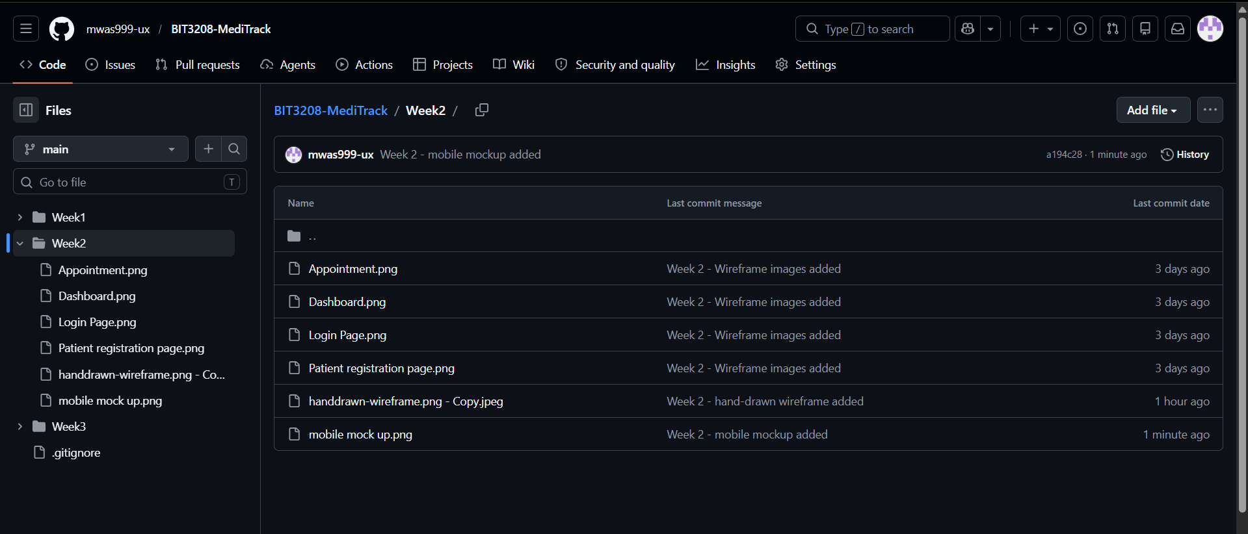

Student Reflection
This week focused on planning and designing the MediTrack Clinic Management System interface. Using Figma, wireframes were created for four key pages: Login, Dashboard, Patient Registration and Appointments. A consistent color palette of navy blues (#021024, #052659) and light blues (#C1E8FF) was selected to give the system a professional medical feel. The design follows a sidebar navigation layout with a top navbar, making it easy to navigate between sections. The project proposal was finalized confirming Node.js, Express and MySQL as the technology stack. All designs were committed to GitHub for version control.

Week 3: JavaScript and PHP Basics

Step 1: JavaScript Form Validation
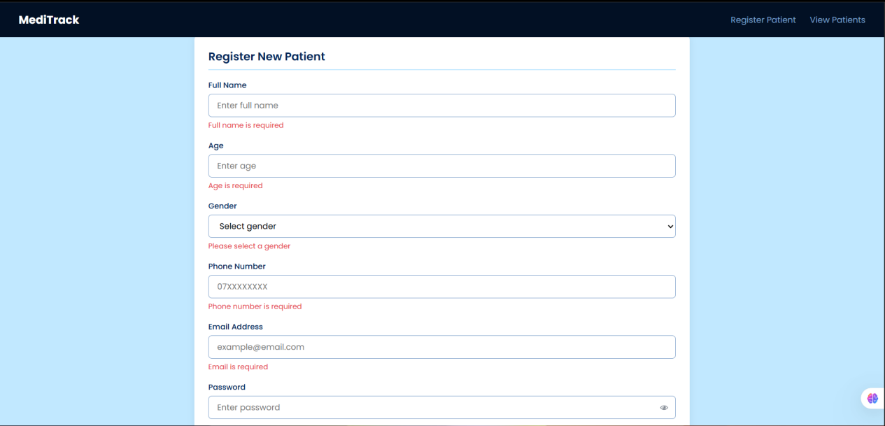

Fig 3.1 : Form all validation errors showing
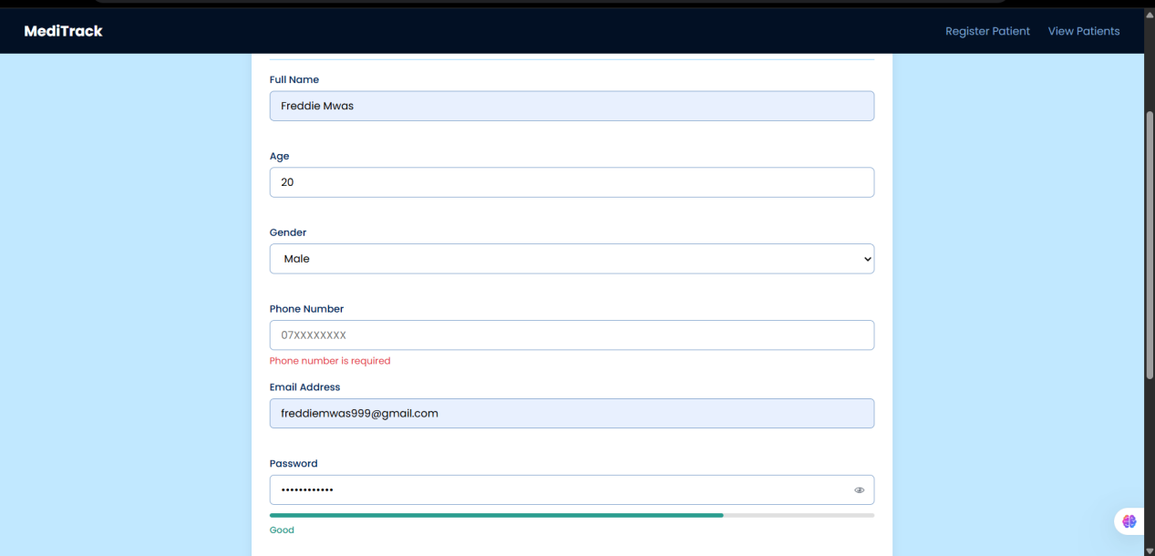

Fig 3.2 : Form phone validation error
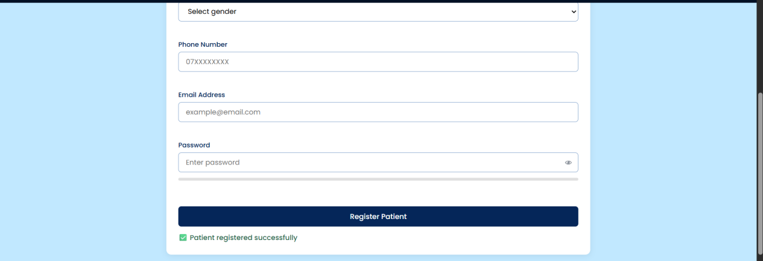

Fig 3.3 : Form validation success

Step 2: Password strength checker
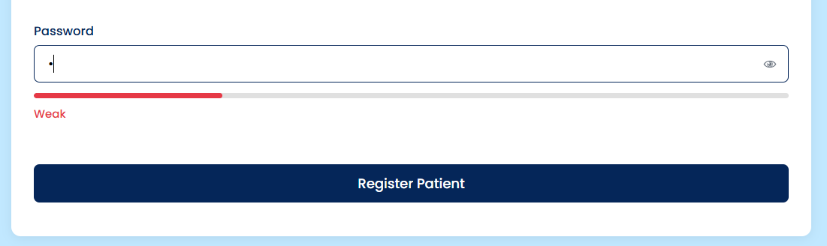
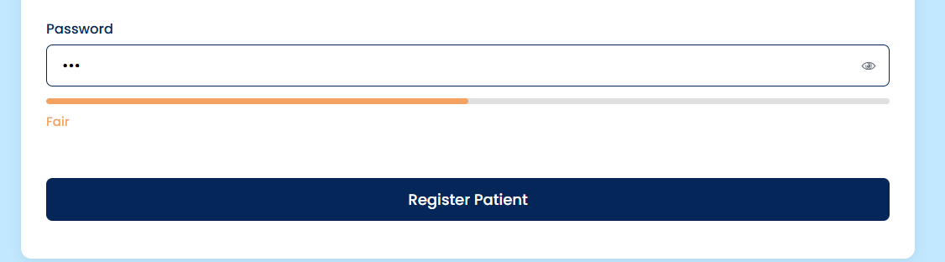
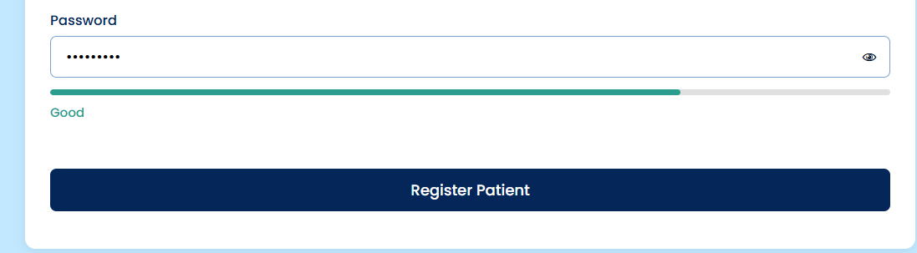
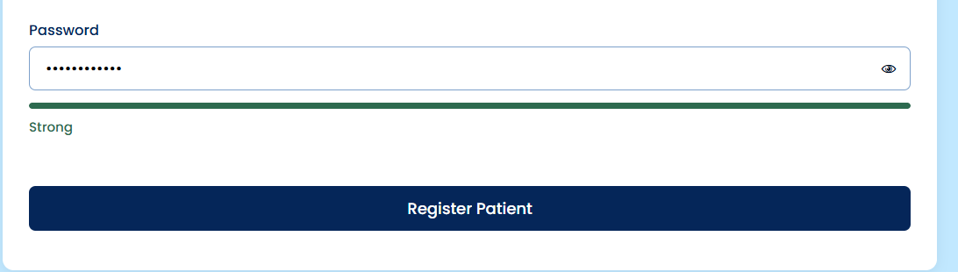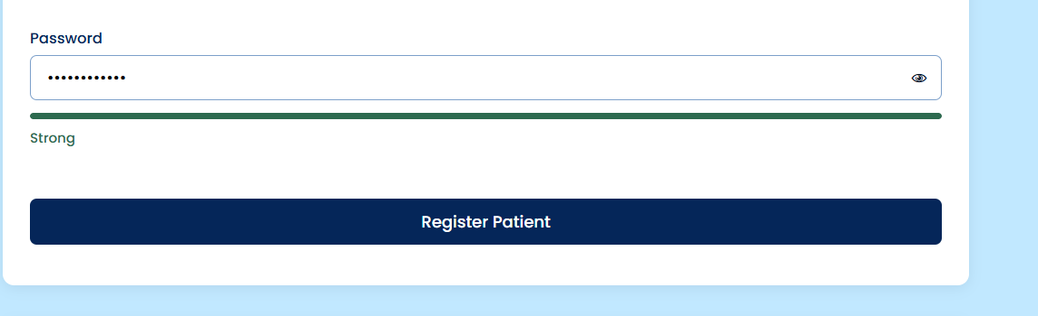

Figs 3.4 : Password strength checker showing Weak/Fair/Good/Strong

Step 3 : PHP Syntax Practice /Node.js equivalent:
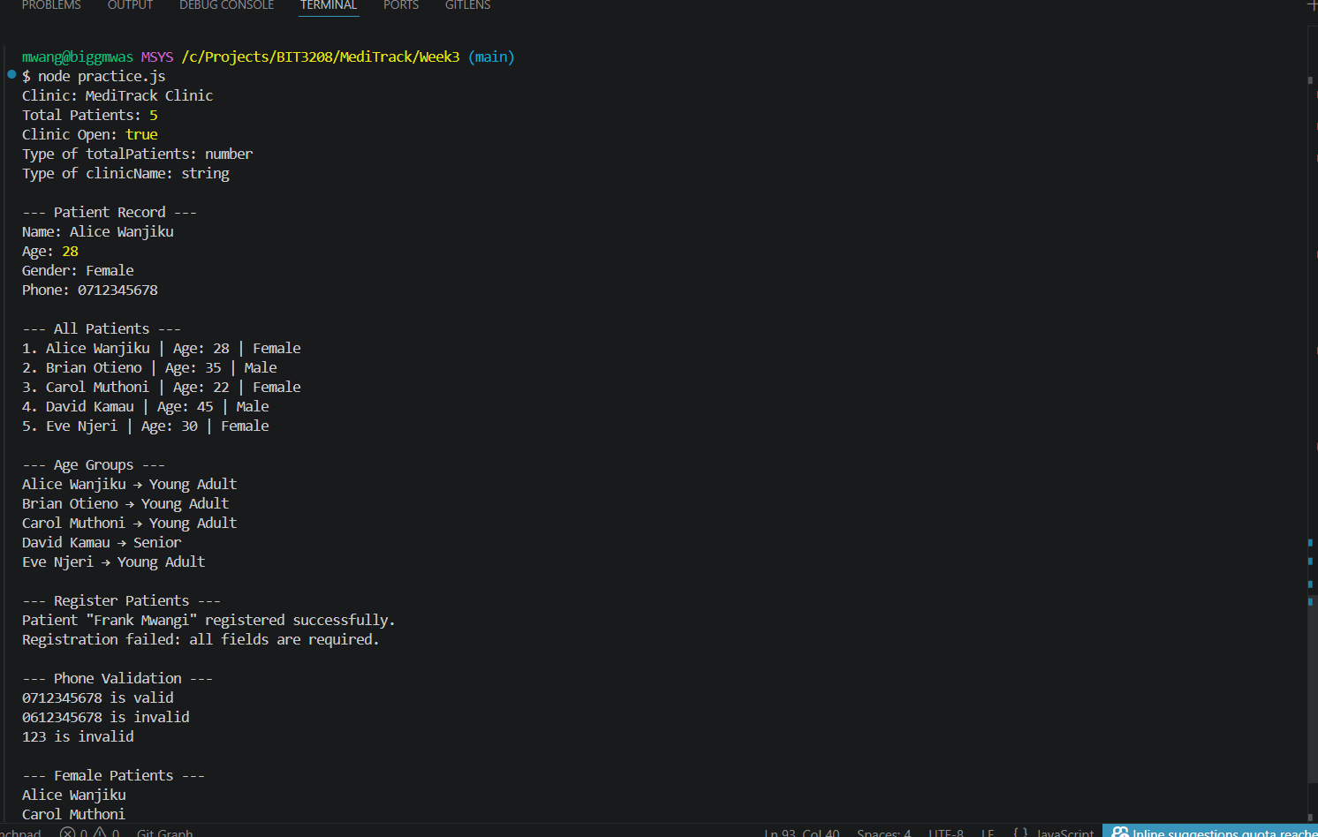

Fig 3.5 : Node.js equivalent

Step 4 : Database Connection Script

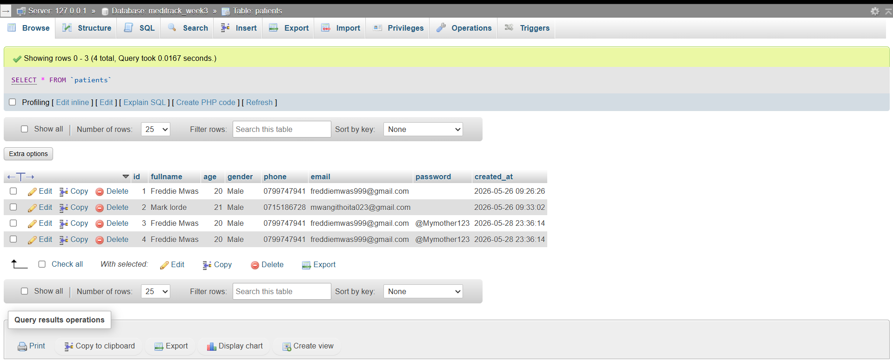

Fig 3.6 : Database connection

Student Reflection:
This week introduced frontend scripting and backend foundations for MediTrack. A patient registration form was built with full JavaScript validation including name, age, gender, phone and email checks. A password strength checker was implemented showing Weak, Fair, Good and Strong levels. DOM manipulation was demonstrated through dynamic error messages and success notifications. Patient data was saved to and retrieved from MySQL using Node.js and Express.

Week 4: Server-side components

Fig 4.1 : Login form screenshots
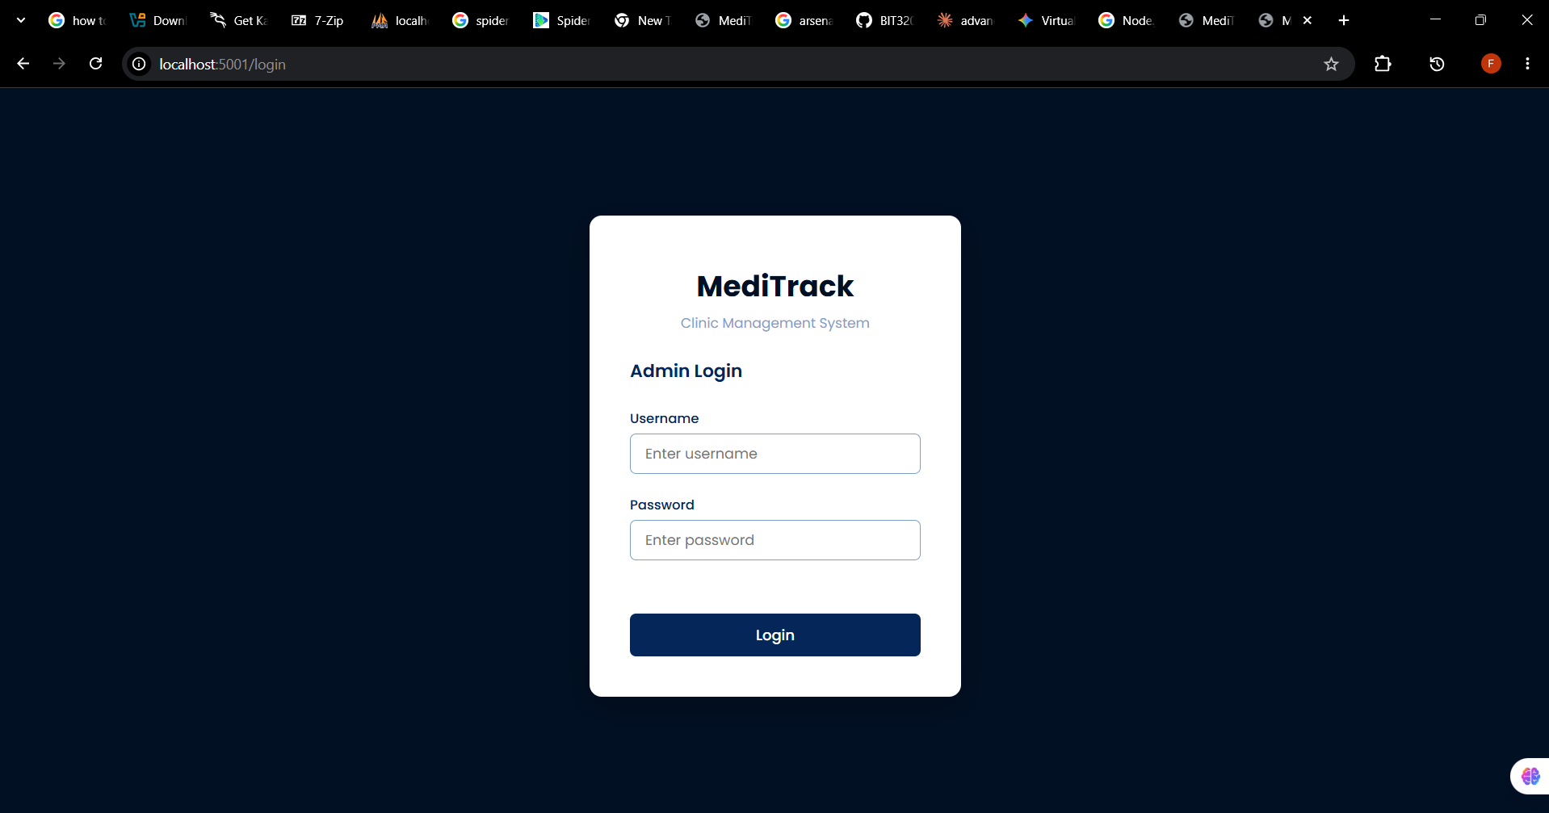

Fig 4.2 :Form validation screenshots
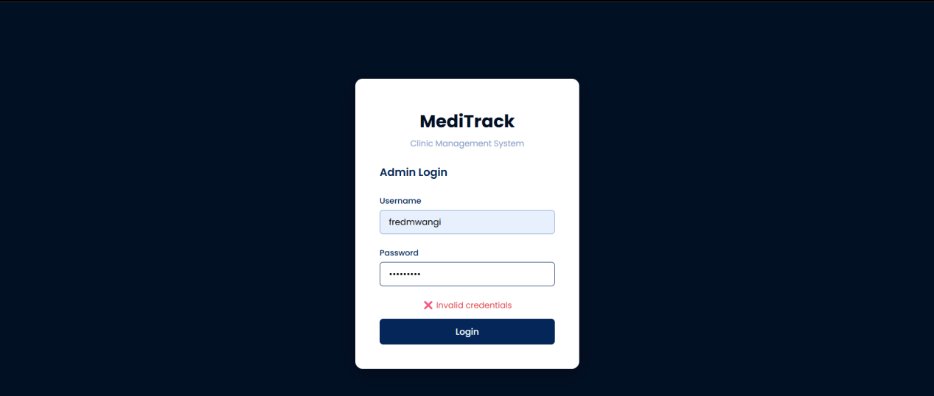

PHP processing/Node.js/Express processing
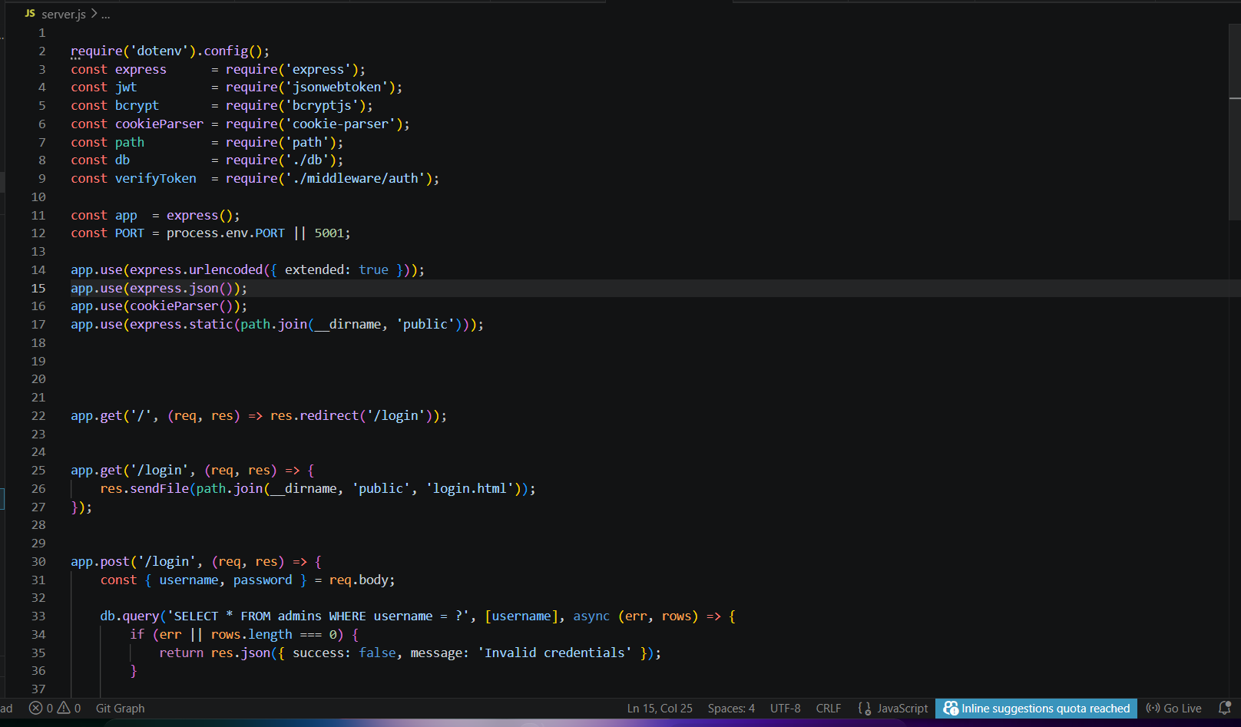

Database connection screenshots
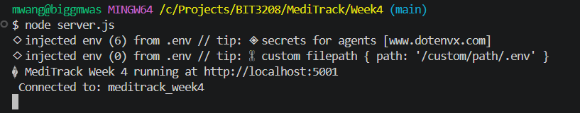

Code snippets
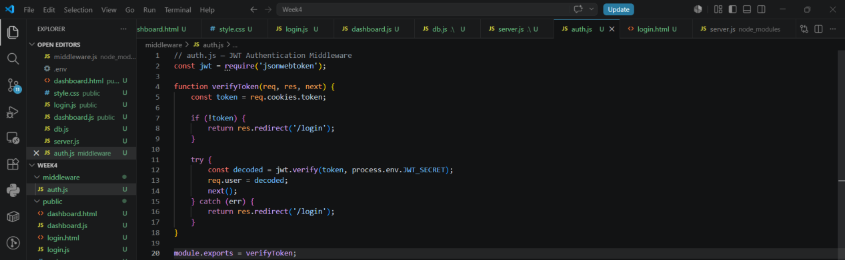

Screenshot of auth.js JWT middleware code

Folder structure
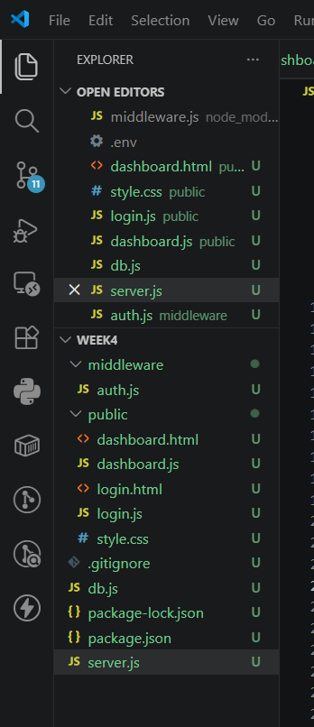

Student Reflection
This week implemented secure admin authentication for MediTrack using JWT (JSON Web Tokens) — the modern equivalent of PHP sessions. An admin login page was created with JavaScript validation. Upon successful login the server generates a JWT token stored in an HTTP-only cookie. A middleware file verifies the token on every protected route. bcryptjs was used to hash and verify passwords securely.

Week 5 :Database Components

Fig 5.1 : Database screenshot

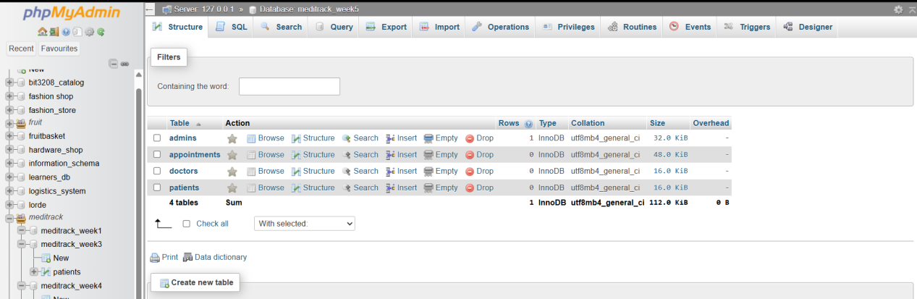

Fig 5.2 : Table Creation

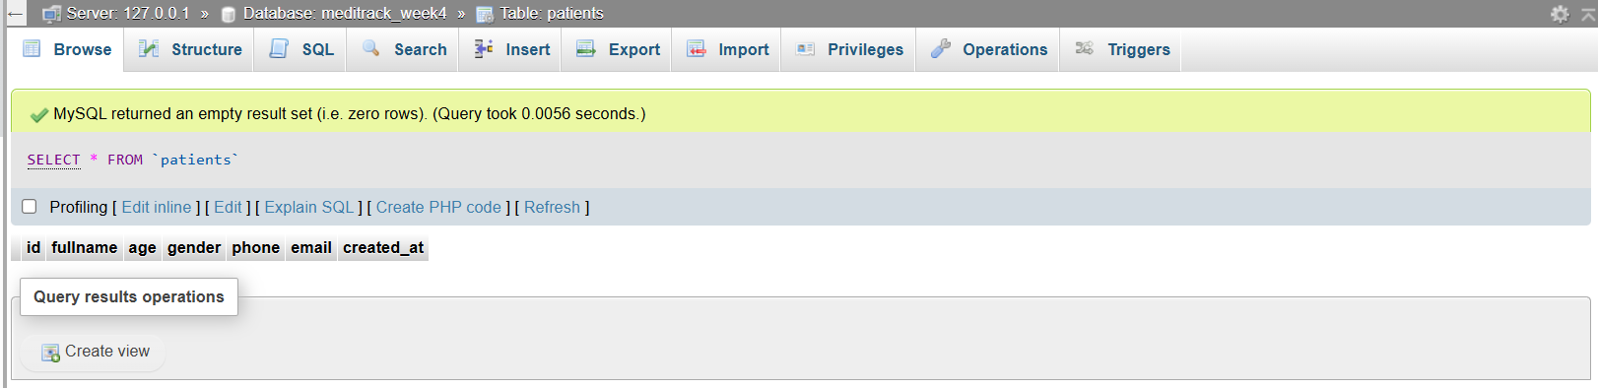

CRUD operations
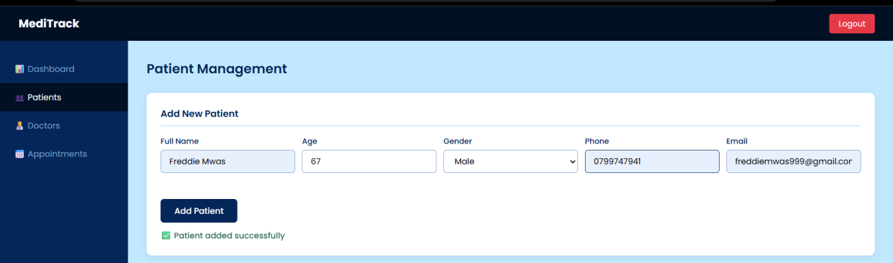
Fig 5.3 : CREATE
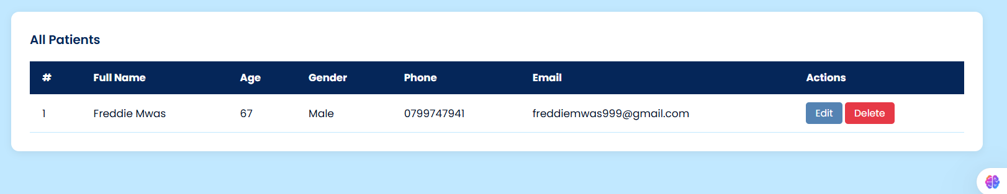
Fig 5.4 : READ
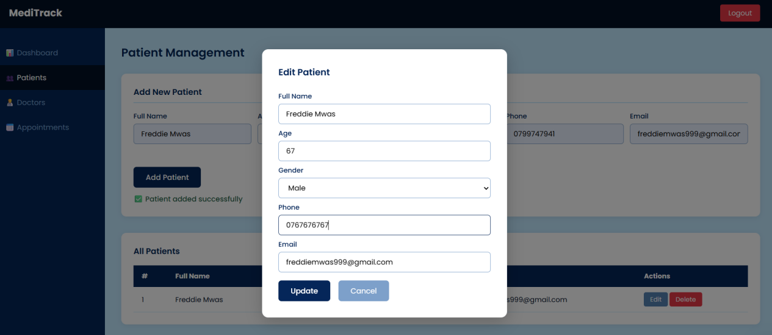
Fig 5.5 : UPDATE
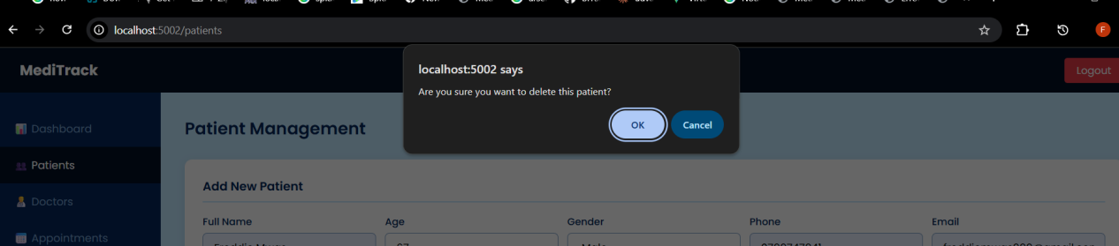
Fig 5.6 DELETE

Login database integration
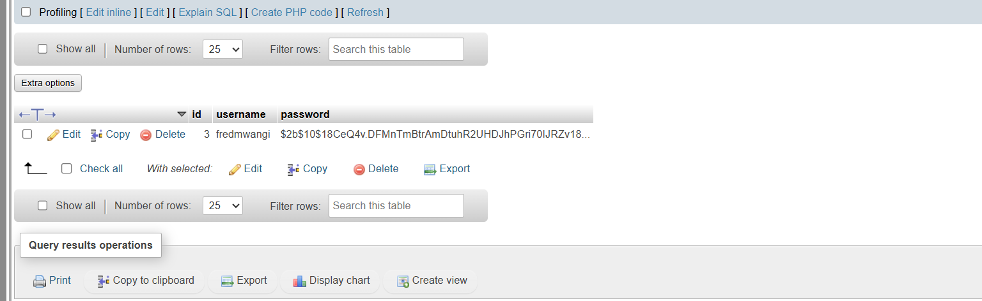

GitHub updates

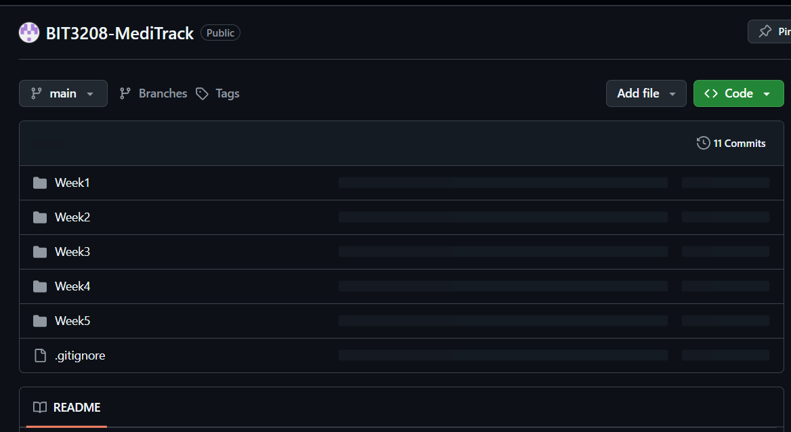

Student Reflection
This week implemented full CRUD operations across three entities: Patients, Doctors and Appointments. The system now allows adding, viewing, editing and deleting patients, adding and deleting doctors, and booking and cancelling appointments. All operations are protected by JWT authentication. SQL JOIN queries were used to fetch appointment data combining patient and doctor information from related tables.

