

BIT4138: Advanced Cryptography
Student Name: Fred Mwangi
Admission Number: BSCCS/2024/74352
Course/Class:Computer Science
Unit Code: BIT4138
Unit Name: Advanced Cryptography:
Lecturer Name:Michael Nyoro
Semester/Academic Year: Year 3 sem 2
Project Detail : Secure Login & Authentication System
Selected Technologies : Python + Flask, Python Cryptography Library, MySQL/SQLite, OpenSSL
Github repo : https://github.com/mwas999-ux/SecureLoginSystem

Table of Content
BIT4138: Advanced Cryptography 1
Week 1: Cryptography Environment Setup 7
Fig 2: Installation of Cryptography Libraries 7
Fig 3: OpenSSL Installation Test 7
Fig 4: Local Encryption Script ExecutionFig 5: GitHub Repository Initialization 7
Student Reflection 8
Week 2: Classical Cryptography and Cipher Design 8
Title 8
Fig 1: Caesar Cipher Implementation 9
Fig 2: Vigenère Cipher Encryption Process 9
Fig 3: Encryption and Decryption Output 9
Fig 4: User Input Validation Interface 10
Fig 5: Cipher Testing Results 10
Student Reflection 10
Week 3: Stream Ciphers and Randomness Testing 10
Title 11
Fig 1: LFSR Generator Implementation 11
Fig 2: Pseudorandom Sequence Output 11
Fig 3: Statistical Randomness Testing 11
Fig 4: RC4 Stream Cipher Simulation 12
Fig 5: Encryption Performance Results 12
Student Reflection 12
12
Week 4: Block Cipher Design and AES 12
Title 12
Fig 1: AES Encryption Script 12
. 13
Fig 2: Key Generation Process 13
Fig 3: File Encryption Demonstration 13
Fig 4: Decryption Results 14
Fig 5: AES Performance Testing 14
Student Reflection 14

Week 5: Public Key Cryptography (RSA) 14
Title 14
Fig 1: RSA Key Pair Generation 15
Fig 2: Public Key Encryption Process 15
Fig 3: Private Key Decryption Results 15
Fig 4: Secure Message Transmission 16
Fig 5: RSA Testing and Validation 16
Student Reflection. 16

Week 1: Cryptography Environment Setup

Title:
Installation and Configuration of Cryptography Development Environment
Fig 1: Installation of Python and VS Code
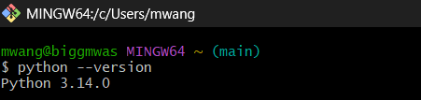

Fig 2: Installation of Cryptography Libraries
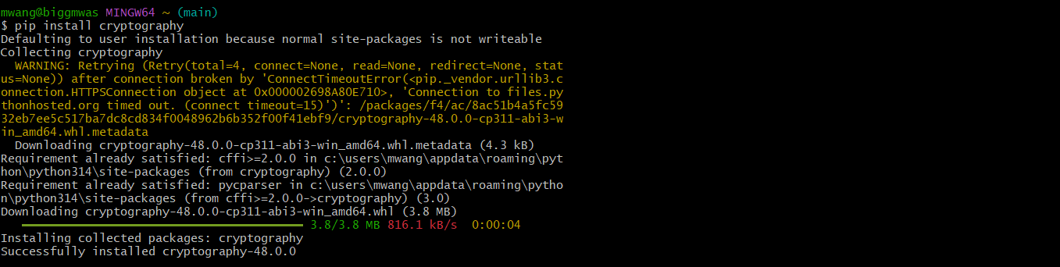

Fig 3: OpenSSL Installation Test
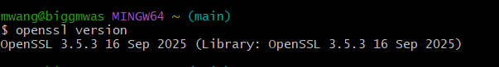

Fig 4: Local Encryption Script Execution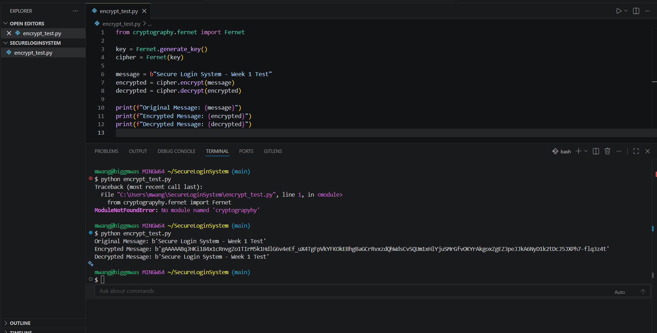Fig 5: GitHub Repository Initialization

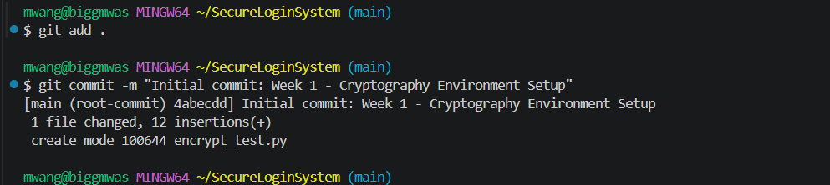Student Reflection
Learned how to configure a cryptography development environment using Python 3.14, OpenSSL 3.5.3, Flask, and the Cryptography library. Screenshots demonstrate successful tool installations, library setup, and a working Fernet encryption and decryption script. Challenges included resolving Flask PATH errors and a module import typo. All tools are now fully operational.

Week 2: Classical Cryptography and Cipher Design

Title:
Implementation of Classical Encryption Algorithms

Fig 1: Caesar Cipher Implementation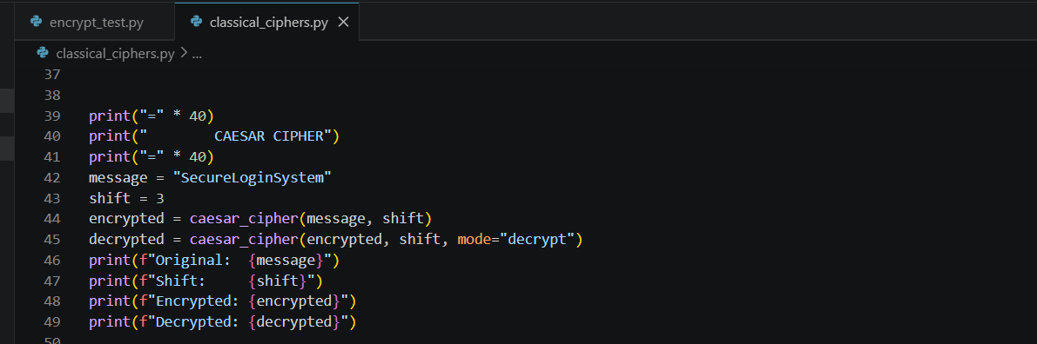

Fig 2: Vigenère Cipher Encryption Process
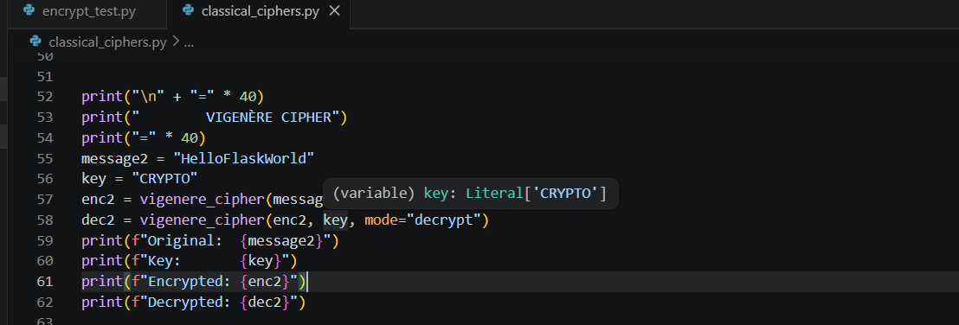

Fig 3: Encryption and Decryption Output
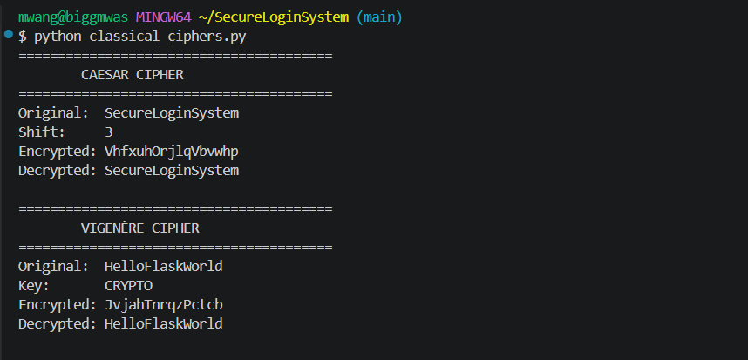

Fig 4: User Input Validation Interface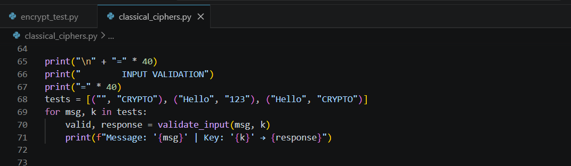
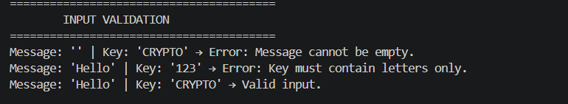

Fig 5: Cipher Testing Results

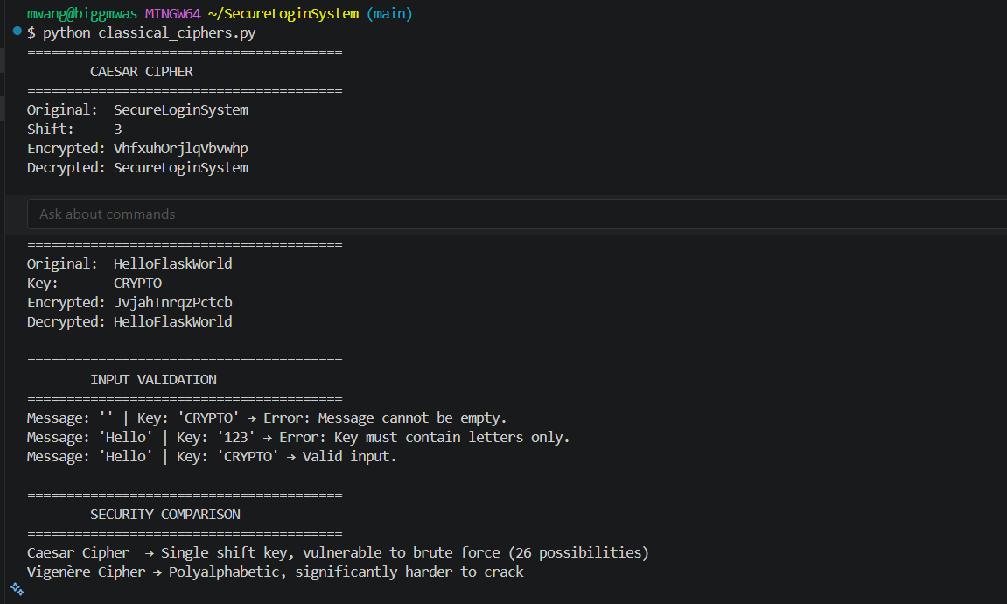Student Reflection
Implemented Caesar and Vigenère cipher algorithms in Python, learning how modular arithmetic drives character shifting and polyalphabetic encryption. Screenshots demonstrate both implementations, encryption and decryption outputs, and input validation handling. The Vigenère key cycling logic was the main challenge. Vigenère proved significantly more secure than Caesar due to variable shifting.

Week 3: Stream Ciphers and Randomness Testing

Title:
Implementation of Stream Cipher Systems and Random Sequence Analysis

Fig 1: LFSR Generator Implementation
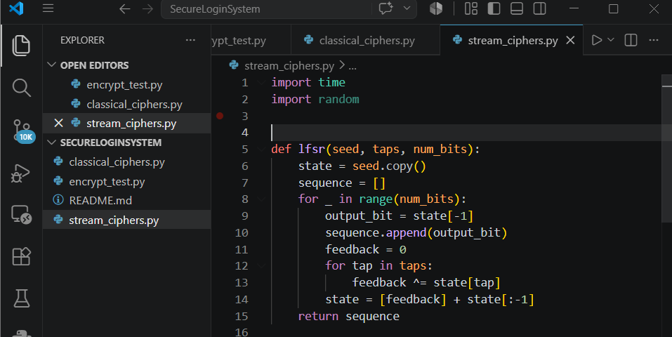

Fig 2: Pseudorandom Sequence Output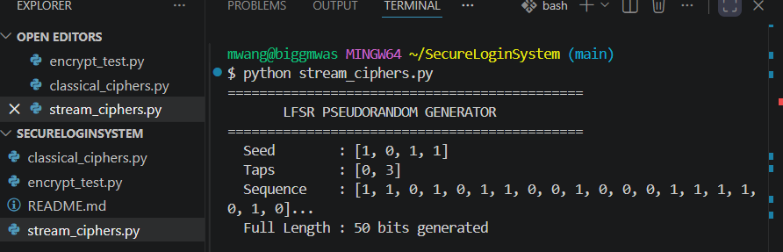

Fig 3: Statistical Randomness Testing
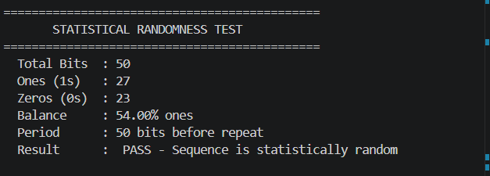

Fig 4: RC4 Stream Cipher Simulation
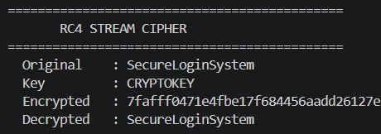

Fig 5: Encryption Performance Results
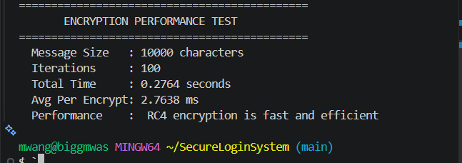

Student Reflection

Learned that randomness in cryptography ensures unpredictable keystreams, making ciphertext harder to crack. RC4 stream cipher operates by generating a pseudorandom keystream via KSA and PRGA, then XORing it with the message. Statistical frequency testing confirmed the LFSR sequence was balanced. Pseudorandom generation is critical — a weak generator compromises the entire encryption system

Week 4: Block Cipher Design and AES

Title:
Advanced Encryption Standard (AES) and Block Cipher Operations

Fig 1: AES Encryption Script

.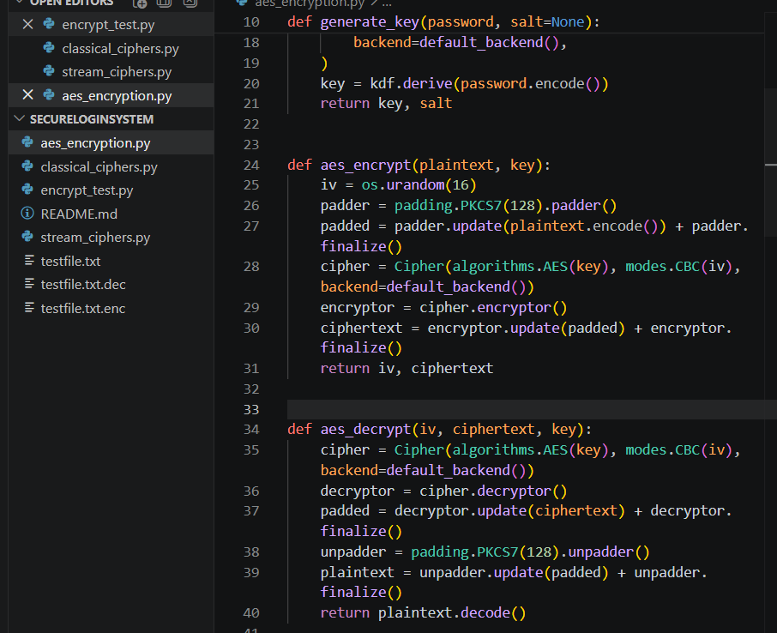

Fig 2: Key Generation Process
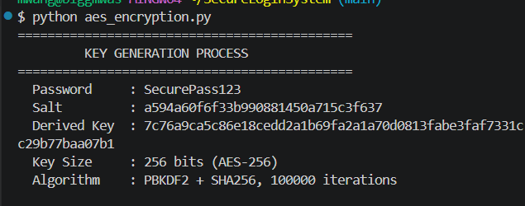

Fig 3: File Encryption Demonstration
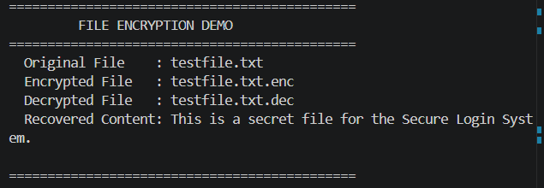

Fig 4: Decryption Results
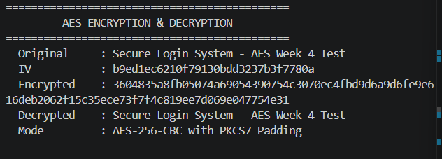

Fig 5: AES Performance Testing
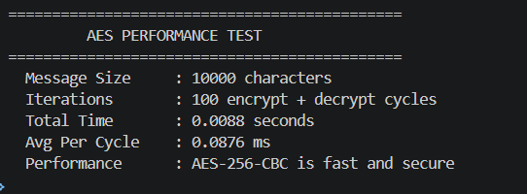

Student Reflection

AES-256-CBC encrypts data in 16-byte blocks using a derived key, IV, and PKCS7 padding. Key security is critical — PBKDF2 with SHA256 and 100,000 iterations prevents brute force attacks. Screenshots demonstrate key generation, encryption, file encryption, and decryption. The main challenge was understanding CBC mode chaining and correctly handling padding during decryption.

Week 5: Public Key Cryptography (RSA)

Title:
Implementation of RSA Encryption and Key Management

Fig 1: RSA Key Pair Generation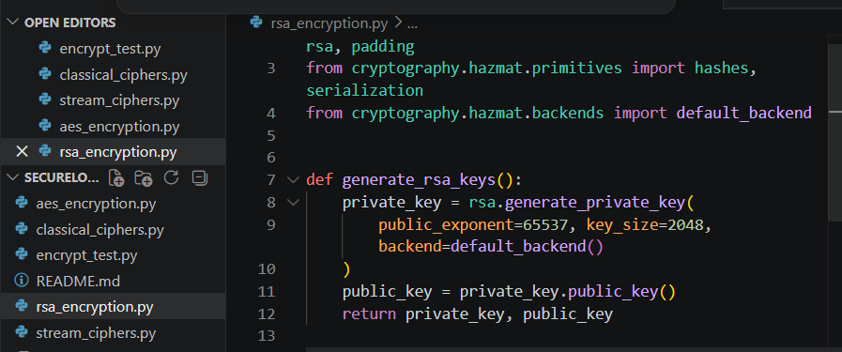

Fig 2: Public Key Encryption Process
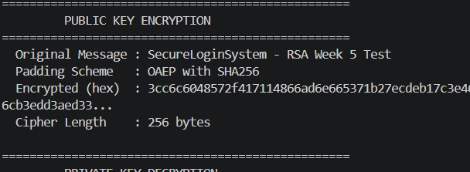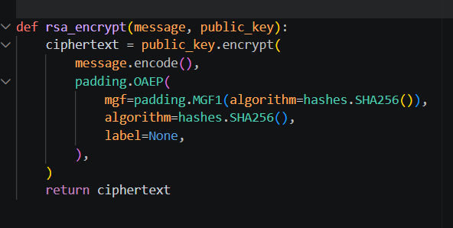

Fig 3: Private Key Decryption Results
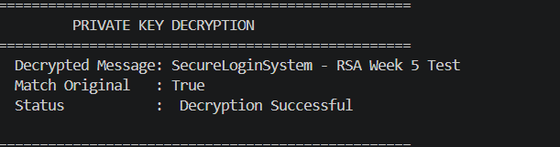

Fig 4: Secure Message Transmission
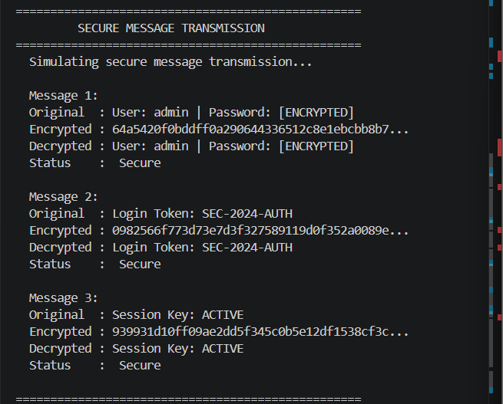

Fig 5: RSA Testing and Validation
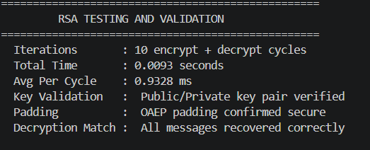

Student Reflection
Unlike symmetric AES which uses one shared key, RSA uses a public key to encrypt and a private key to decrypt, eliminating key sharing risks. Screenshots demonstrate key generation, encryption, decryption, and secure message transmission. RSA's security relies on prime factorization difficulty. Testing confirmed all messages were correctly encrypted and recovered.

