**IC project report sec a te**

oscillators

**GROUP MEMBERS**

* anum sheikh cs-008
* muhammad wasif cs-039
* waleed bin khalid cs-061
* junaid ur rehman cs-068

**OSCILLATORS**

An oscillator is a mechanical or electronic device that works on the principles of oscillation: a periodic fluctuation between two things based on changes in energy. Computers, clocks, watches, radios, and metal detectors are among the many devices that use oscillators.

Electronic oscillators are used to generate signals in computers, wireless receivers and transmitters, and audio-frequency equipment, particularly music synthesizers. There are many types of electronic oscillators, but they all operate according to the same basic principle: an oscillator always employs a sensitive amplifier whose output is fed back to the input in phase. Thus, the signal regenerates and sustains itself. This is known as positive feedback. It is the same process that sometimes causes unwanted "howling" in public-address systems.

The electronic oscillators are classified into two types.

1. Sinusoidal Oscillator
2. Non-Sinusoidal Oscillator

**SINUSOIDAL OSCILLATOR**

An electronic device that generates sinusoidal oscillations of desired frequency is known as a sinusoidal oscillator. The types of Sinusoidal Oscillator are

## FEEDBACK OSCILLATOR

There two types of feedback Oscillators:

* **RC Oscillator**

*In an RC oscillator circuit, the filter is a network of resistors and capacitors. RC oscillators are mostly used to generate lower frequencies, for example in the audio range. Common types of RC oscillator circuits are the phase shift oscillator and the Wien bridge oscillator.*

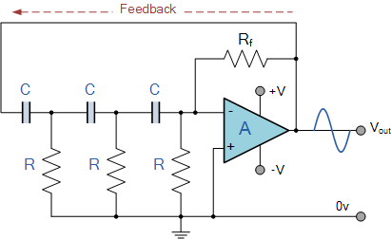

* **LC Oscillator**

# *In an LC oscillator circuit, the filter is a*[*tuned circuit*](https://en.wikipedia.org/wiki/Tuned_circuit)*(often called a tank circuit; the tuned circuit is a*[*resonator*](https://en.wikipedia.org/wiki/Resonator)*) consisting of an*[*inductor*](https://en.wikipedia.org/wiki/Inductor)*(L) and*[*capacitor*](https://en.wikipedia.org/wiki/Capacitor)*(C) connected together. Charge flows back and forth between the capacitor's plates through the inductor, so the tuned circuit can store electrical energy oscillating at its*[*resonant frequency*](https://en.wikipedia.org/wiki/Resonant_frequency)*. There are small losses in the tank circuit, but the amplifier compensates for those losses and supplies the power for the output signal. LC oscillators are often used at*[*radio frequencies*](https://en.wikipedia.org/wiki/Radio_frequency)*, when a tunable frequency source is necessary, such as in*[*signal generators*](https://en.wikipedia.org/wiki/Signal_generator)*, tunable radio*[*transmitters*](https://en.wikipedia.org/wiki/Transmitter)*and the*[*local oscillators*](https://en.wikipedia.org/wiki/Local_oscillator)*in*[*radio receivers*](https://en.wikipedia.org/wiki/Radio_receiver)*. Typical LC oscillator circuits are the*[*Hartley*](https://en.wikipedia.org/wiki/Hartley_oscillator)*, [Colpitts](https://en.wikipedia.org/wiki/Colpitts_oscillator" \o "Colpitts oscillator)and*[*Clapp*](https://en.wikipedia.org/wiki/Clapp_oscillator)*circuits.*

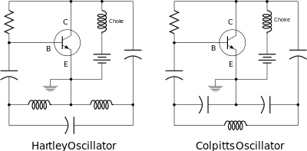

Different

**TYPES OF TRANSISTOR OSCILLATORS OR OSCILLATORS WITH LC FEEDBACK CIRCUIT**

A transistor can work as an oscillator to produce continuous undamped oscillations of any desired frequency if tank and feedback circuits are properly connected to it. All oscillators under different names have similar function i.e., they produce continuous undamped output. However, the major difference between these oscillators lies in the method by which energy is supplied to the tank circuit to meet the losses. The following are the transistor oscillators commonly used at various places in electronic circuits :

(i) Tuned collector oscillator

(ii) Colpitt’s oscillator

(iii) Hartley oscillator

(iv) Phase shift oscillator

(v) Wien Bridge oscillator

(vi) Crystal oscillator

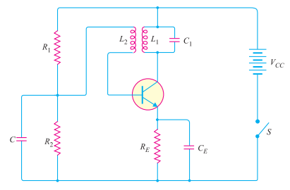**TUNED COLLECTOR OSCILLATOR**

*Fig.14.9 shows the circuit of tuned collector oscillator. It contains tuned circuit L1-C1 in the collector and hence the name. The frequency of oscillations depends upon the values of L1 and C1*

*The feedback coil L2 in the base circuit is magnetically coupled to the tank circuit coil L1. In practice, L1 and L2 form the primary and secondary of the transformer respectively. The biasing is provided by potential divider arrangement. The capacitor C connected in the base circuit provides low reactance path to the oscillations.*

*The LC circuit is often called tuned circuit or tank circuit.*

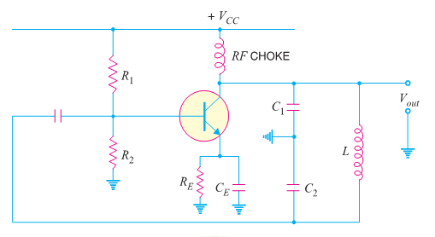**COLPITT’S OSCILLATOR**

*Fig. 14.10 shows a Colpitt's oscillator. It uses two capacitors and placed across a common inductor L and the centre of the two capacitors is tapped. Th e tank circuit is made up of C1, C2 and L. The frequency of oscillations is determined by the values of C1, C2 and L*

**CIRCUIT OPERATION.**

*When the circuit is turned on, the capacitors C1 and C2 are charged. The capacitors discharge through L, setting up oscillations of frequency determined by exp. (i). The output voltage of the amplifier appears across C1 and feedback voltage is developed across C2. The voltage across it is 180° out of phase with the voltage developed across C1 (Vout) as shown in Fig.*

*14.11. It is easy to see that voltage feedback (voltage across C2 ) to the transistor provides positive feedback. A phase shift of 180° is produced by the transistor and a further phase shift of 180° is produced by C1 − C2 voltage divider. In this way, feedback is properly phased to produce continuous undamped oscillation.*

**HARTLEY OSCILLATOR**

*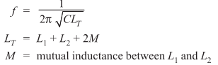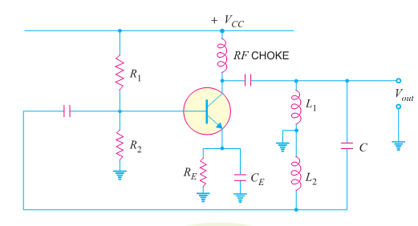The Hartley oscillator is similar to Colpitt’s oscillator with minor modifications. Instead of using tapped capacitors, two inductors L1 and L2 are placed across a common capacitor C and the centre of the inductors is tapped as shown in Fig. 14.13. The tank circuit is made up of L1, L2 and C. The frequency of oscillations is determined by the values of L1, L2 and C and is given by :*

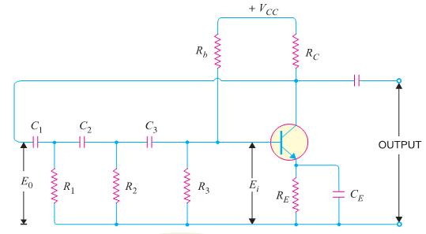**PHASE SHIFT OSCILLATOR**

*Fig.14.17 shows the circuit of a phase shift oscillator. It consists of a conventional single transistor amplifier and a RC phase shift network. The phase shift network consists of three sections R1C1, R2C2 and R3C3. At some particular frequency f0, the phase shift in each RC section is 60º so that the total phase-shift produced by the RC network is 180º.*

**CIRCUIT OPERATION.**

*When the circuit is switched on, it produces oscillations of frequency determined by exp. (i). The output E0 of the amplifier is fed back to RC feedback network. This network produces a phase shift of 180º and a voltage Ei appears at its output which is applied to the transistor amplifier*

**TRANSISTOR CRYSTAL OSCILLATOR**

*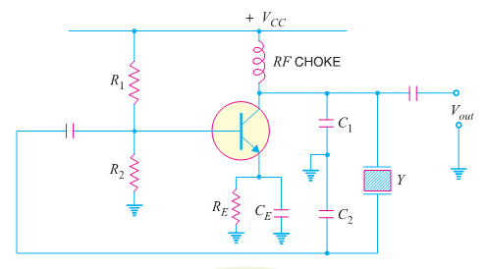Fig. 14.23 shows the transistor crystal oscillator. Note that it is a Collpit’s oscillator modified to act as a crystal oscillator. The only change is the addition of the crystal (Y) in the feedback net-work. The crystal will act as a parallel-tuned circuit. As you can see in this circuit that insteadof resonance caused by L and (C1 + C2), we have the parallel resonance of the crystal. At parallel resonance, the impedance of the crystal is maximum. This m eans that there is a maximum voltage drop across C1. This in turn will allow the maximum energy transfer through the feedback network at fp. Note that feedback is positive. A phase shift of 180° is produced by the transistor. A further phase shift of 180° is produced by the capacitor voltage divider. This oscillator will oscillate only at fp. Even the smallest deviation from fp will cause the oscillator to act as an effective short. Consequently, we have an extremely stable oscillator.*

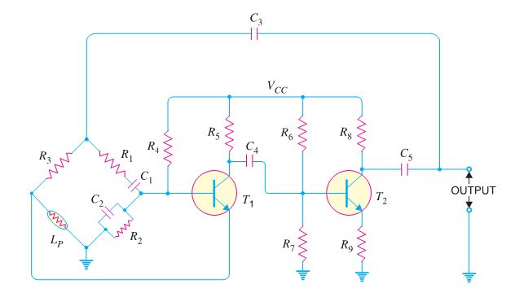**WIEN-BRIDGE OSCILLATOR**

*The Wien-bridge oscillator is the standard oscillator circuit for all frequencies in the range of 10 Hz to about 1 MHz. It is the most frequently used type of audio oscillator as the output is free from circuit fluctuations and ambient temperature. Fig. 14.18 shows the circuit of Wien bridge oscillator. It is essentially a two-stage amplifier with R-C bridge circuit. The bridge circuit has the arms R1 C1. R3, R2C2 and tungsten lamp Lp. Resistances R3 and Lp are used to stabilise the amplitude of the output. The transistor T1 serves as an oscillator and amplifier while the other transistor T2 serves as an inverter (i.e. to produce a phase shift of 180º). The circuit uses positive and negative feedbacks. The positive feedback is through R1C1, C2R2 to the transistor T1. The negative feedback is through the voltage divider to the input of transistor T2.*

**BUBBA OSCILLATOR**

*The bubba oscillator in Figure 18 is another phase-shift oscillator, but it takes advantage of the quad op-amp package to yield some unique advantages. Four RC sections require 45° phase shift per section, so this oscillator has an excellent dφ/dt resulting in minimal frequency drift. The RC sections each contribute 45° phase shift, so taking outputs from alternate sections yields low-impedance quadrature outputs. When an output is taken from each op amp, the circuit delivers four 45 phase-shifted sine waves. The loop equation is given in equation 15. When ω = 1/RCs, equation 15 reduces to equations 16 and 17.*

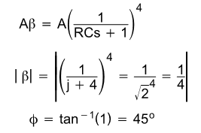

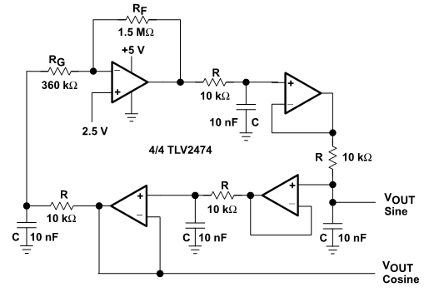

**NON-SINOSOIDAL OSCILLATOR**

It produces an output which has square, rectangle or sawtooth waveform or is of pulse shape. A common characteristic of all non-sinusoidal oscillators is that they are a form of **relaxation oscillator**. A relaxation oscillator stores energy in a reactive component during one phase of the oscillation cycle and gradually releases the energy during the relaxation phase of the cycle.

**TYPES OF NON-SINOSOIDAL OSCILLATORS**

### MULTIVIBRATOR OSCILLATOR

*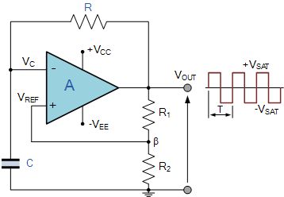Multivibrators**are relaxation oscillators that can function in either of two temporarily stable conditions and is capable of rapidly switching from one temporary state to the other. It is basically an oscillator consisting of two stages coupled together so that the input signal to each stage is taken from the output of the other. One stage conducts while the other stage is cut off, until a point is reached where the stages reverse their conditions. The circuit is free-running because of regenerative feedback.*

* **ASTABLE MULTIVIBRATOR**

*The Astable Multivibrator is another type of cross-coupled transistor switching circuit that has no stable output states as it changes from one state to the other all the time. The astable circuit consists of two switching transistors, a cross-coupled feedback network, and two time delay capacitors which allows oscillation between the two states with no external triggering to produce the change in state.*

*In electronic circuits, astable multivibrators are also known as Free-runni ng Multivibrator as they do not require any additional inputs or external assistance to oscillate. Astable oscillators produce a continuous square wave from its output which can then be used to flash lights or produce a sound in a loudspeaker.*

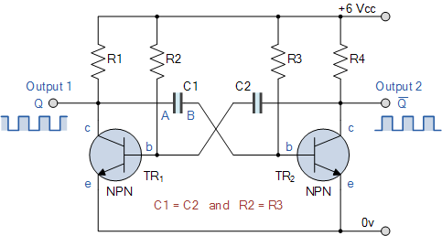

* 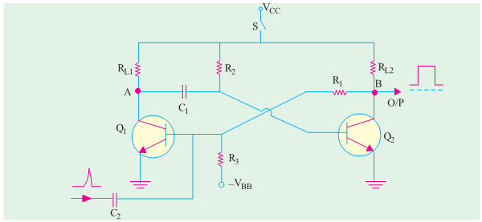 **MONOSTABLE**

*Monostable in which one of the states is stable, but the other state is unstable (transient). A trigger pulse causes the circuit to enter the unstable state. After en tering the unstable state, the circuit will return to the stable state after a set time. Such a circuit is useful for creating a timing period of fixed duration in response to some external event. This circuit is also known as a one shot.*

* 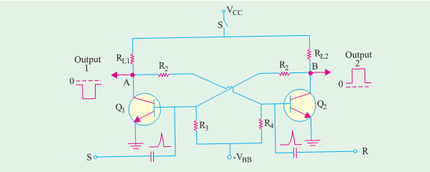**BISTABLE**

*Bistable in which the circuit is stable in either state. It can be flipped from one state to the other by an external trigger pulse. This circuit is also known as a flip-flop. It can be used to store one bit of information.*

*Multivibrators find applications in a variety of systems where square waves or timed intervals are required*.

**TRIANGULAR WAVE OSCILLATOR**

*A basic triangular wave generator is shown in Fig. 16.2 and its waveform is shown in Fig. 16.3. When the switch is at position 1, which is at negative voltage, the out put of the operational amplifier will ramp from negative to positive voltage. Likewise, when the switch is at position 2, which is at positive voltage, the output of the op-amp will ramp from positive to negative voltage. The waveform of the basic triangular waveform is shown in Fig. 16.3, which is derived from integrator, where Vc(t = 0) is the voltage of capacitor at time t = 0.*

*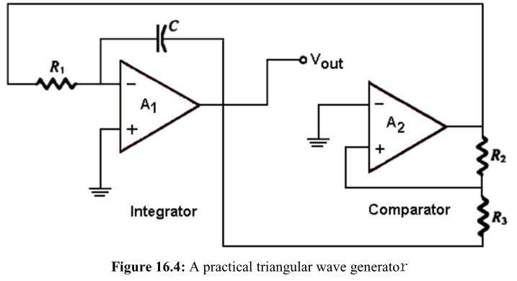****A practical triangular wave generator is shown in Fig. 16.4 whereby its positive and negative peak voltage and period can be specified.***

## SAWTOOTH OSCILLATOR

*A saw tooth wave generator utilizes the concept of voltage-controlled oscillator VCO. It can be designed by using a programmable uni junction transistor and an operational amplifier integrator arranged. Sawtooth wave can also be designed using the triangle wave circuit.*



|  |
| --- |
| **SQUARE-WAVE OSCILLATOR** |

*It is a type of relaxation oscillator because its operation is based on the charging and discharging of a capacitor. Notice that the op-amp’s inverting input is the capacitor voltage and the non-inverting input is a portion of the output fed back through resistors and to provide hysteresis. When the circuit is first turned on, the capacitor is uncharged, and thus the inverting input is at 0 V. This makes the output a positive maximum, and the capacitor begins to charge toward through. When the capacitor voltage reaches a value equal to the feedback voltage on the non-inverting input, the op-amp switches to the maximum negative state. At this point, the capacitor begins to discharge from toward. When the capacitor voltage reaches – the op-amp switches back to the maximum positive state. This action continues to repeats and a square-wave output voltage is obtained.*

FACTORS AFFECTING THE STABILITY OF OSCILLATOR

* **Operating point of active device**
  + The effects of variations in inter-element capacitances can be neutralized by introducing a swamping capacitor across the offending elements
* **Inter-element capacitances**
  + If the operating point of the active device in the circuit is in the non-linear portion of its characteristics, there may be variations in the transistor parameters which, in turn, affects the oscillator frequency stability. So, the operating point, Q is carefully selected to work in the linear portion of the characteristics of the active device.
* **Mechanical vibrations**
  + Although the mechanical vibrations is not such a high frequency stability changing factor, they can be easily avoided by isolating the oscillator circuit from the source of mechanical vibrations.
* When the circuit operates for a long time, the heat starts to build up. As  a result, the values of the frequency determining components like resistors, inductors and capacitors change with temperature. Thus the transistor parameter values also tend to change. But, the change in the values of R,L, and C will be slow and thus the change in oscillator frequency will also be slow.
* The other major factor responsible for deviation in frequency is variations in power supply. However, this problem can be overcome by using regulated power supply.

APPLICATIONS OF OSCILLATOR

* The sciences, music, radio and television broadcasting, medical diagnosis and computing all use oscillators for an astonishingly wide variety of purposes. Oscillators take two general forms: stand-alone benchtop units designed for electronic testing and measurement, and circuits integral to other devices such as radio receivers and electronic organs.
* Virtually all modern computers receive a master timing signal from an oscillator circuit called a “clock.” The circuit generates accurate electronic pulses at rates up to several gigahertz, keeping components such as the microprocessor, memory and interface chips running in sync.
* Radio transmitters and receivers use oscillators to generate high-frequency signals.
* Oscillators have myriad uses in music.
* An audiologist uses an oscillator to check your hearing. The oscillator produces a pure tone of a single frequency between 20 to 20,000 hertz, the normal range of human hearing. The audiologist tests your hearing for different frequencies and levels of loudness as you listen through headphones.