Michael Wasserstein
June 19, 2026
Modification_WRF_Upper_Level_Precipitation_README

This document provides an overview of how to modify the WRF code for output of upper level accumulated precipitation for the Thompson microphysics scheme.
Step 1: Modification of Registry
The registry stores and defines all the variables used in the WRF model. The first step is to modify the file Registry/Registry.EM_COMMON to add a variable which will store precipitation at an upper level. The accumulated total grid scale precipitation at the surface in the WRF model is called RAINNC, so lets call our new variable which will store the effective accumulated precipitation at upper levels RAINNC3d.
I modified the Registry.EM_COMMON file to read:
#=========================================================================================
# Modified by Michael Wasserstein 2 Mar 2026 to get precipitation at a level
state real RAINNC3d ikj misc 1 - rh01du "RAINNC3d" "ACCUMULATED TOTAL GRID SCALE PRECIPITATION at levels" "mm"
#=========================================================================================
The above line initializes a 3D variable (ikj) that will be able to store accumulated total grid scale precipitation at all levels in the domain.
Step 2: Modification of Thompson Microphysics
The next step is to modify the Thompson microphysics scheme, located in the Fortran script /phys/module_mp_thompson.F.
To do this, I used command + f to find any instance where the variable RAINNC (the 2D accumulated precipitation) appeared in the script and made a modification to support the 3d variable.
At line 979 I added the RAINNC3d variable to the microphysics driver:
SUBROUTINE mp_gt_driver(qv, qc, qr, qi, qs, qg, ni, nr, nc, &
nwfa, nifa, nwfa2d, nifa2d, &
th, pii, p, w, dz, dt_in, itimestep, &
RAINNC, RAINNCV, &
RAINNC3d, & ! Michael Wasserstein Feb 24 2026
SNOWNC, SNOWNCV, &
GRAUPELNC, GRAUPELNCV, SR, &
At line 1022 I modified:

REAL, DIMENSION(ims:ime, jms:jme), INTENT(INOUT):: &
RAINNC, RAINNCV, SR
!..=============================================================================
!..Michael Wasserstein modified feb 24 2026 for precip at upper levels
REAL, DIMENSION(ims:ime, kms:kme, jms:jme), INTENT(INOUT):: &
RAINNC3d
!..=============================================================================
to define the variable in the script.
In the Thompson microphysics scheme, the precipitation is calculated for each precipitating hydrometeor type, including rain, snow, graupel, and ice. I needed to create 3d variables corresponding with the 1D variables for each of these hydrometeors at line 1078:

!=================================================================================
!..Modified by Michael Wasserstein to get precip at upper levels
!..February 24, 2026
REAL, DIMENSION(its:ite, kts:kte, jts:jte):: pcp_ra3d, pcp_sn3d, &
pcp_gr3d, pcp_ic3d
REAL, DIMENSION(kts:kte) :: pptrain3d, pptsnow3d, pptgraul3d, pptice3d
!==================================================================================

At line 1163, I initialized the accumulated precipitation at 0:
!================================================================================
!..Michael Wasserstein Feb 24 2026 edits
pptrain3d = 0.
pptsnow3d = 0.
pptgraul3d = 0.
pptice3d = 0.
!================================================================================

At line 1232 I modified the mp_thompson call variable list to account for these 3D variables:
call mp_thompson(qv1d, qc1d, qi1d, qr1d, qs1d, qg1d, ni1d, &
nr1d, nc1d, nwfa1d, nifa1d, t1d, p1d, w1d, dz1d, &
pptrain, pptsnow, pptgraul, pptice, &
pptrain3d, pptsnow3d, pptgraul3d, pptice3d, & ! Wasserstein edits
#if ( WRF_CHEM == 1 )
rainprod1d, evapprod1d, &
#endif

I then modified the code at line 1244 to follow the same structure as the 2D accumulated precipitation variables, except I extended it to 3D space by looping through each level in $z$, which uses k indices in the WRF code:
!=================================================

pcp_ra(i,j) = pptrain
pcp_sn(i,j) = pptsnow
pcp_gr(i,j) = pptgraul
pcp_ic(i,j) = pptice
!==============================================================================
!.. Michael Wasserstein modified 24 feb 2026
do k = kts, kte
pcp_ra3d(i,k,j) = pptrain3d(k)
pcp_sn3d(i,k,j) = pptsnow3d(k)
pcp_gr3d(i,k,j) = pptgraul3d(k)
pcp_ic3d(i,k,j) = pptice3d(k)
enddo
!==============================================================================
RAINNCV(i,j) = pptrain + pptsnow + pptgraul + pptice
RAINNC(i,j) = RAINNC(i,j) + pptrain + pptsnow + pptgraul + pptice
!==============================================================================
!.. Michael Wasserstein modified 24 feb 2026
do k = kts, kte
RAINNC3d(i,k,j) = RAINNC3d(i,k,j) + pptrain3d(k) + pptsnow3d(k) + &
pptgraul3d(k) + pptice3d (k)
enddo
!==============================================================================

A modification to the main Thompson subroutine was required at line 1491:
subroutine mp_thompson ( &
qv1d, qc1d, qi1d, qr1d, qs1d, qg1d, &
ni1d, nr1d, nc1d, nwfa1d, nifa1d, &
t1d, p1d, w1d, dzq, &
pptrain, pptsnow, pptgraul, pptice, &
pptrain3d, pptsnow3d, pptgraul3d, pptice3d, & ! Wasserstein edits

And variable definitions in the subroutine at line 1515:
REAL, INTENT(INOUT):: pptrain, pptsnow, pptgraul, pptice
REAL, DIMENSION(kts:kte), INTENT(INOUT):: & ! Michael Wasserstein Feb 26 2026
pptrain3d, pptsnow3d, pptgraul3d, pptice3d ! Michael Wasserstein Feb 26 2026

The microphysics scheme determines the precipitation that accumulates at a given time step based on the mixing ratio being above a certain threshold (R1) and the lowest level sedimentation rate [sed_r(kts), where kts indicates the lowest index in $z$]. I added a block of code at line 3522 to add rain at each time step. This code follows the 2D code but looks through each level and determines the accumulated rain at a level k, based on the sedimentation rate at that level.
if (rr(kts).gt.R1*1000.) &
pptrain = pptrain + sed_r(kts)*DT*onstep(1)
!..----------------------------------------------------------------------
!..Michael Wasserstein edits Feb 24 2026
do k = kte, kts, -1
if (rr(k).gt.R1*1000.) &
pptrain3d(k) = pptrain3d(k) + sed_r(k)*DT*onstep(1)
enddo
!..----------------------------------------------------------------------

That block is for rain, and I made the same edits for ice at line 3580:
if (ri(kts).gt.R1*1000.) &
pptice = pptice + sed_i(kts)*DT*onstep(2)
!..----------------------------------------------------------------------
!..Michael Wasserstein edits Feb 24 2026
do k = kte, kts, -1
if (ri(k).gt.R1*1000.) &
pptice3d(k) = pptice3d(k) + sed_i(k)*DT*onstep(2)
enddo

And for snow at line 3615:
if (rs(kts).gt.R1*1000.) &
pptsnow = pptsnow + sed_s(kts)*DT*onstep(3)
!..----------------------------------------------------------------------
!..Michael Wasserstein edits Feb 24 2026
do k = kte, kts, -1
if (rs(k).gt.R1*1000.) &
pptsnow3d(k) = pptsnow3d(k) + sed_s(k)*DT*onstep(3)
enddo
!..----------------------------------------------------------------------
enddo
endif

And graupel at line 3649:
if (rg(kts).gt.R1*1000.) &
pptgraul = pptgraul + sed_g(kts)*DT*onstep(4)
!..----------------------------------------------------------------------
!..Michael Wasserstein edits Feb 24 2026
do k = kte, kts, -1
if (rg(k).gt.R1*1000.) &
pptgraul3d(k) = pptgraul3d(k) + sed_g(k)*DT*onstep(4)
enddo
!..----------------------------------------------------------------------
enddo
endif

Step 3: Modification of module_microphysics_driver.F
The microphysics driver script is located in phys/module_microphysics_driver.F.
Similar to my methods in step 2, I searched for any occurrence of the variable rainnc, and added RAINNC3d alongside it. First in the microphysics_driver subroutine, I made a modification at line 95:
,rainnc, rainncv &
,RAINNC3d & ! Michael Wasserstein 2/24/26

I defined the variable in the subroutine at line 676:
REAL, DIMENSION( ims:ime , kms:kme, jms:jme ) :: RAINNC3d ! Michael Wasserstein Mar 2 2026

In the call of the microphysics driver, I added the RAINNC3d variable at line 1055:
RAINNC=RAINNC, &
RAINNCV=RAINNCV, &
RAINNC3d=RAINNC3d, & ! Michael Wasserstein 3d rain

And again at line 1134:
RAINNC3d=RAINNC3d, & ! Michael Wasserstein 3d rain

Step 4: Modification of solve_em.F
The last step is modification of the script dyn_em/solve_em.F. In this script, the microphysics_driver that we modified in the prior step gets called at line 3603. Only one small modification is needed at line 3692 to account for the addition of the RAINNC3d variable:
& , RAINNC=grid%rainnc, RAINNCV=grid%rainncv &
& , RAINNC3d=grid%rainnc3d & ! Michael Wasserstein Feb 24 2026

Step 5: Reconfigure and recompiling
After making these modifications I reconfigured and recompiled the code. After rerunning WRF, I now have a variable RAINNC3D, which gives the effective accumulated precipitation at all levels inside the model domain.
Useful applications for this include understanding the influence of sub-cloud sublimation on simulations. For instance one simulation I have shows precipitation loss over the Salt Lake Valley due to sublimation:
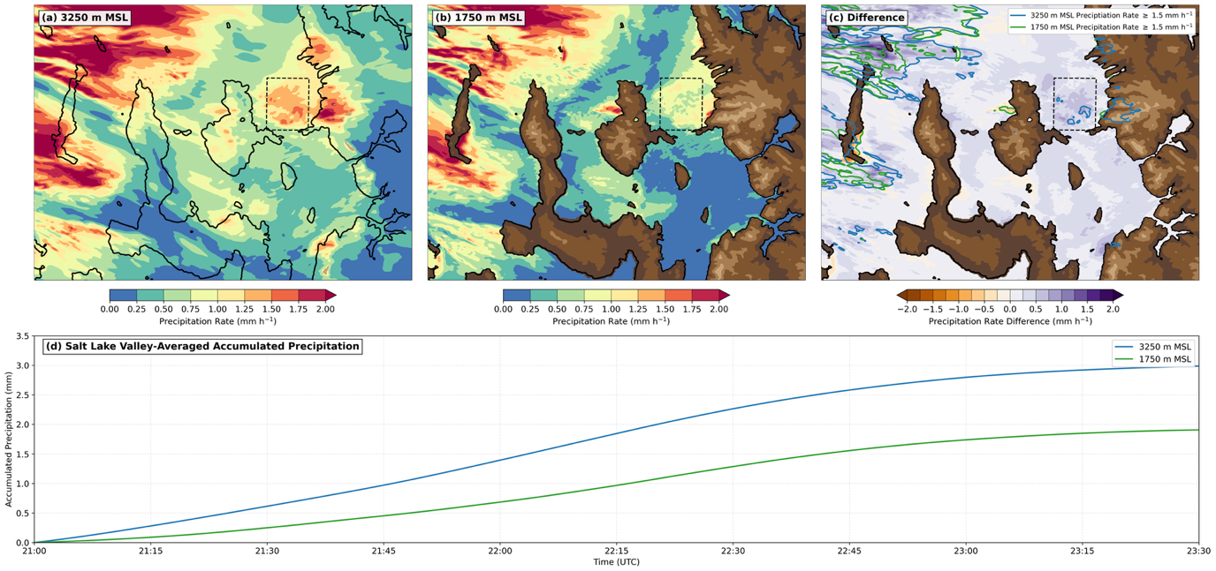
Fig. 1. Time-averaged precipitation rate at (a) 3250 m MSL and (b) 1750 m MSL (mm h⁻¹; scale at bottom) from 2100 UTC 22 Mar 2019 to 2330 UTC 22 Mar 2019. (c) Difference plot of (a) – (b) (mm h⁻¹; scale at bottom) with the blue and green contours outlining areas of precipitation rate ≥ 1.5 mm h⁻¹ at 3250 and 1750 m MSL, respectively. The thick black contour indicates the 1750 m MSL level, and the brown contour fill indicates terrain elevation in 500-m intervals. (d) Time series of SLV-averaged accumulated precipitation at 3250 and 1750 m MSL. The dashed box in (a)-(c) indicates the domain for averaging in (d).
In Fig. 1a, notice how effective precipitation rates at 3250 m MSL (~2000 m AGL) for the analysis time are generally between 0.75 and 1.75 mm h⁻¹ over the black dashed box outlining the Salt Lake Valley. But at 1750 m MSL (~500 m AGL), precipitation rates are lower due to sub-cloud sublimation (Fig. 1b). That can be seen by looking at a difference plot of the rates at 3250 m MSL – the rates at 1750 m MSL (Fig. 1c) or a time series plot indicating the effective accumulated precipitation over time (Fig. 1d), which indicates greater accumulated precipitation at 3250 m MSL (blue line) compared to 1750 m MSL (green line).
This microphysical process can also be viewed by looking at a cross section over the Salt Lake Valley:
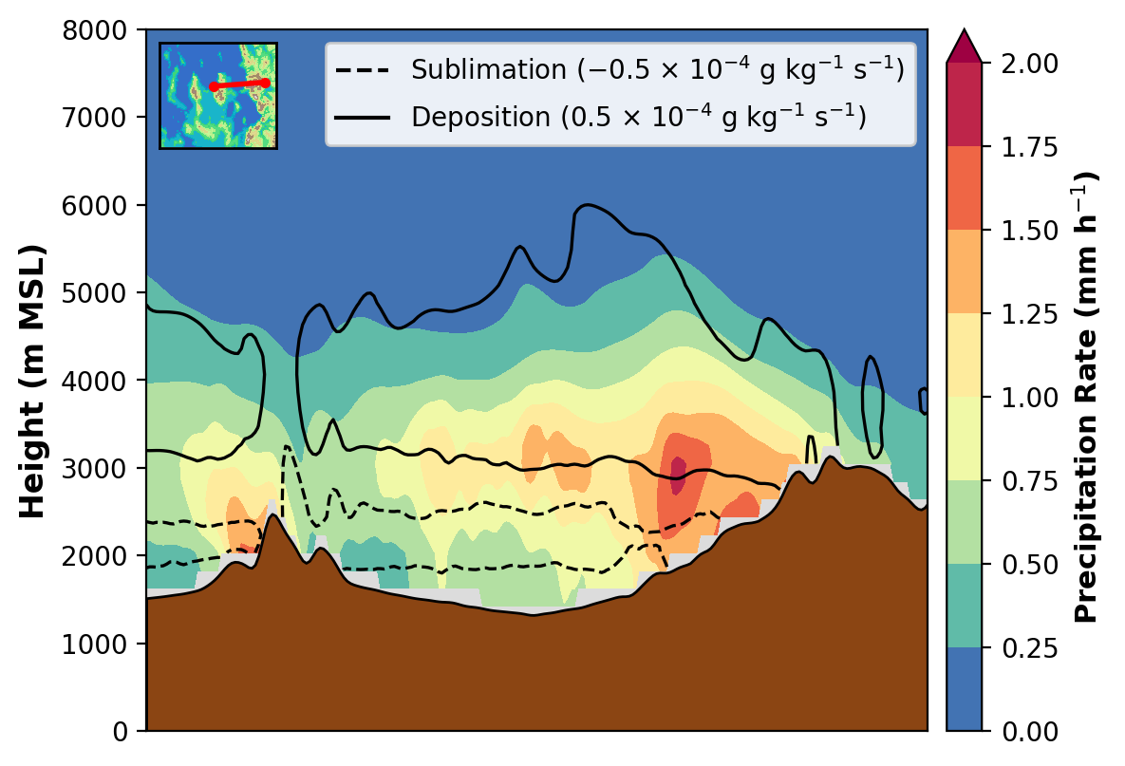
Fig. 2. Cross section of time-averaged precipitation rate at (mm h⁻¹; scale at right), sublimation ≤ -0.5 $×$ 10⁻⁴ g kg⁻¹ s⁻¹ (dashed black contour) and deposition ≥ 0.5 $×$ 10⁻⁴ g kg⁻¹ s⁻¹ (solid black contour) from 2100 UTC 22 Mar 2019 to 2330 UTC 22 Mar 2019 for TECPEC flight leg 2. The brown shading shows model terrain and the path of the cross section is shown with the red line in the inset at upper left.

In Fig. 2, we can see the highest effective precipitation rates occurring at around 3000 m MSL, and they decrease with decreasing height down to the lowest levels. This is likely due to sub cloud sublimation, which is greatest between ~1800 and ~2500 m MSL over the Salt Lake Valley (see dashed line in Fig. 2)

