Delft3D-FM on Windows
Complete Setup, Run, and ParaView Guide
Corrected workflow for the Auburn delft-container repository
Tested workflow • August 2026

What this document is
This is a standalone replacement for the GitHub setup instructions and the tutorial-video workflow for a new Windows computer. It includes the exact corrections needed for the repository issues encountered during installation and the ParaView compatibility workaround required to view Delft3D-FM cell variables.

Repository: https://github.com/mwatts93093/delft-container

How the pieces fit together
Delft3D-FM is not installed as a normal Windows program in this workflow. Windows runs Docker Desktop and ParaView; Ubuntu runs inside Windows through WSL2; and Delft3D-FM runs inside a Linux Docker container.
Layer | What it does | How you recognize it
Windows | Docker Desktop and ParaView | PowerShell, Windows Explorer, ParaView windows
Ubuntu / WSL2 | Controls Docker and stores the repository | Prompt like user@computer:~$
Delft3D container | Runs D-Flow FM, NetCDF tools, ncview, Python | Prompt like root@container:/workspace#

Two Docker words that matter
- Docker image = the built Delft3D environment/template. In this guide it is named delft3dfm:demo.
- Docker container = a running copy of that image. In this guide the routine container is named delft3d.
Beginner rule
Before running a command, check which prompt you are looking at. A large fraction of confusing errors come from running a container command in ordinary Ubuntu, or an Ubuntu Docker command from inside the container.

What this guide covers
- Install WSL2 and Ubuntu.
- Install and connect Docker Desktop.
- Install ParaView.
- Install Git and clone the repository.
- Apply the repository corrections.
- Build the Delft3D-FM Docker image.
- Verify the installation, including GUI forwarding.
- Run the bundled f34 model.
- Inspect output and open it in ParaView.
- Fix the UGRID metadata so ParaView can see water level and velocity.
- Display water surface elevation and calculate velocity magnitude.
- Use a short routine workflow for future sessions.

Part 1 — Install WSL2 and Ubuntu
Do this once on a new Windows computer.

1. Open the correct PowerShell
- Click Start and type PowerShell.
- Right-click Windows PowerShell and choose Run as administrator.
- Do not use Windows PowerShell ISE for this installation.

2. Install Ubuntu through WSL
wsl --install -d Ubuntu
Windows installs WSL and Ubuntu. Restart Windows if requested. The first time Ubuntu opens, create a Linux username and password.
Linux password behavior
When Ubuntu asks for a password in the terminal, nothing appears while you type — no dots or asterisks. This is normal. The password is the Linux/Ubuntu password you created, not your Windows, Auburn, or Docker password.

3. Verify WSL2
Back in Windows PowerShell, run:
wsl --version
wsl --list --verbose
The VERSION column beside Ubuntu must show 2.

4. Update WSL and verify WSLg graphics
wsl --update
wsl --shutdown
Reopen Ubuntu from the Start menu and run:
echo "$DISPLAY"
A value such as :0 means the WSL graphical display connection is available.
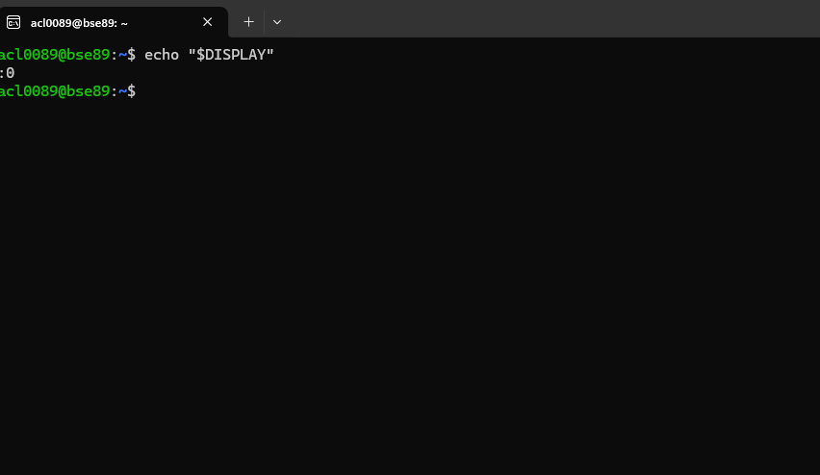
Expected GUI check: echo "$DISPLAY" returns :0.

Part 2 — Install Docker Desktop

1. Install Docker Desktop for Windows
Download Docker Desktop for Windows from Docker’s official website. During the installer configuration:
- Choose Per-user installation (Recommended), unless your organization requires an all-users installation.
- Keep Use WSL 2 instead of Hyper-V checked.
- Leave Allow Windows Containers unchecked for this Delft3D workflow.
- The desktop shortcut is optional.
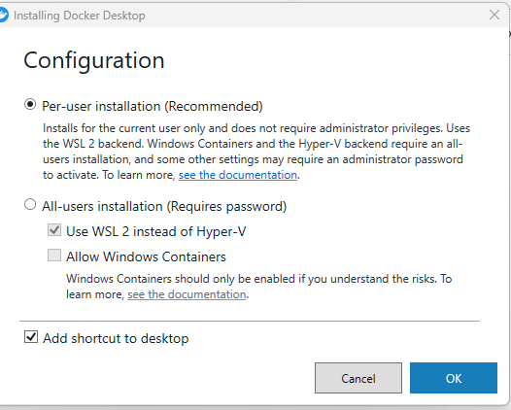
Docker Desktop installer settings used in the tested setup.

2. Connect Docker Desktop to Ubuntu
- Start Docker Desktop.
- Open Settings → General and make sure the WSL 2 based engine is enabled if that option is shown.
- Open Settings → Resources → WSL Integration.
- Enable Ubuntu.
- Click Apply & restart if prompted.
Do not install Docker again inside Ubuntu
Docker Desktop provides the Docker command line to Ubuntu through WSL integration. Installing a second Docker Engine with apt can create conflicts.

3. Verify Docker from the Ubuntu terminal
docker version
docker compose version
docker version should show both a Client section and a Server: Docker Desktop section. docker compose version should return a version number.

Part 3 — Install ParaView
Install ParaView as a normal Windows application. The tested setup used ParaView 6.1.1.
- Go to the official ParaView download page.
- Choose a stable Windows 64-bit release (ParaView 5.12 or later).
- Choose the normal non-MPI .msi installer.
- Do not choose the MPI package unless you specifically need an MPI-enabled ParaView build.
- Install and launch ParaView once.
ParaView stays in Windows
Do not install ParaView inside Ubuntu or the Docker container. It opens NetCDF output stored in the shared workspace.

Part 4 — Install Git and clone the Delft3D repository
In the Ubuntu terminal:
sudo apt update
sudo apt install -y git
git --version
Then create a code directory and clone the repository:
mkdir -p ~/Code
cd ~/Code
git clone https://github.com/mwatts93093/delft-container.git
cd delft-container/docker
pwd
The final path should end with:
/home/<your-linux-user>/Code/delft-container/docker

Part 5 — Apply the repository corrections before verification
Why this section exists
The current repository contains two mismatches that caused the acceptance test to fail in the tested installation. Apply both corrections from the repository's docker directory before running verify.sh.

Correction 1: use the locally built Docker image
The README instructs the user to build a local image named delft3dfm:demo, but docker-compose.yml currently points to ghcr.io/mwatts93093/delft-container:latest. On the tested computer, that registry image returned an unauthorized error.
sed -i 's#ghcr.io/mwatts93093/delft-container:latest#delft3dfm:demo#' docker-compose.yml
This changes Compose to use the image that you build locally.

Correction 2: point the verification script to the actual f34 model
scripts/verify_container.sh currently looks for the f34 model under /workspace/examples/dflowfm/01_dflowfm_sequential/dflowfm, but the complete bundled f34 model is actually stored under /workspace/demo/f34.
sed -i 's#/workspace/examples/dflowfm/01_dflowfm_sequential/dflowfm#/workspace/demo/f34#' scripts/verify_container.sh
Also use the corrected f34 path in this guide
The repository README contains additional example commands using /workspace/examples/dflowfm/01_dflowfm_sequential/dflowfm. For the current repository, use /workspace/demo/f34 instead.

Part 6 — Build Delft3D-FM
Make sure Docker Desktop is running. From ~/Code/delft-container/docker in the Ubuntu terminal:
docker build -t delft3dfm:demo .
The first build compiles Delft3D-FM and dependencies. It may take roughly 45–90 minutes. Leave Docker Desktop running and keep the Ubuntu terminal open.
When the normal Ubuntu prompt returns, confirm the image:
docker image ls delft3dfm:demo
The image should be listed as delft3dfm:demo.

Part 7 — Verify the installation
From the same docker directory:
./verify.sh
A successful non-GUI test ends with text similar to:
Functional verification passed (5 checks, mode=smoke, gui=false).
Then run the graphical test:
./verify.sh --gui
A successful full test ends with:
Functional verification passed (6 checks, mode=smoke, gui=true).
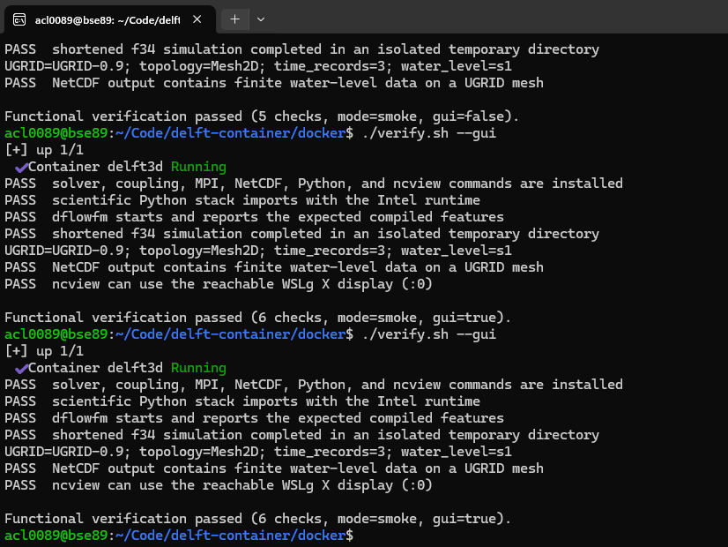
Successful acceptance test, including the WSLg/ncview GUI check.

Part 8 — Start the container and understand /workspace
The repository's docker/workspace folder is mounted into the container as /workspace. Files in this location persist even if the container is stopped or removed.

1. Start the routine container
In the Ubuntu terminal, from ~/Code/delft-container/docker:
docker compose up -d
Open a shell inside the running Delft3D container:
docker exec -it delft3d bash
The prompt should change to something like:
root@<container-id>:/workspace#
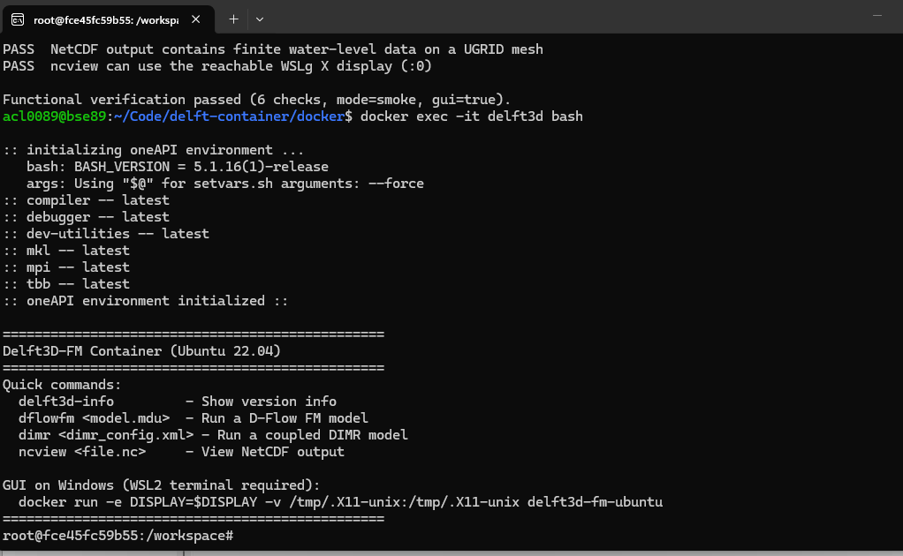
Inside the Delft3D container. The prompt is now root@...:/workspace#.

2. See what is in the shared workspace
ls
The tested repository shows:
demo examples

3. Leave the container without stopping it
exit
To stop and remove the routine container later, run this from Ubuntu:
docker compose down

Part 9 — Run the bundled f34 Delft3D-FM model
Enter the container if you are not already inside it:
docker exec -it delft3d bash
Move to the actual f34 demo model:
cd /workspace/demo/f34
ls

Important files in f34
File | Purpose
f34.mdu | Main D-Flow FM model definition file; this is the file used to start the model.
f34_net.nc | Unstructured computational mesh.
f34_001.bc | Boundary-condition data.
f34_001.pli | Boundary polyline/location file.
f34_obs.xyn | Observation-point locations.
f34_bnd.ext | External forcing references.
output/ | Model results.

Run the model
dflowfm f34.mdu
The bundled demo is short and runs quickly. A successful run returns to the container prompt without an error.

Check the output
ls -lh output
Output | Purpose
f34_map.nc | Spatial results on the unstructured mesh.
f34_his.nc | Time series at observation locations.
*_rst.nc | Restart files.
f34.dia | Diagnostic log.
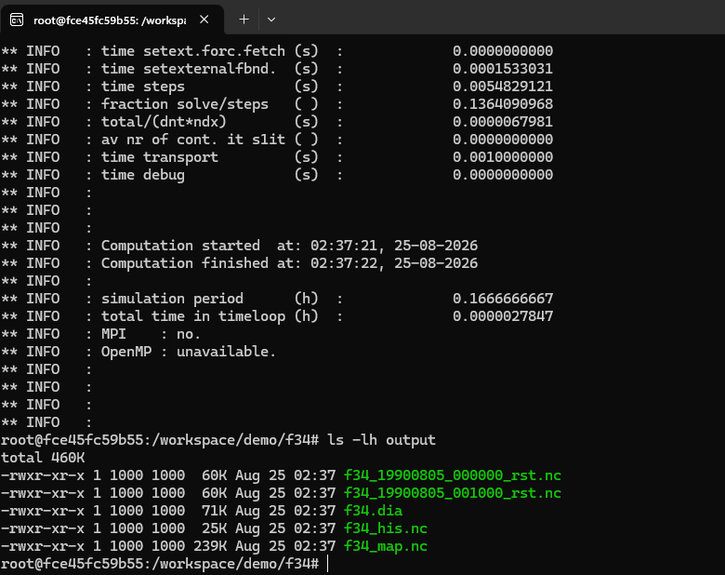
Example f34 output after a successful run. f34_map.nc is the main spatial result file.

Part 10 — Optional quick check with ncview
Inside the container:
ncview output/f34_map.nc
A small ncview window should appear on the Windows desktop. This is a quick check only; ncview does not fully interpret the Delft3D unstructured UGRID metadata. Use ParaView for the main visualization.
Close ncview and leave the container:
exit

Part 11 — Prepare the NetCDF file for ParaView
Important ParaView compatibility issue
With the current Delft3D output and ParaView 6.1.1, the original f34_map.nc opened with the NetCDF UGRID Reader but initially showed no Cell Arrays. The data were present; the face variables lacked the mesh/location attributes ParaView expected. The workaround below adds only metadata to a copy of the output.
Re-enter the container and move to the model directory:
docker exec -it delft3d bash
cd /workspace/demo/f34

1. Confirm the variables if desired
Water level:
ncdump -h output/f34_map.nc | grep -A8 -B2 "s1"
The file identifies s1 as water level / sea_surface_height with units of meters.
Horizontal velocity components:
ncdump -h output/f34_map.nc | grep -A8 -B2 -E "double (ucx|ucy)\("
The file identifies ucx and ucy as x- and y-components of flow-element-center velocity with units of m/s.

2. Make a ParaView copy and add the missing UGRID metadata
cp output/f34_map.nc output/f34_map_paraview.nc
Then run this entire Python block:
python3 - <<'PY'
from netCDF4 import Dataset
path = "output/f34_map_paraview.nc"
with Dataset(path, "r+") as ds:
for name in ["s1", "ucx", "ucy"]:
var = ds.variables[name]
var.setncattr("mesh", "Mesh2D")
var.setncattr("location", "face")
print("Prepared s1, ucx, and ucy for ParaView:", path)
PY
This does not change model results
The original f34_map.nc is left untouched. The copy only receives metadata telling ParaView that s1, ucx, and ucy belong to the Mesh2D faces/cells.
Leave the container:
exit

Part 12 — Open the model in ParaView

1. Open the shared workspace in Windows Explorer
From the Ubuntu terminal, in ~/Code/delft-container/docker:
explorer.exe "$(wslpath -w ./workspace)"
Navigate to:
demo → f34 → output
The file to open is:
f34_map_paraview.nc

2. Open the file in ParaView
- Start ParaView.
- Choose File → Open.
- Select f34_map_paraview.nc.
- If ParaView asks which reader to use, choose NetCDF UGRID Reader.
- In the Properties panel, confirm that Cell Arrays contains s1, ucx, and ucy.
- Click Apply.
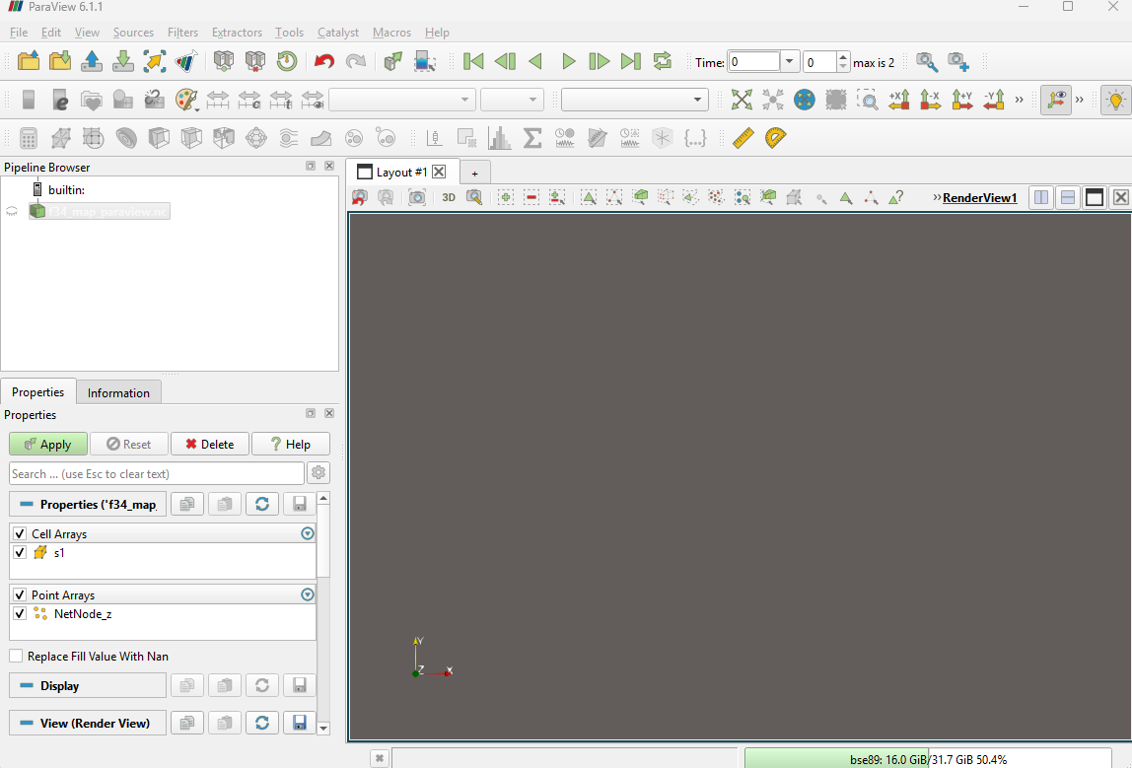
Corrected ParaView input: s1 appears under Cell Arrays. After adding velocity metadata, ucx and ucy should appear there too.

Part 13 — View water-surface elevation
- At the top of ParaView, open the coloring dropdown that initially says Solid Color.
- Choose s1.
- The mesh will be colored by water level. The NetCDF file defines s1 as water level / sea_surface_height in meters.
- Use the time-step controls at the top to move through the saved output records.
- For the bundled 10-minute demo, the final time is 600 seconds.
- Change the representation dropdown from Surface to Surface With Edges to show individual computational cells.
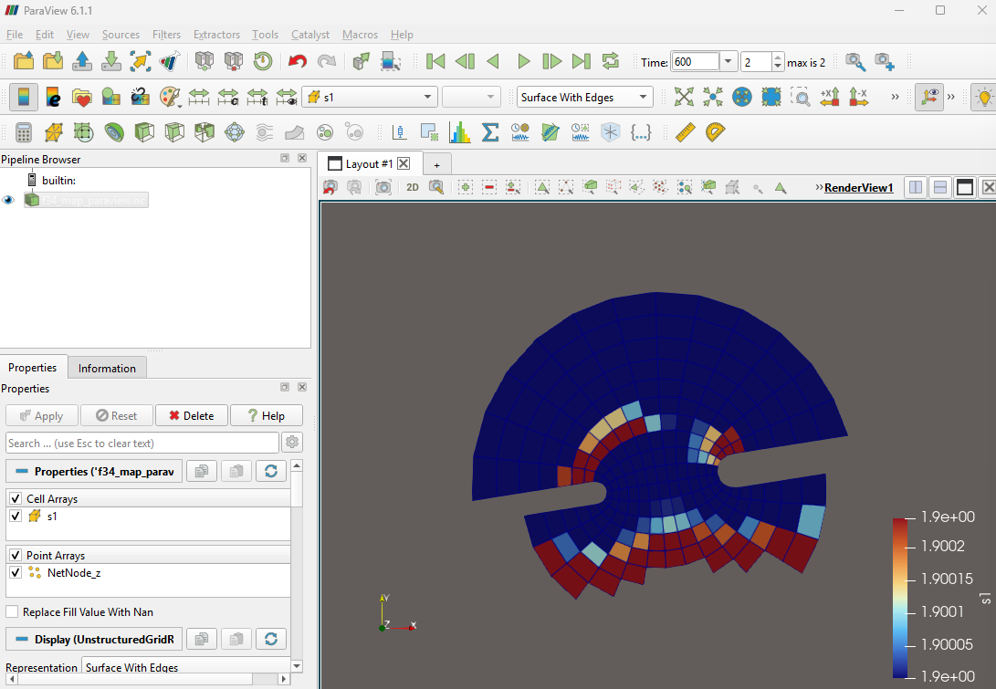
f34 water level (s1) at the final time, shown with Surface With Edges.

Part 14 — View horizontal velocity magnitude
Delft3D stores the two horizontal velocity components separately as ucx and ucy. Horizontal speed is:
Velocity magnitude = √(ucx² + ucy²)

Create velocity magnitude with the Calculator filter
- Select f34_map_paraview.nc in the Pipeline Browser.
- Open Filters → Alphabetical → Calculator. Alternatively press Ctrl+Space and search for Calculator.
- Set Attribute Type to Cell Data.
- Set Result Array Name to VelocityMagnitude.
- Enter the expression: sqrt(ucx*ucx + ucy*ucy)
- Click Apply.
- In the top coloring dropdown, choose VelocityMagnitude.
sqrt(ucx*ucx + ucy*ucy)
VelocityMagnitude is horizontal speed in m/s.
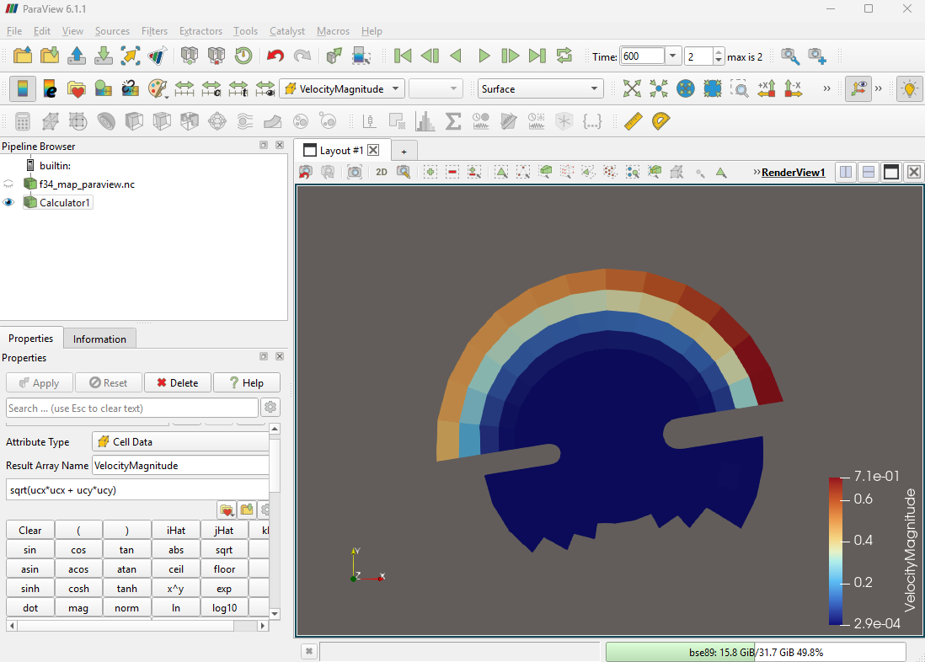
Calculated horizontal velocity magnitude in ParaView.

Part 15 — Routine workflow after the computer is configured
You do not repeat the installation or build every time. A normal work session is much shorter.

Ubuntu terminal
cd ~/Code/delft-container/docker
docker compose up -d
docker exec -it delft3d bash

Container shell
cd /workspace/projects/<your-model-folder>
dflowfm <your-model>.mdu
exit
For the bundled example, the model folder is /workspace/demo/f34.

If ParaView still needs the metadata workaround
Create a fresh *_paraview.nc copy of the new map output and add mesh='Mesh2D' and location='face' to the cell variables you plan to use. For water level and horizontal velocity, use the combined Python block in Part 11.

Windows / ParaView
Open the model output folder from Ubuntu:
explorer.exe "$(wslpath -w ./workspace)"
Open the prepared *_paraview.nc file in ParaView with the NetCDF UGRID Reader.

When finished
docker compose down
Stopping/removing the container does not remove the Docker image or files stored in the mounted workspace.

Part 16 — Troubleshooting
Problem | Likely cause | Fix
docker registry: unauthorized during ./verify.sh | docker-compose.yml points to ghcr.io/mwatts93093/delft-container:latest | Apply Correction 1 in Part 5 so Compose uses delft3dfm:demo.
FAIL bundled f34 model was not found | verify_container.sh points to the wrong example directory | Apply Correction 2 in Part 5 so the path is /workspace/demo/f34.
Cell Arrays is empty in ParaView | s1/ucx/ucy lack mesh/location attributes expected by ParaView's UGRID reader | Create f34_map_paraview.nc and apply the metadata block in Part 11.
cd /workspace/...: No such file or directory | You are in ordinary Ubuntu instead of the Delft3D container | Run docker exec -it delft3d bash, then retry the /workspace path.
ncdump: command not found in Ubuntu | ncdump is included in the Delft3D container, not necessarily in ordinary Ubuntu | Enter the container and run ncdump there.
docker: command not found / cannot reach daemon | Docker Desktop is not running or Ubuntu WSL integration is off | Start Docker Desktop and enable Settings → Resources → WSL Integration → Ubuntu.
echo "$DISPLAY" returns nothing | WSLg/WSL needs updating or restarting | In Admin PowerShell run wsl --update and wsl --shutdown; reopen Ubuntu.

Appendix A — Repository changes recommended for the developer
The following changes would remove the workarounds from the user workflow. These were verified against the current repository during the tested installation.

1. docker-compose.yml image mismatch
Current Compose image:
image: ghcr.io/mwatts93093/delft-container:latest
The README instructs the user to build delft3dfm:demo locally. Either make the registry image accessible and document authentication, or change Compose to use:
image: delft3dfm:demo

2. verify_container.sh uses the wrong f34 path
Current script path:
example_dir="/workspace/examples/dflowfm/01_dflowfm_sequential/dflowfm"
Actual complete f34 directory in the current repository:
example_dir="/workspace/demo/f34"

3. README example paths should be updated
The README also uses /workspace/examples/dflowfm/01_dflowfm_sequential/dflowfm in its single-core and first-run example sections. That directory currently contains only dimr_config.xml; the complete f34 case is under /workspace/demo/f34.

4. ParaView UGRID compatibility
The current map output contains s1, ucx, and ucy, but in the tested ParaView 6.1.1 workflow those variables were not exposed as Cell Arrays until mesh='Mesh2D' and location='face' were added. A repository-level fix could be one of the following:
- Have the Delft3D output writer emit the expected mesh/location UGRID metadata for face variables, if appropriate for this build.
- Add a repository helper script that copies a map file and adds the ParaView metadata automatically.
- Document the post-processing workaround explicitly in the README.

Appendix B — Sources and tested versions
- Auburn repository: https://github.com/mwatts93093/delft-container
- Docker Compose file checked August 24, 2026: https://raw.githubusercontent.com/mwatts93093/delft-container/main/docker/docker-compose.yml
- Verification script checked August 24, 2026: https://raw.githubusercontent.com/mwatts93093/delft-container/main/docker/scripts/verify_container.sh
- Complete f34 model directory: https://github.com/mwatts93093/delft-container/tree/main/docker/workspace/demo/f34
- Tested visualization application: ParaView 6.1.1
- Tested container workflow: WSL2 Ubuntu + Docker Desktop on Windows

