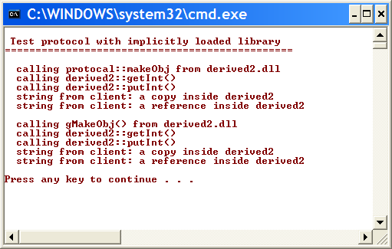
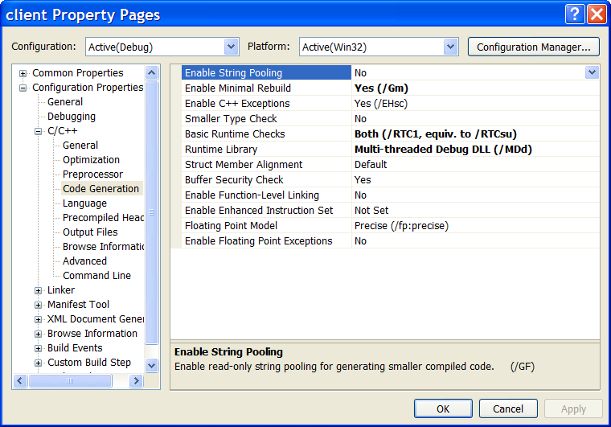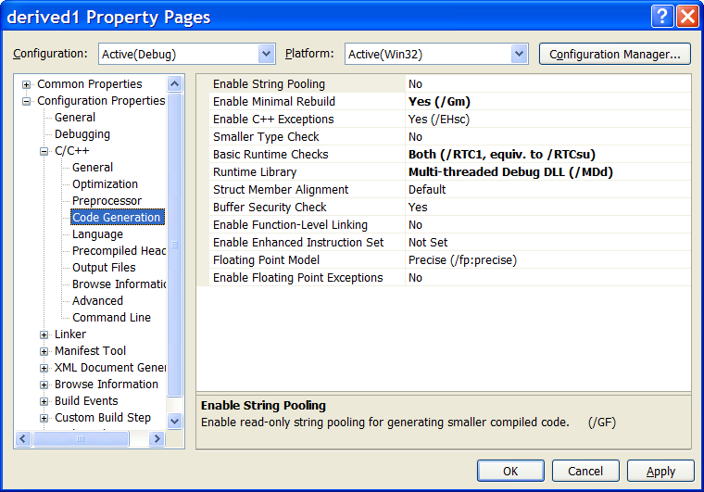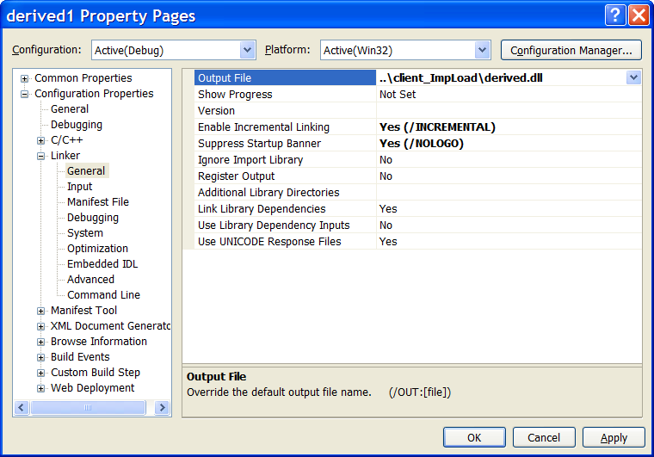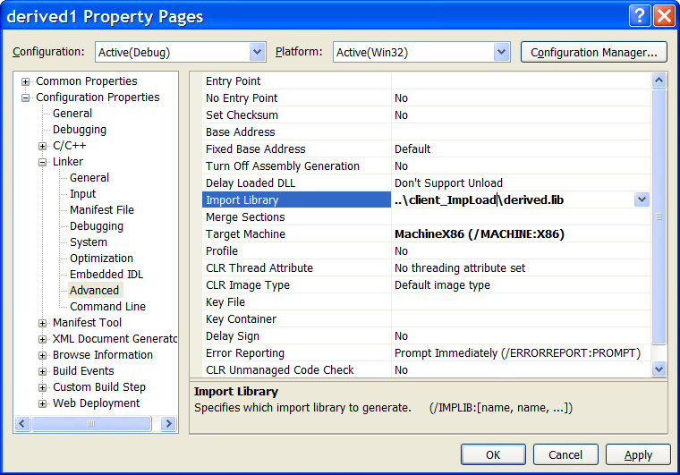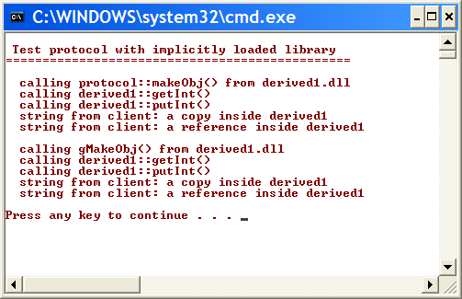
Build both client and all DLLs using Multi-threaded DLL version of the C/C++ runtime library. That is critical.
Make sure that the library, as well as the client, link to the Multi-threaded Debug CRT.
Write DLL created by building the library source code into the client’s project directory. We will do this for both derived1 and derived2, so that building one just copies over older versions.
This tells the linker to put export definition file where the client can find it as well.
Newly built library is loaded and used without rebuilding the client.
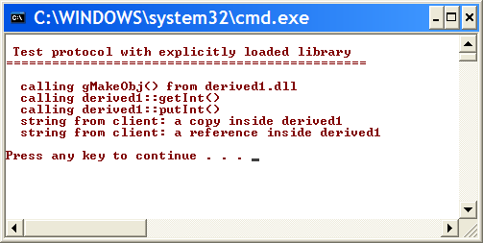

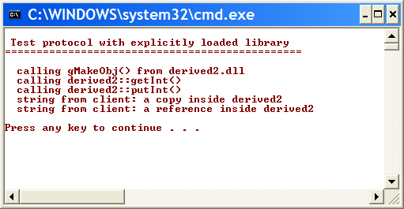
Newly built library is loaded and used without rebuilding the client.

