Note: download internet (pdf) version of the course text book (if you haven’t already): http://linuxcommand.org/tlcl.php

1. Open a terminal and navigate to your home directory (***cd ~*** *)*
   1. From your home directory, create a subdirectory named *hw3*
   2. Navigate to the hw3 folder and print the working directory
   3. Type: echo "This is text file 1" > file1.txt
   4. Type: echo "This is text file 2" > file2.txt
   5. Type: ln -s file1.txt current.txt
   6. Type: cat current.txt
   7. Type: ls -l current.txt
   8. Type: rm current.txt
   9. Type: ln -s file2.txt current.txt
   10. Type: cat current.txt
   11. Type: ls -l current.txt
2. Describe (in a sentence or two) how the text files: file1.txt and file2.txt were created in steps c. and d. (above).
3. What is current.txt? (HINT: type: file current.txt). Give one reason why files like current.txt might be useful?
4. Suppose I want detailed information about a given executable command: its options and arguments etc. (e.g. ls). How might I use the shell to retrieve that information about executable commands? What about commands that built into the shell? (see pages 44-45 in the text).
5. Type*:* ***ls /usr/bin | tee ls.txt | grep ^zip*** and observe the output (see page 65-66 in the text)
   1. Describe what this command does (consider the data flow through the pipeline)
   2. Describe (in two or three sentences) the basic difference between the redirection operator (>) and the pipeline (I) operator
6. **Type “nano first” enter the following text, and save the file**

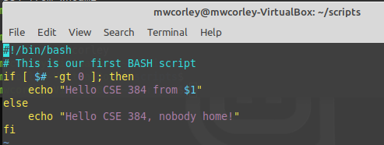

1. Type the following commands:
   1. mv first scripts/
   2. cd scripts/
   3. pwd;ls
   4. ./first <-- Note: The script likely did not produce the desired output (permission denied)
   5. ls -l first <-- **describe (in a few sentences), the output of this command**

*Note: see page 16 in book, (page 40 in pdf viewer) for help.*

*Also see page 92 in book (permissions), page 116 in pdf viewer*

1. Type the following commands:
   1. chmod 700 first
   2. ls -l ./first <-- **notice output this command, describe (in a sentence or two), describe what**

**the command: “chmod 700 first” accomplished**

* 1. ./first
  2. .first $(whoami) -- note: in Webminal this may work: type bash ./first $(whoami)

1. Take a screen of your terminal window and upload to HW2 in Blackboard. Have fun on your own. One suggestion is the Webminal exercises