Note: download internet (pdf) version of the course text book (if you haven’t already): http://linuxcommand.org/tlcl.php

1. **Open terminal and type the following commands:**
   1. pwd
   2. date
   3. cal
   4. echo $SHELL
   5. echo $HOME
   6. echo ~
   7. echo ‘Hello CSE 384’
   8. cd ..; pwd;
   9. cd ~
2. **From your home directory (cd to ~) Make three directories: *code, scripts, tools***:
   1. HINT: use mkdir, see page 28 in the book (52 in the PDF viewer) or type “man mkdir”

1. **Type “nano first” enter the following text, and save the file**

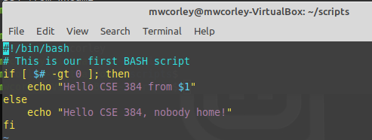

1. Type the following commands:
   1. mv first scripts/
   2. cd scripts/
   3. pwd;ls
   4. ./first <-- Note: The script likely did not produce the desired output (permission denied)
   5. ls -l first <-- **describe (in a few sentences), the output of this command**

*Note: see page 16 in book, (page 40 in pdf viewer) for help.*

*Also see page 92 in book (permissions), page 116 in pdf viewer*

1. Type the following commands:
   1. chmod 700 first
   2. ls -l ./first <-- **notice output this command, describe (in a sentence or two), describe what**

**the command: “chmod 700 first” accomplished**

* 1. ./first
  2. .first $(whoami) -- note: in Webminal this may work: type bash ./first $(whoami)

1. Take a screen of your terminal window and upload to HW2 in Blackboard. Have fun on your own. One suggestion is the Webminal exercises