**Using Shared Folders to Persist Data on the Host (requires Guest Additions)**

Shared folders provide volume mapping support which enables convenient access to the host filesystem from within the guest filesystem. This is useful because it allows for persisting important data (such as source code and scripts) directly on the host rather than internally within VM. We can setup shared folders to map the Guest filesystem to the Host filesystem with just a few clicks as illustrated in the steps that follow…

1. Create a new folder somewhere on **THE HOST** filesystem, and give it a reasonable name should as “shared”, or “CSE384” etc. This folder should be dedicated to sharing files between the host and the guest.
2. From within the running Guest VM window, click Devices🡪”Shared Folders” as illustrated in Figure 8 (below)

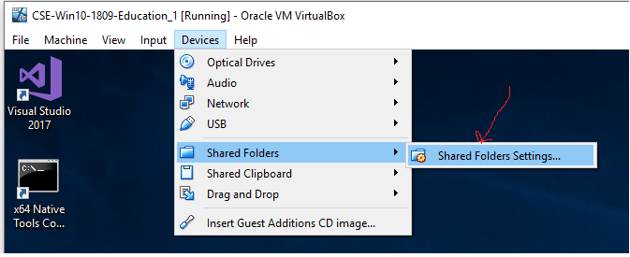

Figure 8: Using Shared Folders

Setup shared folder as illustrated in Figure 9 (below). This setting should only have to be setup once: Guest Additions must be installed to use Shared Folders

1. *Folder path* specifies the “shared” folder on the Host machine
2. *Folder name* specifies folder name (label) used to access shared folder from within the guest filesystem.
3. *Auto-mount* and *Make-Permanent* should be should be checked (as shown) to ensure the shared folder remains mounted and accessible to VM guest
4. Click “Ok” to complete the setup

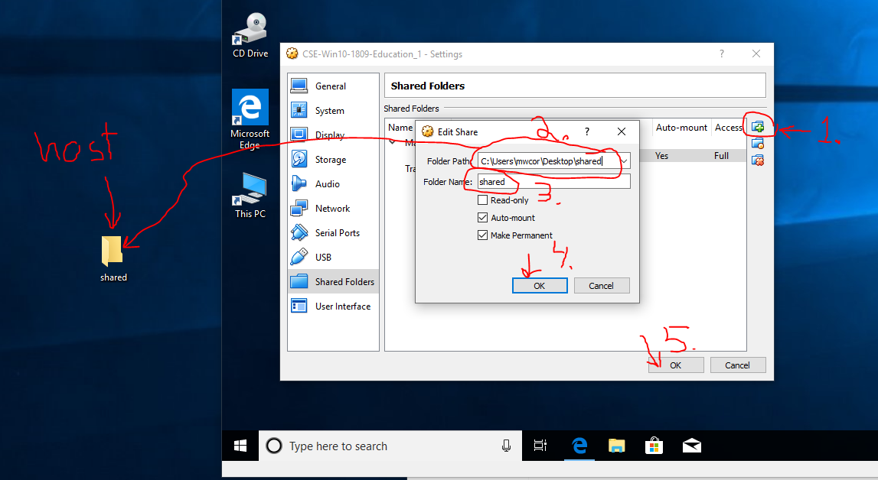

Figure 9: Configuring Shared Folders

**Accessing and the Shared Folder from the Guest**

1. Click “This PC” icon on the guest Desktop
2. In the “Network locations” group you should see a mapped network drive to the Host folder specified during the setup. See Figures and 9 and 10 for an illustration.