* **Virtual machine** – a virtual (rather than physical – software definition) of underlying computer hardware platforms, storage devices, and computer network resources.
  + **Full virtualization** – almost complete simulation of the actual hardware to allow a software environment, including a guest operating system and its apps, to run unmodified.
  + **Paravirtualization –** guest apps are executed in their own isolated domains, as if they are running on a separate system, but a hardware environment is not simulated. Guest programs need to be specifically modified to run in this environment.
  + **Hardware-assisted virtualization** is a way of improving overall efficiency of virtualization. It involves CPUs that provide support for virtualization in hardware, and other hardware components that help improve the performance of a guest environment. <https://en.wikipedia.org/wiki/Virtualization>
* **Hypervisor** - virtual machine manager (VMM) is computer software, firmware or hardware that creates and runs virtual machines.
  + **Type 1 (bare metal)** - hypervisors run directly on the host's hardware to control the hardware and to manage guest operating systems.
  + **Type 2 (hosted)** - hypervisors that run on a conventional operating system (Windows Linux, Mac) just as other computer programs do. <https://en.wikipedia.org/wiki/Hypervisor>

**What is VirtualBox?**

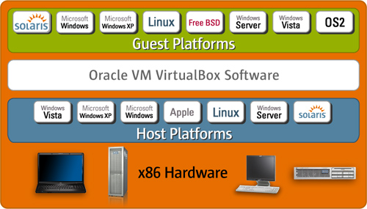**Hosted (Type 2 Hypervisor):** general-purpose full virtualization engine for x86 hardware, targeted at server, desktop

http://www.informit.com/articles/article.aspx?p=1627061ed use