F. Example projects which best illustrate proposed team’s qualifications for this  contract: (Present as many projects as requested by the agency, or 10 projects, if not specified. Complete one Section F for each project.) |  |  | 20. Example project key number:
21. Title and location: (City and State) | 22. Year completed
TxDOT Statewide Complex Bridge Inspections (2021 – Ongoing)  Statewide, Texas | Professional services: |  | Construction: (If applicable)
 | 2021-Ongoing |  | NA
23. Project owner’s information:
A. Project owner:  TXDOT |  | B. Points of contact name:  Justin Wilson, PE |  | C. Point of contact telephone number:  512-348-5747
24. Brief description of project and relevance to this contract (Include scope, size, and cost)

As a prime provider, Strinteg is performing non-redundant steel tension member (NSTM) bridge, tunnel, and pin and hanger inspections on a statewide basis for the Texas Department of Transportation (TxDOT). Services include the hands-on inspection of NSTMs throughout the state and as-inspected load ratings of bridges at the direction of the Department. Work is performed in both on-system and off-system settings, often requiring extensive coordination and pre-planning with traffic control, equipment providers, railroad entities, and TxDOT maintenance personnel. Services include reviewing previous inspection reports, completing a hands-on inspection, preparing bridge inspection reports that identify the condition evaluation of the structures, and updating the SI&A for fracture critical members, where necessary.
The project consists of inspecting numerous structure types, including cable-stayed, tub girder, through and pony trusses, two or three girder framing systems, and bent caps.
Traditional access equipment includes boom lifts, bucket trucks, and under-bridge inspection vehicles. In addition, innovative access techniques are often employed to eliminate or reduce the need for costly traffic control, including the use of technical climbing techniques, rope access, and novel aerial lift equipment (bucket boats).
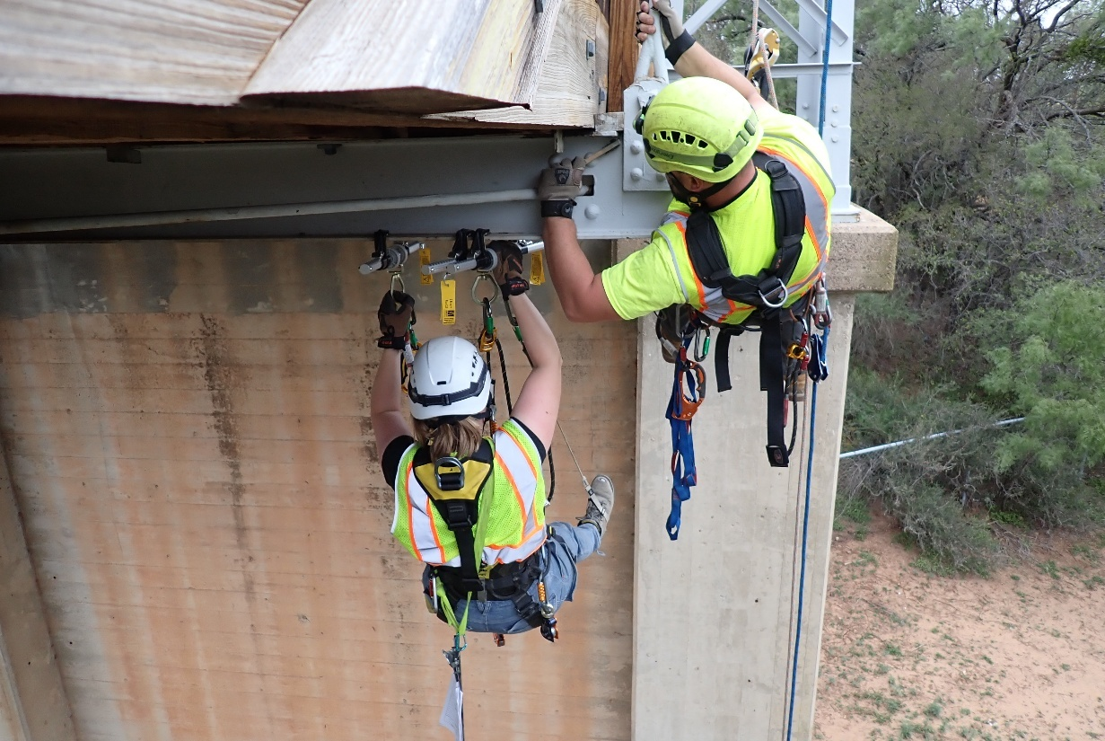
Conservatively, work through this contract has included:
400+ bridges
1,050+ fracture critical elements
480+ box and plate caps
83 fracture critical members over railroads
470+ fracture critical girder spans

Strinteg was recently re-selected for the next 4-year cycle of this contract.
Contact Cap: $12M

25. Firms from Section C involved with this project:
a, (1) Firm Name (2) Firm Location (City and State) (3) Role
Strinteg Corporation Valley View, OH Prime

