F. EXAMPLE PROJECTS WHICH BEST ILLUSTRATE PROPOSED TEAM'S  QUALIFICATIONS FOR THIS CONTRACT  (Present as many projects as requested by the agency, or 10 projects, if not specified.  Complete one Section F for each project.) |  |  |  |  |  |  | 20. EXAMPLE PROJECT KEY NUMBER  2
21. TITLE AND LOCATION (City and State)  SCDOT Bridge Inspection, Districts 1 &7, SC |  |  |  | 22. YEAR COMPLETED
 |  |  |  | PROFESSIONAL SERVICES  2019-2022 |  |  | CONSTRUCTION (If applicable)  NA
23. PROJECT OWNER'S INFORMATION
a. PROJECT OWNER  South Carolina Department of Transportation |  |  | b. POINT OF CONTACT NAME  Emily Berry, PE |  |  | c. POINT OF CONTACT TELEPHONE NUMBER  (803) 737-1053
24. BRIEF DESCRIPTION OF PROJECT AND RELEVANCE TO THIS CONTRACT (Include scope, size, and cost)
WSP is currently performing NBIS bridge inspections for SCDOT in districts 1&7 as a subconsultant. WSP has completed over 210 routine inspections. Through this role the WSP team has gained in-depth knowledge of the Bridge Inspection Guidance Document (BIGD), and Load Rating Guidance Document (LRGD). Further the WSP Team created systems and tools that include Fast Field Form Applications for guided/controlled inspection process, SharePoint for cloud document storage and multiple office collaboration, GIS cloud for mobile data collection and large dataset analytics. These tools focused on allowing our team to be more efficient, and productive with few errors in the field. WSP has utilized the newly created SCDOT Bridge File Policy (BFP) to create/ update folders including plans, load ratings, and inspection reports. Our team has established logins for BIO and ProjectWise and have experience uploading/submitting hundreds of reports into both systems.
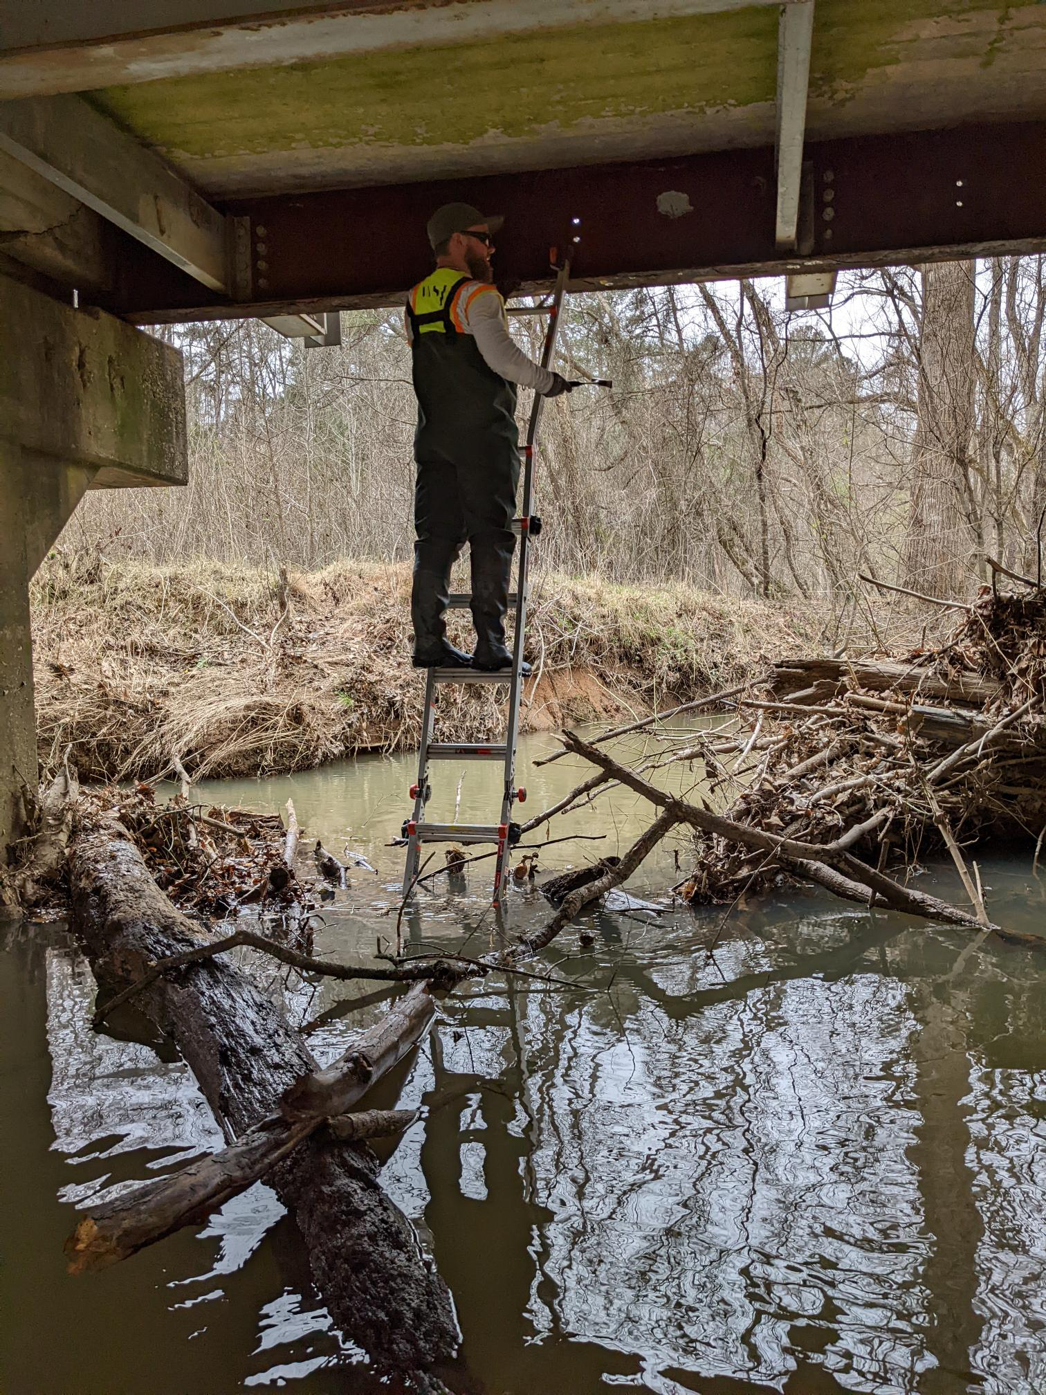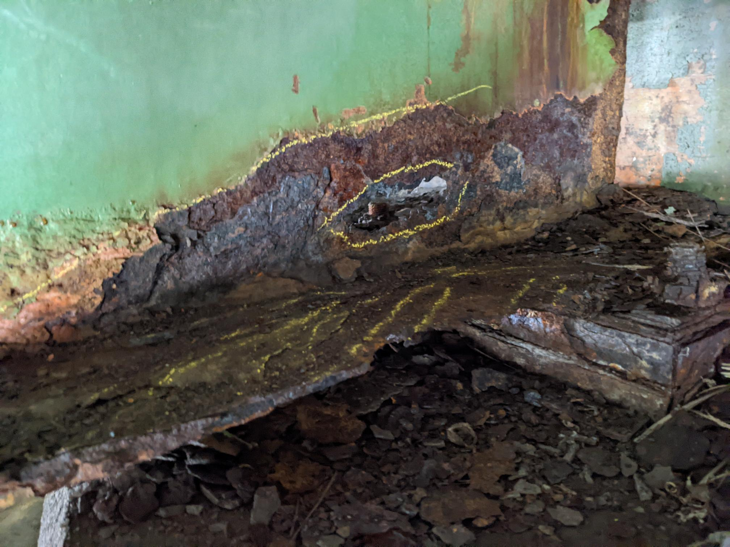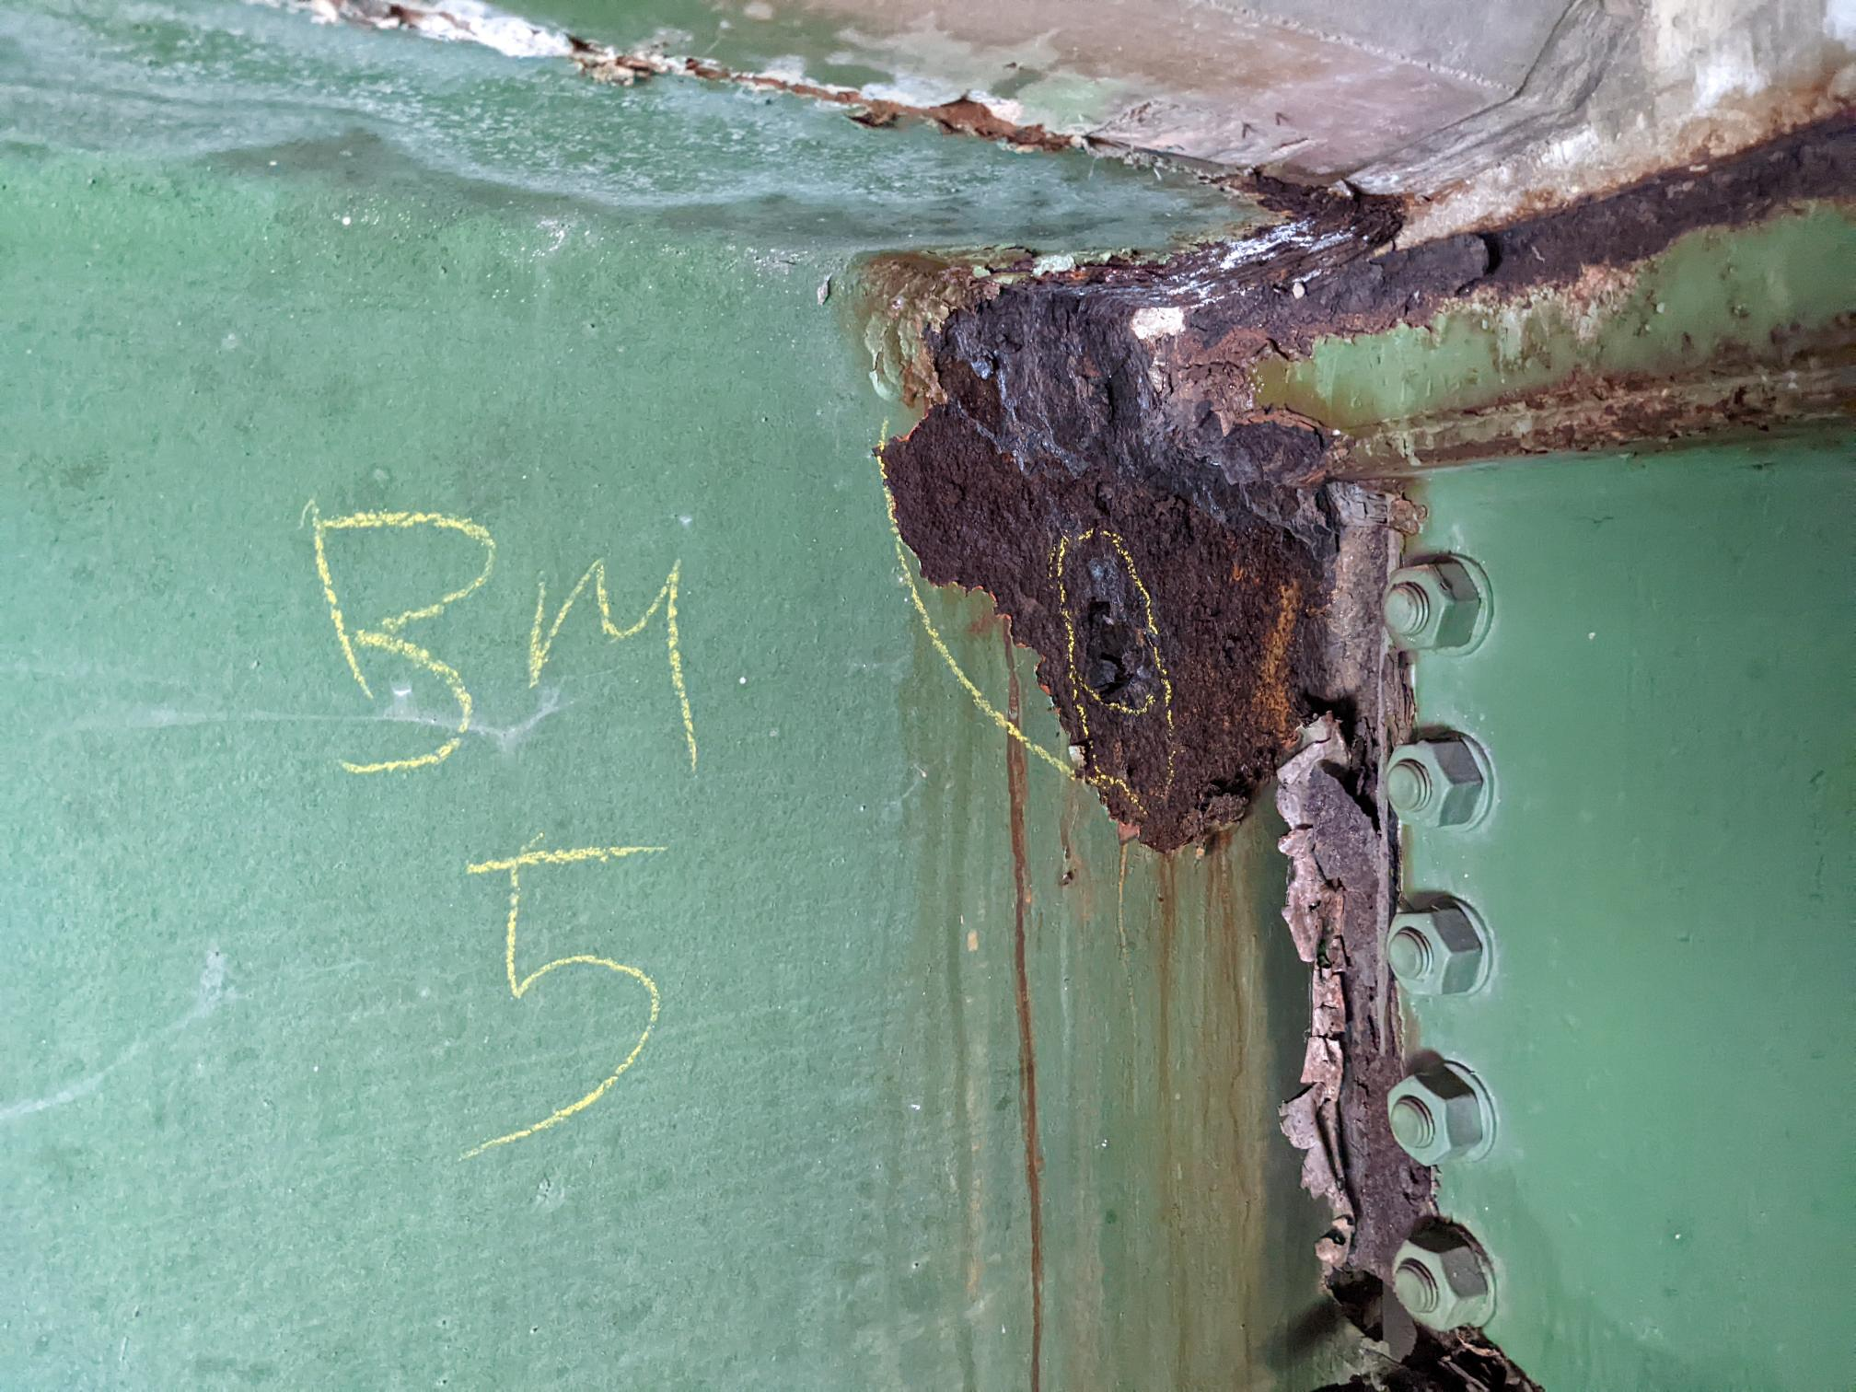

WSP was selected for this project largely because of our capacity to do the inspection work combined with our teams’ ability to assist SCDOT quickly and efficiently with needed bridge repairs.

Total Contract Value - $700k
The following key staff worked on this project:
Michael Warren Craig, PE | Project Manager | Matthew Paul Sullivan, PE | Complex Bridge Inspection Lead
William Coleman Mitchell | Deputy Project Manager | Field Work | Ricardo Emilio Cornejo, PE | Bridge Inspection Team Lead
Casey Jordan Howard, PE | Deputy Project Manager | Engineering | Matthew William Greer, PE | Bridge Inspection Team Lead
Michael Robert Meyer, PE | Bridge Inspection Team Lead | Hasan Istiaque, PE | Load Testing Specialist

5. FIRMS FROM SECTION C INVOLVED WITH THIS PROJECT
a. | (1) FIRM NAME  WSP USA | (2) FIRM LOCATION (City and State)  Columbia, South Carolina |  |  | (3) ROLE  Prime

