Clayto.org [working title] Specification

This document defines the behavior of clayto.org, a photoblog website. At the time of this (the original) writing, the software is in development by one volunteer. The software's goal is to be general-purpose enough that it can be installed and used for any photography website, although the clayto.org is the primary focus for now.

It is built with the Django framework.

http://djangoproject.com/

A significant amount of customization of Django's “automatic admin interface” will be done to accommodate the desired behavior of clayto.org.

Also at the time of this writing, the only fairly-well-thought-out part of the website is the color selection tool.

Color selection tool

When images are posted on a Web site, each image's page traditionally shares the same color palette. Take, for example, photographs posted to flickr.com. The page that displays each photograph is nearly identical. The only features of the page that tie it to the image are

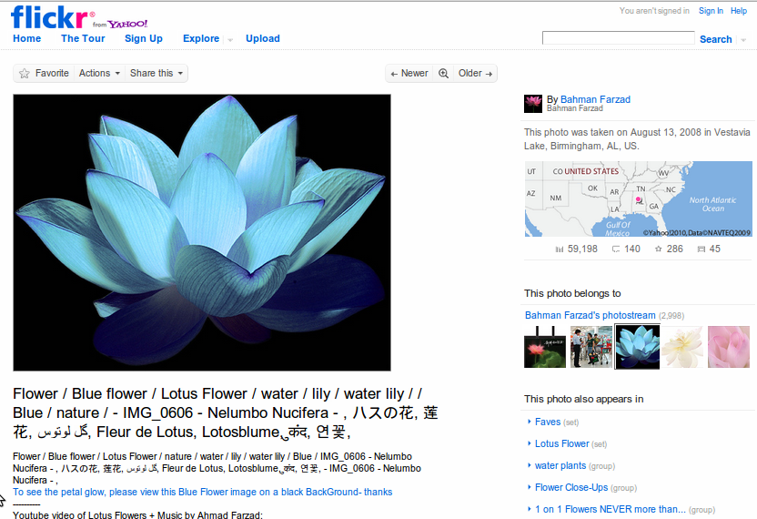
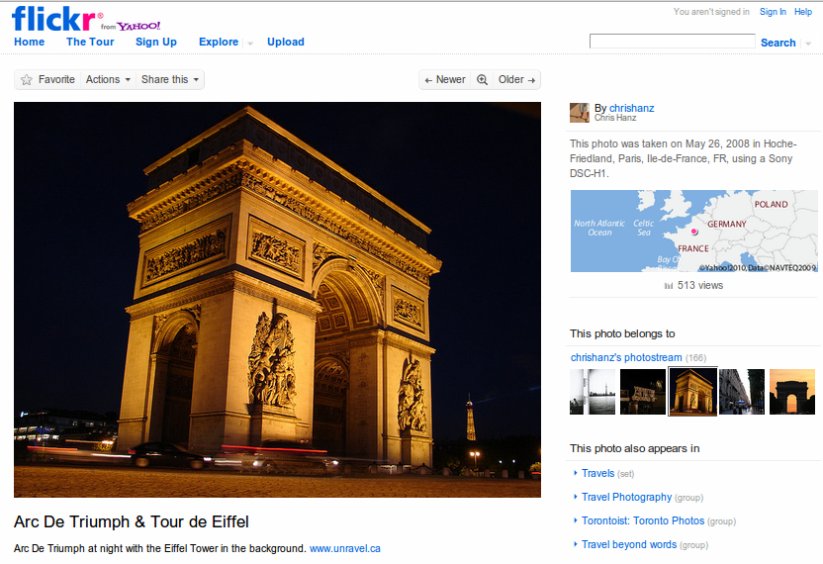
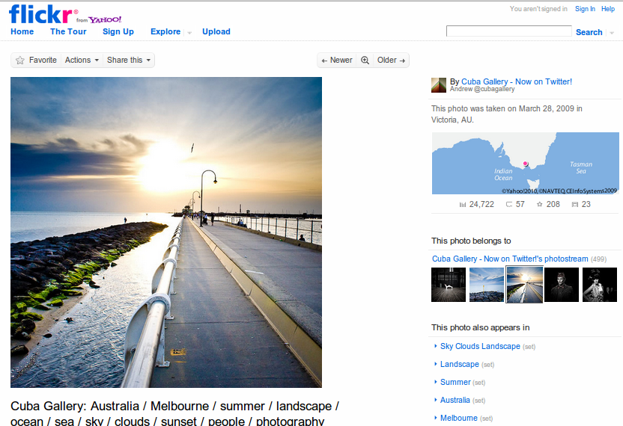

The color selection tool allows the photographer to use colors present in each posted photograph as the palette for that photograph's page. It is important that the page compliments the image but does not distract from it.

Examples from an early version of clayto.org.
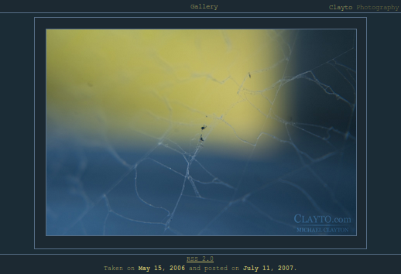
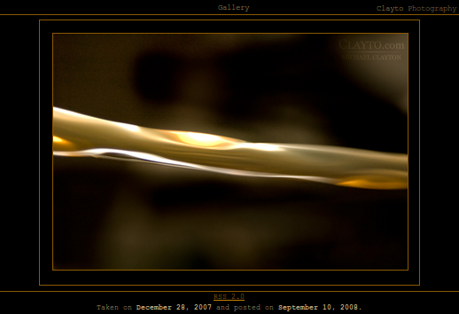
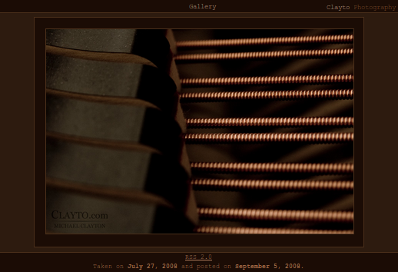
The color selection tool provides (at present) four methods for choosing colors.
- Eyedropper
- Area eyedropper
- Color wheel
- Color quantization

Eyedropper

The eyedropper tool allows the user to choose colors by clicking on individual pixels within the image.

Area eyedropper

The area eyedropper tool allows the user to choose colors by drag-selecting a rectangular area within the image. The average of the selected pixels is returned.

Color wheel

Although not necessarily round, the color wheel allows the user to select any arbitrary color using a JS/HTML color picker.
Possibilities
- http://jscolor.com/
- http://www.nogray.com/color_picker.php
- http://dematte.at/colorPicker/#demo
- http://www.bitrepository.com/color-pickers.html (10 JS color pickers)

Color quantization

When images are uploaded, a suggested palette is automatically generated using the Python Imaging Library (PIL).

NOTE: the color quantization functionality, although complete (it was the first part of clayto.org ever written), is on hold. Adding it to the Django admin interface has proven more difficult than first assumed.

The difficulty stems from the fact that the image must be uploaded before the colors may be quantized. The image must be uploaded in one step, and the colors chosen in another step. Django's form wizard would make multi-part forms easy but for the fact that images can only be added during the final step due to form variables being passed from step to step in hidden fields. Another method must be found.

Django admin interface

templates/admin/photos/photopost/add_form.html
will be used to choose the title/slug/caption/description and upload the file.

templates/admin/photos/photopost/change_form.html
will display the above fields and also display the color selection tool.

