Name: Jeffson Ovilmar
Class: Linux administration
Date:5/3/2026
Final Project
Teacher: William Payne

For this project, I built a simple but realistic web system using Amazon Web Services (AWS). The goal was to create a two-tier architecture, which is basically separating the web server and the database server into different machines to improve security and structure.
I used two EC2 Linux instances inside a Virtual Private Cloud (VPC). One server acts as the web server running Apache, PHP, and WordPress. The second server is the database server running MariaDB. These two systems communicate privately inside the AWS network using private IP addresses.
The main idea behind this setup is how real companies design systems: they don’t put everything on one machine. Instead, they separate layers so the system is more secure, scalable, and easier to manage.

2. Linux Distributions
Chosen: Amazon Linux 2023
Both servers used Amazon Linux 2023 because it is designed to work smoothly with AWS.
Comparison
Feature | Amazon Linux | Ubuntu | Rocky Linux
Package system | dnf | apt | dnf
AWS integration | Very strong | Good | Moderate
Ease of use | Medium | Easy | Medium
Enterprise use | High (AWS-focused) | Very high | Very high
Explanation
Amazon Linux was a good choice because it is optimized for AWS and works well with EC2 instances without needing extra configuration. Ubuntu is more popular overall and easier for beginners, while Rocky Linux is more focused on enterprise stability.
For this project, Amazon Linux made the most sense because everything was already in AWS.

3. Web Servers
Chosen: Apache HTTP Server
I used Apache to serve the WordPress website.
Comparison
Feature | Apache | Nginx | IIS
Performance | High | High | High
Setup | Easy | Medium | Easy (Windows only)
Flexibility | High | Medium | Medium
Popularity | Very high | High | Medium
Explanation
I chose Apache because it is very common, well-documented, and works perfectly with PHP and WordPress. Nginx is faster under heavy traffic, but Apache is easier to configure, especially for a school project like this. IIS is mainly used in Windows environments, so it didn’t fit this setup.

4. Databases
Chosen: MariaDB (MySQL-compatible)
MariaDB was used as the database for WordPress.
Comparison
Feature | MariaDB/MySQL | PostgreSQL | MongoDB
Type | Relational | Relational | NoSQL
WordPress support | Excellent | Good | Poor
Complexity | Medium | High | Medium
Use case | Web apps | Data-heavy apps | Flexible data
Explanation
I used MariaDB because WordPress is built to work with MySQL-based databases. PostgreSQL is more advanced and powerful in some cases, but it is not necessary for WordPress. MongoDB is completely different since it is NoSQL and not ideal for structured WordPress data.

5. Cloud / Virtualization Platform
Chosen: AWS (EC2 + VPC)
The whole system runs on AWS using EC2 instances inside a VPC.
Comparison
Feature | AWS | Azure | Google Cloud
Popularity | Highest | High | Medium
Networking tools | Very strong | Strong | Strong
Ease of learning | Medium | Medium | Harder
Enterprise use | Very high | Very high | High
Explanation
AWS was the best choice because it is the most widely used cloud platform and offers very strong networking tools like VPCs and Security Groups. Azure is better if you're in a Microsoft environment, and Google Cloud is more focused on data and AI workloads.

6. Content Management System (CMS)
Chosen: WordPress
WordPress was used to build the website.
Comparison
Feature | WordPress | Drupal | Joomla
Ease of use | Very easy | Harder | Medium
Flexibility | High | Very high | High
Security | Medium | High | Medium
Plugins | Huge ecosystem | Smaller | Medium
Explanation
WordPress was chosen because it is very easy to install and use, and it has a huge number of plugins. Drupal is more secure and customizable but harder to learn. Joomla is somewhere in between but not as popular.
For this project, WordPress was the fastest and most practical option.

7. Security Design (Defense in Depth)
One important part of this project was making it secure using a “defense in depth” approach. This means using multiple layers of security instead of relying on just one thing.
Here’s what I implemented:
- AWS Security Groups to control traffic
- Database only allows connections from the web server
- No public access to the database server
- Root user access disabled remotely
- A separate database user (wpuser) for WordPress with limited permissions
This setup makes the system safer because even if one layer fails, the other layers still protect the system.

8. Evaluation of WordPress
WordPress turned out to be a good choice for this project. It is easy to install, works well with PHP and MySQL, and allows quick website setup.
However, in real-world enterprise environments, WordPress needs extra care:
- Plugins can create security risks
- It needs regular updates
- It should be protected with proper firewall rules and backups
So overall, WordPress is great for small and medium websites, but it needs proper security setup if used in bigger systems.

9. Conclusion
Following along with your progress and work on my project, even though I wasn’t the one making all the decisions on which technology we got to choose was really interesting because the project helped me understand how real web systems are built using cloud infrastructure. By separating the web server and database server, I was able to create a more secure and realistic setup.
I also learned how important it is to control access using both AWS Security Groups and database permissions. Overall, AWS, Linux, Apache, MySQL/MariaDB, and WordPress worked well together to build a functional and secure web application
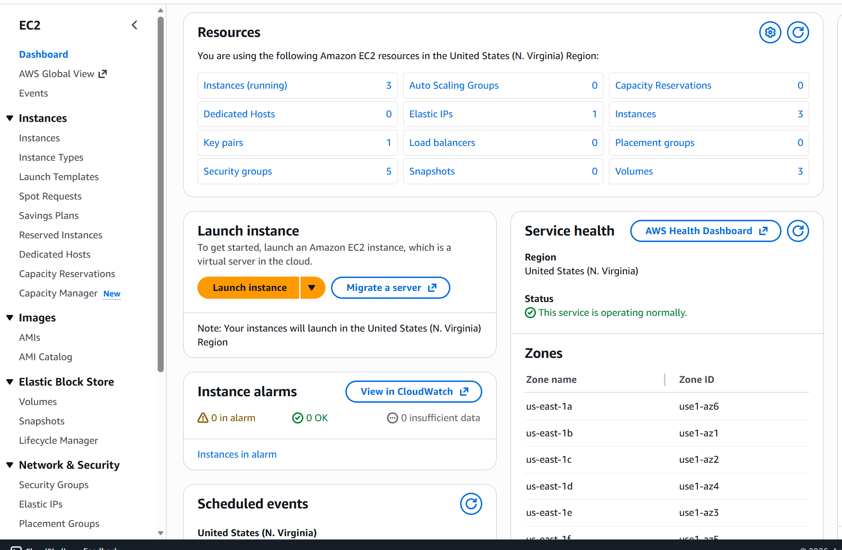
AWS Network setup.
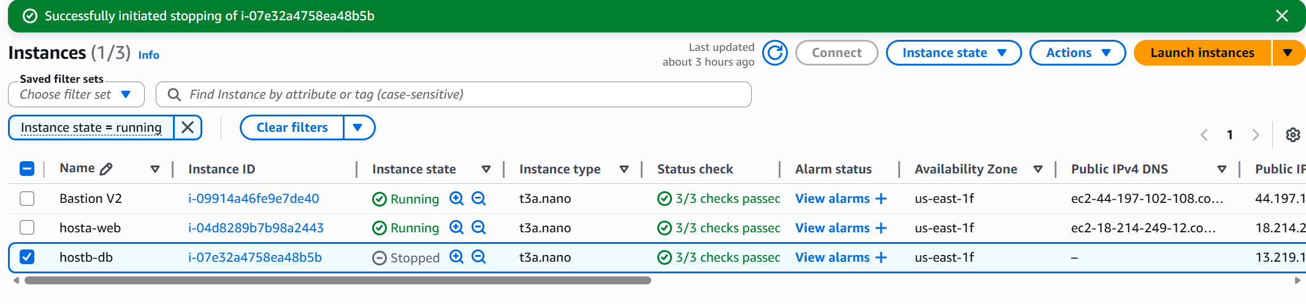
EC2 Instances running web, db, bastion.
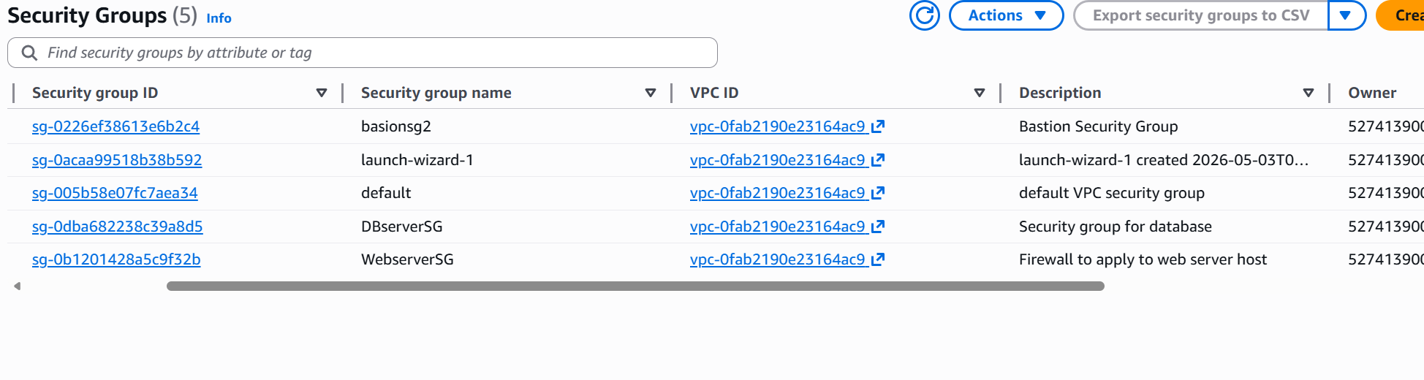
My security Group rules
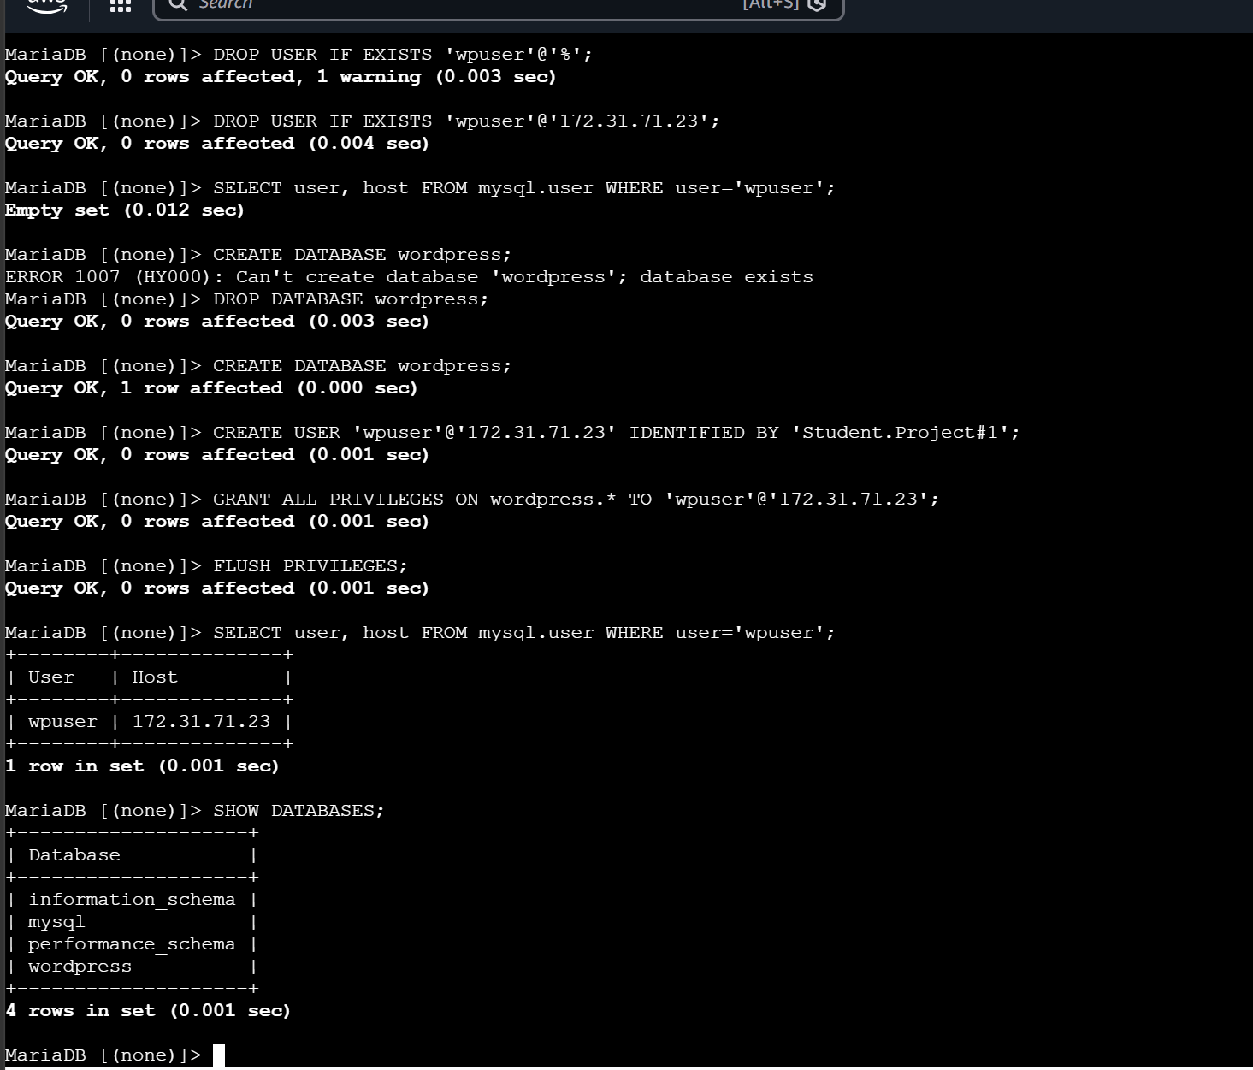
Terminal showing my SQL and WordPress connections and setup.

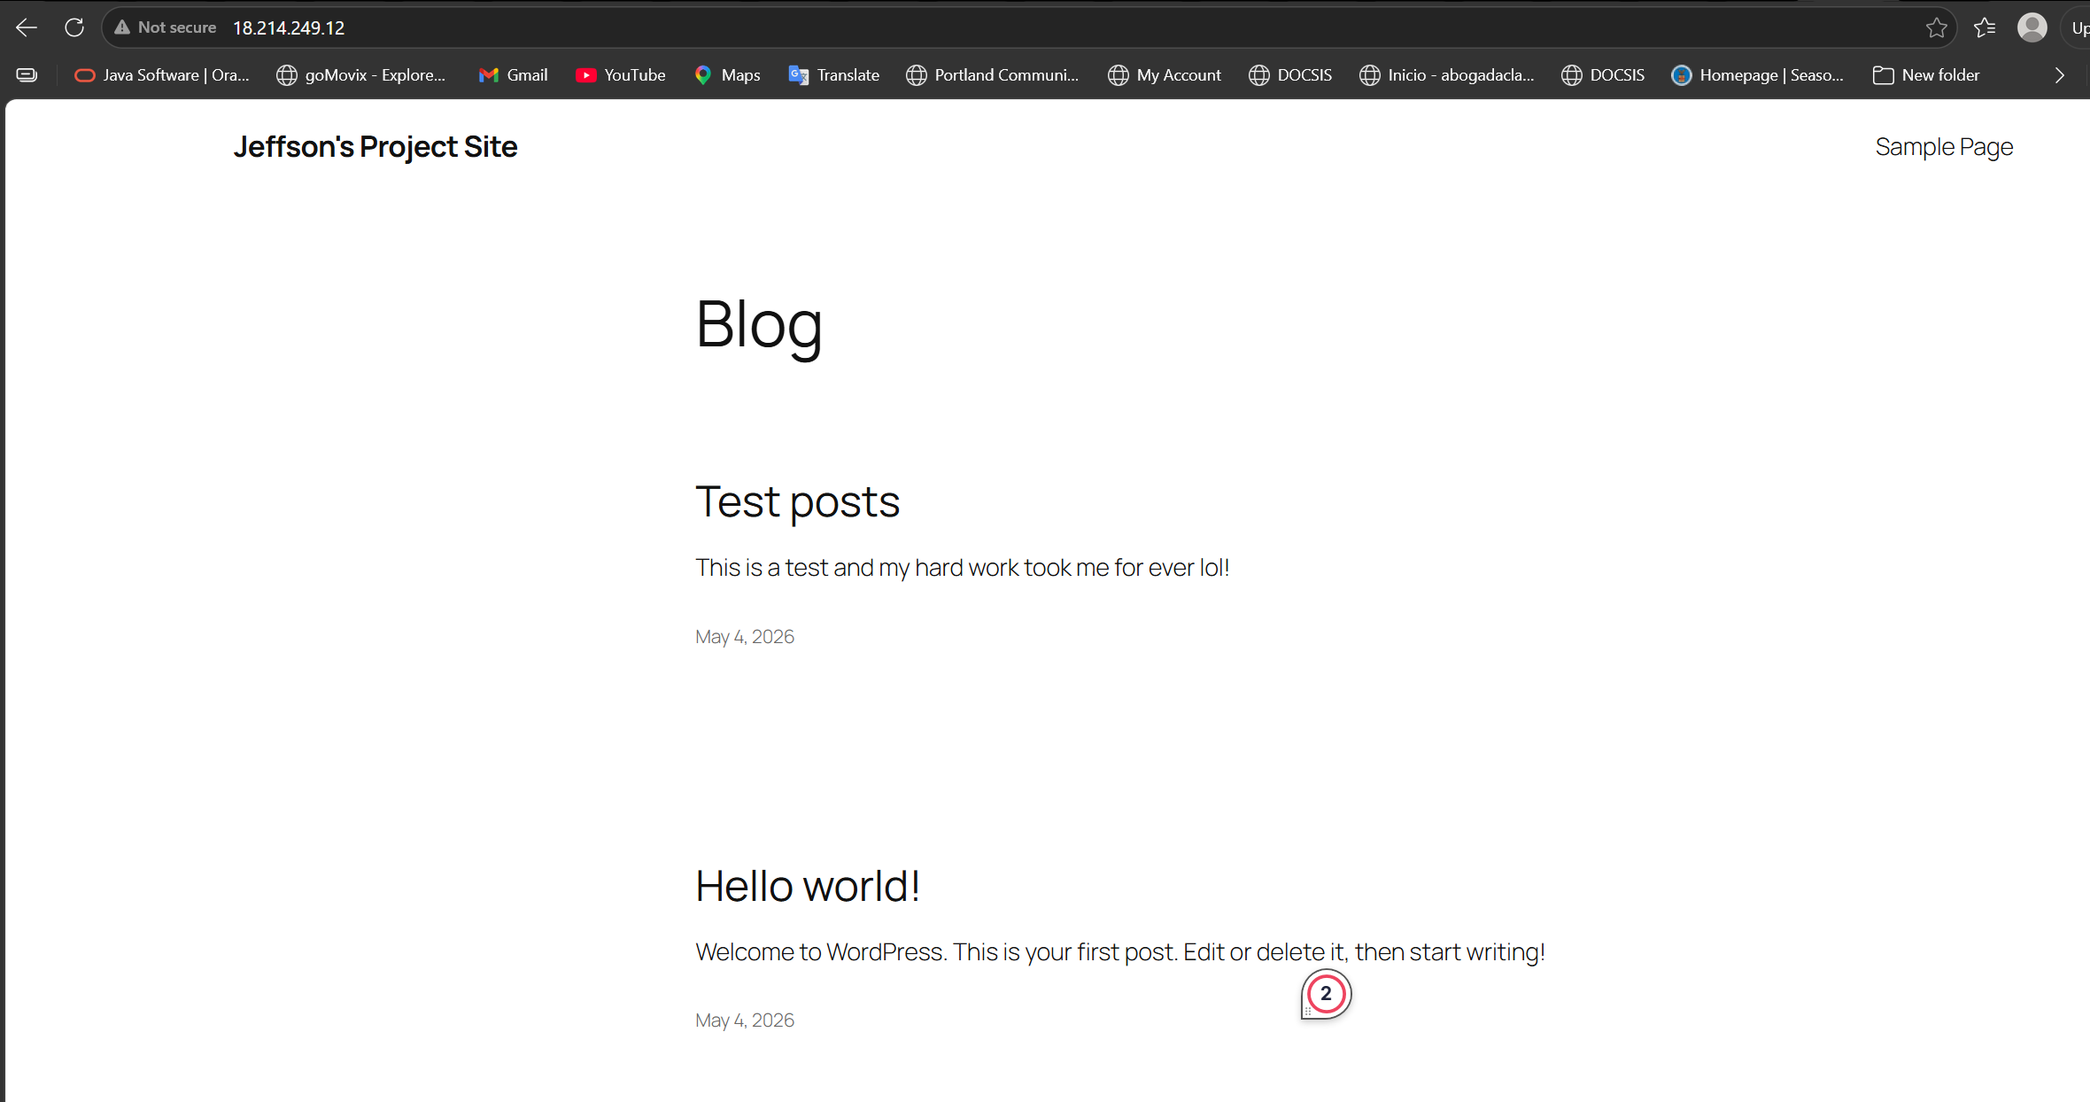
WordPress working in browser

References:
AWS: latest user guide
https://docs.aws.amazon.com/vpc/latest/userguide/what-is-amazon-vpc.html
Apache: installation
Documentation: Apache HTTP Server - The Apache HTTP Server Project
MySQL / MariaDB
MariaDB Documentation
Connecting to MariaDB Server | Server | MariaDB Documentation
MySQL :: MySQL Documentation
WordPress
FAQ Installation – Documentation – WordPress.org
Security – Advanced Administration Handbook | Developer.WordPress.org
LINUX
What is Amazon Linux 2023? - Amazon Linux 2023
Ubuntu Server documentation
Security/concepts
OWASP Top Ten Web Application Security Risks | OWASP Foundation

