Secure Web Application Architecture Design:
Stopping Cross-Site Scripting (XSS) in a LAMP Environment
Jeffson J. Ovilmar
Computer Science Department, Columbus State Community College
ITST-2258: Web Application Security
Michael Greer
August 2026

Introduction & Overview of Cross-Site Scripting (XSS)
Cross-Site Scripting (XSS) is one of the most common and dangerous web application vulnerabilities facing modern web applications today. It occurs when a web application takes untrusted user input, such as text entered into a search box, comment field, or URL parameter, and displays it back on the webpage without properly validating or cleaning it up first (OWASP Foundation, 2021). This flaw allows an attacker to inject malicious client-side JavaScript code that executes directly inside another user's web browser session (OWASP Foundation, 2021).
XSS is particularly dangerous because web browsers operate on trust and treat scripts executed by a domain as authorized. Once a malicious script runs inside a victim's browser, it easily bypasses standard browser security boundaries like the Same-Origin Policy (SOP) (OWASP Foundation, 2021). As a result, an attacker can hijack user session cookies (document.cookie) to log into accounts without needing passwords, perform unauthorized financial or account transactions on behalf of the victim without their knowledge, alter the appearance of a web page, inject fake login prompts to capture credentials, or log keypresses to harvest sensitive personal data (OWASP Foundation, 2021).
LAMP Stack Vulnerabilities
Beyond application-level protections, securing the underlying web infrastructure is essential for protecting the overall system. A standard Linux, Apache, MySQL, and PHP (LAMP) deployment consists of several interconnected software layers. If any component in this stack contains unpatched system vulnerabilities, an attacker could exploit them to elevate privileges, disrupt application availability, or compromise the underlying database server (NIST, 2023). For instance, operating system flaws such as the Netfilter use-after-free vulnerability (CVE-2023-32233) and the nftables memory flaw (CVE-2024-1086) allow local unprivileged users to escalate privileges to full root access on the host system (NIST, 2023; NIST, 2024a). At the web server layer, Apache HTTP Server path traversal flaws (CVE-2021-41773 and CVE-2021-42013) allow unauthenticated remote attackers to read restricted files or execute arbitrary remote commands if CGI is enabled (NIST, 2021a; NIST, 2021b). In the database layer, MySQL vulnerabilities such as the server optimizer flaw (CVE-2023-21980) and InnoDB memory corruption (CVE-2021-2144) enable high-privileged authenticated users to trigger denial-of-service conditions or access unauthorized data (NIST, 2021c; NIST, 2023). Finally, PHP vulnerabilities including CGI argument injection (CVE-2024-4577) and the Phar buffer overflow (CVE-2023-3824) allow remote attackers to trick PHP into executing arbitrary operating system commands or crashing the server process (NIST, 2023; NIST, 2024b).
Threat Model
To systematically analyze how Cross-Site Scripting affects the application, the STRIDE threat modeling methodology was applied (OWASP Foundation, 2021). The STRIDE model categorizes potential security threats into six distinct areas: Spoofing, Tampering, Repudiation, Information Disclosure, Denial of Service, and Elevation of Privilege (OWASP Foundation, 2021). The following threat scenarios represent the primary XSS risk vectors targeting the application structure:
Spoofing (Account Takeover via Cookie Theft): An attacker injects a malicious script that reads document.cookie and transmits the victim's session identification token to an external server controlled by the attacker (OWASP Foundation, 2021). By obtaining this active session token, the attacker can impersonate the legitimate user and bypass authentication controls completely (OWASP Foundation, 2021).
Tampering (Webpage Defacement and Phishing Overlays): The injected script dynamically manipulates the Document Object Model (DOM) of the webpage (OWASP Foundation, 2021). The attacker can inject fake login dialogs or re-authentication forms over legitimate page content, tricking users into entering sensitive login credentials or security answers that are sent directly to the attacker (OWASP Foundation, 2021).
Repudiation (Unauthorized User Actions): XSS enables an attacker to force the victim's browser to send authenticated HTTP POST requests, such as changing account recovery email addresses, resetting passwords, or transferring funds (OWASP Foundation, 2021). Because these requests originate directly from the legitimate user's browser, server logs attribute the actions to the real user, making attribution and investigation difficult (OWASP Foundation, 2021).
Information Disclosure (Sensitive On-Screen Data Scraping): JavaScript running in the context of the victim's browser session can read any data rendered on the screen (OWASP Foundation, 2021). The script can harvest personal profile information, billing addresses, or security tokens displayed on the page and quietly send that stolen data to an offsite location (OWASP Foundation, 2021).
Elevation of Privilege (Administrative Account Hijacking): An attacker submits a stored XSS payload inside a persistent database field, such as a customer support ticket or user review form (OWASP Foundation, 2021). When an administrative user views the ticket inside the admin portal, the payload executes in the admin's session, giving the attacker full administrative control over the entire system (OWASP Foundation, 2021).
Proposed Resilient Architecture & System Diagram
To protect transaction data and ensure high availability, the web application infrastructure is designed without single points of failure. If any single hardware component, web server, or firewall fails, redundant components take over immediately without interrupting service. The network architecture is separated into three distinct security zones: the Demilitarized Zone (DMZ), the Internal Application Zone, and the Secure Database Zone.
Perimeter Protection and Load Balancing
In the DMZ, incoming web traffic passes through redundant Web Application Firewalls (WAFs) operating in an active-passive configuration. The WAF inspects incoming HTTP requests for known XSS patterns, malicious scripts, and SQL injection attempts before allowing traffic into the network (OWASP Foundation, 2021). Directly behind the WAFs, a redundant pair of HAProxy load balancers inspects server health and balances incoming web traffic evenly across multiple backend web servers.
Application and Database Tier Redundancy
The application tier resides in a dedicated internal VLAN and consists of multiple independent Apache web servers running PHP. If Apache Server #1 experiences a crash or hardware failure, the load balancer automatically redirects all user traffic to Apache Server #2. The database tier is isolated in a secure database zone with strictly controlled firewall rules. It uses a primary-secondary MySQL database cluster. The primary database processes all read and write transactions and continuously replicates data to the secondary database. If the primary node fails, the secondary database automatically assumes the primary role.
[ System Architecture Diagram & Threat Model Overlay ]
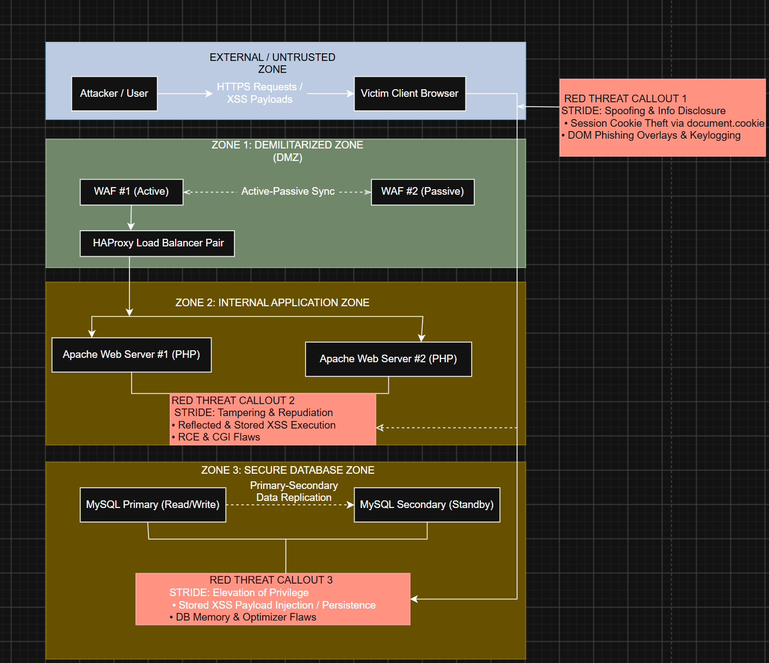
Compensating Controls
To enforce defense-in-depth against XSS at the code and configuration level, four specific controls from the OWASP Application Security Verification Standard (ASVS 4.0) were selected and implemented (OWASP Foundation, 2021):
ASVS V5.3.1: Context-Aware Output Encoding: Requirement V5.3.1 specifies that all user-supplied input must be properly encoded before it is rendered into web pages (OWASP Foundation, 2021). In PHP, this is accomplished using htmlspecialchars($data, ENT_QUOTES, 'UTF-8') (OWASP Foundation, 2021). This function converts special HTML characters such as '<' and '>' into harmless HTML entities ('&lt;' and '&gt;'), ensuring the browser treats input as plain text rather than executable script code (OWASP Foundation, 2021).
ASVS V14.4.1: Content Security Policy (CSP): Requirement V14.4.1 mandates configuring a strong Content Security Policy header to control which script sources the browser is permitted to execute (OWASP Foundation, 2021). Apache is configured to return the header: Header set Content-Security-Policy "default-src 'self'; script-src 'self';" (OWASP Foundation, 2021). This header instructs the browser to block inline script tags and reject scripts hosted on unauthorized third-party domains (OWASP Foundation, 2021).
ASVS V3.4.1: Session Cookie Protection Flags: Requirement V3.4.1 requires setting security attributes on session cookies to safeguard session identifiers (OWASP Foundation, 2021). In the php.ini configuration file, session.cookie_httponly is set to 1, session.cookie_secure is set to 1, and session.cookie_samesite is set to 'Strict' (OWASP Foundation, 2021). The HttpOnly flag prevents client-side JavaScript from accessing document.cookie, ensuring that even if an XSS vulnerability exists, an attacker cannot steal the session cookie (OWASP Foundation, 2021).
ASVS V5.1.3: Server-Side Input Validation: Requirement V5.1.3 requires validating all incoming data on the server side using strict allow-lists prior to processing (OWASP Foundation, 2021). PHP filter functions such as filter_input() are used to verify that inputs conform to expected formats (e.g., verifying email addresses or integers) and reject malformed or suspicious data inputs immediately (OWASP Foundation, 2021).
Conclusion
Cross-Site Scripting continues to pose a serious risk to web application security, but it can be thoroughly mitigated using a combination of secure coding techniques and redundant network architecture. By implementing context-aware output encoding, strict Content Security Policy headers, HttpOnly session cookies, and server-side input validation, application code remains secure against script injection attacks (OWASP Foundation, 2021). Concurrently, deploying redundant WAFs, load balancers, multiple web nodes, and database clustering eliminates single points of failure, ensuring the web application remains resilient, available, and secure.
References
National Institute of Standards and Technology. (2021a). CVE-2021-41773 detail. National Vulnerability Database. https://nvd.nist.gov/vuln/detail/CVE-2021-41773
National Institute of Standards and Technology. (2021b). CVE-2021-42013 detail. National Vulnerability Database. https://nvd.nist.gov/vuln/detail/CVE-2021-42013
National Institute of Standards and Technology. (2021c). CVE-2021-2144 detail. National Vulnerability Database. https://nvd.nist.gov/vuln/detail/CVE-2021-2144
National Institute of Standards and Technology. (2023). CVE-2023-32233 detail. National Vulnerability Database. https://nvd.nist.gov/vuln/detail/CVE-2023-32233
National Institute of Standards and Technology. (2023). CVE-2023-21980 detail. National Vulnerability Database. https://nvd.nist.gov/vuln/detail/CVE-2023-21980
National Institute of Standards and Technology. (2023). CVE-2023-3824 detail. National Vulnerability Database. https://nvd.nist.gov/vuln/detail/CVE-2023-3824
National Institute of Standards and Technology. (2024a). CVE-2024-1086 detail. National Vulnerability Database. https://nvd.nist.gov/vuln/detail/CVE-2024-1086
National Institute of Standards and Technology. (2024b). CVE-2024-4577 detail. National Vulnerability Database. https://nvd.nist.gov/vuln/detail/CVE-2024-4577
OWASP Foundation. (2021). OWASP Application Security Verification Standard 4.0.3. OWASP Project. https://owasp.org/www-project-application-security-verification-standard/

