### Test Case 4: Capture Zone in a Heterogeneous Aquifer

**Test Case Description**

Test Case 4 tests MODPATH’s ability to recreate within acceptable tolerance levels a ten-year capture zone in a heterogeneous aquifer. The capture zone recreated by this test was calculated in ISWS/BUL-69/87, *GWPATH: Interactive Ground-Water Flow Path Analysis*. The test in ISWS/BUL-69/87 defines a ten-year capture zone of an extraction well (shown in Figure 3‑9) in an aquifer with heterogeneous hydraulic conductivity (shown in Figure 3‑8), and with several other active extraction wells operating nearby (shown in Figure 3‑9). MODPATH’s ability to produce a 10-year capture zone within acceptable tolerance levels of the one shown in Figure 3‑9 is the pass/fail metric this test case is based upon.

The test setup for flow in ISWS/BUL-69/87 requires extraction wells, constant head boundaries, and a variable hydraulic conductivity field. The variable hydraulic conductivity field is shown in Figure 3‑8. The extraction wells shown in Figure 3‑9 have the coordinates and pumping rates shown in Table 3‑7. The boundary types of the flow model are not explicitly stated by ISWS/BUL-69/87; very little information about the flow model is given at all, including how the flow field was calculated. However, by investigating Figure 3‑10, it can be safely assumed that all boundaries are constant head boundaries. The heads of the top and bottom boundaries are explicitly listed in Figure 3‑10 as 100 and 60 feet, respectively. The right and left boundaries appear to represent a linear stepdown in heads from 100 to 60 feet.

The setup for particle tracking in ISWS-BUL-69/87 is relatively simple in setup, but different in approach from MODPATH. The particle tracking done in ISWS/BUL-69/87 was calculated using a Runge-Kutta numerical integration scheme, instead of the semi-analytical method used by MODPATH. These methods are different, but can produce similar results. The grid used in ISWS/BUL-69/87 is node-based, while the grid in MODPATH is cell-based. The capture zone was created by placing 300 particles in a circle around the extraction well and reverse-tracking them for ten years.

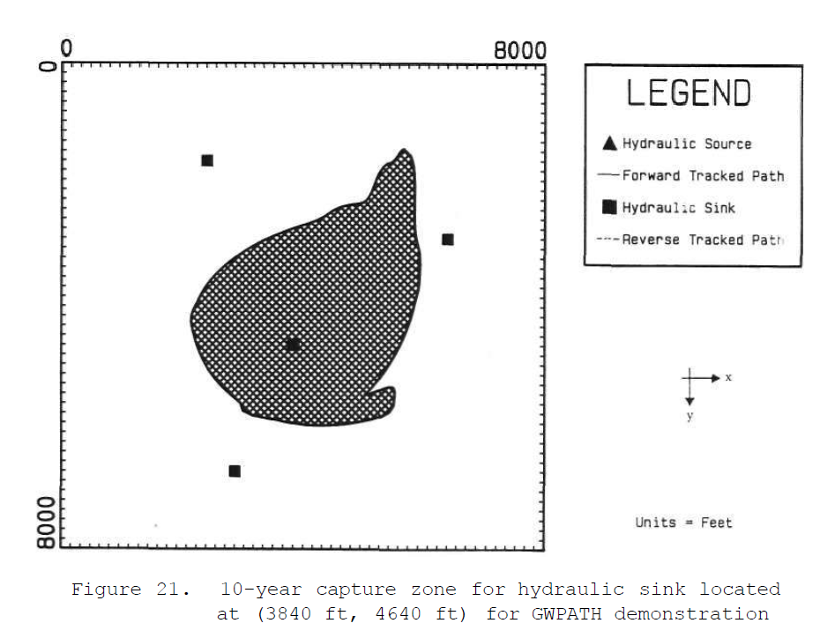

Source: ISWS/BUL-69/87

Figure 3‑9. 10-year capture zone for extraction well located at (3,840 ft, 4,640 ft) in ISWS/BUL-69/87

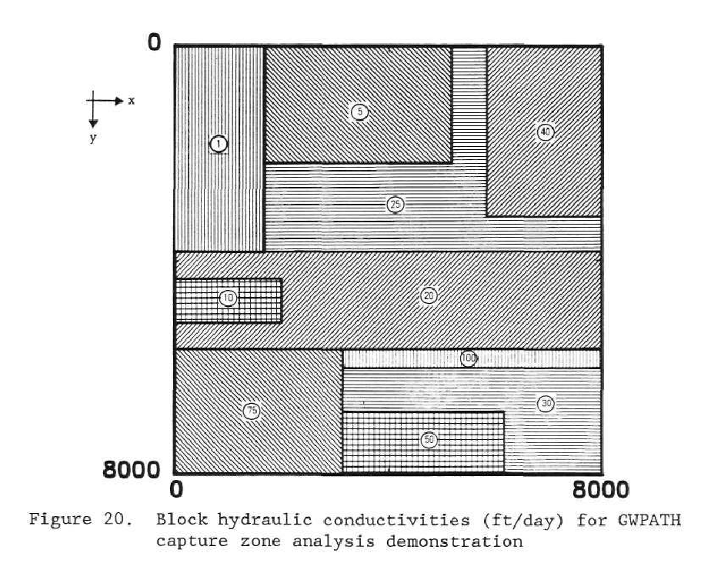

Source: ISWS/BUL-69/87

Figure 3‑8. Hydraulic conductivity (ft/day) used in ISWS/BUL-69/87, and used as the basis for the hydraulic conductivity grid for Test Cases 4, 5, and 6

| **Table 3‑7. Model Properties listed in ISWS/BUL-67/87** | | | |
| --- | --- | --- | --- |
| Variable Name | Variable Value | Units | Source |
| Model length in the x and y directions | 8000 | ft | ISWS/BUL-67/87, Figure 19 |
| Well 1 location (x,y) | 2,400, 1,600 | ft | ISWS/BUL-67/87 |
| Well 1 pumping rate | 200 | gpm | ISWS/BUL-67/87 |
| Well 2 location (x,y) | 6,400, 2,880 | ft | ISWS/BUL-67/87 |
| Well 2 pumping rate | 400 | gpm | ISWS/BUL-67/87 |
| Well 3 location (x,y) | 3,840, 4,640 | ft | ISWS/BUL-67/87 |
| Well 3 pumping rate | 500 | gpm | ISWS/BUL-67/87 |
| Well 4 location (x,y) | 2,880, 6,720 | ft | ISWS/BUL-67/87 |
| Well 4 pumping rate | 300 | gpm | ISWS/BUL-67/87 |
| Porosity | 0.25 | N/A | ISWS/BUL-67/87 |
| Number of particles | 300 | N/A | ISWS/BUL-67/87 |

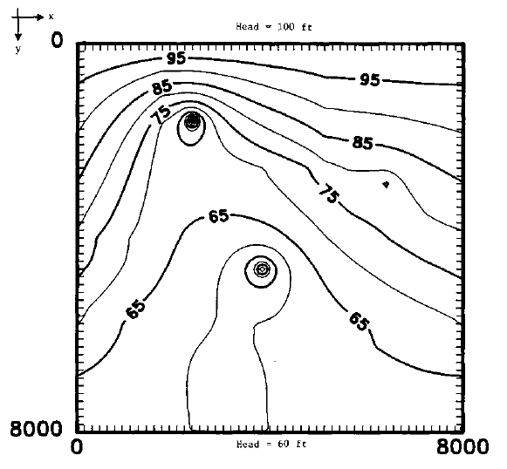

Source: ISWS/BUL-69/87

Figure 3‑10. Head contours used in ISWS/BUL-69/87

**Test Case Setup**

Test setup consists of six parts:

* Offset the MODFLOW grid to better match the node-based grid of ISWS/BUL-69/87.
* Digitize Figure 3‑8 in order to apply the hydraulic conductivity grid in ISWS/BUL-69/87 to the MODFLOW model grid.
* Digitize Figure 3‑9 to quantify the shape of the 10-year capture zone. This capture zone shape is used to assess the pass/fail status of this test case.
* Assemble the MODFLOW model to serve as the underlying flow model. Use the inputs stated in ISWS/BUL-69/87 and estimate inputs when necessary.
* Assemble the MODPATH model for particle tracking. Use the inputs stated in ISWS/BUL-69/87 and estimate inputs when necessary.
* Assess the pass/fail status of the test by comparing the MODPATH results to the digitized results of Figure 3‑9.

*Offset the MODFLOW Grid*

The particle tracking in ISWS/BUL-69/87 is done on a node-based model; MODPATH and MODFLOW are cell-based. To account for this difference, the upper left corner of the MODFLOW model was moved up and to the left by the length of half a grid cell. This put the centers of the grid cells in the MODFLOW model in the same locations as the nodes of the model in ISWS/BUL-69/87. This offset left the bottom row and right column only partially covered by grid cells, so a row was added to the bottom of the model and a column to the right to fully cover the entire modeled area.

*Digitize the Hydraulic Conductivity Grid*

The hydraulic conductivity distribution in Figure 3‑8 was digitized for use in the MODFLOW model. This process took the following steps:

1. Digitize Figure 3‑8
   1. Using a screen-capture tool, capture an image of Figure 3‑8 from ISWS/BUL-69/87 and save it as an image file.
   2. Using a script (“S00_pngs_2_tiffs.py”, described more in [Section x]) convert the image to a raster with projection information.
2. Create the model grid with the same projection information as the raster of Figure 3‑8.
   1. Use the script “S00_create_grid.py”, described further in [Section X].
   2. This creates a shapefile of the grid.
3. In a GIS program, overlay the shapefile of the grid on top of the raster of Figure 3‑8. In the attribute table, create an attribute for hydraulic conductivity, and assign the hydraulic conductivity values here.
   1. The MODFLOW grid is not perfectly aligned with the boundaries of the hydraulic conductivity zones, so professional judgment must be exercised along the boundaries of some hydraulic conductivity zones. The hydraulic conductivity assigned to the grid compared to the hydraulic conductivity zones is shown in [Figure 3-11].
   2. Save the changes to the shapefile. This shapefile will be used in model setup to assign the hydraulic conductivity in the MODFLOW files.

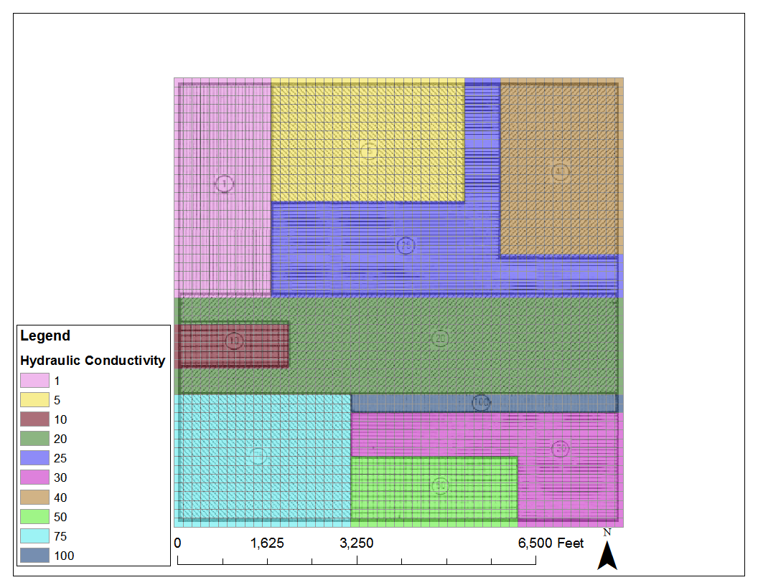

Figure 3‑11. MODFLOW hydraulic conductivity mapped against those seen in ISWS-BUL-69/87

*Digitize the Capture Zone*

Dimensions of the shape of the capture zone in Figure 3‑9 are the metrics upon which the pass/fail status of this test case rest. To get these dimensions into a format that can be compared to model outputs, Figure 3‑9 must be digitized. This process took the following steps:

1. Digitize Figure 3‑9
   1. Using a screen-capture tool, capture an image of Figure 3‑9 from ISWS/BUL-69/87 and save it as an image file.
   2. Using a script (“S00_pngs_2_tiffs.py”, described more in [Section x]) convert the image to a raster with projection information.
2. Create a shapefile defining the 10-year capture zone.
   1. Using a GIS program, create a new polygon shapefile. Open a GIS workspace with the raster of Figure 3‑9 and the new shapefile as layers. Populate the shapefile by digitizing the boundary of the 10-year capture zone from the raster of Figure 3‑9.

*Assemble the MODFLOW Model*

The MODFLOW model was assembled using the values in Pollock, 1988, when provided, and made reasonable assumptions at values needed, but not provided, by Pollock, 1988. [Table 3-8] lists the model length and number of cells, well data, and stress period data. The constant head data for the left and right boundaries, which represent a linear stepdown from 100 to 60 feet, were calculated using a script and shown in [Table 3-9]. The hydraulic conductivity grid data was read from the shapefile created in [Section x] and applied to the proper MODFLOW file.

| Table 3‑8. Model Properties Used in Test Cases 4 and 5 | | |  |
| --- | --- | --- | --- |
| Variable Name | Variable Value | Units | Source |
| Model length in the x and y directions | 8,160 | ft | Modified from ISWS/BUL-69/87 |
| Number of cells in the x and y directions | 51 | N/A | Modified from ISWS/BUL-69/87 |
| Well 1 location (row, column) | 11, 16 | N/A | Assumed from ISWS/BUL-69/87 |
| Well 1 pumping rate | 38,500 | ft3/day | ISWS/BUL-69/87 |
| Well 2 location (row, column) | 19, 41 | N/A | Assumed from ISWS/BUL-69/87 |
| Well 2 pumping rate | 77,000 | ft3/day | ISWS/BUL-69/87 |
| Well 3 location (row, column) | 30, 25 | N/A | Assumed from ISWS/BUL-69/87 |
| Well 3 pumping rate | 96,250 | ft3/day | ISWS/BUL-69/87 |
| Well 4 location (row, column) | 43, 19 | N/A | Assumed from ISWS/BUL-69/87 |
| Well 4 pumping rate | 57,750 | ft3/day | ISWS/BUL-69/87 |
| Number of particles | 100 | N/A | Modified from ISWS/BUL-69/87 |
| Number of stress periods | 10 | N/A | ISWS/BUL-69/87 |
| Stress period length | 365.25 | days | ISWS/BUL-69/87 |

| Table 3‑9. Constant Head Boundary Cell Values for the East and West Boundaries in Test Cases 4 and 5 | | | | | | | |
| --- | --- | --- | --- | --- | --- | --- | --- |
| Constant Head Boundary Cells | |  | Constant Head Boundary Cells | |  | Constant Head Boundary Cells | |
| Row | Head (ft) |  | Row | Head (ft) |  | Row | Head (ft) |
| 1 | 100 |  | 18 | 86.4 |  | 35 | 72.8 |
| 2 | 99.2 |  | 19 | 85.6 |  | 36 | 72 |
| 3 | 98.4 |  | 20 | 84.8 |  | 37 | 71.2 |
| 4 | 97.6 |  | 21 | 84 |  | 38 | 70.4 |
| 5 | 96.8 |  | 22 | 83.2 |  | 39 | 69.6 |
| 6 | 96 |  | 23 | 82.4 |  | 40 | 68.8 |
| 7 | 95.2 |  | 24 | 81.6 |  | 41 | 68 |
| 8 | 94.4 |  | 25 | 80.8 |  | 42 | 67.2 |
| 9 | 93.6 |  | 26 | 80 |  | 43 | 66.4 |
| 10 | 92.8 |  | 27 | 79.2 |  | 44 | 65.6 |
| 11 | 92 |  | 28 | 78.4 |  | 45 | 64.8 |
| 12 | 91.2 |  | 29 | 77.6 |  | 46 | 64 |
| 13 | 90.4 |  | 30 | 76.8 |  | 47 | 63.2 |
| 14 | 89.6 |  | 31 | 76 |  | 48 | 62.4 |
| 15 | 88.8 |  | 32 | 75.2 |  | 49 | 61.6 |
| 16 | 88 |  | 33 | 74.4 |  | 50 | 60.8 |
| 17 | 87.2 |  | 34 | 73.6 |  | 51 | 60 |

*Assemble the MODPATH Model*

Setup for the MODPATH model required defining the locations of the particles, as well as the porosity. ISWS/BUL-69/87 states that the porosity is 0.25. Around Well 3, 100 particles were placed, evenly spaced, in a circle with a diameter of 50 ft. Their locations in the model are seen in Table 3‑10.

| Table 3‑10. Particle Starting Locations for Reverse Particle Tracking in Test Cases 4 and 5 | | | | | | | | | | | | |
| --- | --- | --- | --- | --- | --- | --- | --- | --- | --- | --- | --- | --- |
| Particle ID | Row | Column | Local X | Local Y | Local Z |  | Particle ID | Row | Column | Local X | Local Y | Local Z |
| 1 | 30 | 25 | 0.8125 | 0.5 | 0.5 |  | 51 | 30 | 25 | 0.1875 | 0.5 | 0.5 |
| 2 | 30 | 25 | 0.811883 | 0.519622 | 0.5 |  | 52 | 30 | 25 | 0.188117 | 0.480378 | 0.5 |
| 3 | 30 | 25 | 0.810036 | 0.539167 | 0.5 |  | 53 | 30 | 25 | 0.189964 | 0.460833 | 0.5 |
| 4 | 30 | 25 | 0.806965 | 0.558557 | 0.5 |  | 54 | 30 | 25 | 0.193035 | 0.441443 | 0.5 |
| 5 | 30 | 25 | 0.802682 | 0.577716 | 0.5 |  | 55 | 30 | 25 | 0.197318 | 0.422284 | 0.5 |
| 6 | 30 | 25 | 0.797205 | 0.596568 | 0.5 |  | 56 | 30 | 25 | 0.202795 | 0.403432 | 0.5 |
| 7 | 30 | 25 | 0.790555 | 0.615039 | 0.5 |  | 57 | 30 | 25 | 0.209445 | 0.384961 | 0.5 |
| 8 | 30 | 25 | 0.782758 | 0.633056 | 0.5 |  | 58 | 30 | 25 | 0.217242 | 0.366944 | 0.5 |
| 9 | 30 | 25 | 0.773846 | 0.650548 | 0.5 |  | 59 | 30 | 25 | 0.226154 | 0.349452 | 0.5 |
| 10 | 30 | 25 | 0.763852 | 0.667446 | 0.5 |  | 60 | 30 | 25 | 0.236148 | 0.332554 | 0.5 |
| 11 | 30 | 25 | 0.752818 | 0.683683 | 0.5 |  | 61 | 30 | 25 | 0.247182 | 0.316317 | 0.5 |
| 12 | 30 | 25 | 0.740785 | 0.699195 | 0.5 |  | 62 | 30 | 25 | 0.259215 | 0.300805 | 0.5 |
| 13 | 30 | 25 | 0.727803 | 0.713921 | 0.5 |  | 63 | 30 | 25 | 0.272197 | 0.286079 | 0.5 |
| 14 | 30 | 25 | 0.713921 | 0.727803 | 0.5 |  | 64 | 30 | 25 | 0.286079 | 0.272197 | 0.5 |
| 15 | 30 | 25 | 0.699195 | 0.740785 | 0.5 |  | 65 | 30 | 25 | 0.300805 | 0.259215 | 0.5 |
| 16 | 30 | 25 | 0.683683 | 0.752818 | 0.5 |  | 66 | 30 | 25 | 0.316317 | 0.247182 | 0.5 |
| 17 | 30 | 25 | 0.667446 | 0.763852 | 0.5 |  | 67 | 30 | 25 | 0.332554 | 0.236148 | 0.5 |
| 18 | 30 | 25 | 0.650548 | 0.773846 | 0.5 |  | 68 | 30 | 25 | 0.349452 | 0.226154 | 0.5 |
| 19 | 30 | 25 | 0.633056 | 0.782758 | 0.5 |  | 69 | 30 | 25 | 0.366944 | 0.217242 | 0.5 |
| 20 | 30 | 25 | 0.615039 | 0.790555 | 0.5 |  | 70 | 30 | 25 | 0.384961 | 0.209445 | 0.5 |
| 21 | 30 | 25 | 0.596568 | 0.797205 | 0.5 |  | 71 | 30 | 25 | 0.403432 | 0.202795 | 0.5 |
| 22 | 30 | 25 | 0.577716 | 0.802682 | 0.5 |  | 72 | 30 | 25 | 0.422284 | 0.197318 | 0.5 |
| 23 | 30 | 25 | 0.558557 | 0.806965 | 0.5 |  | 73 | 30 | 25 | 0.441443 | 0.193035 | 0.5 |
| 24 | 30 | 25 | 0.539167 | 0.810036 | 0.5 |  | 74 | 30 | 25 | 0.460833 | 0.189964 | 0.5 |
| 25 | 30 | 25 | 0.519622 | 0.811883 | 0.5 |  | 75 | 30 | 25 | 0.480378 | 0.188117 | 0.5 |
| 26 | 30 | 25 | 0.5 | 0.8125 | 0.5 |  | 76 | 30 | 25 | 0.5 | 0.1875 | 0.5 |
| 27 | 30 | 25 | 0.480378 | 0.811883 | 0.5 |  | 77 | 30 | 25 | 0.519622 | 0.188117 | 0.5 |
| 28 | 30 | 25 | 0.460833 | 0.810036 | 0.5 |  | 78 | 30 | 25 | 0.539167 | 0.189964 | 0.5 |
| 29 | 30 | 25 | 0.441443 | 0.806965 | 0.5 |  | 79 | 30 | 25 | 0.558557 | 0.193035 | 0.5 |
| 30 | 30 | 25 | 0.422284 | 0.802682 | 0.5 |  | 80 | 30 | 25 | 0.577716 | 0.197318 | 0.5 |
| 31 | 30 | 25 | 0.403432 | 0.797205 | 0.5 |  | 81 | 30 | 25 | 0.596568 | 0.202795 | 0.5 |
| 32 | 30 | 25 | 0.384961 | 0.790555 | 0.5 |  | 82 | 30 | 25 | 0.615039 | 0.209445 | 0.5 |
| 33 | 30 | 25 | 0.366944 | 0.782758 | 0.5 |  | 83 | 30 | 25 | 0.633056 | 0.217242 | 0.5 |
| 34 | 30 | 25 | 0.349452 | 0.773846 | 0.5 |  | 84 | 30 | 25 | 0.650548 | 0.226154 | 0.5 |
| 35 | 30 | 25 | 0.332554 | 0.763852 | 0.5 |  | 85 | 30 | 25 | 0.667446 | 0.236148 | 0.5 |
| 36 | 30 | 25 | 0.316317 | 0.752818 | 0.5 |  | 86 | 30 | 25 | 0.683683 | 0.247182 | 0.5 |
| 37 | 30 | 25 | 0.300805 | 0.740785 | 0.5 |  | 87 | 30 | 25 | 0.699195 | 0.259215 | 0.5 |
| 38 | 30 | 25 | 0.286079 | 0.727803 | 0.5 |  | 88 | 30 | 25 | 0.713921 | 0.272197 | 0.5 |
| 39 | 30 | 25 | 0.272197 | 0.713921 | 0.5 |  | 89 | 30 | 25 | 0.727803 | 0.286079 | 0.5 |
| 40 | 30 | 25 | 0.259215 | 0.699195 | 0.5 |  | 90 | 30 | 25 | 0.740785 | 0.300805 | 0.5 |
| 41 | 30 | 25 | 0.247182 | 0.683683 | 0.5 |  | 91 | 30 | 25 | 0.752818 | 0.316317 | 0.5 |
| 42 | 30 | 25 | 0.236148 | 0.667446 | 0.5 |  | 92 | 30 | 25 | 0.763852 | 0.332554 | 0.5 |
| 43 | 30 | 25 | 0.226154 | 0.650548 | 0.5 |  | 93 | 30 | 25 | 0.773846 | 0.349452 | 0.5 |
| 44 | 30 | 25 | 0.217242 | 0.633056 | 0.5 |  | 94 | 30 | 25 | 0.782758 | 0.366944 | 0.5 |
| 45 | 30 | 25 | 0.209445 | 0.615039 | 0.5 |  | 95 | 30 | 25 | 0.790555 | 0.384961 | 0.5 |
| 46 | 30 | 25 | 0.202795 | 0.596568 | 0.5 |  | 96 | 30 | 25 | 0.797205 | 0.403432 | 0.5 |
| 47 | 30 | 25 | 0.197318 | 0.577716 | 0.5 |  | 97 | 30 | 25 | 0.802682 | 0.422284 | 0.5 |
| 48 | 30 | 25 | 0.193035 | 0.558557 | 0.5 |  | 98 | 30 | 25 | 0.806965 | 0.441443 | 0.5 |
| 49 | 30 | 25 | 0.189964 | 0.539167 | 0.5 |  | 99 | 30 | 25 | 0.810036 | 0.460833 | 0.5 |
| 50 | 30 | 25 | 0.188117 | 0.519622 | 0.5 |  | 100 | 30 | 25 | 0.811883 | 0.480378 | 0.5 |

*Pass/Fail Criteria*

The acceptance criteria for this test are as follows:

* Criterion 1 – The area of the capture zone created by MODPATH is within 10% difference of the capture zone in ISWS/BUL-69/87.
* Criterion 2 – The left and right extents in the x-direction, and the top and bottom extents in the y-direction, are within 10% difference of those extents in ISWS/BUL-69/87.

All percent differences are calculated from the ISWS/BUL-69/87 values.

Criterion 1 gives evidence that the overall size of the capture zone is within an acceptable range of ISWS/BUL-69/87. Criterion 2 gives evidence that the shape of the capture zone is within an acceptable range of ISWS/BUL-69/87. The pass/fail status of the criteria will be printed to a file, listed in [Section x].

**Sources of Error**

There are several sources of error in this test case.

* ISWS/BUL-69/87 was not explicit on how the flow field was created.
* The constant head values on the left and right were not explicitly stated. This, combined with the first bullet, resulted in a slightly different flow field for this test case than that seen in ISWS/BUL-69/87.
* The particle tracking was done using a node-based method, as opposed to MODFLOW and MODPATH’s cell-based method. This offset, while corrected for in the test case, still resulted in differences in the internal boundaries of the hydraulic conductivity field. This difference in the hydraulic conductivity field may adjust the shape of the flow field and the capture zone.
* The particle tracking was calculated using the Runge-Kutta method, instead of the semianalytical method used by MODPATH. This may have resulted in some differences in the capture zone shape.

**File Structure**

All files for Test Case 4 are contained within the “Test_Case_4” folder in the root directory. The structure within that folder is as follows:

* /gwpath_digitized (This folder contains shapefiles with data digitized from figures in ISWS/BUL-69/87)
  + fig_20_block_hk_polygon.shp and related files
    - Description: This is a shapefile of the model grid with hydraulic conductivity information attached. It can be seen in [Figure x], overlain on the hydraulic conductivity map from ISWS/BUL-69/87.
  + fig_21_10_yr_capture_zone.shp and related files
    - Description: This is a shapefile of the capture zone, digitized from the raster version of [Figure 3-9]. Information about the raster version of [Figure 3-9] is presented later in this section. This shapefile is used in the pass/fail criteria calculation.
* /output (This folder contains the post-processing files used to determine the pass/fail status of the test case, as well as other output files)
  + /shapefiles (This folder contains shapefiles created as outputs)
    - head_contour.shp and related files
      * Description: This shapefile shows the contours of head in the MODFLOW model. This file can be used to compare against the head values shown in [Figure whatever]. This comparison is not part of the pass/fail criteria.
    - mp6_10_yrs_poly.shp and related files
      * Description: This shapefile shows the ten-year capture zone created in this test case. This shapefile is used during post-processing to calculate the pass/fail status of this test case.
  + contour_head.png
    - Description: This image file shows the MODFLOW head values. This file can be used to compare against the head values shown in [Figure whatever]. This comparison is not part of the pass/fail criteria.
  + pathline.png
    - Description: This image file shows the particle pathlines in MODPATH that define the capture zone for this test case.
  + tc4_results.csv
    - Description: This file contains the pass/fail results for this test case. The pass/fail results are listed in row 5, and rows 1-4 contain the information used to determine the pass/fail result.
* /preprocessing (This folder contains data used in model calculation or post-processing. These data are static and do not need to be re-calculated every time the model is run.)
  + /gwpath_images (This folder contains images copied from Pollock, 1988)
    - fig_19_head.png
      * Description: an image file of [Figure 3-10]. This was captured from a digital version of ISWS/BUL-69/87 using a screen-capture tool.
    - fig_20_block_hk.png
      * Description: an image file of [Figure 3-8]. This was captured from a digital version of ISWS/BUL-69/87 using a screen-capture tool.
    - fig_21_capture_zone.png
      * Description: an image file of [Figure 3-9]. This was captured from a digital version of ISWS/BUL-69/87 using a screen-capture tool.
  + /gwpath_rasters (This folder contains the rasters created from the images in /gwpath_images)
    - fig_19_head.tif
      * Description: The raster of “fig_19_head.png” created by “S00_pngs_2_tiffs.py”.
    - fig_20_block_hk.tif and associated aux file
      * Description: The raster of “fig_20_block_hk.png” created by “S00_pngs_2_tiffs.py”.
    - fig_21_capture_zone.tif and associated aux file
      * Description: The raster of “fig_21_capture_zone.png” created by “S00_pngs_2_tiffs.py”.
    - Starting_location.shp and related files
      * Description: A point file which defines the arbitrarily-selected location of the upper-left corner of the figures during the digitization process.
  + grid_offset_51.shp and related files
    - Description: This is a shapefile of the model grid with the hydraulic conductivity values assigned to every cell, as described in [Section]. This is the grid shapefile seen in [Figure 3-10]. This shapefile was created by “S00_create_grid.py” and edited to contain hydraulic conductivity values.
  + S00_create_grid.py
    - Description: This python script creates the shapefile of the model grid (grid_offset_51.shp) and assigns it the same projection as the rasters in /gwpath_rasters.
  + S00_pngs_2_tiffs.py
    - Description: This python script digitizes an image and assigns it an arbitrary projection. This is done so the model locations depicted in the image can be defined and used as incomes for this test, or be compared to the outcomes of this test.
  + texas_gam.prj
    - Description: projection data for the projection arbitrarily selected for use in this test case.
* /workspace (This folder is empty before the test cases are run, but will be populated with all the MODFLOW and MODPATH files used in the test case).
  + Many of the test files which will be populated here each are titled “test_case_4”, and end with the following file types, listed in alphabetical order: BAS, CHD, DIS, LPF, NAM, OC, PCG, WEL, CBC, GLO, LIST, HDS, MPBAS, MPNAM, MPSIM, MPEND, MPLST, MPPTH
  + starting_locs.csv
    - Description: this is the file of starting location points. It must match [Table 3-?] for the data present in both.
  + starting_locs.loc
    - Description: this is the file of starting location points used in MODPATH. It must match [Table 3-4] for the data present in both.
  + MPATH6.LOG
    - Description: This is a log file created by MODPATH.
* runme.bat
  + Description: A batch file which executes S01_tc2.py. Called by the runme.bat file in the root directory.
* S01_tc4.py
  + Description: A python script that creates the files for the MODFLOW and MODPATH models and executes the models. This script does some post-processing: it creates the output shapefiles.
* S02_post_process.py
  + Description: This script calculates and prints the pass/fail status of the test to “tc4_results.csv” in /output and “All_tc_results.xlsx” in the root directory.
* texas_gam.prj
  + Description: projection data for the projection arbitrarily selected for use in this test case.