**Test Case Description**

Test Case 1 tests MODPATH’s ability to repeat within acceptable tolerance levels a forward-particle tracking test conducted in Pollock, 1988, *Semianalytical Computation of Path Lines for Finite-Difference Models*. The test in Pollock, 1998, involves forward particle tracking in a steady-state system with an injection well. A well injects water at a steady state into a confined aquifer. Around the well in a circle, heads are held constant. This setup is shown in Figure 3‑1. This system is symmetrical, so only one-quarter of the circular flow field needs to be calculated for this test. The flow model setup in Pollock, 1988, is shown in Figure 3‑2. Ten particles, equally spaced apart from each other, were placed in an arc around the well. These particles were tracked forward, and their traveled distances at 2,500, 5,000, and 7,500 days are shown in Figure 3‑3. MODPATH’s ability to repeat the results in Figure 3‑3 is the pass/fail metric this test case is based upon.

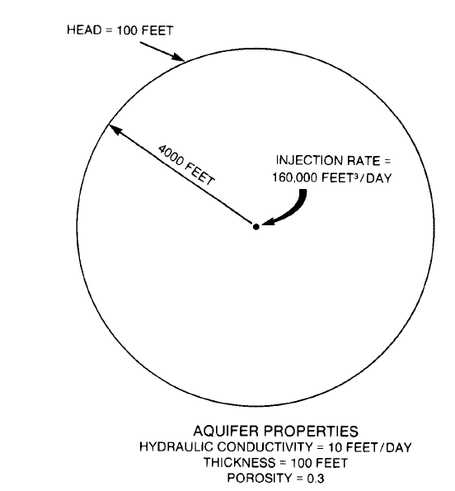

Source: Pollock, 1988

Figure 3‑1. Test Case 1 Layout

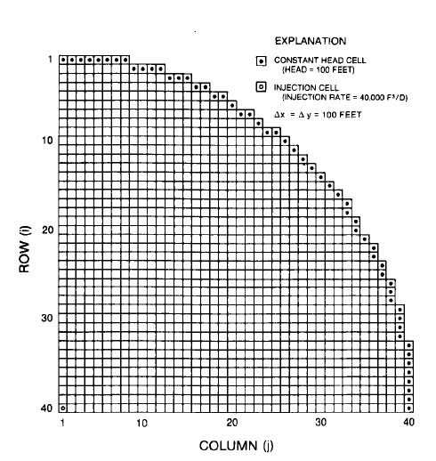

Source: Pollock, 1988

Figure 3‑2. Test Case 1 MODFLOW Setup

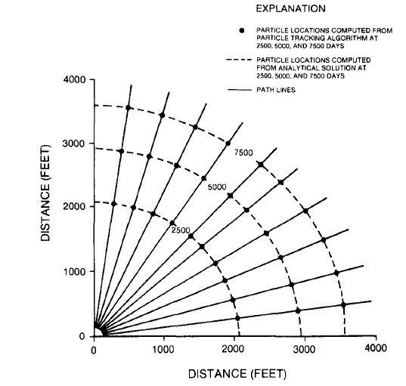

Source: Pollock, 1988

Figure 3‑3. Particle Location Over Time in Test Case 1

*Test Case Setup*

Setting up the test consisted of four parts:

* Assemble the MODFLOW model to serve as the underlying flow model. Use the inputs stated in Pollock, 1988, and estimate inputs when necessary.
* Assemble the MODPATH model for particle tracking. Use the inputs stated in Pollock, 1988, and estimate inputs when necessary.
* Digitize Figure 3‑3 to determine the locations of the points during the times of interest.
* Assess the pass/fail status of the test by comparing the MODPATH results to the digitized results of Figure 3‑3.

*Assemble the MODFLOW model*

The MODFLOW model was assembled using the values in Pollock, 1988, when provided and made reasonable assumptions at values needed, but not provided by Pollock, 1988. Model inputs are seen in Table 3‑1. The model has a single layer and has 40 rows and 40 columns each with a length and width of 100 ft. The thickness of the model is set to a uniform 100 ft. Constant head cells were assigned to match the constant head boundary cells in Figure 3‑2, and have a constant head of 100 ft. Constant head cell locations are listed Table 3‑2. The injection well is located in the bottom left corner (row 40, column 1) and injects at a rate of 40,000 ft3/day, representing a quarter of the pumping rate of the full-size model. The center of the well is located in the center of the cell.

| Table 3‑1. MODFLOW Model Parameter Values for Test Case 1 | | | |
| --- | --- | --- | --- |
| Variable name | Variable Value | Units | Source |
| Number of rows | 40 | N/A | Pollock, 1988, Figure 6 |
| Number of columns | 40 | N/A | Pollock, 1988, Figure 6 |
| Height of rows | 100 | ft | Pollock, 1988, Figure 6 |
| Width of columns | 100 | ft | Pollock, 1988, Figure 6 |
| Number of layers | 1 | N/A | Assumed |
| Thickness of layer | 100 | ft | Pollock, 1988 |
| Injection rate | 40,000 | ft3/day | Pollock, 1988, Figure 5 |
| Hydraulic conductivity (hk and vka) | 10 | ft/day | Pollock, 1988, Figure 5 for hk, vka assumed |
| Constant head | 100 | ft | Pollock, 1988, Figure 6 |
| Starting head | 100 | ft | Assumed |
| Number of stress periods | 15 | N/A | Assumed |
| Stress period length | 500 | days | Assumed |
|  | | | |

| Table 3‑2. Constant Head Boundary Cell Locations | | | | |
| --- | --- | --- | --- | --- |
| Constant Head Boundary Cells | |  | Constant Head Boundary Cells | |
| Row | Column |  | Row | Column |
| 1 | 1 |  | 13 | 29 |
| 1 | 2 |  | 14 | 30 |
| 1 | 3 |  | 15 | 31 |
| 1 | 4 |  | 16 | 32 |
| 1 | 5 |  | 17 | 33 |
| 1 | 6 |  | 18 | 33 |
| 1 | 7 |  | 19 | 34 |
| 1 | 8 |  | 20 | 34 |
| 2 | 9 |  | 21 | 35 |
| 2 | 10 |  | 22 | 36 |
| 2 | 11 |  | 23 | 36 |
| 2 | 12 |  | 24 | 37 |
| 3 | 13 |  | 25 | 37 |
| 3 | 14 |  | 26 | 38 |
| 3 | 15 |  | 27 | 38 |
| 4 | 16 |  | 28 | 38 |
| 4 | 17 |  | 29 | 39 |
| 5 | 18 |  | 30 | 39 |
| 5 | 19 |  | 31 | 39 |
| 6 | 20 |  | 32 | 39 |
| 7 | 21 |  | 33 | 40 |
| 7 | 22 |  | 34 | 40 |
| 8 | 23 |  | 35 | 40 |
| 9 | 24 |  | 36 | 40 |
| 9 | 25 |  | 37 | 40 |
| 10 | 26 |  | 38 | 40 |
| 11 | 27 |  | 39 | 40 |
| 12 | 28 |  | 40 | 40 |

*Assemble the MODPATH model*

Setup for the MODPATH model required defining the locations of the particles, as well as the porosity. Pollock, 1988 states that the porosity is 0.3. Ten particles were used for forward tracking in Pollock, 1988, which describes the particle placement as “at a radial distance of 150 feet from the center of the well.” Because the MODFLOW Well Package designates a well as the entire cell the well is in, this was interpreted to mean the distance is measured from the center of the cell the well is in. Therefore, starting particle locations were placed evenly-spaced in an arc with a 150-foot radius from the center of the well cell ([Table x]). These locations were calculated using a python script, which will be discussed in [section x].

|  |  |  |  |  |  |  |
| --- | --- | --- | --- | --- | --- | --- |
| Table [x]. Particle Starting Locations | | | | | | |
| Particle ID | Row | Column | Local X | Local Y | Local Z | Release Time |
| 1 | 40 | 2 | 1 | 0.51 | 0.5 | 0 |
| 2 | 40 | 2 | 0.9596 | 0.8559 | 0.5 | 0 |
| 3 | 39 | 2 | 0.8404 | 0.1832 | 0.5 | 0 |
| 4 | 39 | 2 | 0.6491 | 0.4742 | 0.5 | 0 |
| 5 | 39 | 2 | 0.3957 | 0.7132 | 0.5 | 0 |
| 6 | 39 | 2 | 0.0941 | 0.8873 | 0.5 | 0 |
| 7 | 39 | 1 | 0.7605 | 0.9872 | 0.5 | 0 |
| 8 | 39 | 1 | 0.4128 | 1.0075 | 0.5 | 0 |
| 9 | 39 | 1 | 0.0698 | 0.947 | 0.5 | 0 |
| 10 | 40 | 2 | 0.9596 | 0.1641 | 0.5 | 0 |

*Digitize the Particle Tracks*

The particle tracks were digitized in order to compare the results of the MODPATH model to those in Pollock, 1988. First, the image of Figure 3‑3 was captured and saved. Then, the image was digitized using WebPlotDigitizer, an open-source software. Finally, the locations of the particles at each of the times was interest were digitized and saved into a comma-separated file. The data in this file is the metric against which one of the pass/fail criteria is calculated.

*Pass/Fail Criteria*

The acceptance criteria for this test are that the MODPATH simulation are as follows:

* Criterion 1 – the MODPATH simulation produces straight particle tracks that radiate outward
* Criterion 2 – the percent difference between the length of the flow paths digitized from Figure 2‑3 calculated value must not be more than 5%. The length of the flow paths calculated by MODPATH are calculated in post-processing by selecting the global X and Y values for each particle at the time of interest, and calculating the distance from that particle to the lower left corner of the model.

Criterion 1 gives evidence that the particle tracks are moving according to the flow direction. Criterion 2 gives evidence that the particles are moving at a speed that is within an acceptable range of similarity to the particles in Pollock, 1988. Criterion 1 must be determined using professional judgment, by observing the image files to confirm that the particle tracks radiate outward, as seen in Figure 3‑3.

**Sources of Error**

There are several sources of error in this test case. The first is that a different version of MODFLOW was used to calculate the underlying flow model in Pollock, 1988 than was used in this test case. The second is that the particles were calculated using a method very similar to that used by MODPATH, but did not use the version of MODPATH tested in this document. The third is that the locations of the points at 0, 2,500, 5,000, and 7,500 days were not explicitly stated and had to be reproduced via digitization. Errors may have been introduced in the reproduction, either through the calculation of the location of the starting points, or through minor errors in the digitization of Figure 3‑3.

**File Structure**

All files for Test Case 1 are contained within the “Test_Case_1” folder in the root directory. The structure within that folder is as follows:

* /gw_codes (This folder contains the executables used in the test case)
  + mf2k-chprc08spl.exe
    - Description: executable of single-precision MODFLOW, “CHPRC Build 8”. Used in S01_tc.py to execute the MODFLOW model.
  + mp6.exe
    - Description: executable of MODPATH, version 6. Used in S01_tc.py to execute the MODPATH model.
* /output (This folder contains the post-processing files used to determine the pass/fail status of the test case)
  + /figures (This folder contains figures showing the results of the MODPATH forward particle tracking at 2,500, 5,000, and 7,500 days)
    - 2500_days.png
      * Description: image of the MODPATH forward particle tracking result at day 2,500. Created by S01_tc.py.
    - 5000_days.png
      * Description: image of the MODPATH forward particle tracking result at day 5,000. Created by S01_tc.py.
    - 7500_days.png
      * Description: image of the MODPATH forward particle tracking result at day 7,500. Created by S01_tc.py.
  + tc1_results.csv
    - Description: This file contains the pass/fail results for Criterion 2 of Test Case 1. The pass/fail results are listed in column E, and columns A-D contain the information used to determine the pass/fail result.
* /preprocessing (This folder contains data used in model calculation or post-processing. These data are static and do not need to be re-calculated every time the model is run.)
  + chb_t1.csv
    - Description: This file contains the row, column, and head data of the constant head cells. Row and column data of the constant head cells are copied from [Figure 3-2].
  + figure_7_distances.csv
    - Description: This file contains the location data digitized from [Figure 3-3]. These location data are used as the basis against which the MODFLOW particle tracks are compared for Criterion 2 of the pass/fail criteria.
* /workspace (This folder is empty before the test cases are run, but will be populated with all the MODFLOW and MODPATH files used in the test case).
  + Many of the test files which will be populated here each are titled “test_case_1”, and end with the following file types, listed in alphabetical order: BAS, CHD, DIS, LPF, NAM, OC, PCG, WEL, CBC, GLO, LIST, HDS, MPBAS, MPNAM, MPSIM, MPEND, MPLST, MPPTH
  + starting_locs.loc
    - Description: this is the file of starting location points. It must match [Table 3-x].
  + MPATH6.LOG
    - Description: This is a log file created by modpath.
* runme.bat
  + Description: A batch file which executes S01_tc.py. Called by the runme.bat file in the root directory.
* S01_tc1.py
  + Description: A python script that creates the files for the MODFLOW and MODPATH models, executes the models, post-processes the results, and prints the pass/fail status of the test to “tc1_results.csv” in /output and “All_tc_results.xlsx” in the root directory.
* Write_starting_locations.py
  + Description: calculates the locations of the starting point files.