### Test Case 2: Particle Tracking in Non-Uniform Flow

**Test Case Description**

Test Case 2 tests MODPATH’s ability to repeat within acceptable tolerance levels a test conducted in Pollock, 1988 on forward-particle tracking of a non-uniform flow field. This test in Pollock, 1988 involves examining flow under an impermeable wall in the steady-state system shown in Figure 3‑4. To the left of an impermeable retaining wall is a 50-foot thickness of fine sand overlain by 5 ft of water in a reservoir. A seepage face at an elevation of 25 ft above the base of the aquifer is present to the right of the retaining wall. The flow model setup in Pollock, 1988 is shown in Figure 3‑5. Particles were released at the base of the reservoir and tracked forward until they reached the seepage face, as shown in Figure 3‑6. MODPATH’s ability to repeat the results in Figure 3‑6 is the pass/fail metric this test case is based upon.

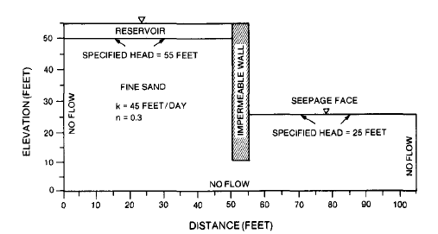

Source: Pollock, 1988

Figure 3‑4. Test Case 2 Layout

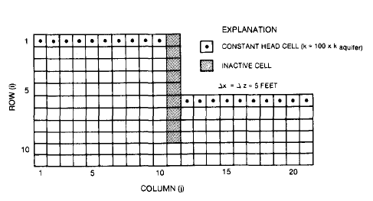

Source: Pollock, 1988

Figure 3‑5. Test Case 2 MODFLOW Layout

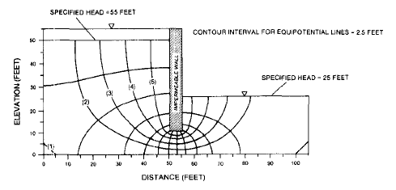

Source: Pollock, 1988

Figure 3‑6. Particle Location Over Time in Test Case 2

**Test Case Setup**

Test setup consists of four parts:

* Assemble the MODFLOW model to serve as the underlying flow model. Use the inputs stated in Pollock, 1988, and estimate inputs when necessary.
* Assemble the MODPATH model for particle tracking. Use the inputs stated in Pollock, 1988, and estimate inputs when necessary.
* Digitize Figure 3‑6 to determine the particles’ ending locations and pathlines.
* Assess the pass/fail status of the test by comparing the MODPATH results to the digitized results of Figure 3‑6.

*Assemble the MODFLOW model*

The MODFLOW model was assembled using the values in Pollock, 1988, when provided and made reasonable assumptions at values needed, but not provided by Pollock, 1988. Model inputs are seen in [Table 3-3]. This model has a single layer, with 11 rows and 21 columns, each with a length and width of 5 ft. The thickness of the model is set to a uniform 25 ft. The thickness was not defined in Pollock, 1988, so a thickness of 25 ft was assumed. No-flow cells were assigned as seen in Figure 3‑5. Constant heads of 55 and 25 ft were assigned to the cells representing the reservoir and seepage face, respectively, as seen in Figure 3‑5. Starting heads were also not listed in Pollock, 1998, so it was assumed that the area beneath the reservoir and the impermeable berm had a starting head of 55, and the area beneath the seepage face had a starting head of 25.

| Table 3‑3. MODFLOW Model Parameter Values for Test Case 2 | | | |
| --- | --- | --- | --- |
| Variable name | Variable value | Units | Source |
| Number of rows | 11 | N/A | Pollock, 1988, Figure 9 |
| Number of columns | 21 | N/A | Pollock, 1988, Figure 9 |
| Height of rows | 5 | ft | Pollock, 1988, Figure 9 |
| Width of columns | 5 | ft | Pollock, 1988, Figure 9 |
| Number of layers | 1 | N/A | Assumed |
| Thickness of layer | 25 | ft | Assumed |
| Hydraulic conductivity (aquifer, hk and vka) | 45 | ft/day | Pollock, 1988, Figure 8 for hk, vka assumed |
| Hydraulic conductivity (reservoir and seepage face, hk and vka) | 4,500 | ft/day | Pollock, 1988, Figure 9 for hk, vka assumed |
| Constant head (reservoir) | 55 | ft | Pollock, 1988, Figure 8 |
| Constant head (seepage face) | 25 | ft | Pollock, 1988, Figure 8 |
| Starting head (columns 1 through 11) | 55 | ft | Assumed |
| Starting head (columns 12 through 21) | 25 | ft | Assumed |
| Number of stress periods | 30 | N/A | Assumed |
| Stress period length | 1 | days | Assumed |

*Assemble the MODPATH model*

Setup for the MODPATH model required defining the locations of the particles, as well as the porosity. Pollock, 1988 states that the porosity is 0.3. Five particles were used for forward tracking in Pollock, 1988. The particle track locations were estimated for use in the MODPATH model and listed in Table 3‑4. Particle 1 was not modeled, as its starting location was unclear.

|  |  |  |  |  |  |  |  |  |
| --- | --- | --- | --- | --- | --- | --- | --- | --- |
| Table 3‑4. Particle Starting Locations, Test Case 2 | | | | | | | | |
| Particle ID | Grid | Layer | Row | Column | Local X | Local Y | Local Z | Release Time |
| 2 | 1 | 1 | 1 | 3 | 0.5 | 0 | 0.5 | 0 |
| 3 | 1 | 1 | 1 | 5 | 0.5 | 0 | 0.5 | 0 |
| 4 | 1 | 1 | 1 | 7 | 0.5 | 0 | 0.5 | 0 |
| 5 | 1 | 1 | 1 | 9 | 0.5 | 0 | 0.5 | 0 |

*Digitize the Particle Tracks*

The particle tracks were digitized in order to compare the results of the MODPATH model to those in Pollock, 1988. First, the image of Figure 3‑6 was captured and saved. Then, that image file was converted into a raster and given arbitrary projection information. Finally, the particle pathlines were digitized in a GIS program and saved as a shapefile. The endpoints of the particle pathlines were also digitized in a GIS program and saved as a shapefile. The data in these shapefiles are the metric against which the pass/fail criteria are calculated.

*Pass/Fail Criteria*

The acceptance criteria for this test are that the MODPATH simulation are as follows:

* Criterion 1 – the MODPATH simulation produces particle tracks that are visually similar to those seen in Figure 3‑6, according to professional judgment.
* Criterion 2 – the percent difference between the particle end points digitized from Figure 3‑6 and the MODPATH-calculated particle end points must not be more than 10%.

Criterion 1 gives evidence that the particle tracks are moving according to the flow direction. Criterion 2 gives evidence that the particles’ ending locations are within an acceptable range of similarity to the particles in Pollock, 1988. Criterion 1 must be determined using professional judgment, by observing the output image file to confirm that the particle tracks follow pathlines similar to those seen in Figure 3‑6. The pass/fail status of Criterion 2 will be printed to a file, listed in [Section x].

**Sources of Error**

There are several sources of error in this test case. The first is that a different version of MODFLOW was used to calculate the underlying flow model. The second is that the particles were calculated using a method very similar to that used by MODPATH, but did not use the version of MODPATH tested in this document. The third is that Figure 3‑6 as it was printed in Pollock, 1988 was slightly warped and required georeferencing to reduce the effect on the pathline shape. Some effect of the warped figure may still remain on the digitized pathlines, causing a slightly different shape than the true results.

**File Structure**

All files for Test Case 2 are contained within the “Test_Case_2” folder in the root directory. The structure within that folder is as follows:

* /gw_codes (This folder contains the executables used in the test case)
  + mf2k-chprc08spl.exe
    - Description: executable of single-precision MODFLOW, “CHPRC Build 8”. Used in S01_tc2.py to execute the MODFLOW model.
  + mp6.exe
    - Description: executable of MODPATH, version 6. Used in S01_tc2.py to execute the MODPATH model.
* /output (This folder contains the post-processing files used to determine the pass/fail status of the test case)
  + Compared_pathlines.png
    - Description: image comparing the pathlines digitized from Figure 3‑6 (“Digitized Pathlines”) to those created for this test case (“Modpath6 Pathlines”). Created by S01_tc2.py. Used to determine the pass/fail status of Criterion 1.
  + tc2_results.csv
    - Description: This file contains the pass/fail results for Criterion 2. The pass/fail results are listed in columns J and K, and columns A-I contain the information used to determine the pass/fail result.
* /preprocessing (This folder contains data used in model calculation or post-processing. These data are static and do not need to be re-calculated every time the model is run.)
  + /digitize (This folder contains the digitized shapefiles of the particle tracks and the particle endpoints, as seen in Figure 3‑6)
    - endpoints.shp and related files
      * Description: Approximate ending location of the particle pathlines in Figure 3‑6.
    - figure_10_pathline.shp and related files
      * Description: Particle pathlines digitized from a raster of Figure 3‑6.
  + /gwpath_images (This folder contains images copied from Pollock, 1988)
    - figure_10_pathline.png
      * Description: An image file of Figure 3‑6. This was captured from a digital version of Pollock, 1988 using a screen-capture tool.
  + /gwpath_rasters (This folder contains the rasters created from the images in /gwpath_images)
    - figure_10_pathline.tif and associated aux file
      * Description: The raster of “figure_10_pathline.png” created by “S00_pngs_2_tiffs.py”.
    - figure_10_pathline.tif.points
      * Description: the points used to digitize the raster of the image in order to remove the warp.
    - Figure_10_referenced and associated aux file
      * Description: A georeferenced version of “figure_10_pathline.tif”. It was georeferenced in QGIS using a transformation type of Polynomial 1 and nearest neighbor resampling. The points used in the georeferencing are saved in “figure_10_pathline.tif”.
    - Starting_location.shp and related files
      * A point file which defines the arbitrarily-selected location of the upper-left corner of the figures during the digitization process.
  + particle_starting_locs_ex2.csv
    - Description: this is the file of starting location points. It must match [Table 3-4] for the data present in both.
  + S00_pngs_2_tiffs.py
    - Description: This python script digitizes an image and assigns it an arbitrary projection. This is done so the particle locations can be defined and compared to the outcomes of this test.
  + S01_make_model_grid.py
* /workspace (This folder is empty before the test cases are run, but will be populated with all the MODFLOW and MODPATH files used in the test case).
  + Many of the test files which will be populated here each are titled “test_case_2”, and end with the following file types, listed in alphabetical order: BAS, CHD, DIS, LPF, NAM, OC, PCG, WEL, CBC, GLO, LIST, HDS, MPBAS, MPNAM, MPSIM, MPEND, MPLST, MPPTH
  + starting_locs_ex2.loc
    - Description: this is the file of starting location points. It must match [Table 3-4] for the data present in both.
  + MPATH6.LOG
    - Description: This is a log file created by modpath.
* runme.bat
  + Description: A batch file which executes S01_tc2.py. Called by the runme.bat file in the root directory.
* S01_tc2.py
  + Description: A python script that creates the files for the MODFLOW and MODPATH models, executes the models, post-processes the results, and prints the pass/fail status of the test to “tc2_results.csv” in /output and “All_tc_results.xlsx” in the root directory.
* texas_gam.prj
  + Description: projection data for the projection arbitrarily selected for use in this test case.
* Write_starting_locations.py
  + Description: calculates the locations of the starting point files.