

Thanks for using Device Magic!

# 'Template Test Form' Submission

Submitted by: Matts gain

Submission timestamp: 2015-08-21 15:11:08 +02:00

Submission ID: 110

## Free Text Question

I  
Am  
Cool

## Untitled Question

Here

## Decimal Question

1.8

## Select Question

2,4

## Group

|  |  |  |  |
| --- | --- | --- | --- |
| Group.Free_Text_Question | Group.Image_Question | Group.Location_Question | Group.Group |
| Q |  | lat=-33.863495, long=18.641860, alt=166.692398, hAccuracy=104.580297, vAccuracy=10.000000, timestamp=2015-08-21T13:09:54Z | |  | | --- | | Group.Group.Free_Text_Question | | 1 | | 2 | |
| Q2 |  | lat=-33.863396, long=18.641903, alt=167.221832, hAccuracy=65.000000, vAccuracy=10.000000, timestamp=2015-08-21T13:10:57Z | |  | | --- | | Group.Group.Free_Text_Question | | 3 | | 4 | |

## Image Question

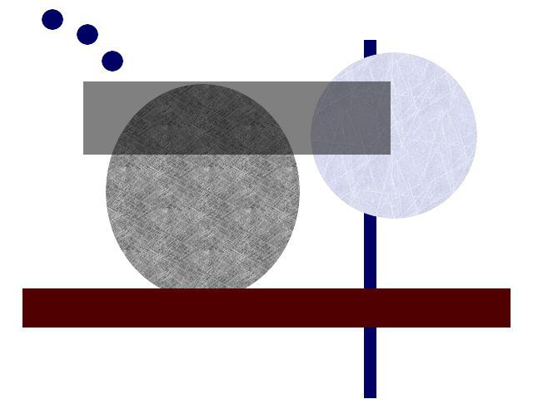

## Location Question



lat=-33.863396, long=18.641903, alt=167.221832, hAccuracy=65.000000, vAccuracy=10.000000, timestamp=2015-08-21T13:11:04Z

Optionscurrency : 1.80

Each_answer_on_new_line: 2  
4

Hyperlink:

[](http://maps.google.com/?q=-33.863396,18.641903)

lat=-33.863396, long=18.641903, alt=167.221832, hAccuracy=65.000000, vAccuracy=10.000000, timestamp=2015-08-21T13:11:04Z

Image_size: 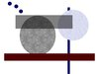

map_size:



lat=-33.863396, long=18.641903, alt=167.221832, hAccuracy=65.000000, vAccuracy=10.000000, timestamp=2015-08-21T13:11:04Z

show_coordinate_info:



Group Options

Filter Fields :

|  |
| --- |
| Group.Group |
| |  | | --- | | Group.Group.Free_Text_Question | | 1 | | 2 | |
| |  | | --- | | Group.Group.Free_Text_Question | | 3 | | 4 | |

Full Width :

|  |  |  |  |
| --- | --- | --- | --- |
| Group.Free_Text_Question | Group.Image_Question | Group.Location_Question | Group.Group |
| Q |  | lat=-33.863495, long=18.641860, alt=166.692398, hAccuracy=104.580297, vAccuracy=10.000000, timestamp=2015-08-21T13:09:54Z | |  | | --- | | Group.Group.Free_Text_Question | | 1 | | 2 | |
| Q2 |  | lat=-33.863396, long=18.641903, alt=167.221832, hAccuracy=65.000000, vAccuracy=10.000000, timestamp=2015-08-21T13:10:57Z | |  | | --- | | Group.Group.Free_Text_Question | | 3 | | 4 | |

List:

Group.Free_Text_Question Q

Group.Image_Question



Group.Location_Question



lat=-33.863495, long=18.641860, alt=166.692398, hAccuracy=104.580297, vAccuracy=10.000000, timestamp=2015-08-21T13:09:54Z

Group.Group

- Group.Group.Free_Text_Question 1

- Group.Group.Free_Text_Question 2

Group.Free_Text_Question Q2

Group.Image_Question



Group.Location_Question



lat=-33.863396, long=18.641903, alt=167.221832, hAccuracy=65.000000, vAccuracy=10.000000, timestamp=2015-08-21T13:10:57Z

Group.Group

- Group.Group.Free_Text_Question 3

- Group.Group.Free_Text_Question 4

Image size:

|  |  |  |  |
| --- | --- | --- | --- |
| Group.Free_Text_Question | Group.Image_Question | Group.Location_Question | Group.Group |
| Q |  | lat=-33.863495, long=18.641860, alt=166.692398, hAccuracy=104.580297, vAccuracy=10.000000, timestamp=2015-08-21T13:09:54Z | |  | | --- | | Group.Group.Free_Text_Question | | 1 | | 2 | |
| Q2 |  | lat=-33.863396, long=18.641903, alt=167.221832, hAccuracy=65.000000, vAccuracy=10.000000, timestamp=2015-08-21T13:10:57Z | |  | | --- | | Group.Group.Free_Text_Question | | 3 | | 4 | |

Map size:

|  |  |  |  |
| --- | --- | --- | --- |
| Group.Free_Text_Question | Group.Image_Question | Group.Location_Question | Group.Group |
| Q |  | lat=-33.863495, long=18.641860, alt=166.692398, hAccuracy=104.580297, vAccuracy=10.000000, timestamp=2015-08-21T13:09:54Z | |  | | --- | | Group.Group.Free_Text_Question | | 1 | | 2 | |
| Q2 |  | lat=-33.863396, long=18.641903, alt=167.221832, hAccuracy=65.000000, vAccuracy=10.000000, timestamp=2015-08-21T13:10:57Z | |  | | --- | | Group.Group.Free_Text_Question | | 3 | | 4 | |

Show labels:

|  |  |  |  |  |  |  |
| --- | --- | --- | --- | --- | --- | --- |
| Q |  | lat=-33.863495, long=18.641860, alt=166.692398, hAccuracy=104.580297, vAccuracy=10.000000, timestamp=2015-08-21T13:09:54Z | |  | | --- | | Group.Group.Free_Text_Question | | 1 | | 2 | |
| Q2 |  | lat=-33.863396, long=18.641903, alt=167.221832, hAccuracy=65.000000, vAccuracy=10.000000, timestamp=2015-08-21T13:10:57Z | |  | | --- | | Group.Group.Free_Text_Question | | 3 | | 4 | |