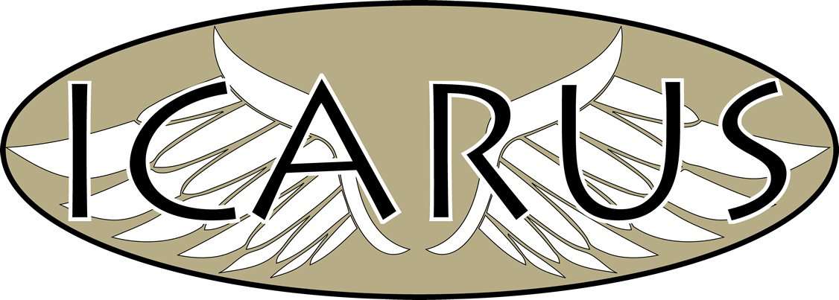
ICARUS Newsletter
Edition 3:13-Nov-2010

Upcoming Team Meeting/Site Visit
SIU-Carbondale Site Visit has been canceled due to various people traveling for the holidays.

Team Meeting
A Team Meeting will be held in Mid-January. Stay posted for more information.

New Website
The new website is up and running. We need biographies (short) and small pictures for people involved with ICARUS. Email Ben Wasson at ben.wasson@icarusuav.com with your information.
Visit www.icarusuav.com today!

Project Management
2 Tools are being used for Project Management. These are:
dotProject: Central Project Management site. All people involved should have an account. As the ICARUS team is geographically separated, this will be the primary tool for keeping track of all work.
Google Code: This site will be used for keeping track of bugs and features to be added during the engineering process. This site is open to the public, and will especially useful when other groups of people are helping us with development. Which leads to…

New People/Promotions
As part of their Senior Design UAV project, a group of students from Washington University will be involved in beta-testing the Ground Control Station Interface. Welcome aboard!

The ICARUS Team would also like to welcome Michael Welling as the ICARUS Systems Engineer. Michael has already been a key founding member of ICARUS and is stepping up to be in charge of all Systems under the ICARUS umbrella. Thanks Mike!

Sincerely,
Ben Wasson, ICARUS Business Manager
ben.wasson@icarusuav.com

