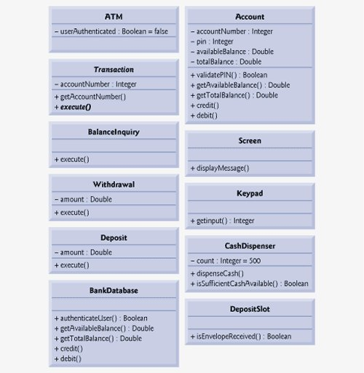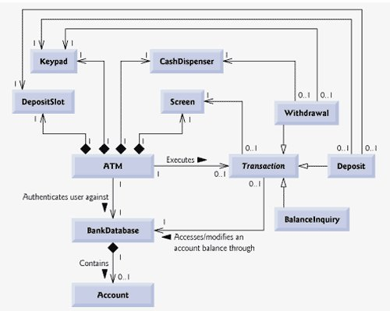

1 – One relationship

0..1 one object of ATM executes zero or 1 objects of associated class

Solid Diamond – composition relationships “has a” relationships. ATM (ATMmain) formed by one object of each association.

Synchronous calls – wait for receiving object processes the message and returns control to the sending object.

White arrows – “is a” relationships

<http://www.deitel.com/Books/Java/JavaHowtoProgram7e/tabid/1191/Default.aspx>