Michael Wells

Problem Set 2

1c

Overall, it seems like room availability, room type, and neighborhood have an impact on price. Using Algiers Point as a reference for neighborhood, we see that certain neighborhoods significantly (p<.001) impact price, such as the French Quarter, Central Business District, Seventh Ward, Audubon, and West Riverside. Using entire house as a reference we see that both private rooms and shared rooms have a significantly lower price. Lastly, room availability has a significant positive impact on price. It seems that room type has the greatest impact on price as there estimate coefficients are greatest.

2b

Note although these boxplots only show the median, in this case the median and means are very similar. This helps explain the data but also the coefficients from my regression.

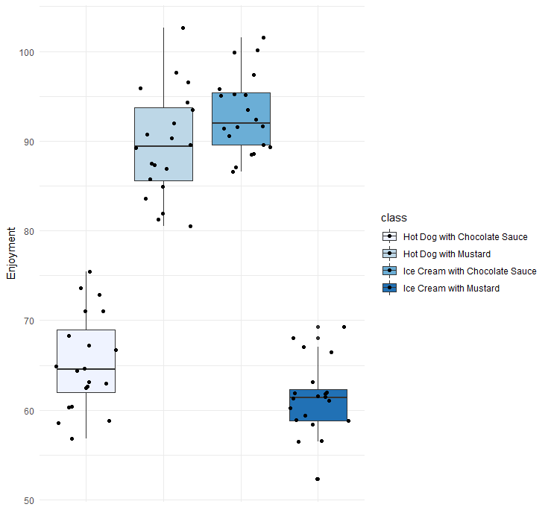

3a

The figures below really helps show the relationship between x1 and x2. First, in the figures below it is obvious that both x1 and x2 have significant impact on y. But utilizing a linear regression model that includes x1 and x2 interaction shows that their interaction is significant. Looking at the scatter plot below we see x2 = 1 has an increase in y but that change in y for each change in x1 is also increased.

