Michael Wells

Stats HW1

1.1)

|  |  |  |
| --- | --- | --- |
|  | Compensation | Age |
| Mean | 10.54 | 57.03 |
| Median | 6.97 | 57.00 |
| Standard Deviation | 11.47 | 6.12 |
| Variance | 131.51 | 37.25 |

1.2)

I think **compensation** is defiantly more variable. Not only does it have a higher sd and variance, but as shown in the figure below the range is also greater.

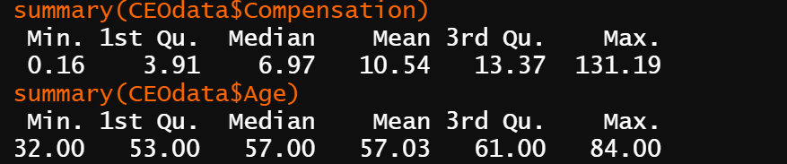

1.3) Not the bin number is different. Yet bin size is the same.

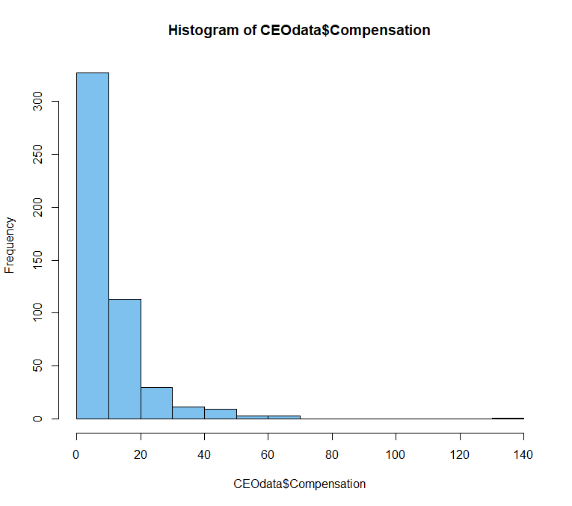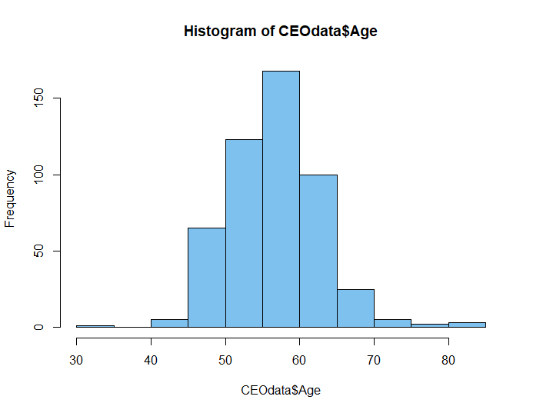

1.4) 

1.5)

|  |  |
| --- | --- |
|  | ln(Compensation) |
| Mean | 1.94 |
| Median | 1.94 |
| Standard Deviation | 0.928 |
| Variance | 0.861 |

1.6)

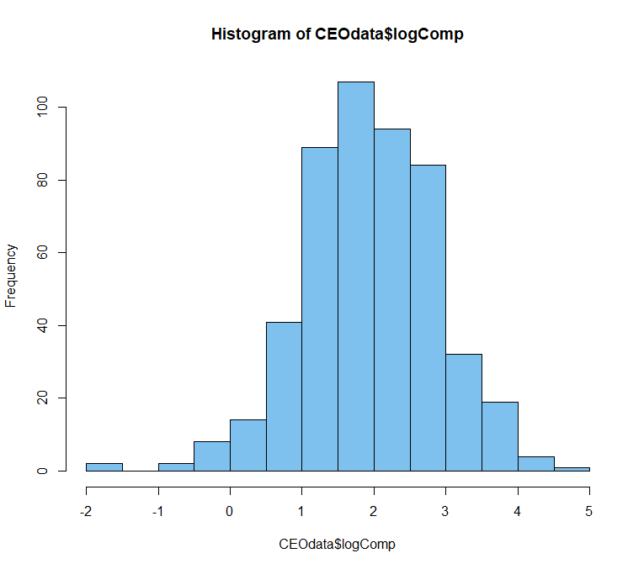



1.7) 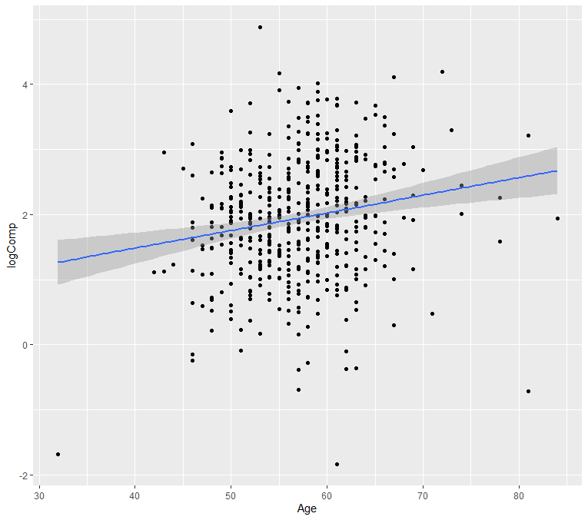

1.8)

There is a slight linear trend saying you are more likely to have a higher compensation the higher your age, but I stress again it is same and most likely not significant. Being that bot variables now show normal distribution we can state that the majority of CEOs are between the age of 50 – 65 with a logComp between 1-3.

2.1)

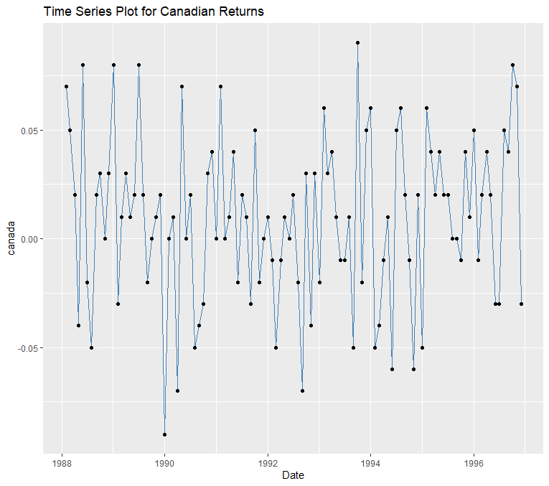

2.2)

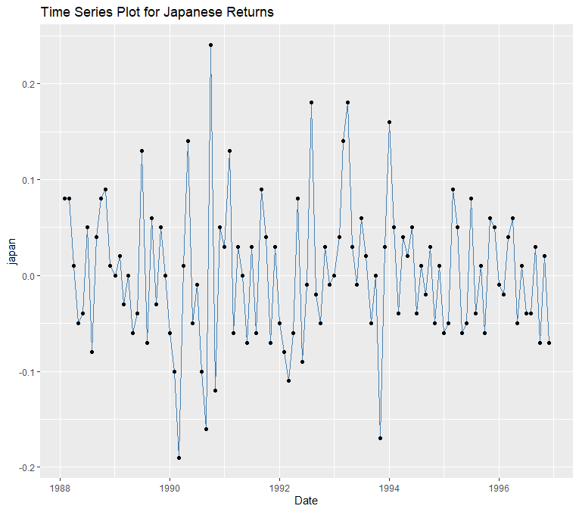

2.3)

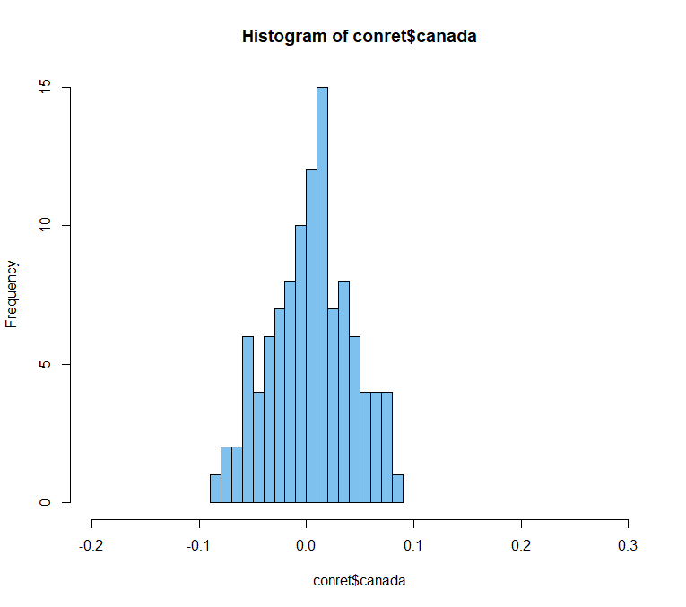

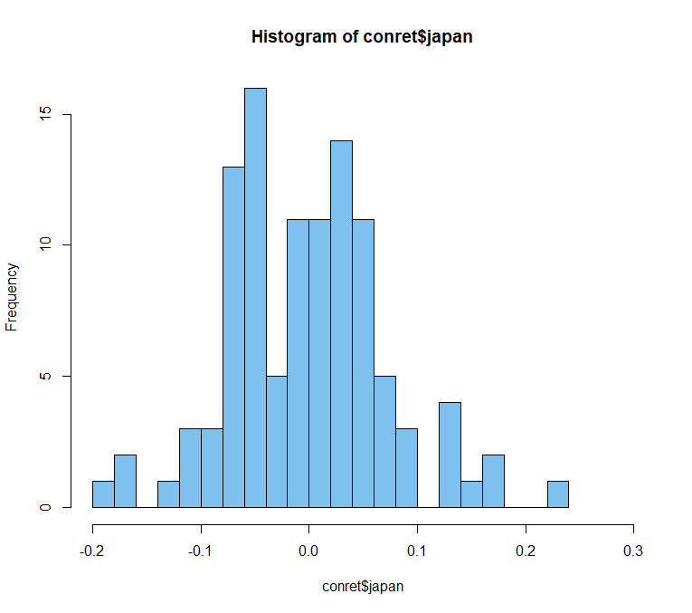

Japan’s data is more disperse, with a larger range. While Canada’s is smaller range and more evenly distributed.

2.4)

|  |  |  |  |  |
| --- | --- | --- | --- | --- |
| **country** | **mean** | **median** | **sd** | **variance** |
| australia | 0.0122 | 0.01 | 0.0541 | 0.00293 |
| canada | 0.00907 | 0.01 | 0.0383 | 0.00147 |
| france | 0.0138 | 0.01 | 0.0549 | 0.00302 |
| germany | 0.0129 | 0.01 | 0.0561 | 0.00315 |
| honkong | 0.021 | 0.02 | 0.0722 | 0.00521 |
| irleland | 0.0121 | 0.01 | 0.0588 | 0.00346 |
| italy | 0.00607 | 0 | 0.0713 | 0.00508 |
| japan | 0.00234 | 0 | 0.0737 | 0.00543 |
| malaysia | 0.017 | 0.02 | 0.0679 | 0.00461 |
| netherlands | 0.0155 | 0.02 | 0.0381 | 0.00145 |
| singapore | 0.0136 | 0.02 | 0.0542 | 0.00293 |
| spain | 0.00953 | 0.01 | 0.0605 | 0.00366 |
| switzerland | 0.0147 | 0.01 | 0.0493 | 0.00243 |
| uk | 0.0117 | 0.01 | 0.0503 | 0.00253 |
| usa | 0.0135 | 0.02 | 0.0333 | 0.00111 |

Code used to generate values.

