Michael Wells

Project 2 Design

08/04/19

**UML Design**

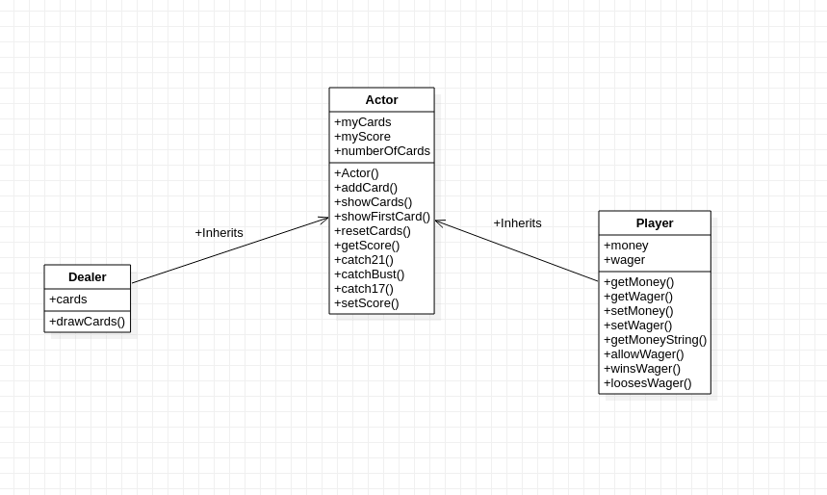 Because the project gave us some room to be creative in our design there was things I had defined to make it easier for me and honestly save time. First, I designed my simulation to be played on theoretically an unlimited number of decks. Each card is pulled is random and it is “replaced” ( I think that is the statistics term) so in theory 5 Kings could be drawn in a row. This is not possible if you are playing with just a single deck of cards, but it saved me a lot of time to just not worry about that. I thought about having the user enter how much they want to have going into playing. This would be simple but not needed so I didn’t add it.

I considered using interfaces for some of the methods, specifically the showCards() method and the catch methods. This because the dealer and the user both show cards but they do it differently to start, and really only the dealer needs the catch17() method. Using interfaces would probably be better if this was a large casino project, where these interface would be used for other games. But considering the scope of the project it made it simpler to just have an Actor class to handle the game play, a dealer subclass that handles the dealing, the player subclass to handle the players money.

I thought about maybe making a Game() class that would take in player and Dealer as parameter instead of having Player and Dealer be a subclass to a base class. I saw that there would be things that both the dealer and the player would do, so I thought a hierarchy was better. If I had made a Game class I would’ve had to do things like setPlayerScore() and setDealerScore() instead of just setScore().

I wanted to create methods in my BlackJackSimulator class other than main(), specifically some one for displaying UI for the hands and scores. Honestly, I just didn’t have time to implement them, I was more focused on the design of Actor classes and sub classes.