
FundPath (CDF Loan Platform): Functional Documentation
Henry Mutale BIT24127569 | Hadassah Muyunda BIT24123017
Wezi Wanjelani BIT24224235 | Chimwemwe Siyingwa BIT24126947

1. Overview
FundPath is a web application that helps applicants prepare for a Constituency Development Fund (CDF) loan, from first idea to final repayment. FundPath does not issue loans: the council and CDF Committee decide and disburse, while FundPath helps applicants apply well and plan how they will repay if a loan is granted. A React client calls a Node/Express API, which stores all data in PostgreSQL. Three roles use it: applicants, advisors and administrators. The API enforces what each role may do, so the functions below share one set of records and stay consistent with each other.
2. User Interface
Applicant. Applicants browse CDF funding opportunities, build a business plan, and receive a feasibility score from 0 to 100 (High 70+, Medium 45+, otherwise Low) with a short recommendation. They book a verified advisor, apply with a scored plan and track the application through its stages. If the council grants and disburses the loan, they log repayments, view the balance and a 12-month schedule, and may list products on the storefront.
Advisor. Advisors keep a profile with a specialty and session price, accept paid bookings, chat with clients in a thread attached to each paid booking, and co-edit the plan of a linked client. A client can leave one review per paid booking.
Shared and public. All users receive in-app notifications (for example repayment due within 7 days or overdue). A public resource library and a success-stories page, showing loans at least 50% repaid, are open to visitors.
3. Administrator Interface
The admin area sits behind one role guard, so only administrators can reach it. It lets administrators manage and monitor the platform:
- Review applications: see every application with its business plan and feasibility score.
- Control the pipeline: record the council’s decision as an application moves through its stages (rejection is possible); the server accepts only legal transitions, and moving to Disbursed records the amount the council paid out.
- Verify advisors: review pending profiles; only verified advisors appear publicly and can be booked.
- Manage opportunities: create and edit the funding windows applicants choose from.
4. Administrator Analysis
The admin dashboard turns system activity into summaries. Charts are drawn with inline SVG and CSS bars, so no external service is needed.
Report / table | What it shows | Source
Summary statistics | Total applications, money requested, disbursed, repaid and outstanding, advisors awaiting verification, number of opportunities | Applications, repayments, advisor profiles, opportunities
Applications by status | Count in each pipeline stage (table and bar chart) | Applications
Disbursed, repaid, outstanding | Platform totals: all disbursed minus all repaid, floored at zero (chart of disbursed against repaid) | Applications, repayments
Feasibility categories | Submitted plans rated High, Medium and Low | Feasibility scores, applications
Demand by constituency | Applications per constituency, highest first | Applications, opportunities
The outstanding figure uses the same repayment-summary calculation that applicants see on their own screen (disbursed minus repaid, never below zero), here applied to platform totals, so the rule is written once. Advisor and opportunity lists, with their amounts and verification status, are on the administrator pages described in Section 3.
5. How the Functions Are Connected
Figure 1 shows the relationships. The links below follow a loan through the system:
- Plan to score: every plan creation or edit, including an advisor's co-edit, re-runs the feasibility engine and stores one score per plan. Applicant, advisor and administrator all see the same value.
- Advisor to client: a booking must be paid before chat or a review is allowed; the advisor must be verified by an administrator before bookings are possible.
- Applicant to administrator: a submitted application appears in the admin review list; each status change returns to the applicant as a notification and unlocks later functions.
- Disbursement to repayment: once the council has disbursed the loan, reaching Disbursed enables repayment logging and the storefront; a repayment advances the loan to Repaying and closes it when fully repaid.
- Repayment to analysis and showcase: repayment records feed the admin totals and, at 50% repaid, publish the loan as a success story.
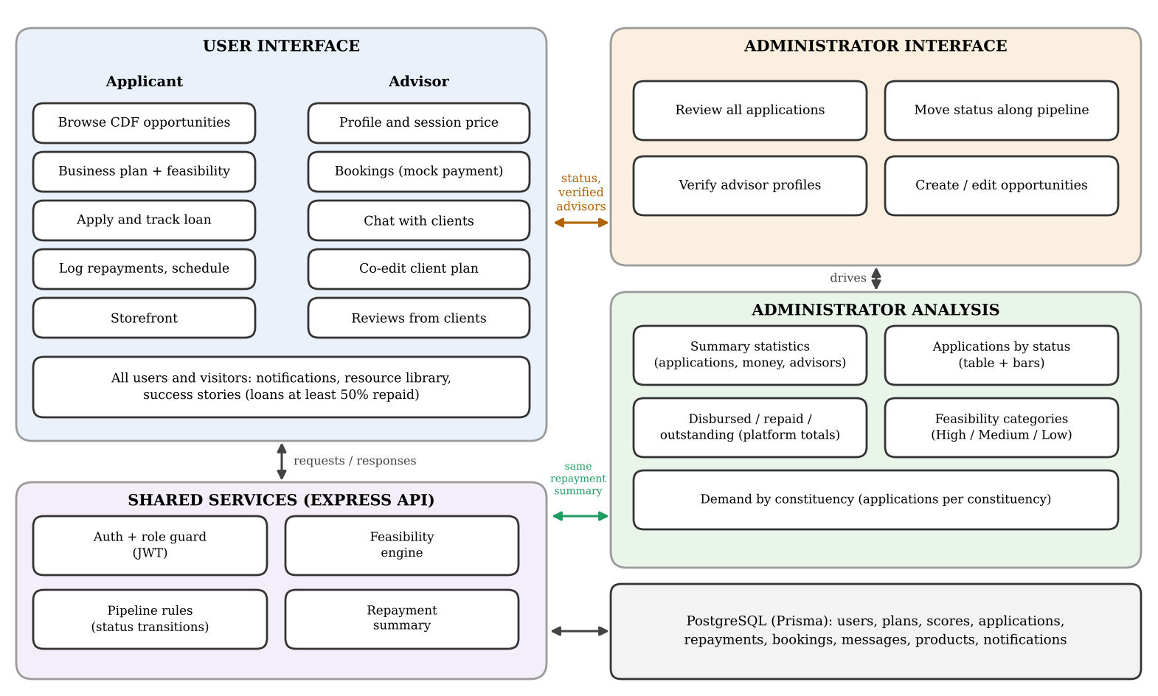
Figure 1: FundPath functions and how they connect
Every request passes through the same chain: rate limit, authentication, role check, input validation, then the module. Rules are therefore stated once on the server, and the client only hides screens for convenience.

