Chapter 2

The first chapter followed along with the concept of TDD when creating a web application. I will attempt to combine the information with W3 schools. That being said, we need to create an application. Application will have a specific meaning or purpose like a travel reservation system or an inventory mobile application.

1. Create Application
   1. We set up everything in the previous chapter. Navigate to the working directory of the project and run the command below. Make sure the Django server is not running. Otherwise, you will not be able to run commands.
   2. > django-admin startapp drivers
   3. 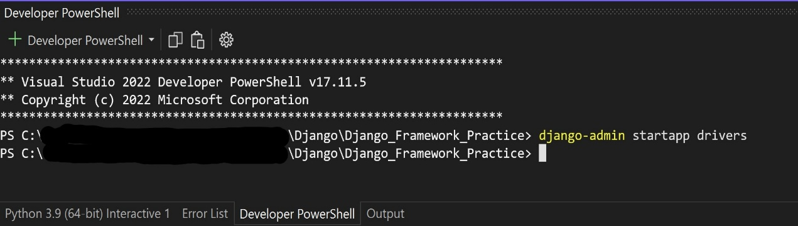
   4. The statement creates a drivers app folder under the current project folder with the associated subfolders. Please see below.
   5. 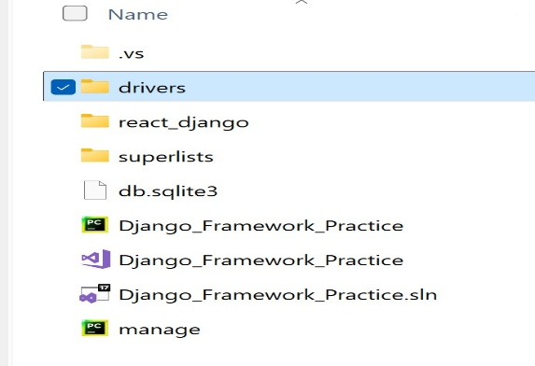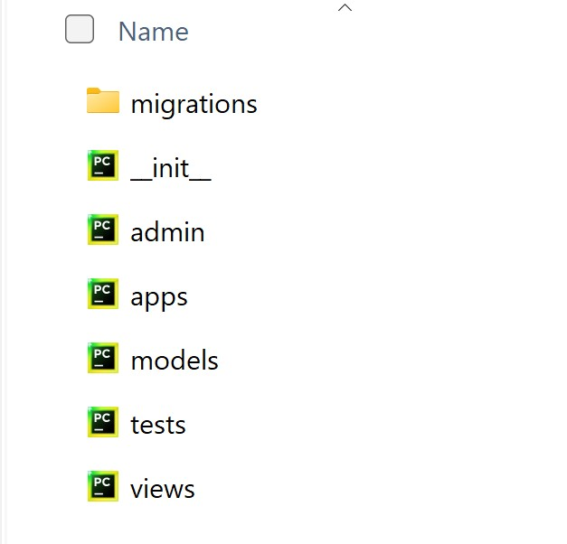
   6. Please note the views.py file. The view takes HTML elements as arguments and finds the appropriate model. We will use this file to make sure we cast back a correct response.
   7. 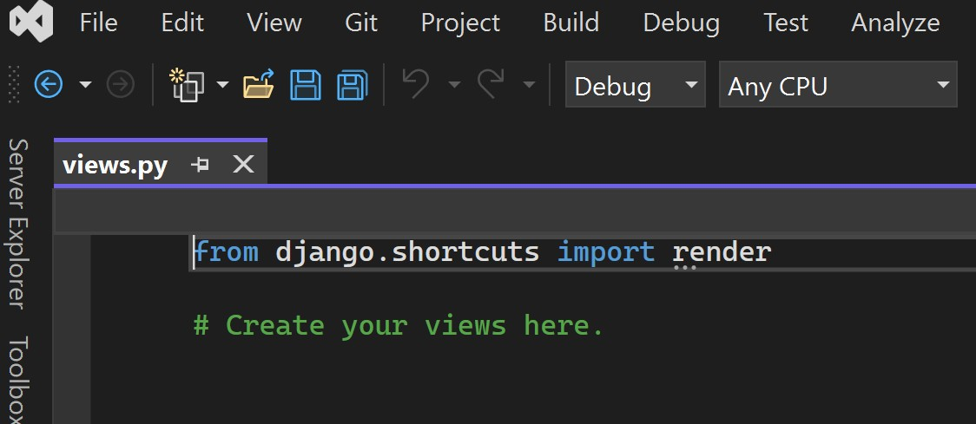
   8. Import Http Response from the Django HTTP library and add the following
   9. 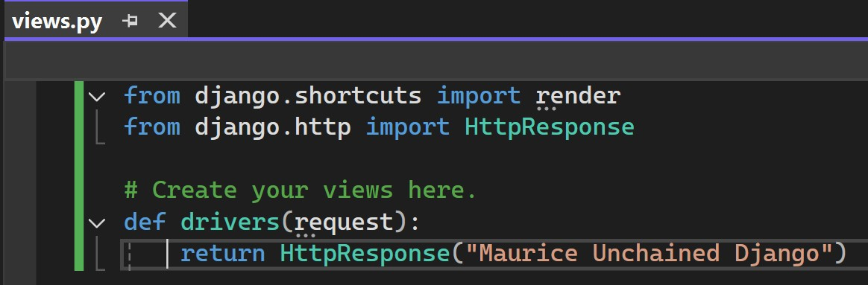
   10. We created a new app called Drivers and looked at the view file. Now we will create another python file under the Drivers folder called ‘urls.py’. The new file will access the view file.
   11. In the terminal, run the code below. Echo will print the statement. The ‘>’ will instruct the statement to go to a file. If the file does not exist, then Python will create one.
   12. 
   13. Open the newly created file in VS and you should see below:
   14. 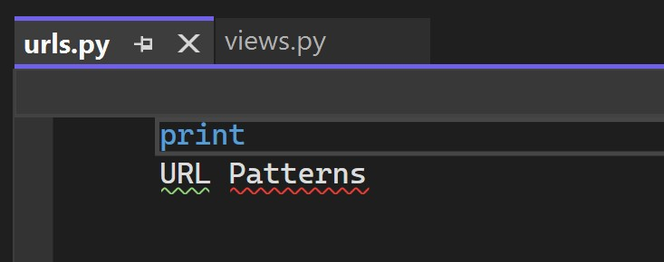
   15. Edit the file to import the path from the URL library in Django. Additionally, we will need the import statement to have access to the views file. Please see below
   16. 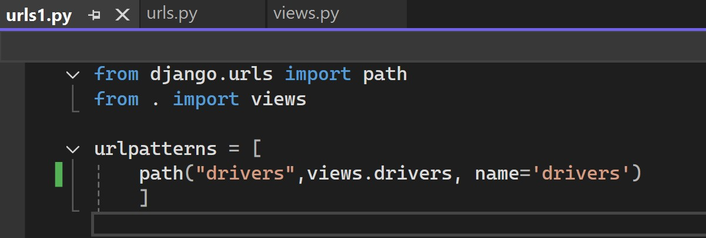
   17. Now that we have our URL patterns, we will need to do some routing from the top-level folder (Django Framework Practice). Open the URL file already located in the superlists folder and add the following.
   18. 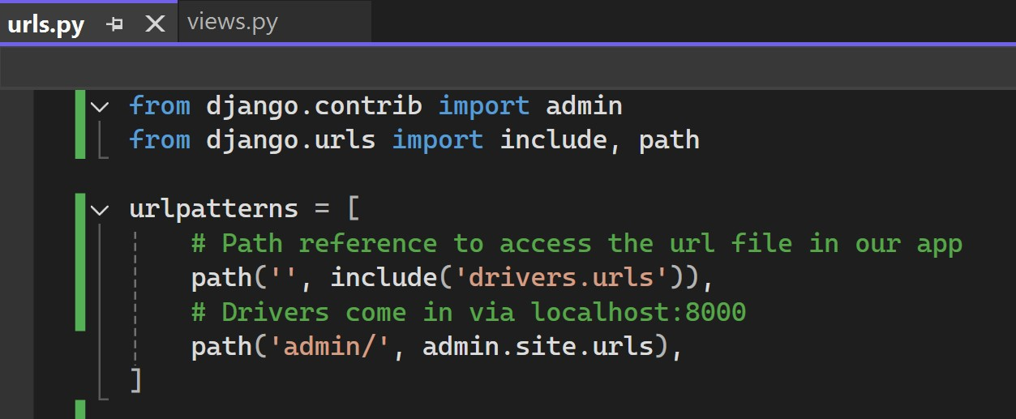
2. Start Django server and navigate to localhost:8000/drivers. You should see below:
   1. 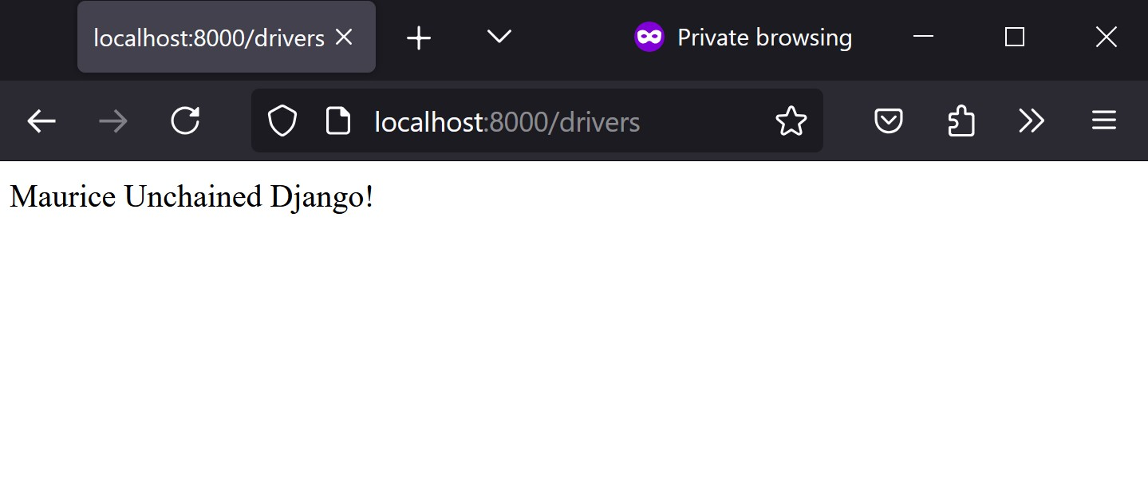
   2. We have successfully created a virtual environment for our web application, installed Django to create a web application, and add a new URL python file to render text on a web page.
3. Template
   1. Django implements a model view template architecture. Previously, we used the view to check the URL in driver app to send the response ‘Maurice Unchained Django’. Now we are going to put this text in an html document.
   2. Create a template folder inside the drivers app directory. Inside the folder, create a new html file. The new tree should look similar to below.
   3. 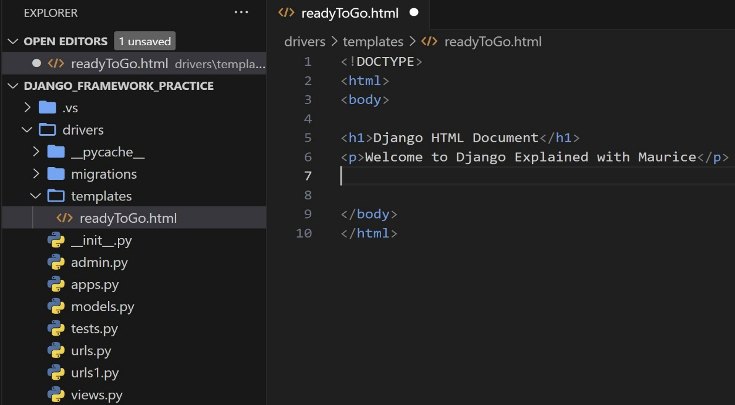
      1. There are several takeaways from the above. There are two URLS files under our driver app. I had a problem reading the original URL file that python created with VS. I had to open Note Pad and save a new file with the python file extension.
      2. Make sure to select UTF-8 encoding.
   4. Now we have to modify the view to retrieve the HTML document stored inside the template folder. We will need the ‘loader’ function from the template library in Django.
   5. 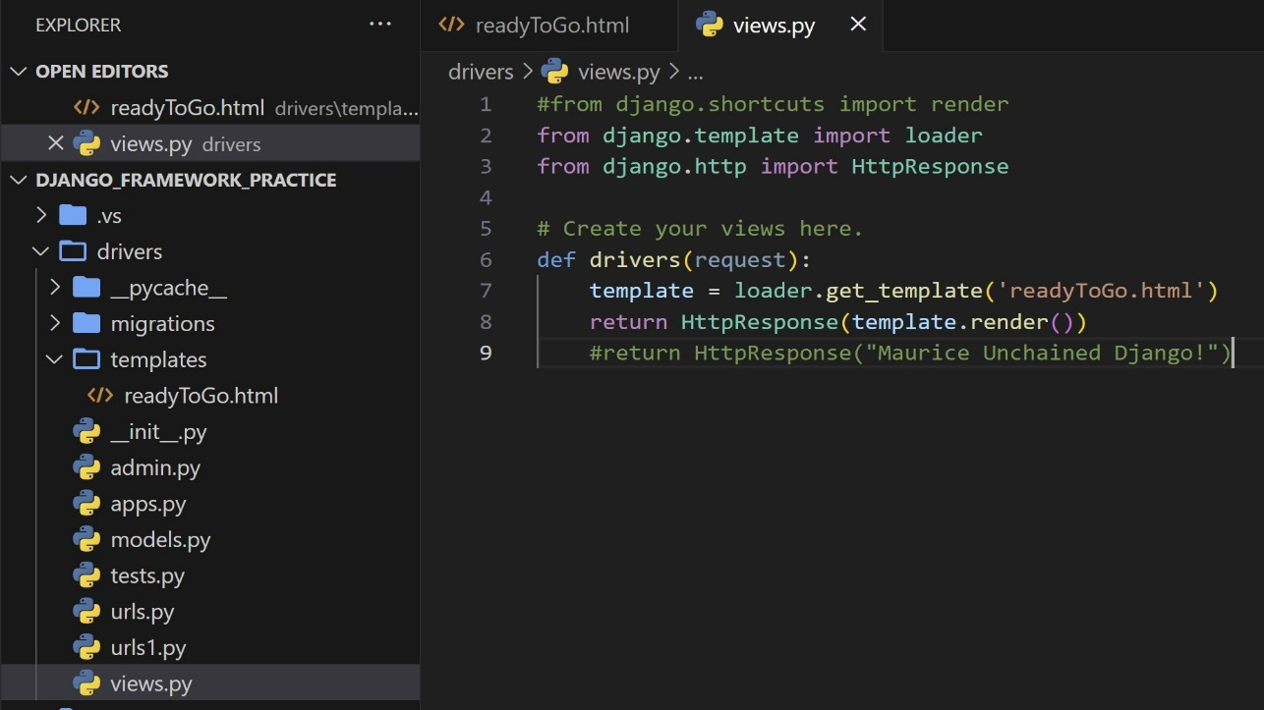
   6. At his point, Django does not know about the new app. If we were to run the Django server and navigate to localhost:8000, then we would see an error. We need to navigate to the superlist folder and open the settings.py file. We can add our driver app. Please see below.
   7. 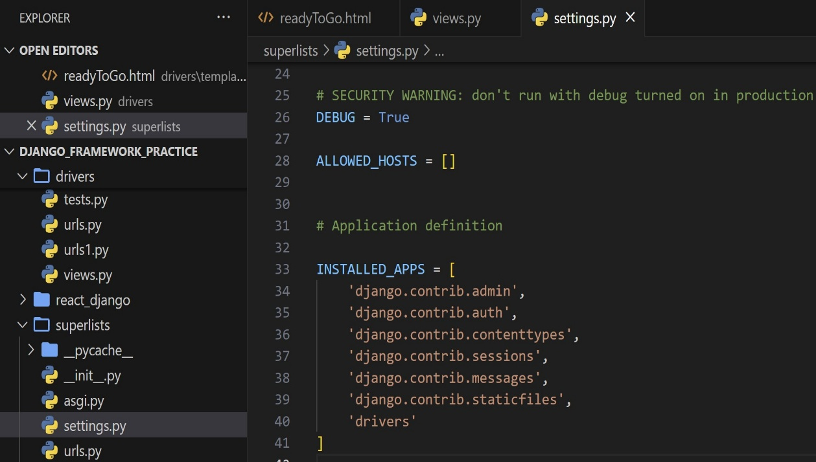
4. Migrating
   1. We can start the application and view the changes
   2. 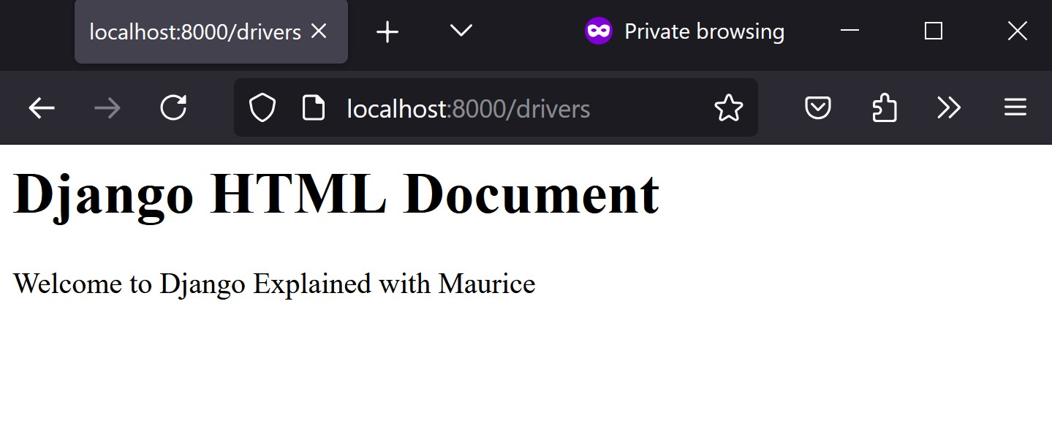
   3. Now that we know we can render the HTML document from the view, we will need to migrate the changes. Originally when we ran the app, we would get an error telling us about unapplied migration. See below.
   4. 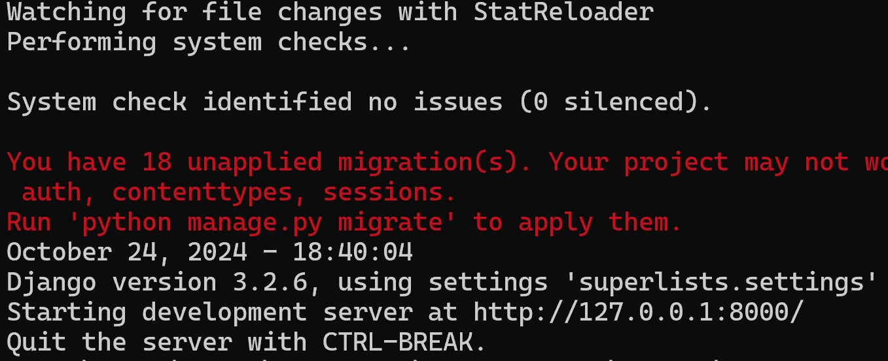
   5. Run: ‘python manage.py migrate’. This will show something similar to below.
   6. 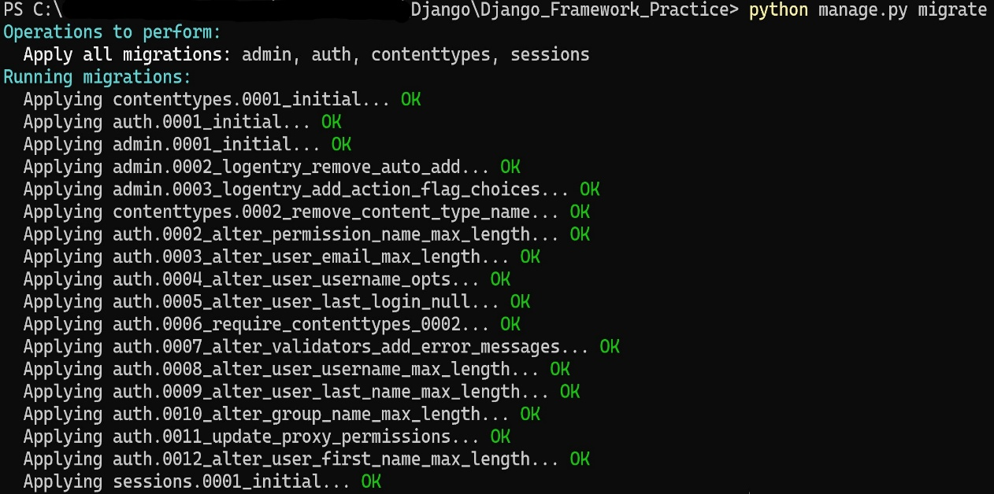
   7. Now we can start the server and the warning message should be gone.
   8. 