Got_Goat_Chapter_5

1. Admin
   1. Earlier we performed CRUD operations for testing without permission as an authorized user. Django provides built-in functionality for CRUD operations, member authentication and member authorization.
   2. Run the server and navigate to localhost:8000/admin
   3. The page is found because the path was specified in the top-level URL file of the superlists fold.
   4. 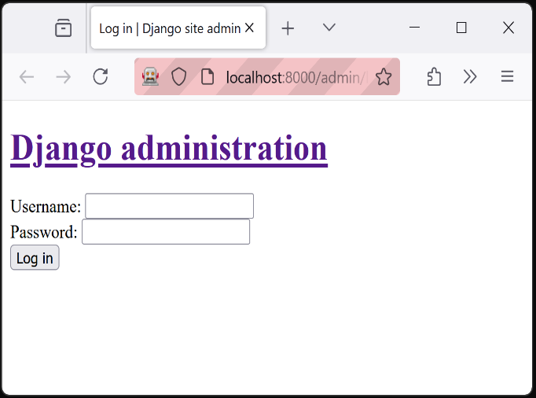
2. Create Dispatch/User
   1. Run: python manage.py createsuperuser (stop server if running)
   2. Enter name, email, and password.
   3. 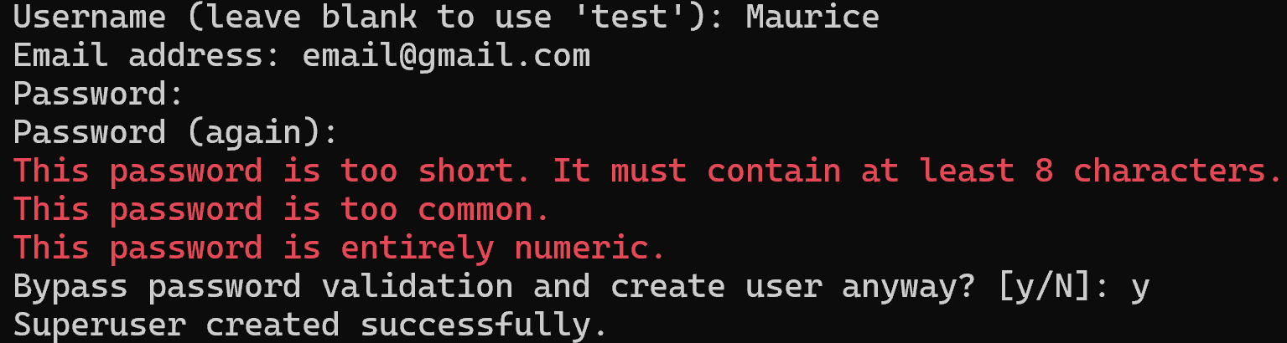
   4. Now start the server
3. Login User
   1. 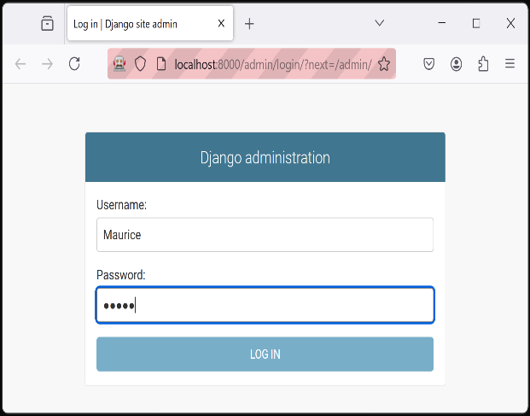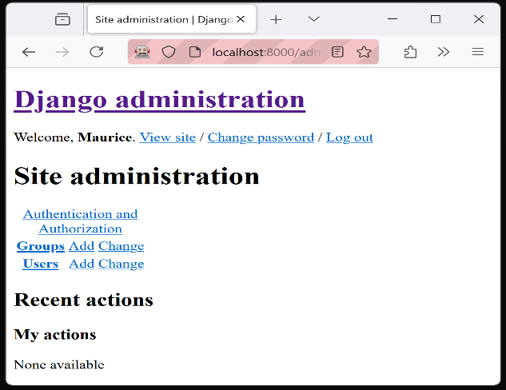
4. Register Driver Model
   1. Currently our driver model is not listed on the admin landing page after login. We need to register the app in the models admin.py. See below.
   2. 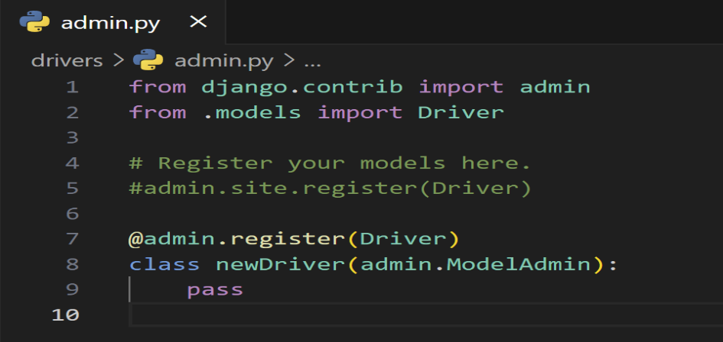
   3. Now that the driver model has been registered with the admin, we can refresh the page after login.
   4. 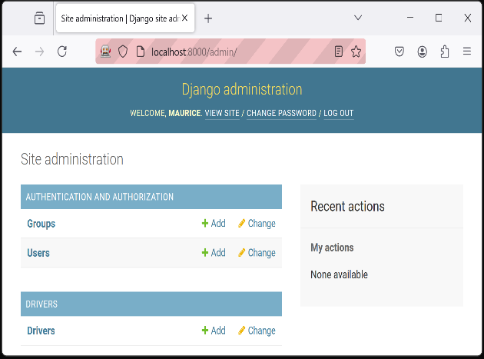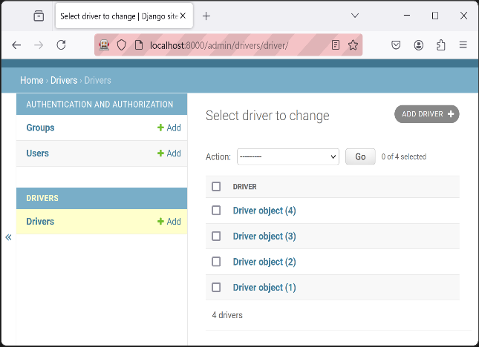
   5. Selecting our drivers model will bring the member to the edit page.
   6. Additionally, adding the below code to the models.py file will format each object as a string when displayed in the rows.
   7. 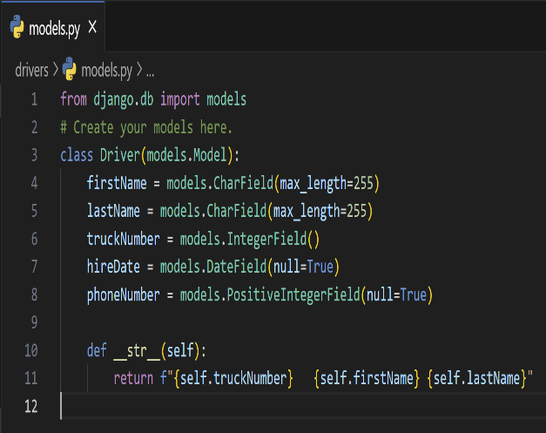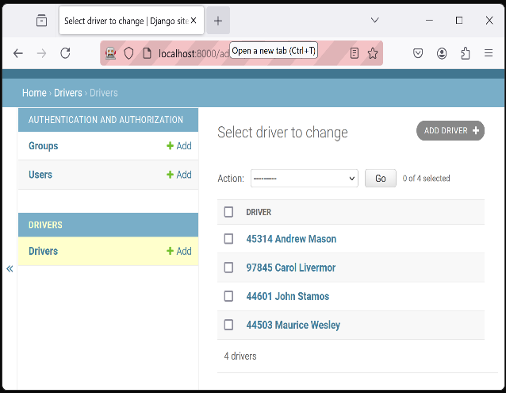
   8. Each row is under the column driver. We change the output to two columns with the first column being clickable to the edit page.
   9. 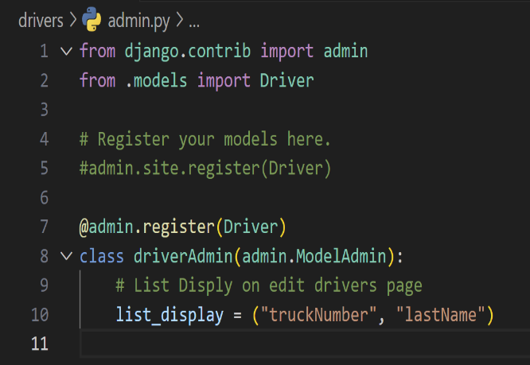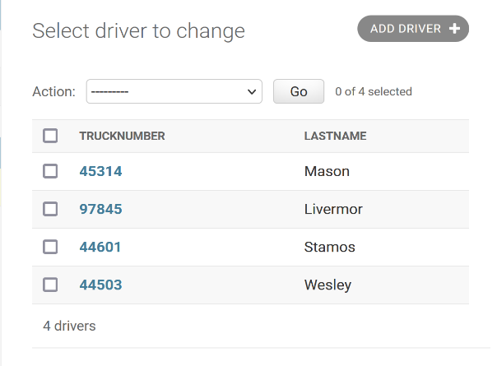
5. Update
   1. 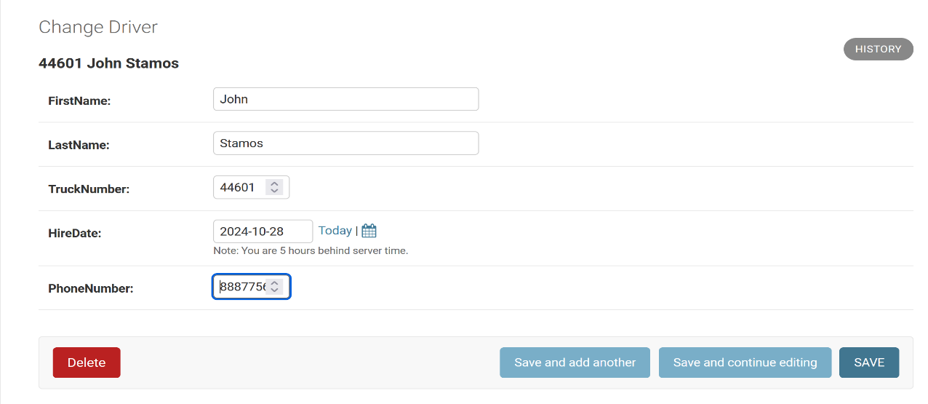
6. Add
   1. 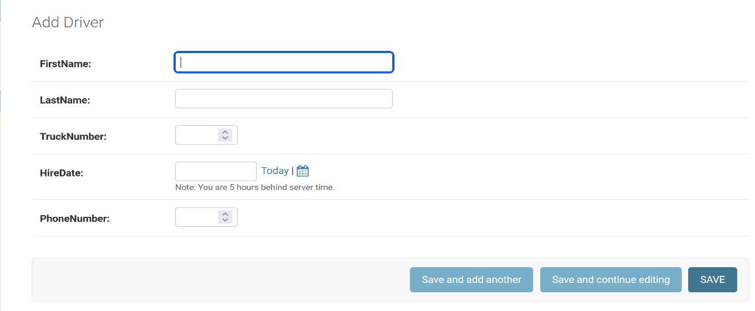
7. Delete
   1. Check one or more box under the truck number column. Then click the drop-down arrow by Actions. Select ‘Delete’. A screen will ask you to confirm. Click ‘yes’ and continue.