Got_Goat_Chapter 6

1. Variables
   1. Navigate to the to testing html we created earlier in this tutorial. Make the following changes.
   2. 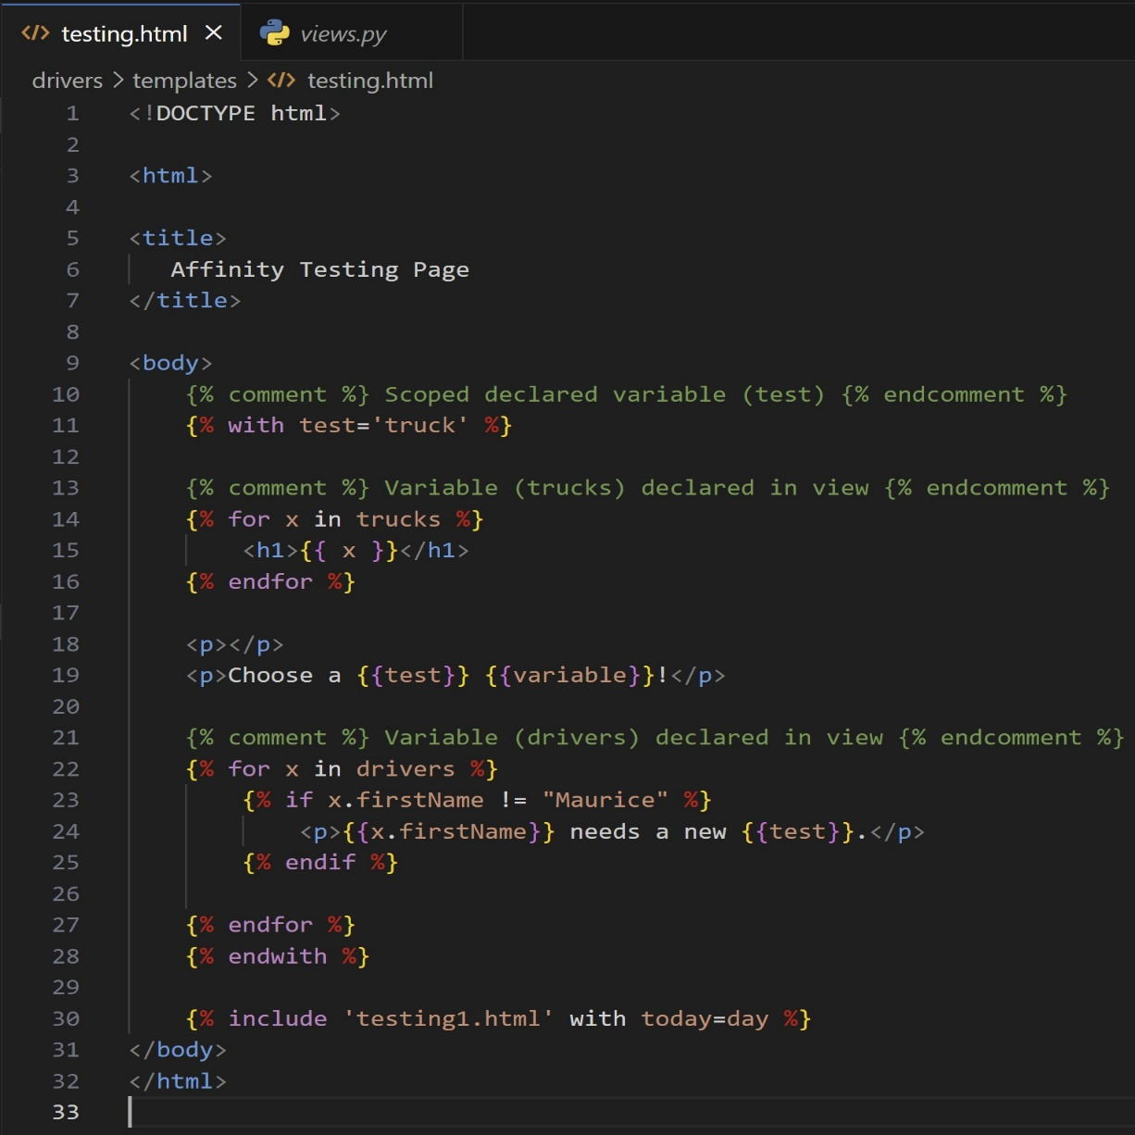
   3. Line 11: Django provides functionality to access a variable declared within the template. The variable ‘test’ is assigned to the string literal ‘truck’. Wrap the variable in double curly brackets to access the value (lines: [19,24]).
2. View Variables
   1. Make the following changes to the views.py file.
   2. 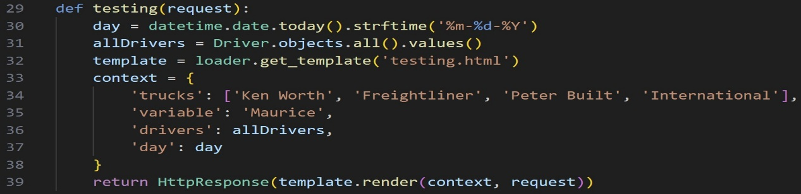
   3. Line 22: A for loop in place inside programming logic and iterates over the model object instance that is past to the template from the view. The driver Model was previously imported into the view. The view accesses the model and passes the object in the context dictionary.
      1. The context dictionary contains key, value pairs that are passed to the render call of the template. The template references the context dictionary when performing programming logic.
   4. Line 23: A nested condition is wrapped in programming logic to prevent a duplicate.
3. Testing Page
   1. Start the server and navigate to the testing page
   2. 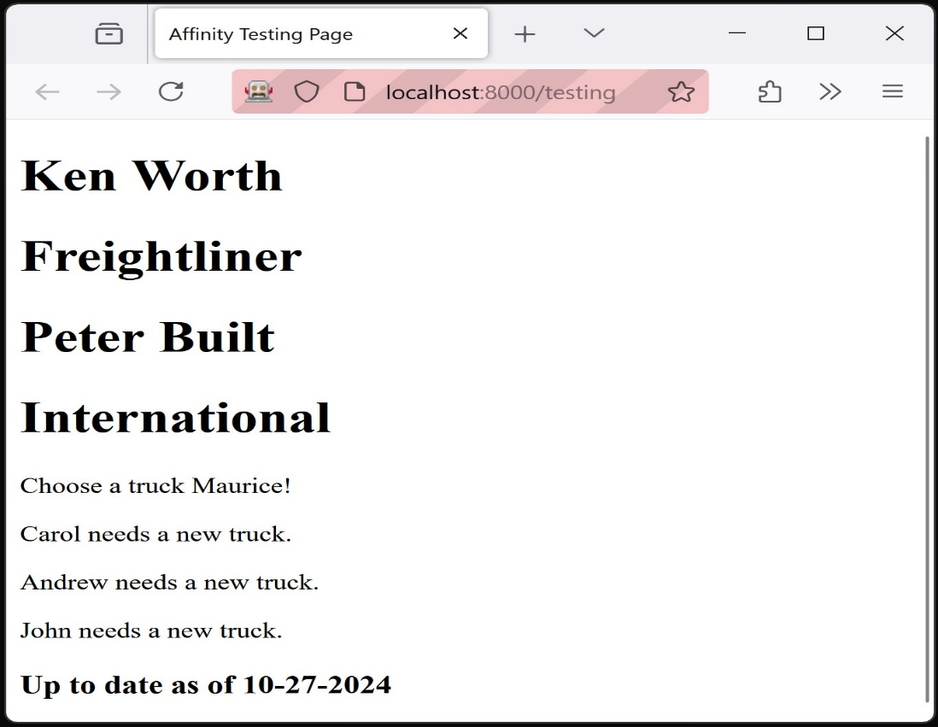
   3. Line 30: The view imports the date time library and assigns today’s date to a variable that is passed to the testing html. The testing html has programming logic that contains an include keyword for the testing1 html. The with keyword will pass the variable from the view to the testing1 html in the render call.