Got_Goat_Chapter 7 Query Sets

1. Introduction
   1. 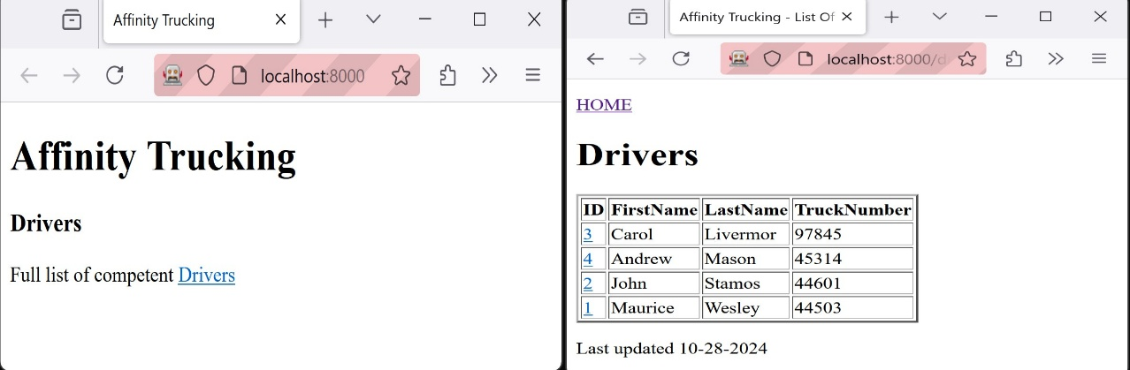
   2. We have a simple driver application with an administrative back end. On the left, is the client facing landing page. The user is taken to the page on the right after they click on Drivers.
   3. I updated our drivers landing page to include a Table with a link to the driver’s details. In this chapter, we will more closely analyze the view statement that accesses the model in the driver app.
   4. 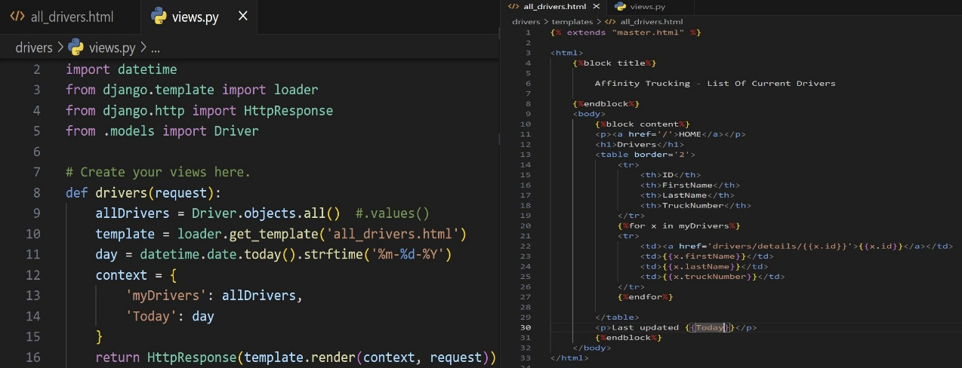
   5. Left Line 9: We imported the Driver model with line 5. Next, we declare a variable called ‘allDriver’ that is assigned to an object instance of the model that contains Query Sets.
      1. The context variable is a hash map that uses the name in the HTML file as the key and it is assigned the value declared in the view.