Got Goat Chapter 1

We will take a dive into the wonderful world of web development using python with the popular web framework Django. Also, we will build a web application using selenium for the browser automation tool. Content was provided with aid from the [book](https://www.obeythetestinggoat.com/book/praise.forbook.html) *Test-Driven Development with Python*.

1. Prerequisites
   1. Visual Studio
   2. Create a New Project in Visual Studio
   3. Activate Virtual Environment
   4. Pip install django
   5. Pip install selenium
2. Functional Test
   1. Create a new python file
   2. Insert the code below
   3. 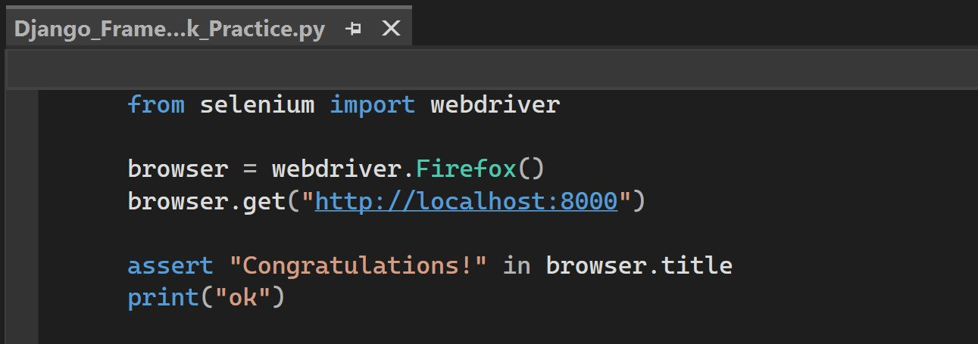
3. Install Django configuration package
   1. Open up the terminal inside Visual Studio. The current directory should be before the prompt. Insert the code below in your working directory
   2. django-admin startproject superlists .
   3. 
4. Deploy our first Django application
   1. Open up a Power Shell window and navigate to the working directory. Insert the code below.
   2. python manage.py runserver
   3. 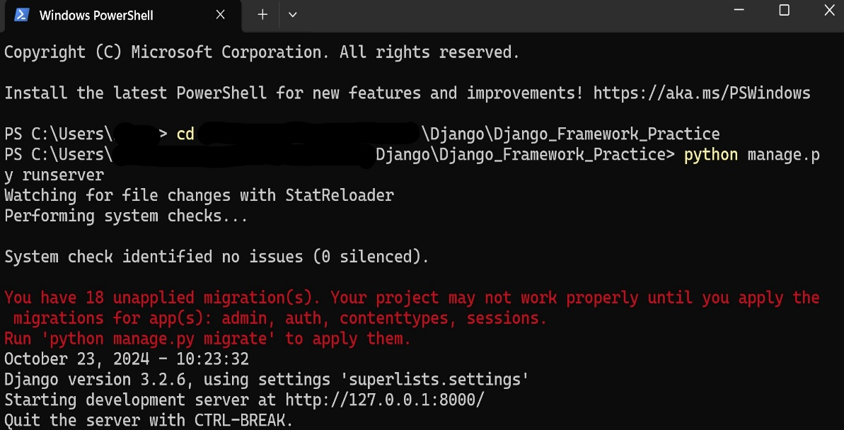
   4. The files in the superlist are used to configure the Django server. The above shows that the server is listing on local host 8000. Navigating back to our open project, we can now execute the functional test code written above in our python file.
   5. 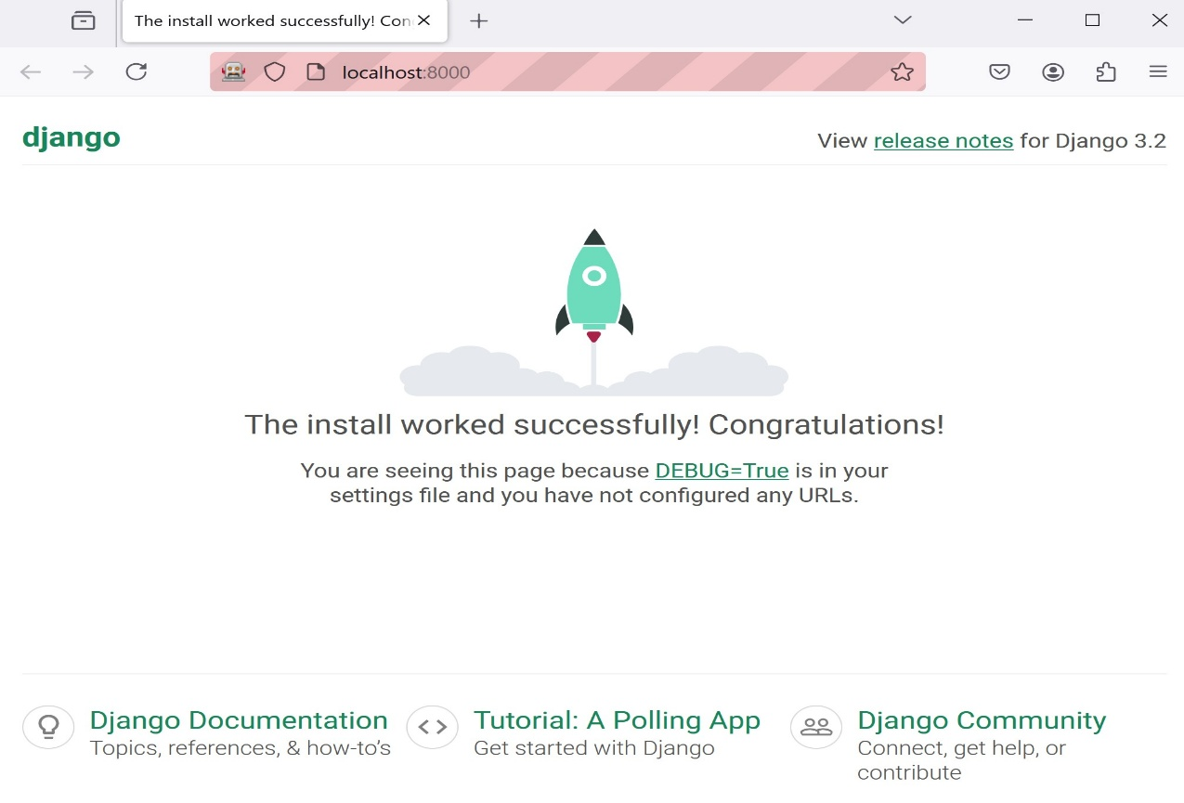
   6. Our python file contains a print statement as a functional test to ensure to program completed successfully.