AIM:-To develop program modules based on scaling of signals

SOFTWARE REQUIRED:- MATLAB

Theory:-scaling of a signal stands for multiplication of that signal with a coastant.It is of two types

a} **Amplitude-Scaling of Signal:**

There are some important properties of signal such as amplitude-scaling, time-scaling and time-shifting. Among these properties now we are discussing about amplitude scaling. Consider a signal *x(t)* which is multiplying by a constant *'A*' and this can be indicated by a notation *x(t) → Ax(t)*. For any arbitrary *'t'*  this multiplies the signal value *x(t)* by a constant*'A'*. Thus, *x(t) → Ax(t)* multiplies *x(t)* at every value of *'t'* by a constant *'A'*. This is called amplitude-scaling. If the amplitude-scaling factor is negative then it flips the signal with the*t-*axis as the rotation axis of the flip. If the scaling factor is -1 then only the signal will be flip. This is shown in the Figure 6(a), 6(b), 6(c) which is given below.

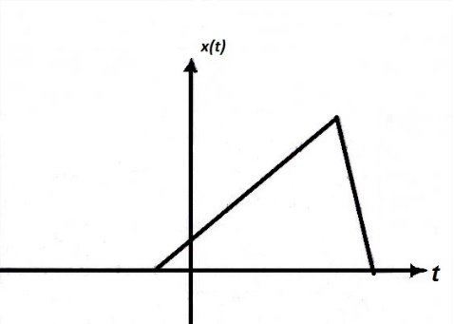    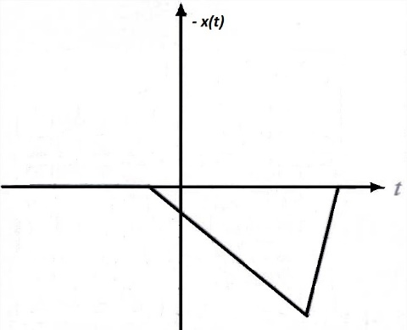    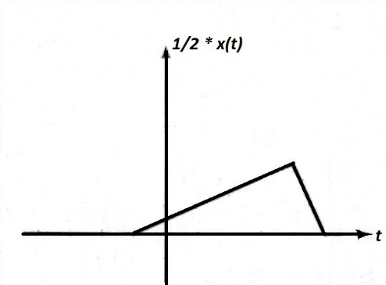

        Fig.6(a) A signal x(t)                  Fig.6(b) A signal x(t) scaled by *-1*Fig.6(c) A signal x(t) scaled by*1/2*

**Time-Scaling of Signal:**

Time scaling compresses or dilates a signal by multiplying the time variable by some quantity. If that quantity is greater than one, the signal becomes narrower and the operation is called compression. If that quantity is less than one, the signal becomes wider and the operation is called dilation. Figure 7(a), 7(b), 7(c) shows the signal x(t), compression of signal and dilation of signal respectively.

|  |  |  |
| --- | --- | --- |
| http://iitg.vlab.co.in/userfiles/7/image/sig1/tim_scal%281%29.jpg | http://iitg.vlab.co.in/userfiles/7/image/sig1/tim_scal1.jpg | http://iitg.vlab.co.in/userfiles/7/image/sig1/tim_scal2.jpg |
| Fig.7(a) Signal x(t) | Fig.7(b) Compression of signal | Fig.7(c) Dilation of signal |

PROCEDURE:-

1. Open MATLAB software.
2. Open new m-file.
3. Type the program.
4. Save in current directory or if save to other add it to path.
5. Run the program.
6. For the output see command window and graph.

PROGRAM:-

clc;

clear all;

close all;

k=2

x1=[1;2;3;4;5]

x2=k*x1

subplot(3,1,1);

stem(x1);

xlabel('number of samples');

ylabel('amplitude');

title('input signal');

subplot(3,1,2);

stem(x2);

xlabel('number of samples');

ylabel('amplitude');

title('amplified signal');

x3=x1/k;

subplot(3,1,3);

stem(x3);

xlabel('number of samples');

ylabel('amplitude');

title('attenuated signal');

OUTPUT:- output is shown below

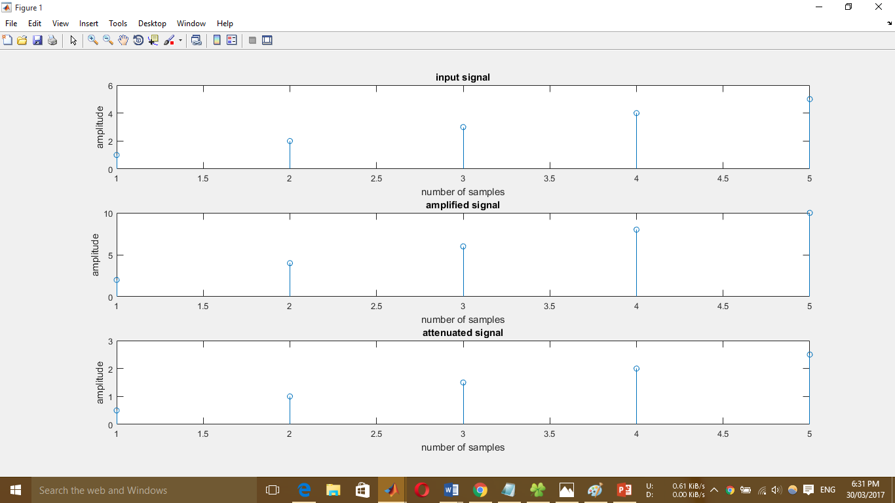

Precaution:-write codes correctly.