
BIT3208: ADVANCED WEB DESIGN AND DEVELOPMENT

Student Name: MOSES KIMATHI

Admission Number: BBIT/2024/73877

Course: BACHELOR OF BUSINESS AND INFORMATION TECHNOLOGY

Unit Code: BIT3208

Unit Name: Advanced Web Design and Development

Lecturer Name: MICHAEL NYORO

Academic Year: 2025/2026

Project Title: Student Management System

Selected Technologies:
PHP
MySQL
JavaScript

GitHub Repository Link:https://github.com/mwiathi382/BIT-3208.git

Table of Contents
WEEK 1 5
Installation and Testing of Local Development Environment. 5
Fig 1. INSTALLATION OF XAMPP 5
Fig 2. Apache and MySQL services running successfully. 6
Fig 3. Localhost test page running in browser. 6
Fig 4. Hello World PHP page. 6
Fig 5. Successful MySQL database connection. 7
7
REFLECTION. 7
WEEK 2 8
User Interface Planning and System Design. 8
Fig 1. Hand-drawn wireframe. 8
Fig 2. Dashboard Layout Design. 8
Fig 3. Mobile responsive design 9
Fig 4. GUI Prototype developed using figma. 10
REFLECTION WEEK 2 10
WEEK 3 11
Frontend Interaction and Backend Foundations. 11
Fig 1.Javascript form validation 11
Fig 2. Password strength Checker. 11
Fig 3. PHP syntax practice 12
Fig 4. Database connection script 12
Fig 5. Dynamic user input page 12
REFLECTION 13
WEEK 4 14
Server Side Programming and Authentication 14
Fig 1. User Registration Form 14
Fig 2. Login Form 14
Fig 3. PHP form processing page 15
Fig 4. Session-based login system 15
Fig 5. Project folder organization structure 16
REFLECTION 16
WEEK 5 17
Database Components and CRUD Operations 17
Fig 1. Database creation in phpMyAdmin 17
Fig 2. Users table structure 17
Fig 3. Create Operation 18
Fig 4. Read Operation 18
Fig 5.Update/Delete Operation 19
REFLECTION 19
WEEK 6 19
USABILITY TESTING INSTRUCTIONS. 19
Fig 1: Evidence of users interacting with the system (or the testing process). 19
Fig 2: Usability evaluation results and observations. 20
Reflection 21
WEEK 7 21
PROTOTYPING AND USER INTERFACE DESIGN. Fig 1: Interface mock-up. 21
REFLECTION 22
WEEK 8 22
Responsive Web Design and Mobile-First Development 22
Fig 1 :HTML structure of the responsive webpage. 22
Fig 2: CSS media queries used in the design. 24
REFLECTION 24

WEEK 1

Installation and Testing of Local Development Environment.

Fig 1. INSTALLATION OF XAMPP
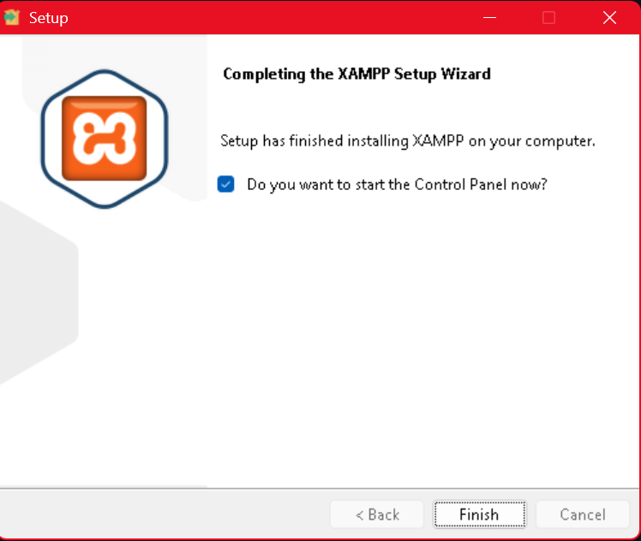

Fig 2. Apache and MySQL services running successfully.
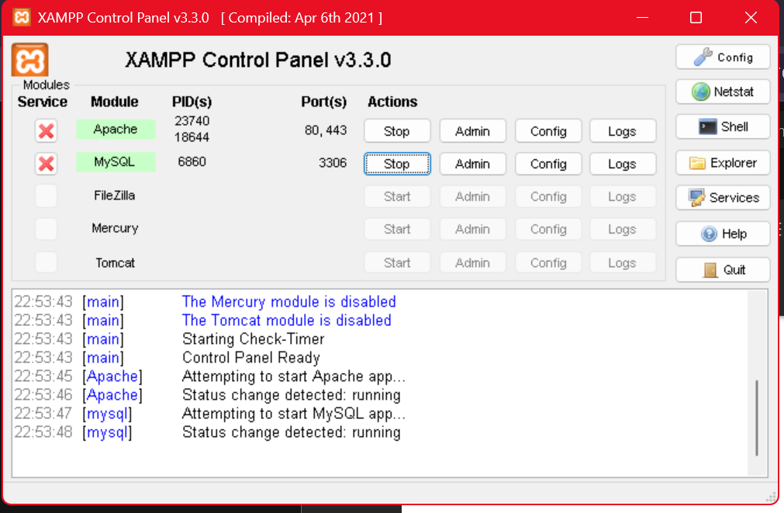

Fig 3. Localhost test page running in browser.
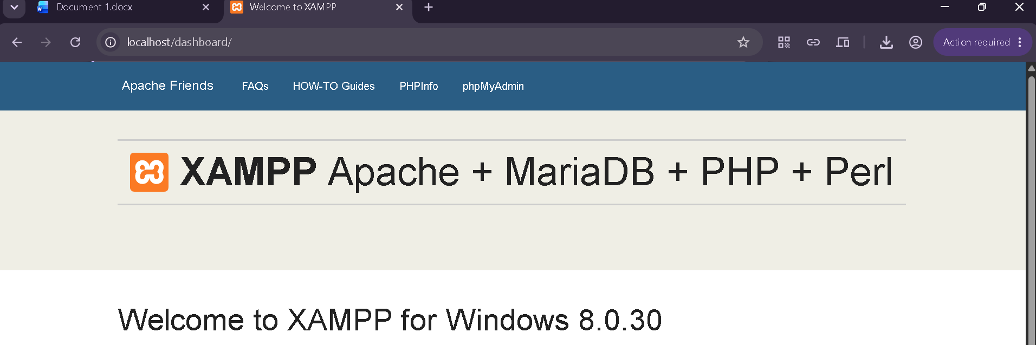

Fig 4. Hello World PHP page.
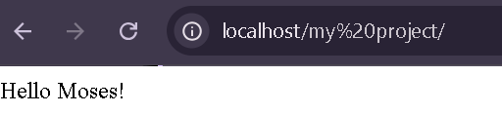

Fig 5. Successful MySQL database connection.
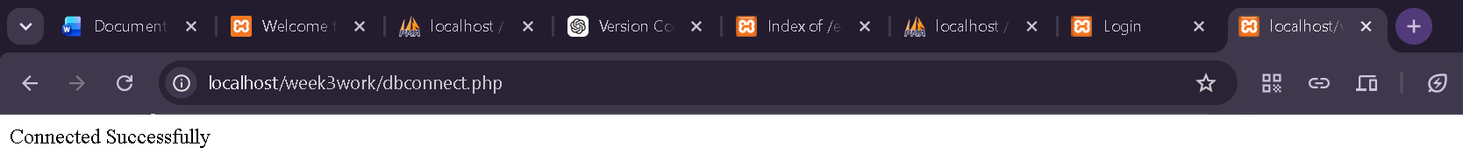

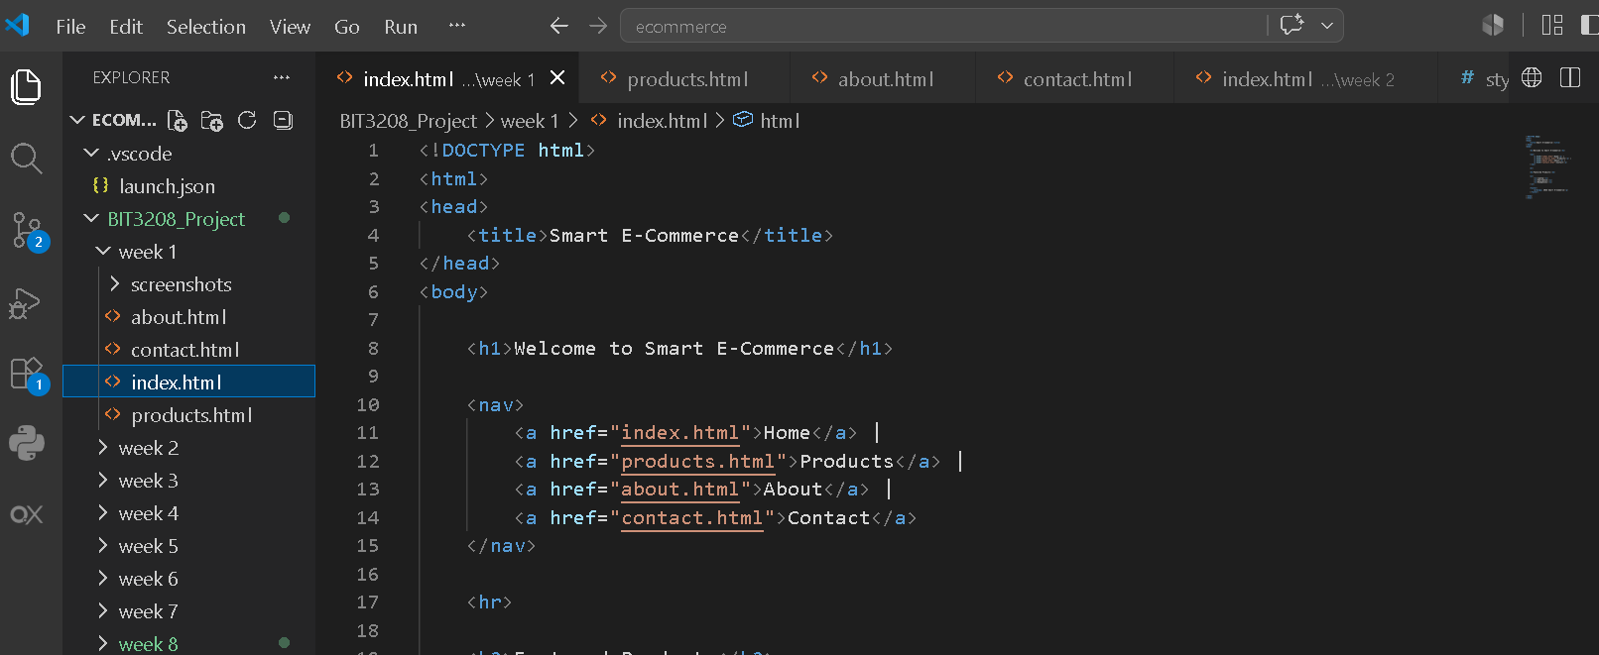

REFLECTION.
In Week 1, I was introduced to the project setup process, including installing and configuring XAMPP and setting up the development environment using VS Code. I also learned how to create project folders in the htdocs directory to run PHP applications on localhost.

WEEK 2

User Interface Planning and System Design.

Fig 1. Hand-drawn wireframe.
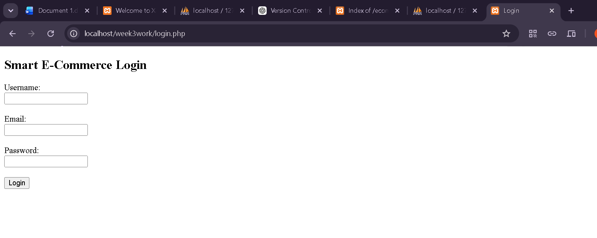

Fig 2. Dashboard Layout Design.
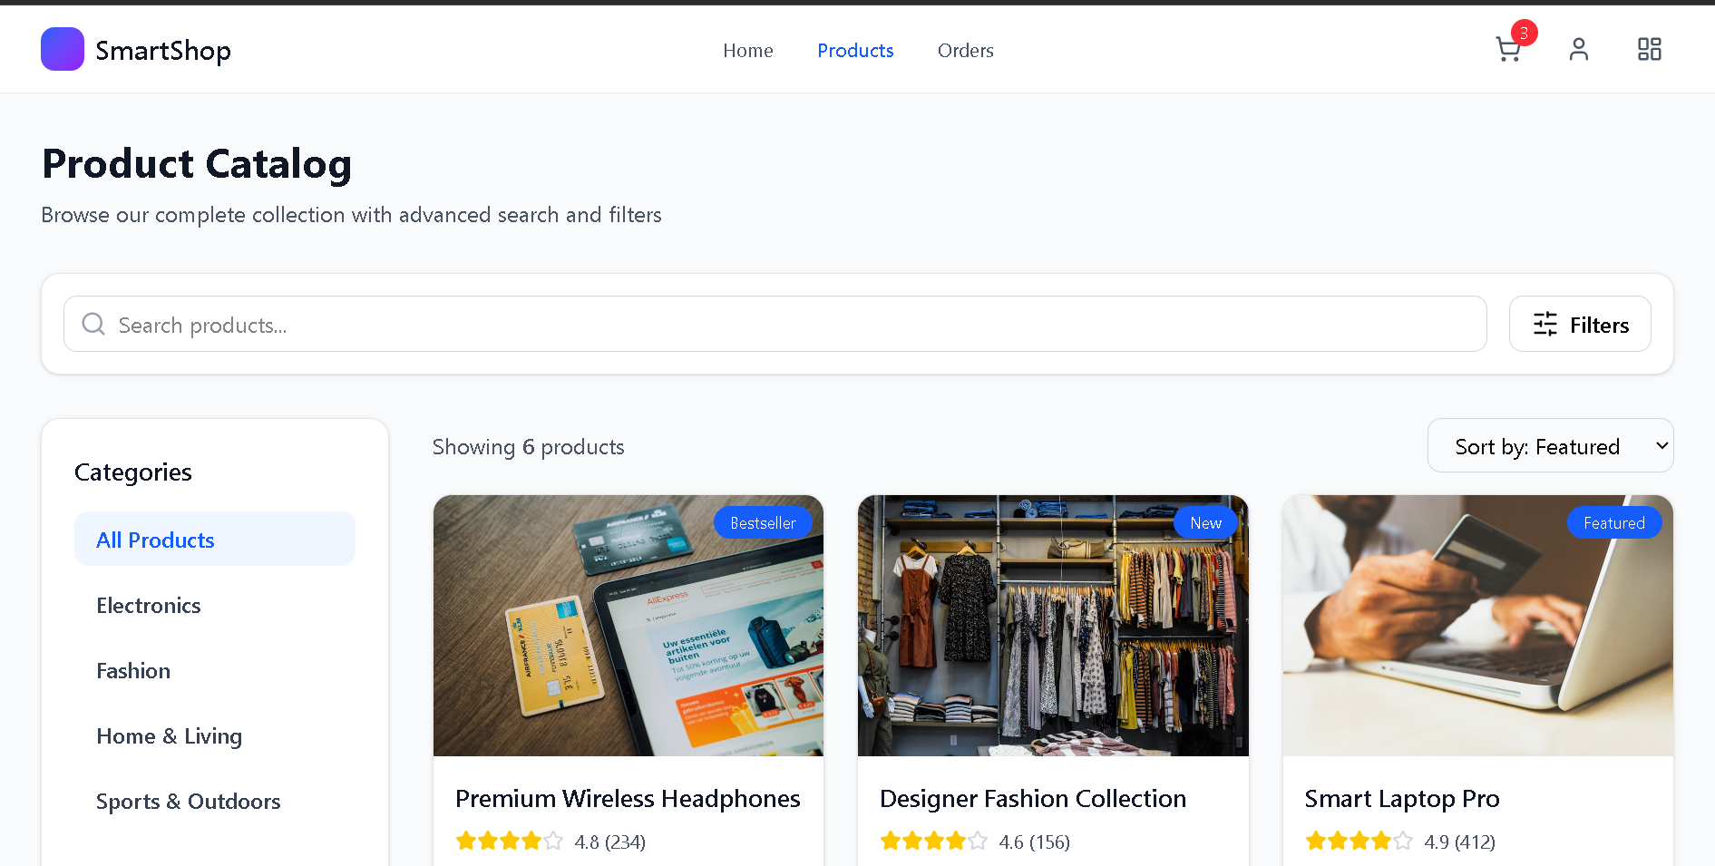

Fig 3. Mobile responsive design

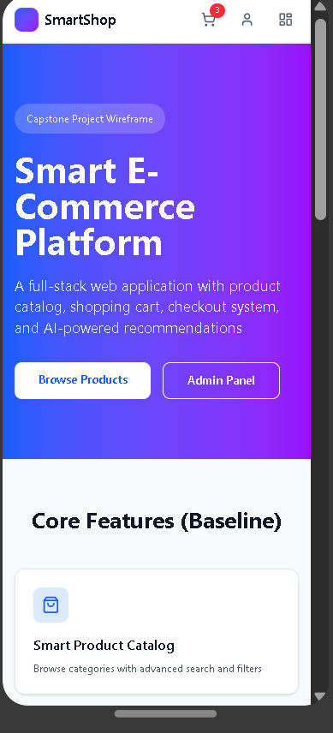

Fig 4. GUI Prototype developed using figma.
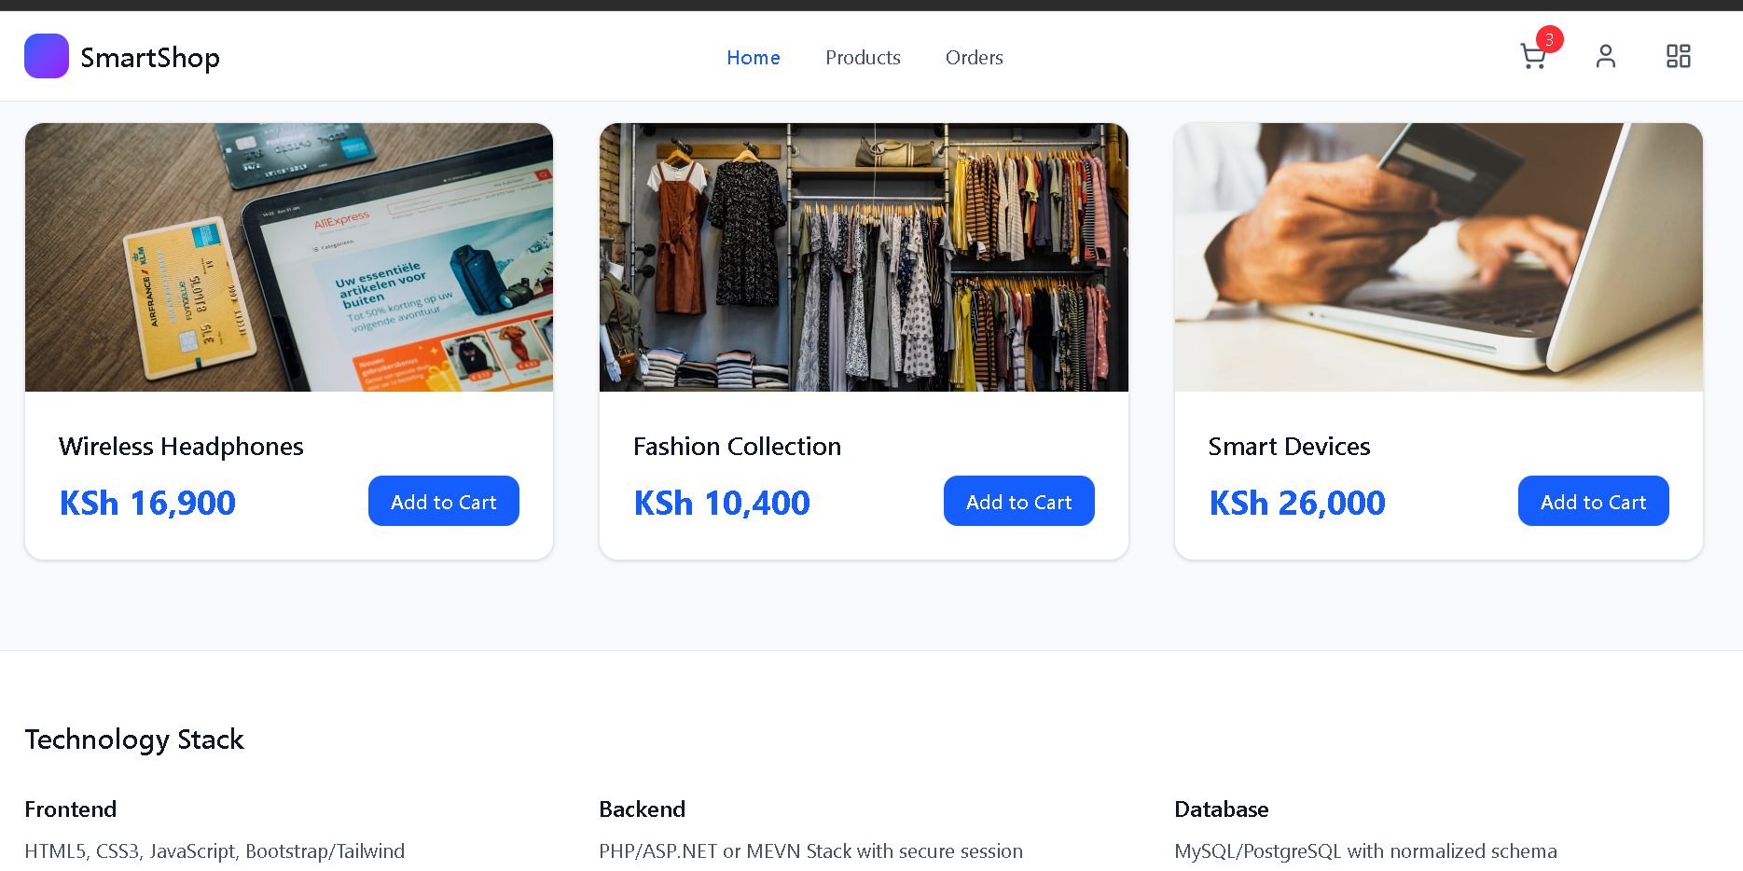

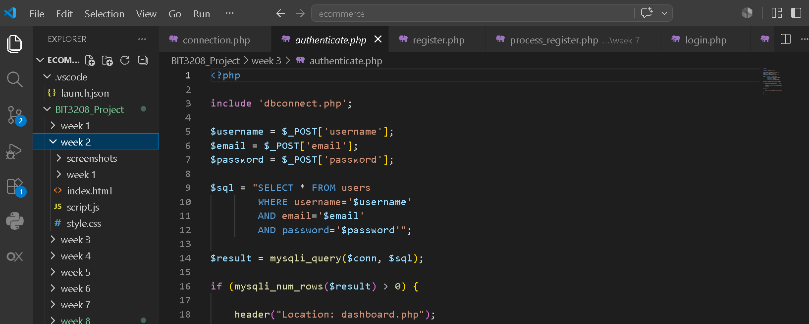

REFLECTION WEEK 2
In Week 2, I focused on designing the basic user interface of the system using HTML. This included creating simple web pages such as the homepage and navigation structure, which helped me understand how users interact with web applications.

WEEK 3

Frontend Interaction and Backend Foundations.

Fig 1.Javascript form validation
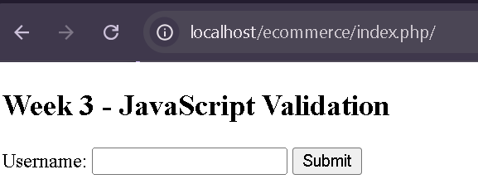

Fig 2. Password strength Checker.
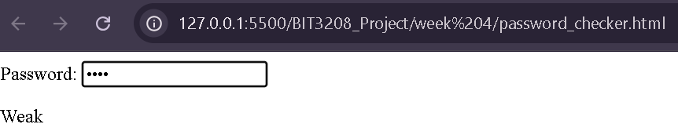
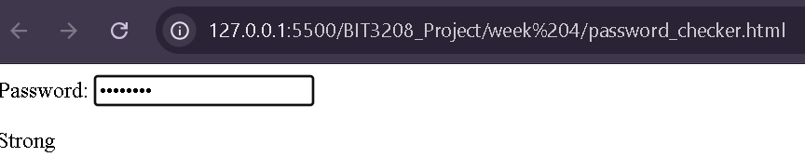

Fig 3. PHP syntax practice
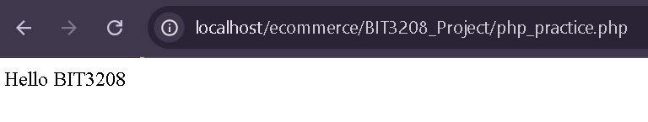

Fig 4. Database connection script


Fig 5. Dynamic user input page
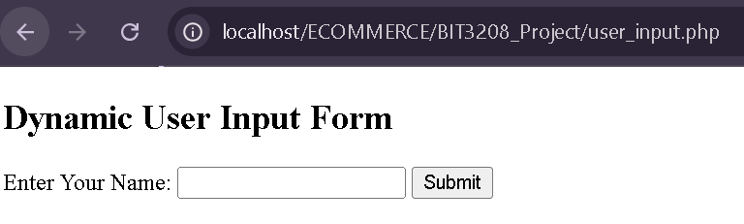
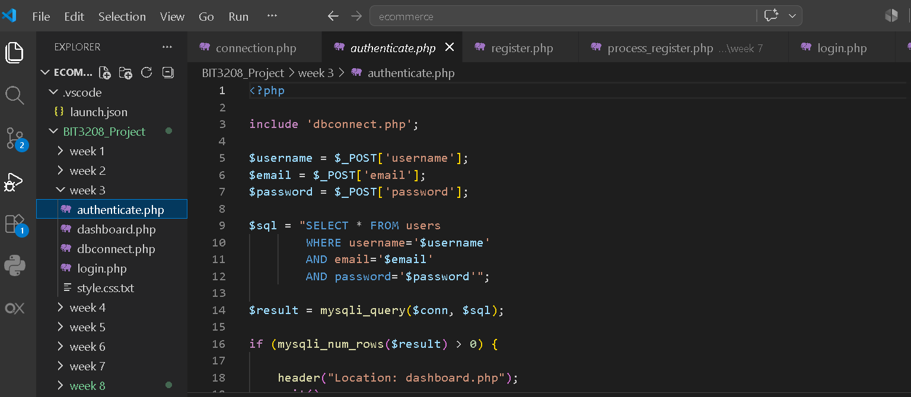

REFLECTION
In Week 3, I implemented database connectivity using PHP and MySQL. I learned how to create a database in phpMyAdmin and connect it to my PHP project using a connection script. This stage helped me understand how web applications store and retrieve data.

WEEK 4

Server Side Programming and Authentication

Fig 1. User Registration Form
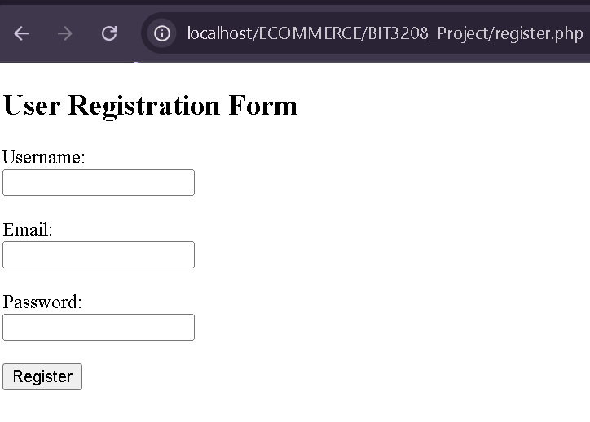

Fig 2. Login Form
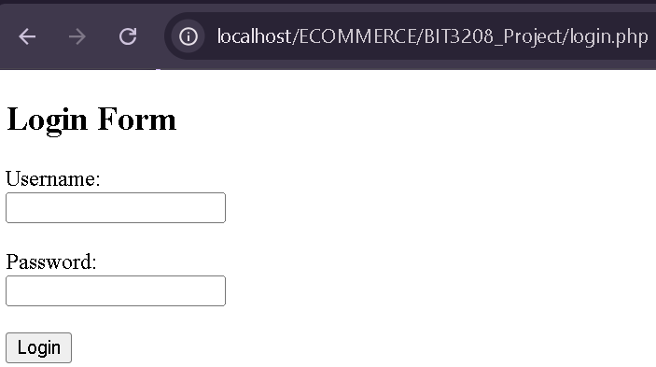

Fig 3. PHP form processing page
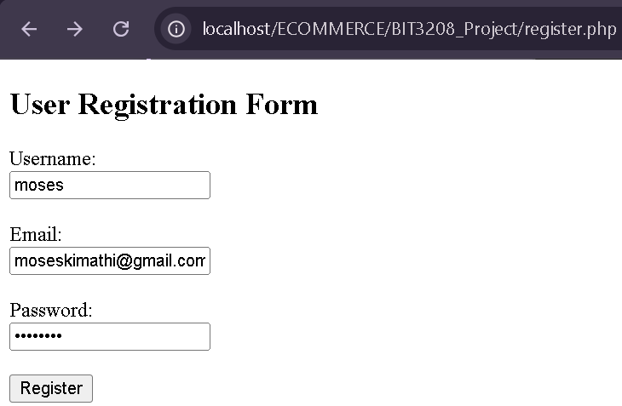

Fig 4. Session-based login system
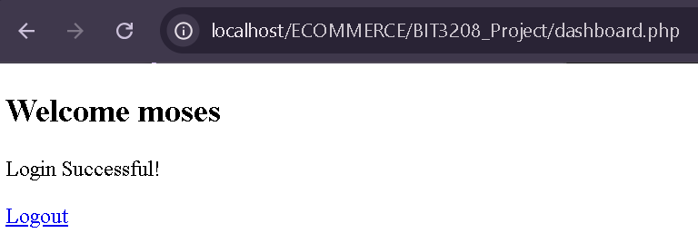

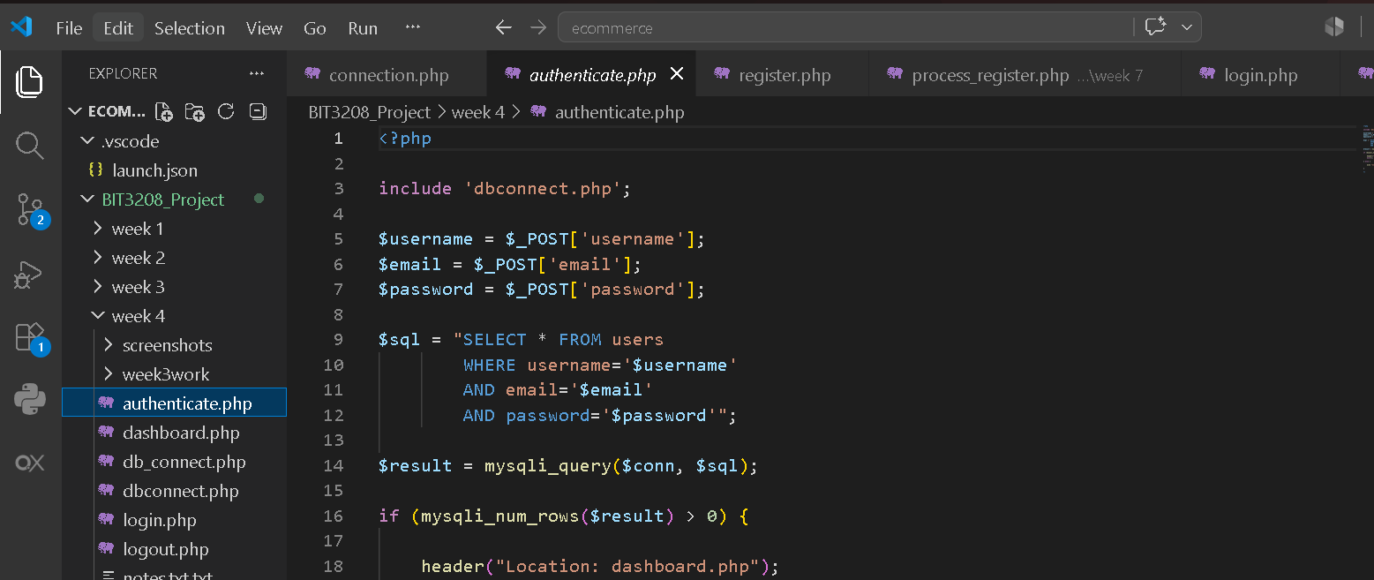

Fig 5. Project folder organization structure
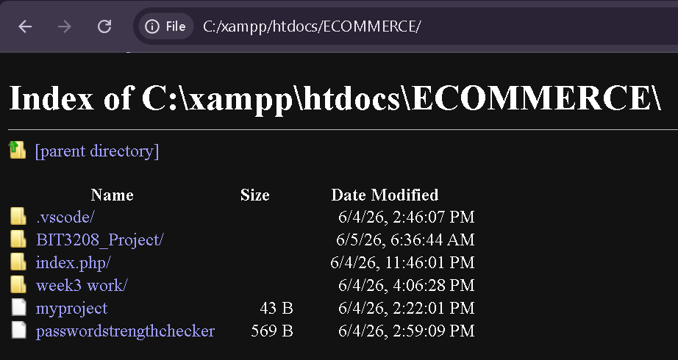

REFLECTION
In Week 4, I developed a server-side authentication system. I created user registration and login forms, processed form data using PHP, and implemented session-based login functionality. This helped me understand how user authentication works in real-world web applications and how sessions maintain user state.

WEEK 5

Database Components and CRUD Operations
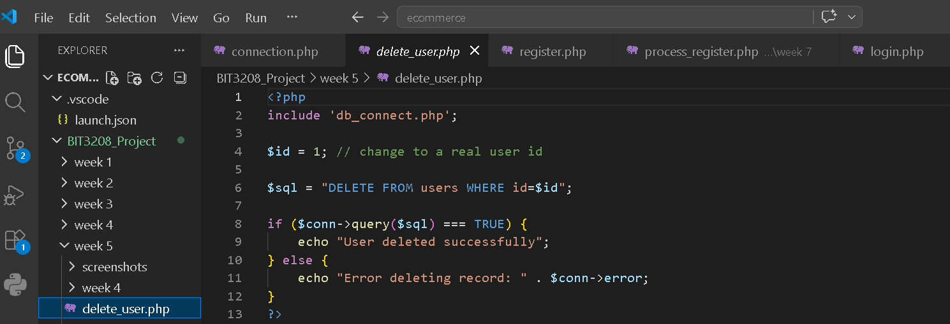

Fig 1. Database creation in phpMyAdmin
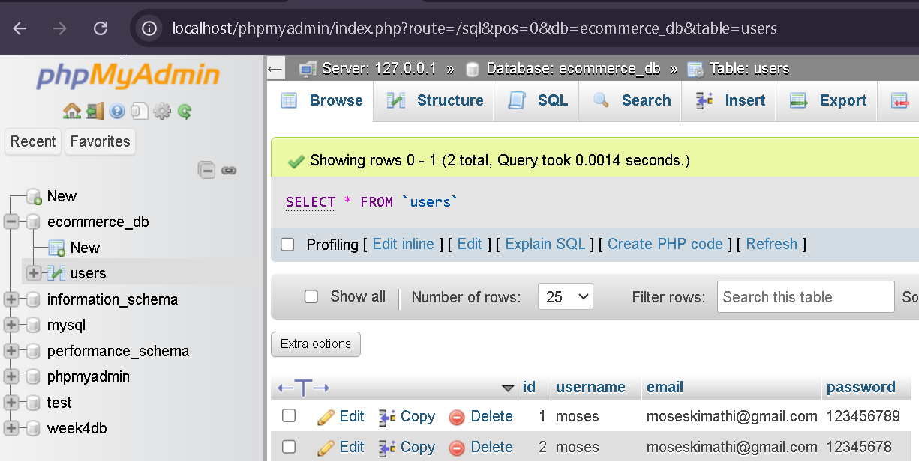

Fig 2. Users table structure
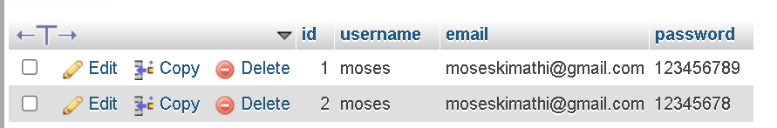

Fig 3. Create Operation
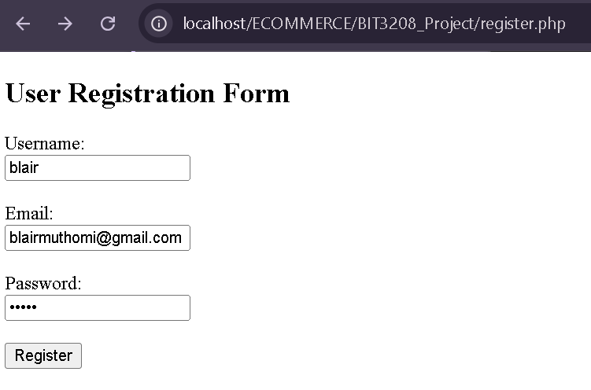
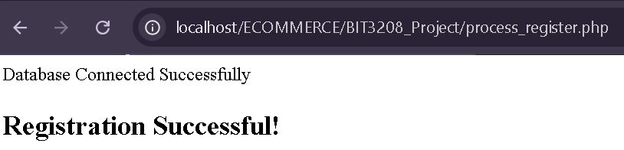
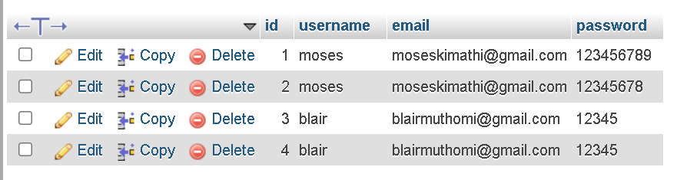

Fig 4. Read Operation
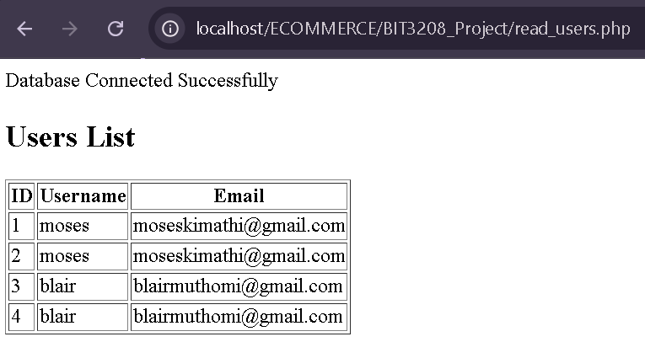

Fig 5.Update/Delete Operation
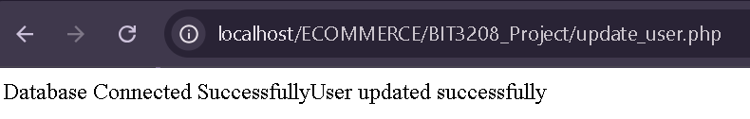
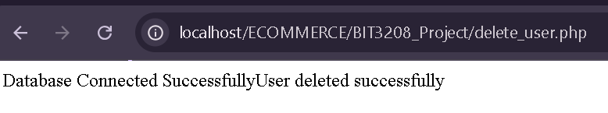

REFLECTION
In Week 5, I implemented CRUD (Create, Read, Update, Delete) operations. I learned how to insert, display, update, and delete data from a MySQL database using PHP. This strengthened my understanding of database operations and dynamic web application development.

WEEK 6

USABILITY TESTING INSTRUCTIONS.

Fig 1: Evidence of users interacting with the system (or the testing process).
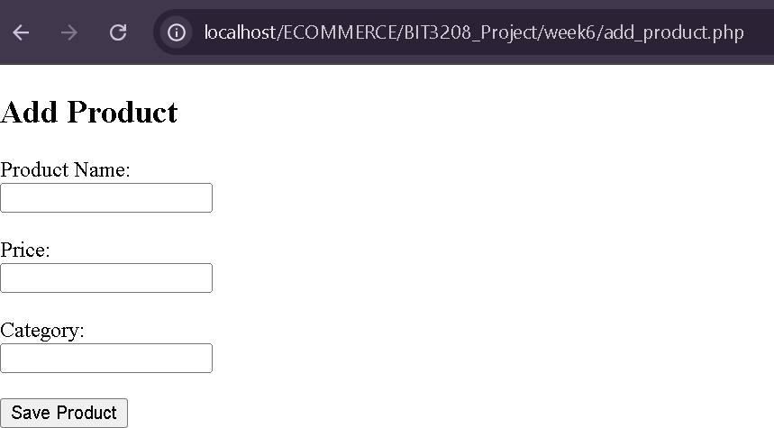
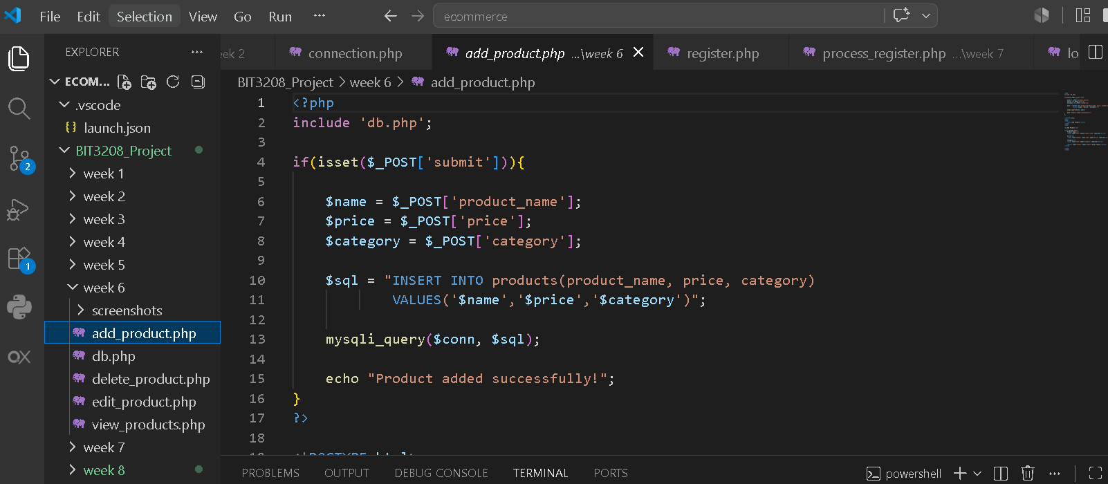

Fig 2: Usability evaluation results and observations.

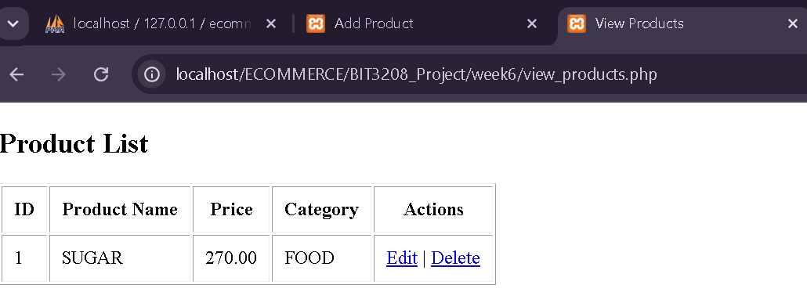
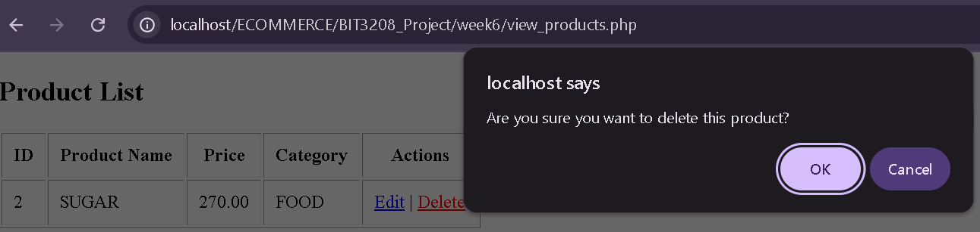

Reflection
In Week 6, I focused on testing how easy a system is to use. I performed different tasks while observing their interactions. Their feedback helped identify areas that needed improvement, such as navigation and clear instructions. This activity showed that usability testing is important in creating systems that are user-friendly and effective.

WEEK 7

PROTOTYPING AND USER INTERFACE DESIGN.
Fig 1: Interface mock-up.
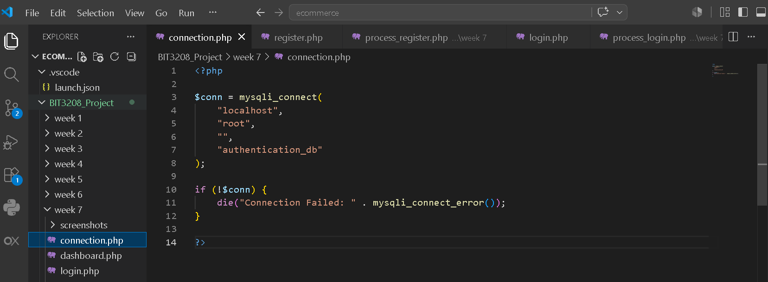

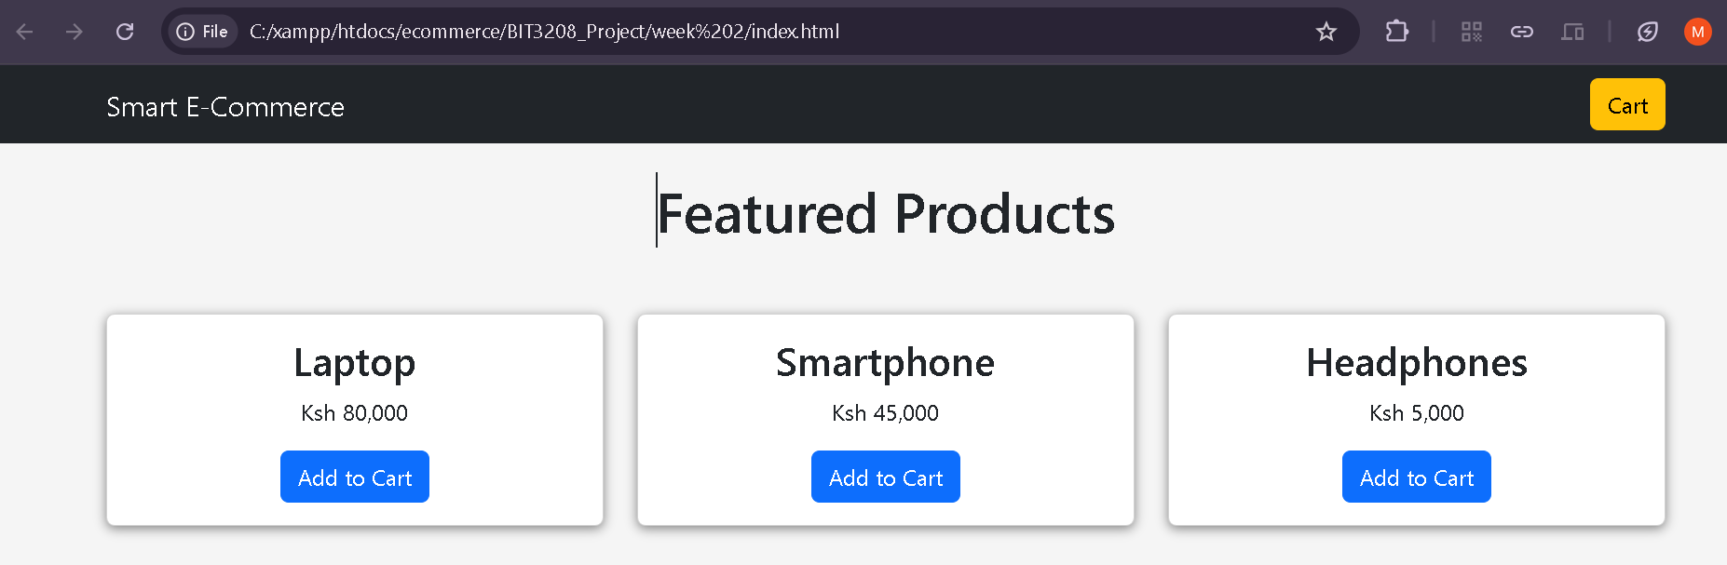
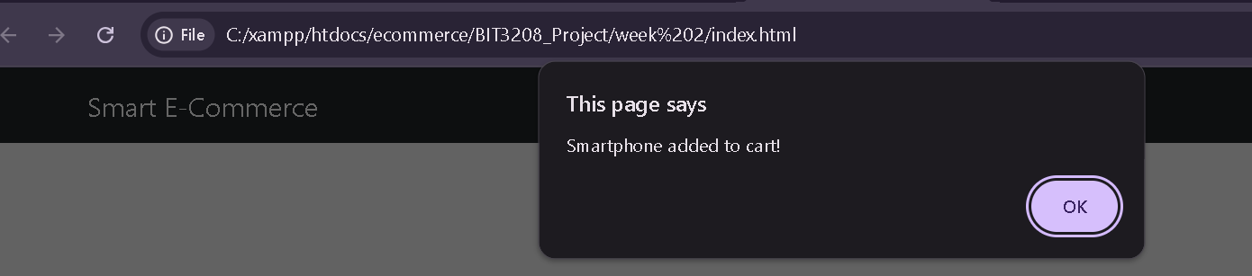
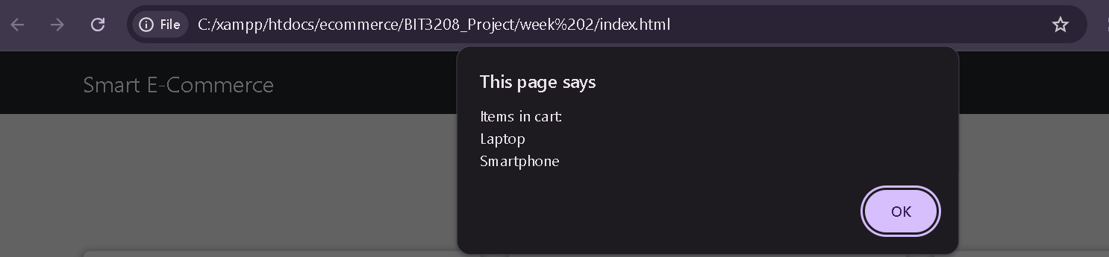
REFLECTION
I focused on designing and refining user interfaces through prototyping. Both low-fidelity and high-fidelity prototypes were developed to visualize how the final system would function. The activity highlighted the importance of gathering feedback before implementation, allowing design issues to be identified early. Prototyping proved to be an effective approach for creating user-centered interfaces.

WEEK 8

Responsive Web Design and Mobile-First Development

Fig 1 :HTML structure of the responsive webpage.
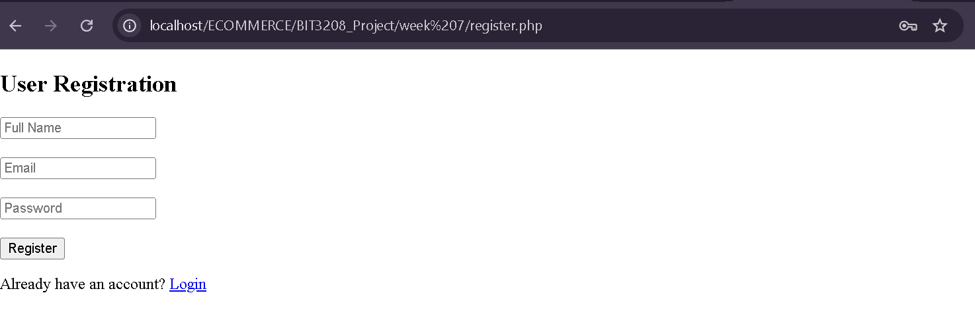
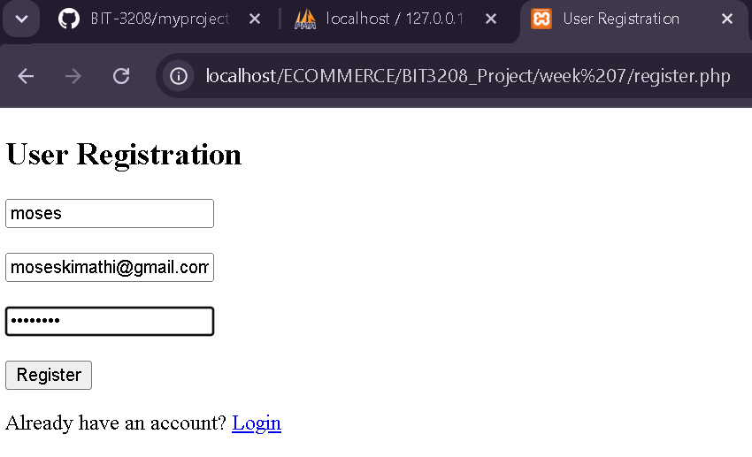
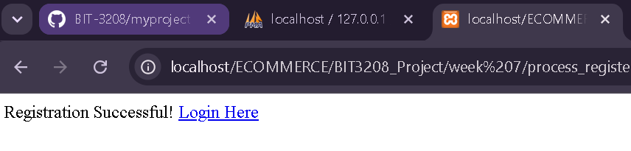
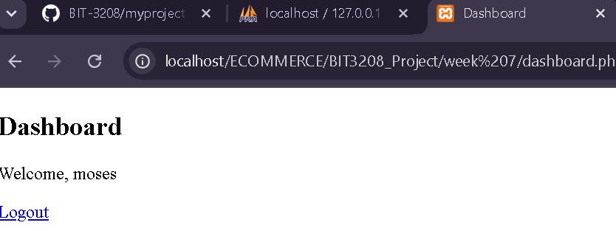

Fig 2: CSS media queries used in the design.
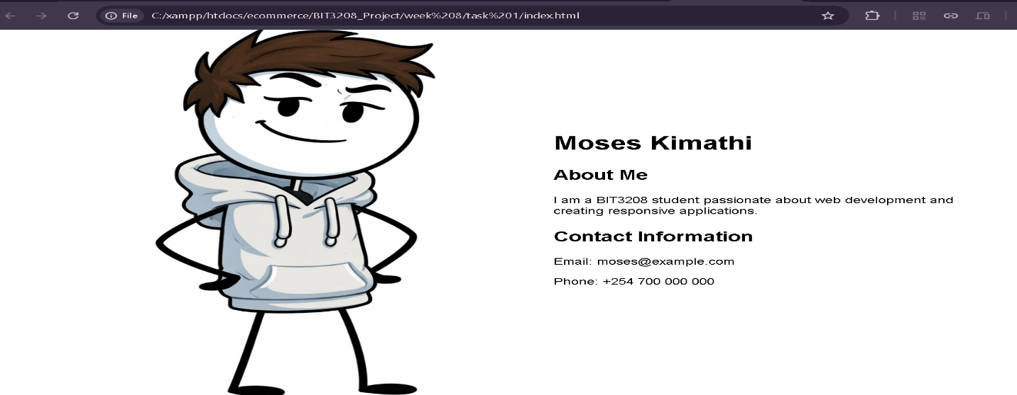
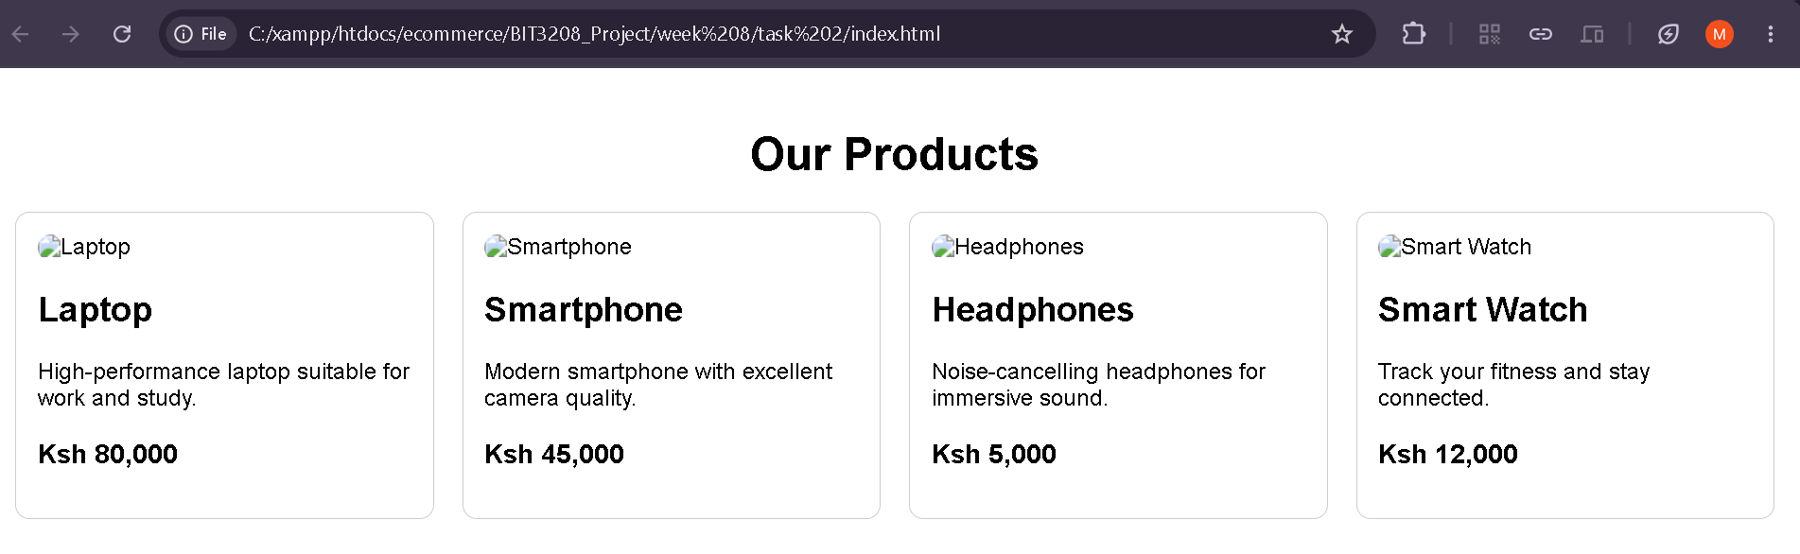
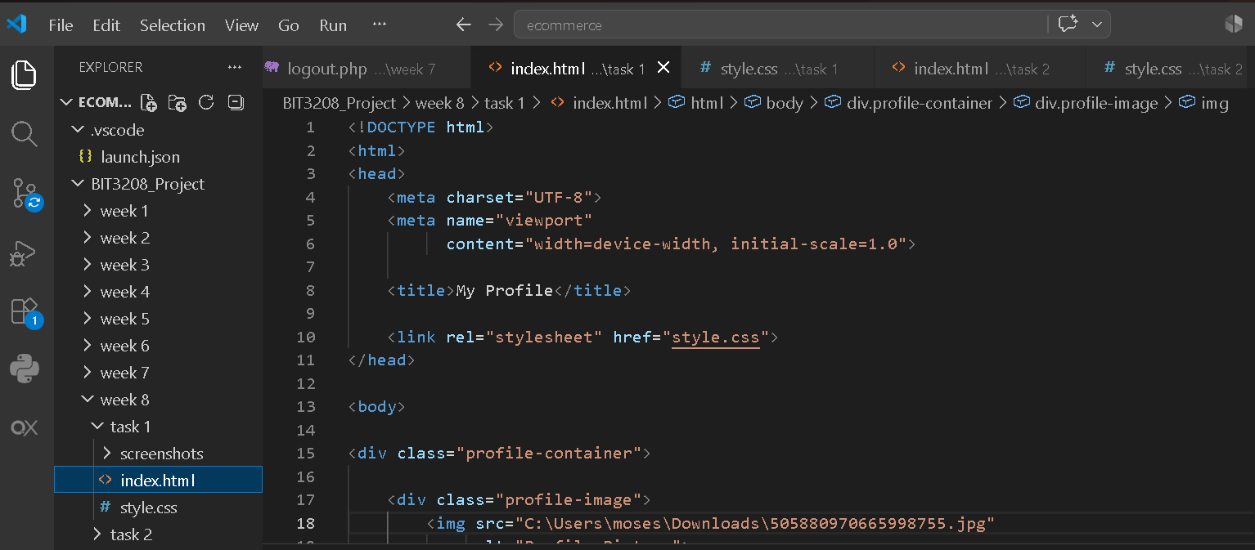

REFLECTION
In week 8 I focused on implementing responsive web design techniques to ensure websites function effectively across different devices. Media queries were used to adjust layouts based on screen size, while a mobile-first approach guided the design process. Testing the interface on desktop and mobile views demonstrated the importance of responsiveness in enhancing accessibility and user experience.

