
Business Studies Division
Department of ICTE

Final Year Project Report

Sunday, June 1, 2025
Bachelor of Computer Science

Institution Based Peer-to-peer Loaning App

Final Year Project
By
Samson Chisanga Chishala
Computer Number: 29004791
Supervised by: Dr Mwenge Mulenga

Declaration of Project Paper and Copyright
I, Samson Chisanga Chishala, hereby declare that the following project paper titled " Institution Based Peer-to-peer Loaning App " is my original work and has not been submitted elsewhere for any academic or professional purpose. All so
urces used in this paper have been properly cited and acknowledged in accordance with the required citation style.
I affirm that:
- The content presented in this project paper is the result of my independent research and analysis.
- All references, citations, and sources used in this paper have been appropriately credited.
- No part of this project paper infringes upon the intellectual property rights, copyrights, or proprietary information of any individual, entity, or publication.
- Any contributions made by others in the completion of this project paper have been duly acknowledged and credited.
I acknowledge and understand that the copyright of this project paper, including all original content, diagrams, illustrations, and written material, is owned by me, Samson Chisanga Chishala, from the date of its creation.
I understand that this declaration and the copyright ownership extend to the electronic version, print version, or any other form or medium in which this project paper may be reproduced or distributed.

Author’s Signed

Samson Chisanga Chishala
05/05/2025

Acknowledgement
I would like to express my deepest gratitude to everyone who contributed to the successful completion of this project.
First and foremost, I extend my sincere appreciation to my supervisor, Dr Mwenge Mulenga, for his invaluable guidance, constructive feedback, and unwavering support throughout the research and development of this project. Their expertise and insights played a crucial role in shaping the direction of this study.
I also wish to thank my colleagues and peers who provided helpful discussions, suggestions, and encouragement during the course of this work. Their insights and feedback contributed significantly to refining the concepts and implementation of the project.
A special thanks to my parents, whose love, support, and belief in me have been a constant source of motivation throughout my academic journey. I am forever grateful for their sacrifices and encouragement. I would also like to extend my gratitude to the rest of my family, as well as my friends, who have always been there for me, offering support and understanding during this project.
Finally, I acknowledge everyone that provided their input either by time, energy, resources, or tools. This project would not have been possible without the collective support and contributions of all those mentioned.

Abstract
Access to affordable credit remains a persistent challenge, particularly in underserved communities where banks and other traditional financial institutions may be inaccessible or inflexible. This project presents the design, development, and evaluation of an institution-based peer-to-peer (P2P) lending platform, to address lending and borrowing needs within closed institutional environments.
This project focuses on the development of mobile application designed to streamline borrowing and lending activities within institutional settings. The goal is to create an application to enhance financial inclusion by providing a secure, accessible, and community-trusted lending solution, minimizing risks associated with open-market P2P request without relying on traditional financial intermediaries.
The outcome is a functional prototype that promotes financial inclusion, trust, and transparency within trusted communities. This project also aims to lay the groundwork for a practical and scalable digital lending solution tailored to institutional ecosystems.

Table of Contents
CHAPTER ONE 7
1. Introduction 7
1.1. Background 7
1.2. Problem Statement 8
1.3. Aim and Objectives 8
1.4. Scope of Study 9
1.5. Hardware & Software Requirements 9
1.6. Significance of the study 10
1.7. Constraints and Critical Assumptions 10
1.8. Project Management 11
CHAPTER TWO 12
2. Literature Review 12
2.1. Introduction 12
2.2. Software Development Methodologies 12
2.3. Programing Languages 13
2.4. Frameworks 14
2.5. Database Management Systems 14
2.6. Categories of Lending Institutions 15
2.7. Existing Peer-to-Peer Lending Systems 16
CHAPTER THREE 19
3. Research Methodology 19
3.1. Introduction 19
3.2. Data Collection Methods 19
3.3. Data Analysis Methods 20
3.4. Software Development Methods 20
3.5. Summary 20
CHAPTER FOUR 21
4. Analysis 21
4.1. Introduction 21
4.2. User Requirements 21
4.3. System Requirements 21
4.4. Summary 22
CHAPTER FIVE 23
5. Design 23
5.1. Introduction 23
5.2. System Design 23
5.3. Database Design 25
5.4. Interface Design 26
5.5. Summary 29
CHAPTER SIX 30
6. Implementation and Testing 30
6.1. Introduction 30
6.2. Implementation 30
6.3. Testing 31
6.4. Summary 31
CHAPTER SEVEN 32
7. Conclusion 32
7.1. Introduction 32
7.2. Conclusion 32
7.3. Recommendation 33
7.4. Summary 33
References 34

CHAPTER ONE

Introduction

Background
The concept of credit is often not given explicit attention, yet, it plays a significant role in economic development, financial stability as well as promoting financial inclusion. Credit enables individuals to meet immediate needs pursue education, and start businesses. For businesses, especially Small-Medium Enterprises (SMEs), it is crucial for scaling operations, managing cash flow, and seizing market opportunities. Credit services, therefore, drive growth both at individual level and societal level.
Access to credit services is available through three main channels: traditional banks, formal financial institutions, and digital lending platforms. Banks and similar institutions provide structured loan services, but often impose strict eligibility criteria, such as proof of income and established credit histories, which can exclude large segments of the population. Financial institutions, including microfinance organizations, aim to bridge some of these gaps by offering more accessible loans; however, they may still require collateral, or high interest rates, which limit their reach. Digital lending platforms emerged to simplify access to credit through business-to-consumer (B2C) apps, where companies directly lend to users. While these B2C platforms streamline application processes, they still rely on centralized control, often maintaining high interest rates or fees to mitigate risk. Peer-to-peer (P2P) lending apps then emerged and enabled individuals to lend directly to each other, bypassing traditional intermediaries. Yet, P2P lending faces challenges with borrower trustworthiness, high default rates, and minimal regulatory oversight. Recognizing these gaps, this project proposes an institution-based P2P loaning platform as a solution to address these challenges. Unlike open-market P2P platforms, this model will operate within a specific institution, such as a university or workplace, leveraging institutional verification processes to build trust and reduce the risks associated with direct lending.
The proposed solution combines the flexibility and accessibility of P2P lending with the security and trust provided by an institutional framework. By confining lending activities within an institution, the platform seeks to mitigate the risks of open-market P2P lending, providing a viable credit alternative that is accessible and user-friendly while reducing the likelihood of defaults through verified, trust-based transactions.
This project is important because it addresses gaps left by traditional financial institutions and B2C lending models, offering a safer, more accessible lending solution that supports financial inclusion and community-based lending. The expected outcome is a functional prototype of a P2P lending app tailored for institutional use, providing users with a secure and convenient platform for accessing and offering short term loans.

Problem Statement
Financial institutions often exclude individuals without substantial credit history or collateral from accessing credit. This gap has driven the demand for alternative lending models, such as P2P lending, which offers more flexible lending terms and lower barriers to entry. However, P2P lending on the open market introduces risks, including higher default rates, lack of regulatory oversight, and difficulty in verifying borrower trustworthiness. This project aims to mitigate these risks by developing a P2P loaning platform within a specific institution, leveraging the institution’s internal verification processes to create a secure, accessible lending solution.

Aim and Objectives
To develop an institution-based peer-to-peer (P2P) loaning platform that provides a secure, accessible, and community-trusted lending solution, minimizing risks associated with open-market P2P lending by leveraging institutional verification and flexible loan management. The following is an outline of the objectives that will help attain the aim.
- Objective 1: Develop a user registration system based on institutional data to authenticate and verify borrowers and lenders, reducing fraud and fostering trust within the platform.
- Objective 2: Design an intuitive interface that allows users to set and manage loan terms, track repayment schedules, and view transaction histories for a seamless user experience.
- Objective 3: Implement a community trust feature where users can build credibility through ratings and feedback, encouraging responsible and trustworthy borrowing and lending behaviour.
- Objective 4: Develop a deposit and fund management feature that allows users to securely store money within the app for loan disbursements, repayments, and withdrawals, creating an integrated and streamlined financial experience.

Scope of Study
This project focused on developing a functional prototype of an institution-based P2P loaning platform tailored for use within an institutional framework, to facilitate transactions between institutional members, ensuring that borrowers and lenders can engage in financial activities within a trusted environment. The scope of the study includes:
- Design and Development: The design and development of a functional prototype of an Android-based mobile application.
- User Interaction: The platform carters to both borrowers and lenders, allowing them to manage loans and transactions seamlessly.
Institutional Framework: The project only supports institutional members, with data from a simulated institutional database, ensuring that verification and security protocols are based on institutional data.

Hardware & Software Requirements
To successfully develop the project, the following hardware and software requirements were necessary:
- Hardware:
  - A computer or laptop capable of running Android Studio (preferably with at least 8 GB of RAM and 256 GB storage).
  - Android device (smartphone) for testing the app.
- Software:
  - Android Studio for app development.
  - Visual Studio Code for the development of the API
  - MySQL Workbench installed to database development and management
  - Postman to test the API before integration into the application

Significance of the study
This project is significant for several reasons. For users, it provides accessible, short-term loans without traditional financial barriers. For institutions, it encourages financial wellness and offers a safe, internal lending alternative for members. For society, it helps bridge the gap between informal lending and formal financial systems by providing a regulated, transparent, and accessible solution within a trusted community.

Constraints and Critical Assumptions
In the development and expected deployment of the CreditCircle platform, several limitations and underlying assumptions must be acknowledged. These factors may affect the functionality, adoption, and scalability of the system, and are important to consider when evaluating the feasibility and success of the project.
The project is subject to a number of constraints that may influence both development and implementation outcomes:
- User Education and Awareness: The concept of peer-to-peer lending is relatively unfamiliar to many potential users, especially within local institutional settings, a key constraint will be the level of user understanding and digital literacy. Educating users on how the platform works, building trust in the system, and encouraging adoption may require extra resources and time during rollout.
- Institutional Adoption: A core feature of the platform is its reliance on institutional participation. The success of the system depends heavily on institutions' willingness to adopt the app, provide employee verification data, and allow integration with their internal systems. Without broad institutional engagement, the platform’s effectiveness in promoting trust and responsible borrowing within closed communities may be significantly reduced.
For the project to function as intended, certain assumptions have been made throughout the planning and design stages:
- Access to Mobile Devices and Internet: It is assumed that most users within institutions will have access to smartphones and stable internet connections, which are essential for using the application and accessing its services.
- User Willingness to Engage: The platform assumes that users will be willing to register, borrow, lend, rate others, and interact responsibly within their institutional communities, leveraging the trust environment created by shared affiliation.

Project Management
The project development underwent several stages, that followed a general structure depicted in the Gantt Chart below. It outlines stages that include requirement gathering and analysis, the system design, development of core features, testing and feedback collection, Implementation and evaluation, and documentation.
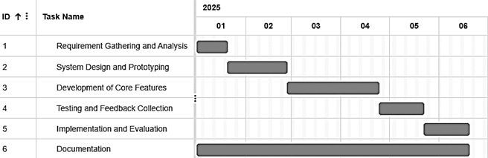

CHAPTER TWO

Literature Review

Introduction
Digital platforms are increasingly becoming the medium through which individuals gain access to multiple services, giving rise to financial technologies. As financial technology continues to evolve, the innovative development of peer-to-peer (P2P) lending platforms has transformed the traditional credit ecosystem by introducing more accessible, decentralized, and user-driven financial solutions. As this transformation continues to gain momentum, the design and implementation of such platforms demand a solid understanding of both technological and financial domains. This chapter presents a comprehensive review of software development methodologies, technologies and relevant literature relevant to the implementation of a P2P lending platform. It also explores the strengths and limitations of existing P2P platforms.

Software Development Methodologies
Software Development Methodologies are procedures that define the different phases of software development step-by-step. There are many methodologies in use in use, each with their own advantages and disadvantages, and each suitable for different software projects. The Waterfall model, for example, is a linear and sequential approach that consists of phases that need to be executed in a specific order. It is mostly used in situations project has well defined requirements and clear goals. However, it is rigid which is a significant drawback when changes or unforeseen circumstances arise. There is little customer involvement and a high risk since validation and testing occur at the end of the process. The Incremental Model on the other hand applies linear sequences as the waterfall model but in a repetitive manner. Each linear sequence produces a deliverable “increment” of the software and is commonly used in situations where there is a need to get the product to the market early or a new technology is being used. Risks are handled at each iteration and there is higher customer involvement. However, the total cost of this model is higher than the Waterfall model and a clear interpretation of the whole system is needed before it can be broken down. The Agile Model is highly a flexible approach that promotes a continuous feedback loop through iterative development cycles. It prioritizes customer collaboration throughout the development process, which allows for regular feedback and adaptability to changes. However, Agile's customer-centric approach may hinder the progress of software quality engineering efforts if customers are not readily available. It may also lack comprehensive documentation as it places less emphasis on exhaustive documentation.

Programing Languages
Programming languages considered for a P2P lending platform cover multiple aspects of development such as frontend and backend development, security, and management of financial transactions. For frontend and mobile app development, JavaScript, Dart, and Kotlin are prominent options. JavaScript is a cross-platform language commonly used for developing web and mobile applications. Its extensive community support and adaptability make it a strong candidate, though its performance is dependent on application complexity. Dart is another cross-platform language developed by Google. It uses a single codebase, making it efficient for developing applications for both Android and iOS. Its widget-based approach and strong community support are notable advantages. However, its larger app size and limited support for platform-specific features are potential drawbacks. Kotlin, the official language for Android, offers a concise syntax, strong performance, and seamless integration with Android-specific features. However, its limitation to Android requires separate development efforts for iOS platforms.
For backend development, PHP, Python and Java are the most prominent. PHP is a server-side programming language, primarily known for web development. It integrates well with databases like MySQL, making it suitable for applications requiring dynamic content generation and data manipulation. However, PHP can struggle with performance in high-concurrency applications and has historically faced security concerns. Python is a programming language known for its readability and rapid prototyping. Its rich libraries and frameworks enhance security and scalability, though it may lag behind compiled programming languages in execution speed. Java is another widely used language and is known for its robustness, scalability, and suitability for enterprise-grade applications. Its mature ecosystem and extensive libraries simplify complex backend logic. It its verbose syntax, however, can be challenging for beginners.

Frameworks
Frameworks are pre-built collections of tools, libraries, and conventions designed to help developers build software applications more efficiently. Spring Boot, for example, is a Java-based framework, particularly advantageous for enterprise-grade applications, offering built-in security, scalability, and flexibility. Its downside is its steep learning curve, especially for developers new to enterprise frameworks. Django, a Python framework, excels in security and rapid development, offering features such as an admin panel and Object-Relational Mapping (ORM). However, it is less suited for lightweight or real-time applications. Node.js, often paired with Express.js, provides a lightweight and efficient framework for creating APIs and handling real-time features. Its minimalist design offers flexibility but requires additional effort to establish structure in complex projects.

Database Management Systems
There are several database management systems on the market such as Oracle, MySQL, MSSQL, PostgreSQL, and Firebase. Each of them has its own strength and weaknesses. For instance, Oracle is a powerful, enterprise-grade relational database management system known for its scalability and robustness, making it ideal for large-scale applications that require high availability and complex data management. However, it is proprietary and can be expensive to use. MySQL, on the other hand, is an open-source relational database that offers fast performance and ease of use, making it a cost-effective solution for web development and moderate-scale applications. On the other hand, its scalability is limited compared to more advanced databases like PostgreSQL, and it may not handle very complex queries as efficiently. PostgreSQL is also an open-source, database and is known for its high performance, scalability, and support for advanced features like full-text search. It is ideal for applications that require complex data relationships and reliability, but it can be more difficult to set up and may be considered excessive for simpler projects. Firebase Realtime Database is a NoSQL cloud-based database that excels in real-time data synchronization, making it a great choice for applications that require live updates, such as messaging apps. It offers a serverless backend and seamless integration with mobile and web platforms, but it lacks the complex querying capabilities of relational databases and can become costly as the application scales.

Categories of Lending Institutions
Over the years, various channels were developed to provide access to credit services, each catering different members of society. Banks and formal financial institutions have been the primary sources of credit. However, the rise of digital technology led to the emergence of digital lending platforms, including Business to Consumer lending platforms and Peer-to-Peer lending platforms.
Traditional banks impose strict criteria that exclude many borrowers, especially in underserved populations. These high standards often leave individuals in emerging economies without sufficient credit options​. For example, some of the minimum requirements for eligibility to take a loan with a bank at are: one has to be a salaried employee, a letter of confirmation from the employer, and a recent salary payslip to serve as a proof of payment [1] [2]. Financial institutions, on the other hand, will usually request for an item (collateral) that is valued at either the price of the loan to be gotten or higher to serve as surety until the loan repayment is completed.
Digital loan platforms arose to meet demand by simplifying the loan process. Digital lending is quick in nature and loans are approved in shorter periods of time by using technology and alternative credit scores at affordable rate of interest [3]. B2C platforms aimed to streamline the lending process as compared to financial institutions by leveraging mobile technology and internet access to make loans more accessible to users who may not meet the criteria of traditional financial institutions. Users can apply for loans directly through apps or websites, often receiving approval and funds within a matter of hours.
Consequently, the need for even more flexible, user-centred lending solutions has led to the rise of peer-to-peer (P2P) lending platforms, where individuals lend directly to one another, bypassing traditional financial intermediaries. P2P lending provides online users with an innovative loaning and investment platform without the intermediation of financial institutions. Because it is collateral-free, P2P lending can bring in large unbanked and uncredited population to the formal financial system and hence aids in rapid financial inclusion. [4]
One of the benefits of a P2P lending model is that borrowers and lenders can easily post and search for information and complete transactions on online platforms with lower transaction costs. [5] Another notable advantage of such a platform is that low transaction costs make very small loans feasible. Like other digital lending platforms, P2P lending platforms also allow people to access loans without formal documentation, information, or qualification. Because these services are offered online, the overheads, processing, maintenance, and operating costs are lower compared to other traditional forms of lending [6]. Thus, these platforms can offer credit at attractive interest rates and more quickly [4].
However, in online P2P lending settings, it is difficult for lenders to obtain comprehensive information about borrowers, resulting in a severe hazard of information asymmetry [5]. It was discovered that lenders consider the borrower's reputation as the primary signal in P2P lending transaction decisions [6]. The main determinant factors that influence the lender’s willingness and intention to loan are (1) detailed information about the borrower and their project and (2) trust and willingness toward the borrower which is the most important factor that influences the lender in lending [7]. Additionally, research shows that the success rate of a loan is negatively correlated with the interest rate. In practice, borrowers have to trade-off between these two factors.
Social networks within P2P platforms serve as signalling mechanisms, which help lenders assess the trustworthiness of borrowers. Social connections provide critical information about borrowers' reputations and credibility, which reduces information asymmetry and helps to mitigate the risk of loan defaults. [5] In an institution-based P2P lending model, members would share a level of trust through their affiliation, similar to social networks in a study by Lin et al., which would signal trustworthiness. This setup could reduce default risks by allowing users to rely on institutional affiliation as a marker of reliability. Unlike open-market P2P platforms, an institution-based system can use internal verification (e.g., HR records) to reduce information asymmetry and uncertainties for lenders. Additionally, the community-based environment within the institution would foster accountability, as members would be more likely to repay loans to maintain their reputation. Internal trust-building mechanisms, like institution-specific ratings, would further strengthen borrower credibility, making an institution-based platform a safer and more attractive option for lenders compared to open-market P2P systems.

Existing Peer-to-Peer Lending Systems
Many P2P lending platforms have been developed and implemented in different parts of the world and a review of some of them from the internet and from the Google play store revealed the benefits, as well as some of the challenges that some of the users faced with using these platforms such as processing of information, loan disbursements, and loan defaults.
P2Vest, for example, operates as a leading P2P lending platform in Nigeria, focusing on financial inclusion for underserved markets. It offers quick access to loans for individuals and businesses, with a streamlined digital process ensuring rapid approvals. Borrowers benefit from a range of loan products catering to both personal and business needs. However, P2Vest is criticized for high-interest rates and rigid repayment terms, particularly for first-time borrowers. Additionally, users have reported issues with customer support and app reliability, affecting the overall experience​.
LenDenClub, based in India, specializes in personal and microloans, using credit risk assessment models to cater to borrowers in underserved regions. The platform provides small-ticket loans and higher returns for lenders compared to traditional options. Despite its advantages, LenDenClub faces challenges such as high default rates due to limited borrower verification. Users have also reported delays during the application and verification process, and the platform lacks a comprehensive borrower rating system to build lender trust​.
Prosper is one of the oldest P2P platforms in the United States and one of the few that still continues to connect borrowers directly with individual lenders. It provides competitive interest rates based on credit scores, making it an attractive option for those with strong financial histories. Prosper also enables lenders to diversify their portfolios by investing in fractional loans. However, borrowers with lower credit ratings face higher interest rates, limiting affordability. Users have noted hidden fees and delays in disbursement, reducing the platform's appeal​.
PeerBerry, a Europe-based platform, focuses on short-term consumer loans and offers buyback guarantees to protect lenders from defaults. Its user-friendly interface and quick loan processing make it ideal for borrowers with urgent needs. PeerBerry also allows lenders to diversify their investments across multiple loans and originators. Nevertheless, the platform primarily serves consumer loans, with limited options for business financing. Additionally, lenders cannot directly negotiate loan terms, and users have expressed dissatisfaction with the tools for portfolio tracking and accessing detailed loan data​.
The literature highlights a shift from traditional lending models to more accessible digital and peer-to-peer platforms, driven by the need for financial inclusion and user-centered solutions. While these platforms have improved access to credit, they often lack mechanisms for trust and accountability, especially in open, anonymous environments. Studies emphasize the value of community ties and institutional frameworks in promoting responsible borrowing and lending. This reinforces the relevance of an approach of offering an institution-based P2P lending platform that leverages social familiarity and trust within closed communities to create a more secure and reliable credit system.

CHAPTER THREE

Research Methodology

Introduction
The research methodology adopted for this project is a combination of quantitative and qualitative data collection methods, used to gain a comprehensive understanding of user needs, system integration considerations, and operational feasibility. Additionally, the Agile software development practices were employed to ensure a user-centered and iterative approach for successful implementation.

Data Collection Methods
    - Qualitative methods
Qualitative data was gathered primarily through interviews, that were used to collect in-depth information about experiences with borrowing or lending money. Additionally, they provided insights on the implications of integrating the system into existing institutional frameworks. These semi structured interviews were with various groups:
- Target end-users (institution staff and employees): to to explore their real-life experiences with borrowing and lending, and gather expectations, needs, and concerns regarding the adoption of a peer-to-peer digital lending platform
- A legal expert: insights were gained on the implications of integrating the system within institutional policies and legal frameworks.
- IT personnel: Technical compatibility, security requirements, and data management policies related to system adoption.
- Administrative staff: To understand the feasibility of deploying and managing the platform within the institution’s operational workflow.

    - Quantitative methods
Quantitative data was collected using structured questionnaires distributed to a broader group of to gain insights on borrowing and lending behavior, usage of digital lending tools, trust factors, and willingness to use an institution-based P2P lending platform. The use of closed-ended questions enabled the collection of measurable data points that informed the design and prioritization of platform features.

Data Analysis Methods
The collected data was analyzed using methods appropriate to the type of data gathered:
- Qualitative Data Analysis: Interview responses from prospective users, legal experts, IT personnel, and administrative staff were transcribed and analyzed to identify key patterns, recurring concerns, and insights related to borrowing and lending experiences, as well as the institutional integration of the proposed system.
- Quantitative Data Analysis: Responses from the structured questionnaires were statistically analyzed to uncover trends in user behavior, identify common challenges in accessing credit, and assess levels of interest and trust in a closed-community lending platform. Descriptive statistics such as frequencies and percentages were used to summarize responses.

Software Development Methods
The Agile methodology was adopted to guide software development due to its iterative and feedback-driven nature. Agile's iterative nature promotes regular feedback loops, ensuring that the evolving needs of the application are continually addressed throughout the development lifecycle. The development the development process was broken down into manageable phases, each focusing on a specific core feature. This allowed the system to evolve with growing insight from both technical evaluations and user experience feedback

Summary
The integration of qualitative and quantitative research methods provided a comprehensive understanding of institutional lending behaviors, user expectations, and system feasibility. Interviews offered rich insights from stakeholders, while surveys yielded measurable data to guide feature prioritization. The adoption of Agile methodology ensured adaptability, continuous feedback incorporation, and user-centered development, resulting in a platform that is both functional and aligned with the evolving needs of its intended users.

CHAPTER FOUR

Analysis

Introduction
This chapter presents a comprehensive analysis of the proposed institution-based peer-to-peer (P2P) lending platform. It examines the data collected, which provided insights into user needs, institutional constraints, and the limitations of existing informal or traditional lending systems.
The analysis from stakeholder responses identified common pain points, such as lack of trust, inefficient loan tracking, and poor accountability. User requirements, as well as the functional and non-functional expectations of the system, were then defined based on the analysis.

User Requirements
The target end-users of the system expressed a need for more accessible and trustworthy means of borrowing and lending money. User feedback collected through interviews and questionnaires highlighted the following key requirements:
- A secure and easy-to-use platform for initiating loan requests or offers within the institution.
- Verified user identities to reduce the risk of fraud or default.
- A trust and rating system to guide lending decisions based on past behavior.
- Access to transaction history and loan records.
- The ability to report issues or disputes during loan transactions.

System Requirements
    - Functional Requirements
- User Registration and Authentication: Allow users to create accounts using institutional credentials and verify their identity.
- Loan Creation and Management: Enable borrowers to request loans with specific terms and lenders to browse and accept requests.
- Rating and Review System: Let users rate each other after transactions to build a reputation system.
- Wallet and Fund Management: Support deposits, withdrawals, disbursements, and repayments within the application.
    - Non-Functional Requirements
- Security: Role-based access control, and secure authentication to protect sensitive information.
- Usability: The system should offer an intuitive user interface, minimizing the learning curve for new users.
- Performance: The system should load quickly and respond within 2 seconds for most user actions under normal conditions.
- Availability: The platform should maintain a minimum uptime of 99% during business hours.

Summary
The analysis of existing borrowing and lending practices identified common pain points such as such as lack of trust, inefficient loan tracking, and poor accountability. The analysis further revealed that current borrowing and lending practices are often informal, inefficient, and unregulated, emphasizing the need for a secure, accessible, and structured digital platform. Through a combination of stakeholder consultations, user feedback, and technical evaluation, both functional and non-functional requirements were defined to guide the system's design and development.

CHAPTER FIVE

Design

Introduction
This chapter outlines the system design decisions that guided the development of the application, discussing the technologies used and illustrating the architecture, interface, system modelling, and database design.

System Design
Technology Selection
The chosen technology stack used for developing the app comprised different languages to achieve the different components of the application. For the frontend, Kotlin was chosen as the primary programming language due to its conciseness, and seamless compatibility with Android Studio for mobile app development.
On the backend, the Spring Boot framework in Java was used as it offered a powerful and flexible platform for building RESTful APIs, handling authentication, business logic, and managing service-to-service communication. MySQL was used as the relational database system, for designing and managing the database schema. This combination of technologies was chosen as it allowed for a structured development approach, supporting modular architecture, secure data handling, and smooth integration between the client and server components of the application.
Architecture
The app development followed a layered architecture, where the client (Android app) interacts with the server (Spring Boot server), using RESTful APIs to send and receive requests, and get the required response from the database. This architecture allowed for a modular software design approachand best practices. For example, on the Android frontend, the Model-View-ViewModel (MVVM) architecture was implemented to promote a clean separation of tasks by isolating UI logic from business logic, thus improving maintainability, and supporting dynamic user interfaces. For a seamless communication between the frontend and backend, the system uses a RESTful API design which manages interactions using HTTP methods. To maintain data integrity and optimize performance, Data Transfer Objects (DTOs) are employed to encapsulate and structure the exchange of data between client and server. Additionally, security measures such as JWT-based authentication and role-based access control are integrated to safeguard user data and restrict unauthorized access. Collectively, these design strategies contribute to a scalable, maintainable, and user-friendly mobile application aligned with modern software engineering principles.
High Level Architecture
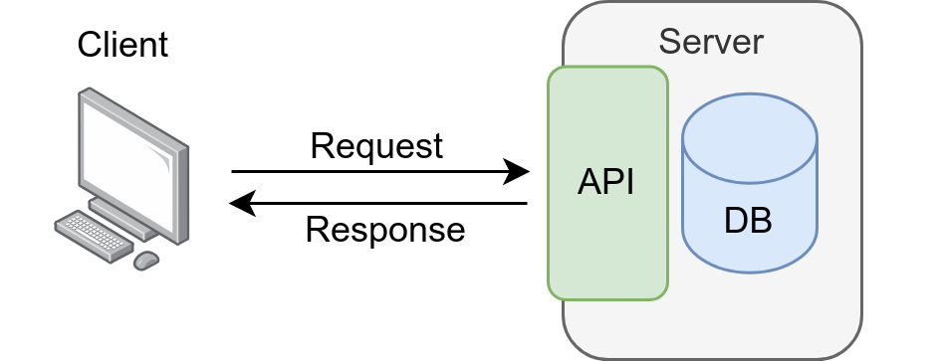
Key Modules
The application is composed of several key modules, each serving a distinct function within the institution-based peer-to-peer lending system.
- User Authentication and Role Management module: handles user registration, login, and secure access control using JWT-based authentication, ensuring that users interact with the system based on their assigned roles (borrower or lender).
- Loan Management module: enables users to request, track, approve, and repay loans, incorporating logic to manage loan statuses such as pending, approved, disbursed, and repaid.
- Wallet and Fund Management module: supports financial transactions like deposits, repayments, and disbursements, maintaining balance records and transaction histories.
- Rating and Trust module: allows users to rate and review their transaction partners, helping build a trust system that promotes responsible borrowing and lending behavior.

Use Case Diagrams
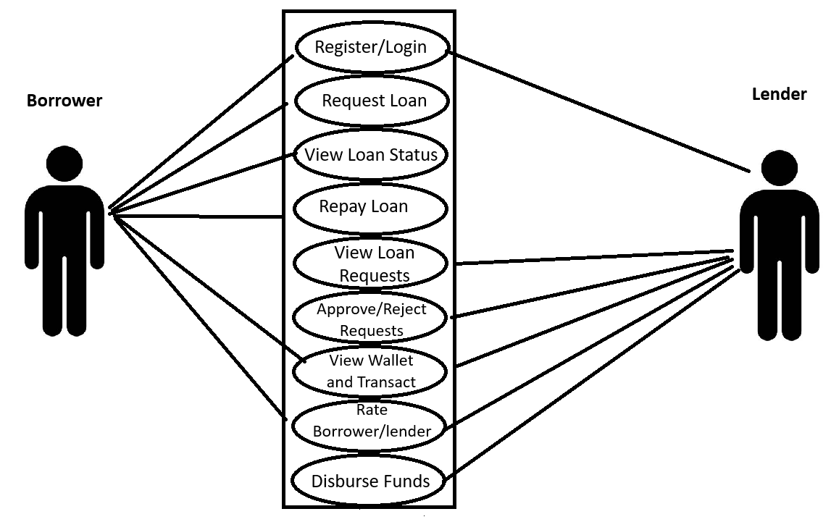

Database Design
The database was structured to support core functionalities such as user management, loan processing, wallet transactions, and ratings. The design adopts a relational approach, mapping key entities and following a normalized structure to minimize redundancy and support clear relationships between tables.

Database Tables
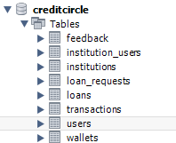
Entity Relationship Diagram
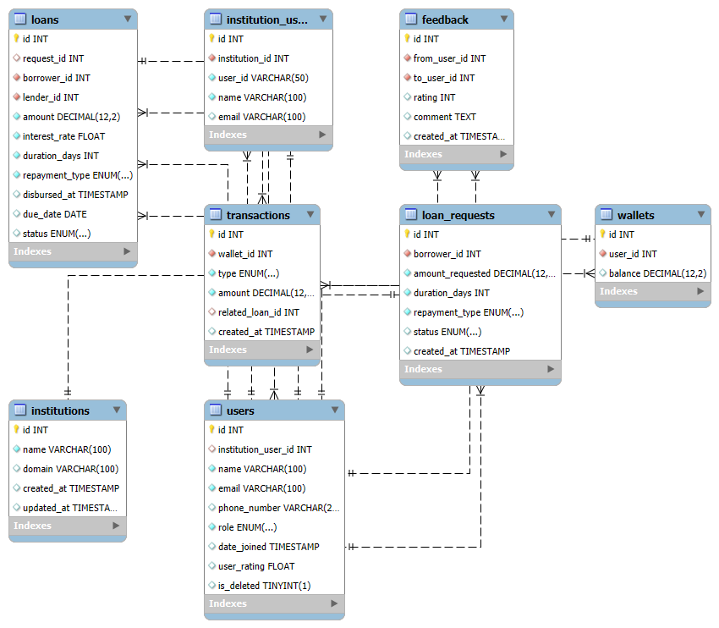

Interface Design
The interface design of the application prioritizes user-friendliness, clarity, and responsiveness. Core user flows such as login, registration, loan requests, and wallet management are clearly structured with intuitive layouts, meaningful icons, and actionable prompts. Each user role (borrower or lender) is presented with a role-specific interface.
App Screens
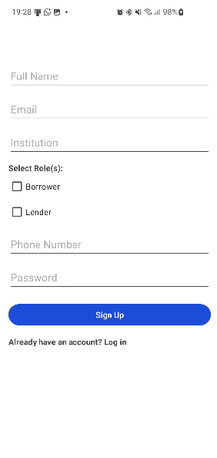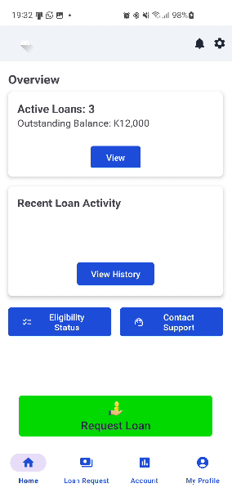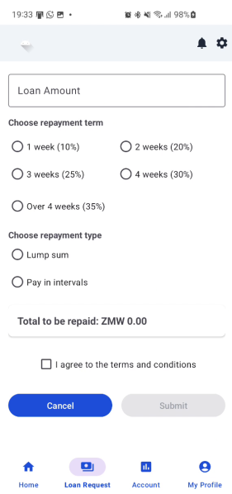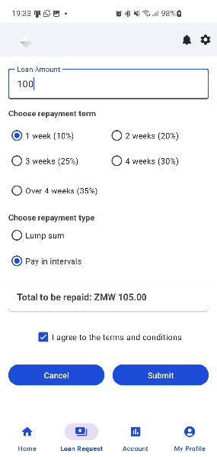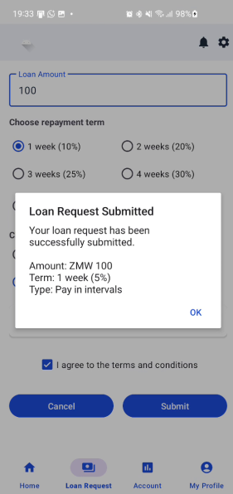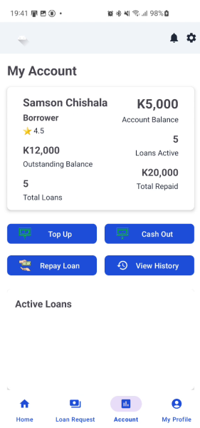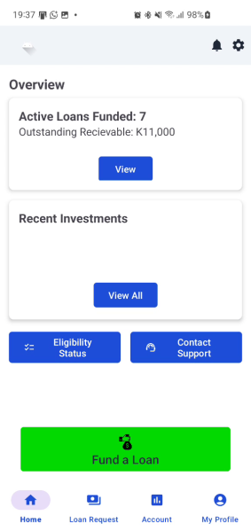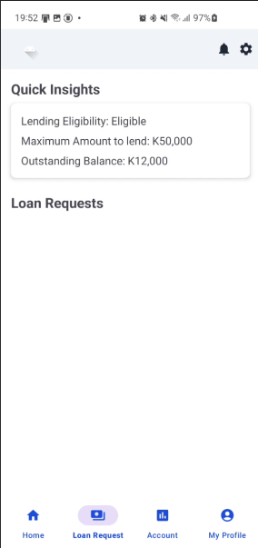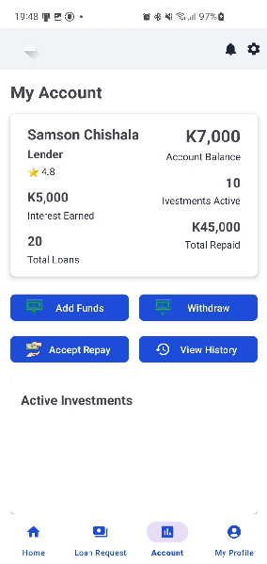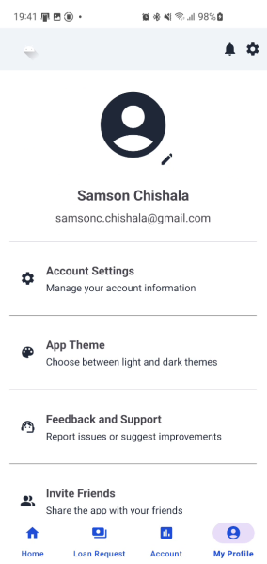

Summary
The design phase laid the foundation for the application, outlining the architecture, the. Through the application of the MVVM architecture on the Android frontend, RESTful API design with Java Spring Boot, and the use of DTOs for clean communication between components, the system achieves a high degree of modularity, flexibility, and maintainability. The database design using MySQL ensured data normalization, integrity, and support for secure transactional operations essential to loan processing and fund management. Additionally, the interface design emphasized accessibility, clarity, and usability, creating a seamless experience for both borrowers and lenders. Together, these design decisions ensured that the platform is technically sound, operationally efficient, and aligned with user expectations.

CHAPTER SIX

Implementation and Testing

Introduction
This chapter outlines how the various components of the developed platform were implemented and tested. It highlights the tools and technologies used, describes the implementation steps for key modules and explains the testing strategies employed to ensure system functionality, reliability, and performance.

Implementation
Development Tools and Environment
The development environment for the platform comprised Android Studio IDE for the Android application, Visual Studio Code IDE for the API development and MySQL Workbench for the database. Kotlin was used as the primary programming language, while the Java Spring Boot framework was utilized for the backend.
Implementation of Key Modules
- User Registration & Verification Module: Users register via a custom form, providing a verified email or phone number. Role assignment (e.g., borrower or lender) is handled server-side and securely stored in the database. JWT-based authentication was implemented to maintain secure access and session management.
- Loan Management Module: This module manages the full loan lifecycle—from application to repayment. Users can request loans, view their application status, and track repayments. Data is managed through structured database tables, and access control ensures that only authorized users can perform sensitive actions.
- Trust and Rating System: After loan completion, lenders can rate borrowers using a 1–5 star system with optional comments. These ratings are stored in a dedicated table and influence the borrower’s future credibility within the platform.
- Fund Management Module: Wallet functionality was implemented to support deposits, disbursements, repayments, and internal transfers. Each financial operation is logged in a transactions table to ensure accountability and traceability. Security controls ensure that users can only access and manage their own financial data.

Testing
Testing was conducted continuously throughout the development process to ensure that each feature met its requirements and performed as expected.
- Unit Testing: Key logic components such as input validation, balance updates, and loan calculations were tested.
- Integration Testing: Focused on the integration of the different modules and the interaction between the mobile application and backend APIs.
- System Testing: The complete application was tested across multiple Android devices and emulators. This stage ensured full functional coverage, stability, and responsiveness under different scenarios and user roles.
- User Acceptance Testing (UAT): A pilot test group evaluated the application’s usability, relevance, and ease of navigation. Their feedback led to several UI and workflow enhancements, helping align the platform more closely with user expectations.

Summary
The implementation of the proposed institution-based peer-to-peer lending system involved developing key modules to transform the design a functional mobile application. Various testing methods were employed throughout the development process to validate system performance, security, and usability thereby ensuring the platform aligned with user needs. The user feedback that was obtained was particularly valuable in guiding improvements.

CHAPTER SEVEN

Conclusion

Introduction
The development of the institution based mobile application represented a focused effort to improve access to credit services. By restricting the system to work within a closed community, promotes trust and authenticity among users. This closed network helps reduce risks and encourages borrowing and lending practices, creating a secure and reliable peer-to-peer lending ecosystem. This concluding chapter reflects on these achievements, discusses the challenges encountered during the project’s development and deployment, and offers recommendations for future enhancements to further strengthen the system’s functionality and impact.

Conclusion
Achievements
The project has successfully delivered a mobile-based platform that supports peer-to-peer lending within institutional frameworks. The system enables users to register, request and manage loans, rate transactions, and securely handle funds — all through a user-friendly and scalable interface. The project's strengths lie in its modular system architecture, use of secure authentication via JWT, and the continuous feedback-driven development approach, which contributed to a functional, accessible, and institution-specific lending solution.
However, like any first release, certain challenges arose that impacted specific aspects of performance and integration. These include managing device compatibility, refining role-based access controls, and ensuring consistent UX across different screens. While these issues were addressed through iterative testing and improvement, they provide valuable insights for future optimization.
Difficulties
Throughout development, key challenges were encountered around backend integration, especially during the shift from Firebase to MySQL and JWT-based authentication. This required redesigning data models and handling token-based access controls with greater precision. Additionally, coordinating real-time updates without Firebase's built-in syncing capabilities added complexity. These hurdles occasionally affected development speed and required added testing and debugging efforts.

Recommendation
- Role Management Improvements: Introduce more control over roles and permissions to support institutional hierarchies or hybrid borrower-lender roles.
- Data Visualization & Analytics: Incorporate dashboards to display loan trends, repayment rates, and user performance to improve financial literacy and transparency.
- Push Notifications & Messaging: Implement an in-app or push notification system to alert users of repayment deadlines, approval status, or system updates.
- Offline Support: Provide basic offline capabilities (e.g., saving loan requests locally) to increase reliability in areas with unstable internet access.
- Institution Integration: Develop APIs or integration modules that allow institutions to plug into the CreditCircle system for deeper collaboration and record-keeping.
This project marks a meaningful step toward enhancing financial inclusion and responsible lending practices within institutions. While CreditCircle fulfills its foundational objectives, it also opens opportunities for future innovation in the digital lending space. The framework built here offers flexibility for expansion, adaptation, and continual evolution based on user and institutional needs.

Summary
The journey from conceptualization to implementation of the CreditCircle application demonstrates a committed effort to bridge gaps in institutional lending through technology. The project's achievements reflect a well-structured and thoughtfully tested solution, with challenges providing valuable lessons for ongoing improvement. Ultimately, the system lays a strong foundation for expanding access to credit, improving trust within institutional ecosystems, and leveraging technology for financial empowerment

References

[1] | Standard Charterd Bank, "Personal Loan," [Online]. Available: https://www.sc.com/zm/borrow/personal/. [Accessed 02 November 2024].
[2] | FNB Zambia, "Personal Loan," [Online]. Available: https://www.fnbzambia.co.zm/promotions/PersonalLoans/index.html. [Accessed 02 November 2024].
[3] | T. Ravikumar , "Digital Lending: Is It Alternative Lending," International Journal of Scientific & Technology Research, vol. 8, no. 10, pp. 599-601, 2019.
[4] | V. K. Manda and S. Yamijala, "PEER-TO-PEER LENDING USING BLOCKCHAIN," International Journal of Advance and Innovative Research , vol. 6, no. 1, pp. 61-66, 2019.
[5] | M. Lin, N. R. Prabhala and S. Viswanathan, "Social Networks as Signaling Mechanisms: Evidence from Online Peer-to-Peer Lending," [Online]. Available: https://pages.stern.nyu.edu/~bakos/wise/papers/wise2009-p09_paper.pdf. [Accessed 03 November 2024].
[6] | R. R. Suryono, I. Budi and B. Purwandari, "Detection of fintech P2P lending issues in Indonesia," April 2021. [Online]. Available: https://www.cell.com/heliyon/fulltext/S2405-8440(21)00885-9. [Accessed 1 November 2024].
[7] | D. W. Sukmaningsih, "A Model for Lender-Borrower Trust in Peer-To-Peer Lending," ComTech: Computer, Mathematics and Engineering Applications, vol. 9, no. 1, pp. 15-24, 2018.

