Part 1 - Use Case #1 - Tiger Center

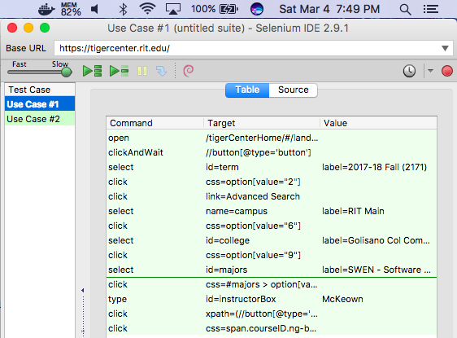

Part 1 - Use Case #2 - SIS

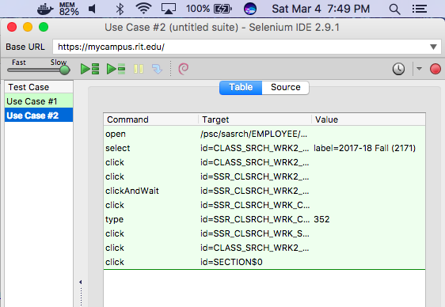

Part 2 - Tiger Center - 4 Classes

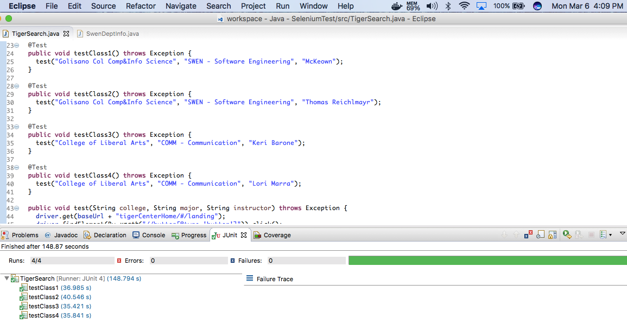

Part 3 - SWEN Dept Info

