1.h)

* Does this estimator look unbaised?

Yes it does the mean of the 10000 estimators is very close to the equal mean.

* What is the variance?

In our example the variance is 0.04837741

* What distribution does the estimator follow?

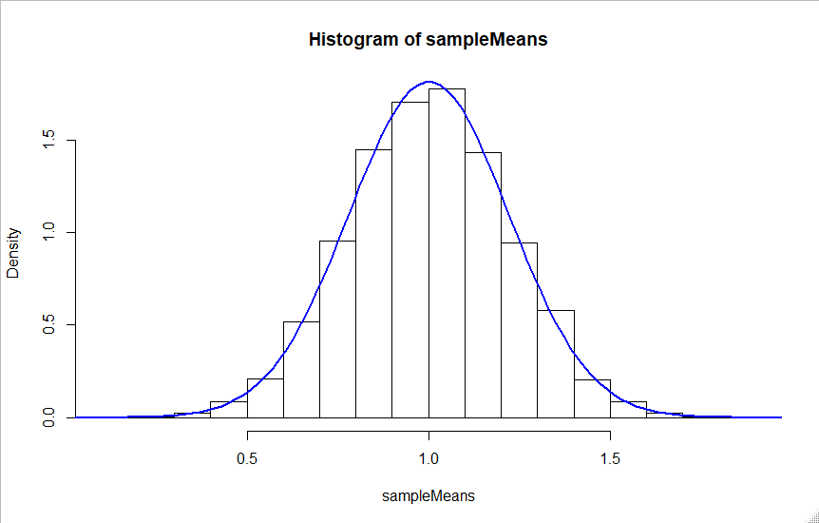

Image 1

The estimator has a normal distribution. In the histogram in image 1 there’s a normal distribution plotted with the variance and mean of the estimator. From the image can be seen that the estimator follows a normal distribution.

* Comparing the results to exercise 1.e

Expected value:

The expected value of the estimator is almost the same as estimated in question 1.e.1. The difference is the result in not an infinite amount of estimations.

Variance:

The variance should be 1/20 = 0.05 and this is also almost met. The found variance is 0.04837741

* Comparing the results to exercise 1.h

If we look at Image 1 we can see that the estimator has a normal distribution with mean = mu and variance sigmasq/n. This is also what we calculated in 1.h.1. In question 1.h.2 we used the CLT to calculate the asymptotic distribution. That this is true can also be concluded from this simulation.

1.i)

N = 100:

Mean: 1.000792

Variance: 0.009927161

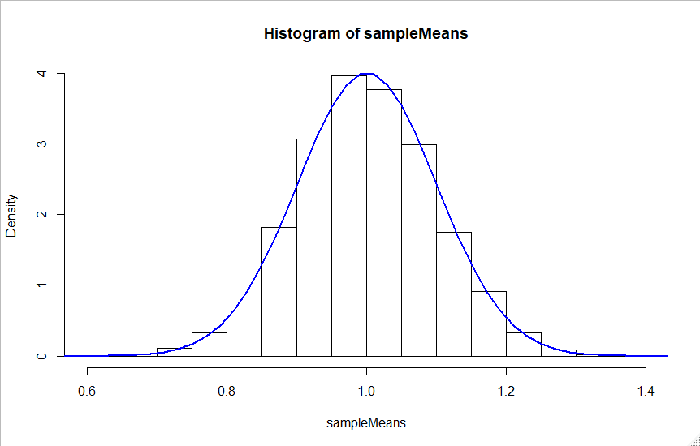

Pivot quantity:

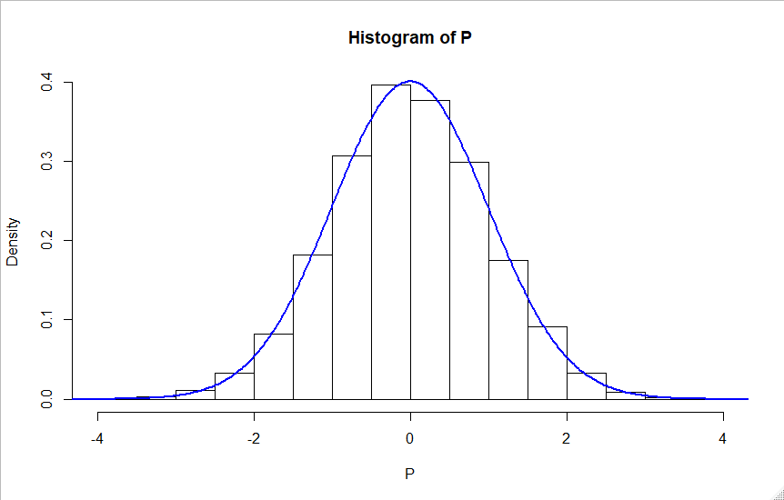

N = 1000:

Mean: 1.000792

Variance: 0.0009932432

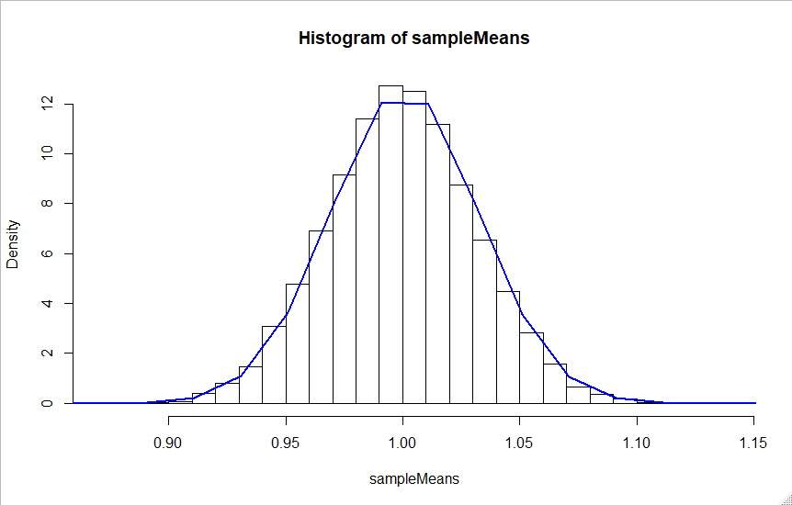

Pivot quantity:

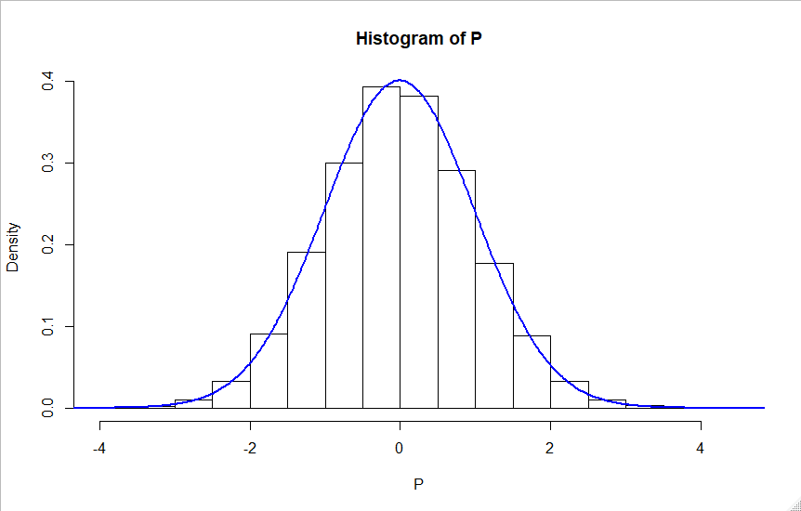

N = 10000:

Mean: 1.000792

Variance: 9.986911e-05

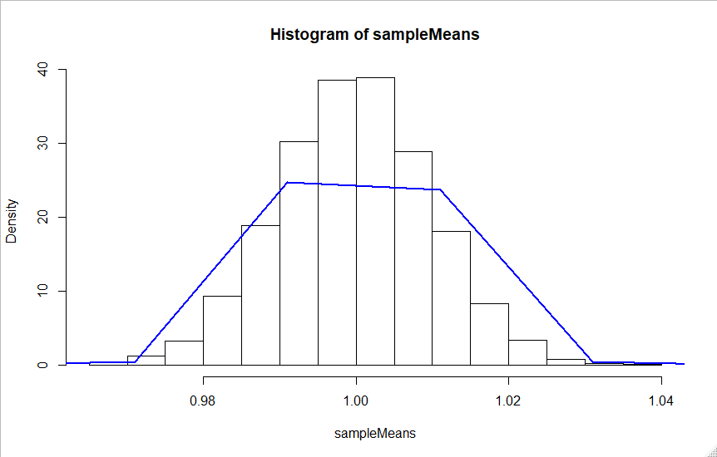

Pivot quantity:

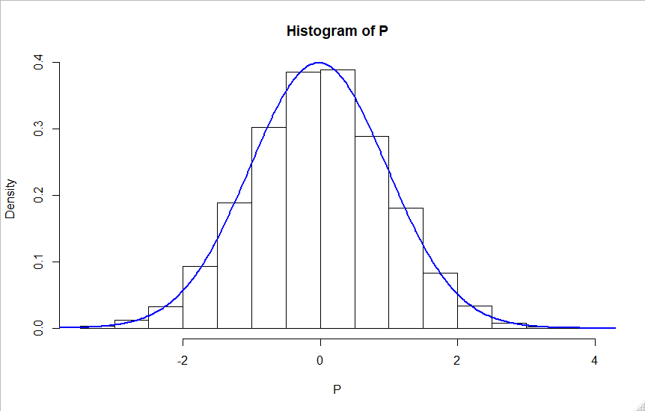

* Is the estimator consistent?

Yes the estimator is consistent. The mean is for all the simulations the same.

* Difference of the estimators distributions.

If we compare the different histograms we can see that all the estimators follow a normal distribution with the same mean. The difference when N gets bigger is the density around the mean. This is also expected if we look at question 1.f.2 the variance gets a lot smaller.

* Distributions pivot quantity for different N:

As expected the distribution of the pivot quantity doesn’t chance for a bigger N. There is only a very small chance in how “clean” the normal distribution is.

2.g)

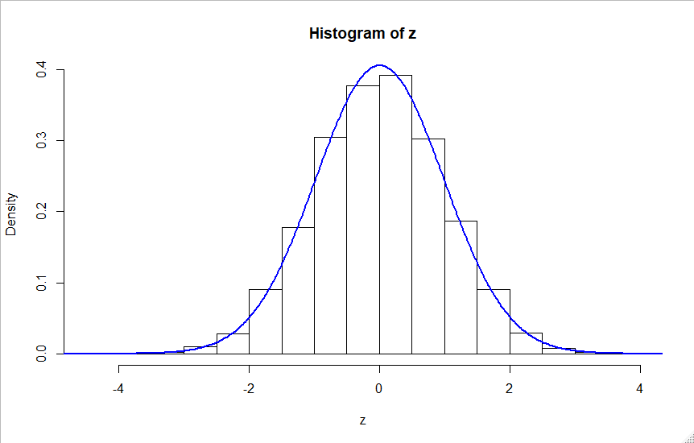

As seen from the given image the distribution of z is from the form standard normal. This was also the result from question 2.c

2.h)

Results:

The estimated value of the sample set is: 0.005420443

The variance of the sample set is: 0.9675482

For alpha = 0.01 we reject H0 is mu < -2.282869

For alpha = 0.05 we reject H0 is mu < -1.612524

For alpha = 0.10 we reject H0 is mu < -1.255165

Because we already discussed that z follows a normal distribution the rejection values are calculated using a normal distribution with the calculated mean and variance. The rejection regions is in the same direction as the alternative hypothesis. In this case a one sided bound.